Lenard-Jones Potential

Apparatus
diagram of Lenard-Jones potential, for example that shown below

Action
The students examine the diagram and identify directions of forces in different regions, positive and negative potential energies, etc.

The Physics

The equilibrium distance between the atoms occurs when the potential is a minimum. The force is the negative of the gradient of the potential, F = -dP/dr, so where the slope is positive the force is negative, ie towards r = 0. To the left of the equilibrium separation the force is repulsive, where the gradient is negative. To the right of this point the force is attractive (where the gradient is positive).

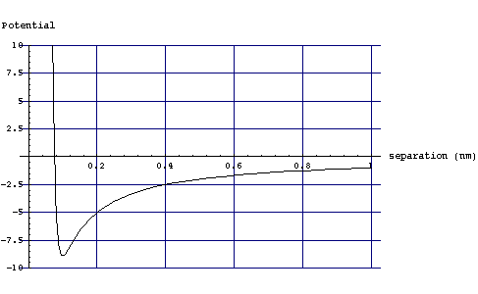

Accompanying sheet

Lenard-Jones Potential

The graph shows a plot of potential as a function of inter-atomic distance.
Where is the potential energy positive
and where is it negative for this pair of atoms?

Where the force between them repulsive?
Where is it attractive? How do you know?

What is the equilibrium distance for this pair of atoms?

