Workshop Tutorials for Biological and Environmental Physics
MR7B: Conservation of Momentum

A. Qualitative Questions:

- A great many of the interesting things that happen during sports are collisions; between people, (boxing, football) between people and objects such as in (soccer, skydiving) or between two objects (cricket, car racing). When there is a collision between two objects there is a change in momentum of each object although the total momentum before and after the collision remains constant when there are no external forces acting.
- What factors contribute to the amount of damage which is done during a collision?
- How can you minimise the effects of a collision?
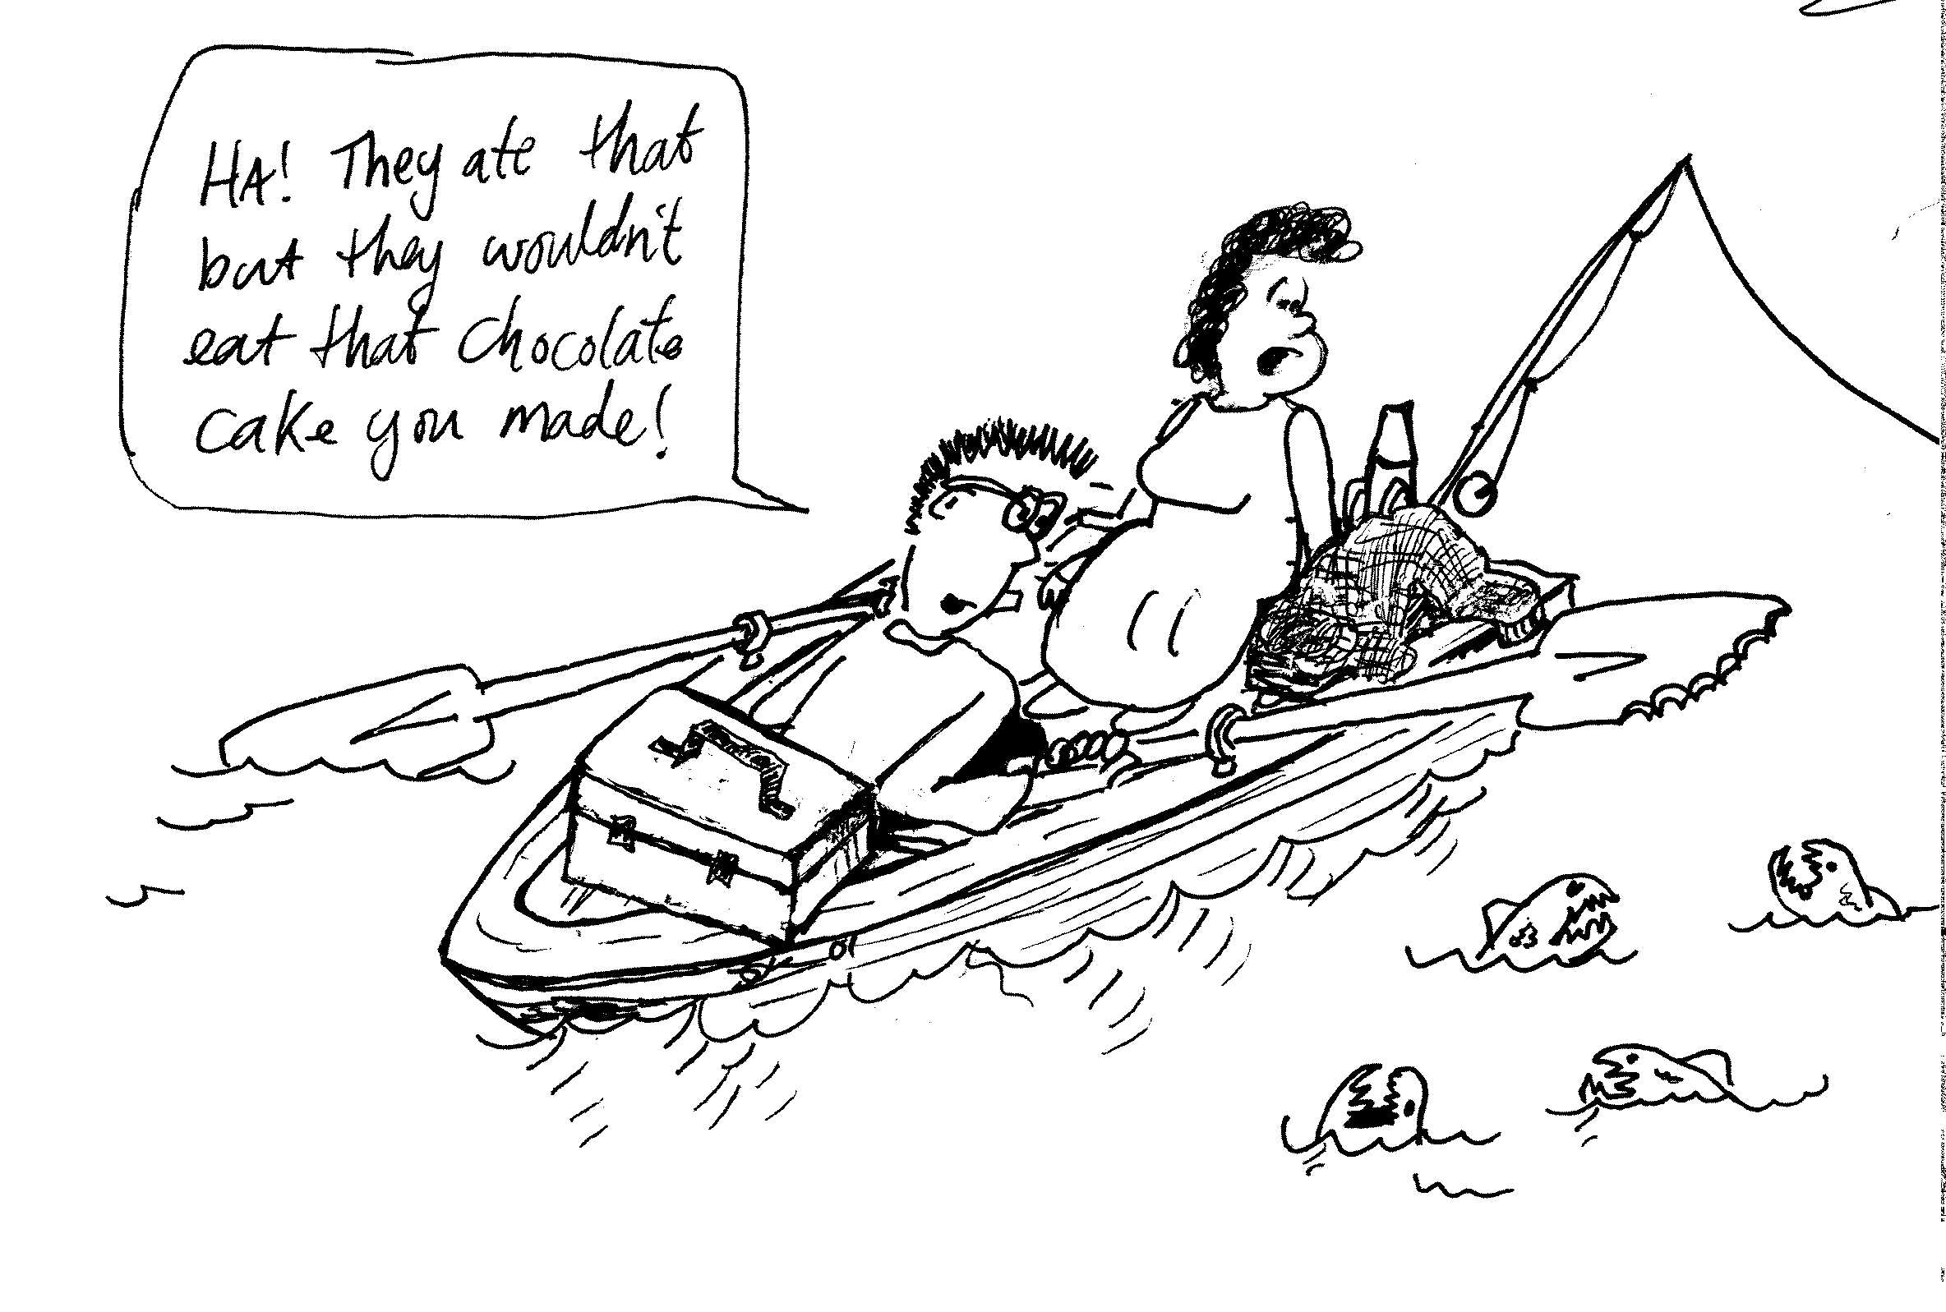
2. Rebecca and Brent are on safari, and have taken a boat out on a lake to do some fishing. They’re well prepared, with plenty of fishing gear, lunch, raincoats and warm jumpers, but no mobile phone. They throw in a line and see a host of little fish descend upon the bait and guzzle it and the line. Brent pokes the paddle at them to see what they do, and they eat that too. At this point Rebecca recognises the fish as piranhas, and also the problem that they are now in the middle of the lake, miles from civilization, with no paddle, no mobile phone, and surrounded by piranhas. She suggests that Brent walk on the boat away from the shore, and because of conservation of momentum this will make the boat go towards the shore.
- Will this get them to shore?
- What should they do to get themselves back to shore?

B. Activity Questions:

- Pendulum on Trolley
Swing the pendulum bob.
What happens to the trolley? Why does it behave like this?

- Air track
- What happens when a moving object collides with an identical stationary one? What if they have different masses?
- Send two identical objects, spaced a few centimetres apart, with the same velocity towards a third. What happens when they collide? This is like a row of moving traffic hitting a stationary vehicle.
Experiment with other combinations of moving and stationary objects.
- What purpose do the metal loops serve?
- Note the difference in collisions when the air track is switched on and when it is off. When is the coefficient of kinetic friction greater?

- Newton's cradle
Explain the difference between the two types of apparatus on display.
Can you explain the behaviour of the balls with only energy conservation or do you need conservation of momentum as well. Discuss your answer.

- Bouncing balls II
Hold a little ball in contact with and directly above a big ball. Drop the balls together.
Describe what happens. Why does this happen?
Do you get the same behavior if the big ball is above the little ball?

C. Quantitative Questions:

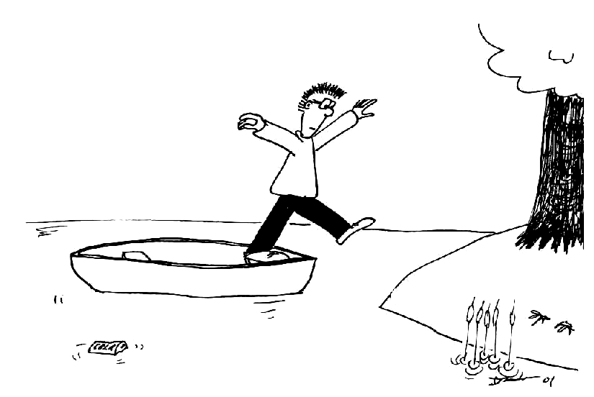
- Brent is standing in a canoe and wishes to jump ashore without getting wet. The canoe has a mass of 60 kg and Brent has a mass of 70 kg. The canoe is 1 m from the shore. Brent jumps with a velocity of 2.5 m.s⁻¹ towards the shore.
- Draw a diagram showing the movement of Brent and the canoe.
- At what initial velocity does the canoe move away from Brent?

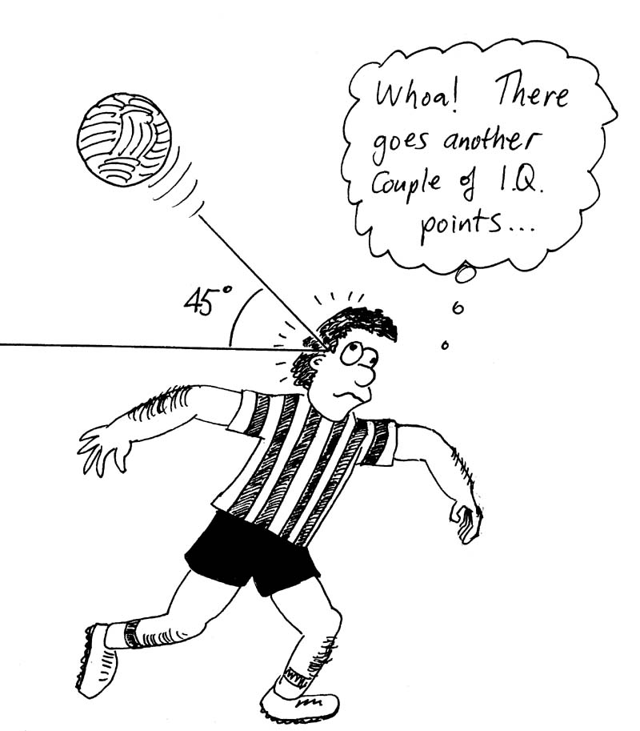
- Around 30% of professional soccer players, as well as many amateur players, suffer permanent headaches, memory loss and other ill effects due to “heading” the ball. On the field, at least 22% of injuries are to the head or neck from heading the ball. A soccer ball weighing 450 g is headed by an 80 kg player. The ball is traveling horizontally with a velocity of 20 m.s⁻¹ when it hits him, and bounces off at an angle of 45º with a velocity of 8 m.s⁻¹.
- What is the change in momentum of the ball? Draw a diagram showing the initial and final momentum to help explain your answer.
- If only the head of the player moves, pivoting on the neck, what velocity does the head have immediately after the collision? The head is around 7% of the total body mass.
- How much kinetic energy must the neck absorb as the head comes to a stop?

