Mechanics

Introductory Mechanics Worksheets and Solutions

MI1: | Motion in a Line | 3
MI2: | Using Vectors | 7
MI3: | Motion in a Plane | 11
MI4: | Newton’s Laws | 15
MI5: | Newton’s Laws II – Frictional Forces | 19
MI6: | Work, Power and Energy | 23
MI7: | Conservation of Energy | 27
MI8: | Momentum | 31
MI9: | Collisions | 35
MI10: | Equilibrium | 39
MI11: | Rotational Dynamics | 43
MI12: | Gravity and Kepler’s Laws | 47

Workshop Tutorials for Introductory Physics
MI1: Motion in a Line

A. Review of Basic Ideas:

Use the following words to fill in the blanks:
starting line, velocity, displacement, constant, acceleration, kinematics, change, time, Δt = t₁ – t₀ , increases, average, ½ (v₀ + v₁).

Describing motion
The study of motion is called ________. We can describe the motion of an object by talking about how far it has moved, how long it took to move that far, how fast it is moving and how much it is speeding up or slowing down.
Imagine watching a drag race. At the start of the race the cars are lined up at the _______ _______, not moving. Let’s label this time and position as time t = t₀, and position x = x₀. The race starts and the cars take off. A short time later one of the cars is halfway along the track, we’ll call this position x₁, and the ________ it arrives there is t = t₁. The distance the car has traveled is called the ________, and is given by Δx = x₁– x₀, the time it took to travel this distance is ________. The car started at rest, so its velocity at (x₀, t₀) was v₀ = 0. As the car accelerates away from x₀ its velocity ________. We can find the average velocity of the car between t = t₀ and t = t₁ by using
v_{av} = $\frac{Δx}{Δt}=\frac{x_{1}−x_{0}}{t_{1}−t_{0}}$
________ is the rate of change of displacement with time. The rate of ________ of velocity with time is called the acceleration. If the car is moving with velocity v₁ when it reaches the point x₁ at time t₁ then its ________ acceleration between t = t₀ and t = t₁ is
a_{av} = $\frac{Δv}{Δt}=\frac{v_{1}−v_{0}}{t_{1}−t_{0}}$
In car racing it’s important not only that the car has a high velocity, but also that it has a large _____ so that it can reach that velocity quickly.
If we decide to set the time t₀ = 0, which is usually very convenient, then we can rearrange to find our velocity at some later time, say at t₁:
v₁ = v₀ + a_{av} t₁
If the acceleration is ________ then the average velocity is v_{av} =________.Using this and the expression for v₁ above, we can work out how far the car has gone, how fast it’s moving and how quickly it’s accelerating.

Discussion questions
What is the difference between instantaneous velocity and average velocity? How can you find an instantaneous velocity?

B. Activity Questions:

- Velocities
Try to walk from one marker to the other at 1 m.s⁻¹.
Get someone to time you so that you can check how fast you are going.
Now try to go at 0.5 m.s⁻¹ and 3 m.s⁻¹.
What do you need to do to move at –1 m.s⁻¹?
- Train set
The train can only move in one dimension.
Choose a convention to label the positive and negative directions.
Use the controller to vary the velocity and acceleration of the train. Can you move the train from one point to another point such that it has a negative velocity and a positive acceleration?

- Acceleration due to collision
Send the toy car into the sponge, so that it bounces back.
a. Describe what happens in terms of the velocity and acceleration of the car.
b. Sketch the acceleration of the car as a function of time.

- Acceleration due to gravity
Throw the ball straight up into the air, and catch it when it comes back down again.
- Describe what happens to the velocity and acceleration of the ball.
- Sketch the acceleration as a function of time.
- Sketch the ball’s velocity and displacement with time.

C. Qualitative Questions:

- Brent is jumping on a trampoline. He leaps up into the air, and falls back again.
- Is Brent’s acceleration zero at any point? If so, where?
- Is the direction of Brent’s velocity always in the direction of his acceleration? If not, when is it different?

You are driving west on Parramatta Road at peak hour, so you are starting and stopping a lot. A graph of your velocity as a function of time is shown.
- Describe what is happening to the speed and position of the car in the first 10 minutes shown.
- Describe what is happening to the speed and position of the car in the second 10 minutes shown.
- Sketch a graph of the car’s acceleration as a function of time.
- Sketch a graph of the car’s displacement as a function of time.

D. Quantitative Question:

A sneeze can exit the body at more than 150 km.h⁻¹, or around 42 m.s⁻¹. Imagine a droplet of moisture initially at rest in your mouth, which travels 5 cm to be sneezed out at 150 km.h⁻¹ in the horizontal direction.
- What is the average acceleration of the droplet during the sneeze?
When you sneeze you involuntarily close your eyes.
- If your eyes are closed for 0.2 seconds after the droplet leaves your mouth, how far has it traveled horizontally when you open your eyes again? (ignore air resistance).
Little droplets of moisture usually only travel a few metres before coming to a stop due to air resistance.
- If a droplet travels 5m horizontally before coming to a stop, what is its average deceleration?
- How long does it take to travel this distance?

Solutions to MI1: Motion in a Line

A. Review of Basic Ideas:

Describing motion
The study of motion is called kinematics. We can describe the motion of an object by talking about how far it has moved, how long it took to move that far, how fast it is moving and how much it is speeding up or slowing down.
Imagine watching a drag race. At the start of the race the cars are lined up at the starting line, not moving. Let’s label this time and position as time = t₀, and position = x₀. The race starts and the cars take off. A short time later one of the cars is halfway along the track, we’ll call this position x₁, and the time it arrives there is time t = t₁. The distance the car has traveled is called the displacement, and is given by Δx = x₁– x₀, the time it took to travel this distance is Δt = t₁ – t₀. The car started at rest, so its velocity at (x₀, t₀) was v₀ = 0. As the car accelerates away from x₀ its velocity increases. We can find the average velocity of the car between t = t₀ and t = t₁ by using
v_{av} = $\frac{Δx}{Δt}=\frac{x_{1}−x_{0}}{t_{1}−t_{0}}$
Velocity is the rate of change of displacement with time. The rate of change of velocity with time is called the acceleration. If the car is moving with velocity v₁ when it reaches the point x₁ at time t₁ then its average acceleration between t = t₀ and t = t₁ is
a_{av} = $\frac{Δv}{Δt}=\frac{v_{1}−v_{0}}{t_{1}−t_{0}}$
In car racing it’s important not only that the car has a high velocity, but also that it has a large acceleration so that it can reach that velocity quickly.
If we decide to set the time t₀ = 0, which is usually very convenient, then we can rearrange to find our velocity at some later time, say at t₁:
v₁ = v₀ + a_{av} t₁
If the acceleration is constant then the average velocity is v_{av} =½ (v₀ + v₁).Using this and the expression for v₁ above, we can work out how far the car has gone, how fast it’s moving and how quickly it’s accelerating.

Discussion questions
Instantaneous velocity is the velocity an object has at some instant in time. For example, you may be driving down a hill and speeding up, so that when you reach the bottom your velocity is 70 km.h⁻¹, and a speed camera at the bottom of the hill will measure this speed. If you draw a graph of your position as a function of time then your velocity at any instant is the gradient of a tangent to the graph at that point. Your average velocity is the total distance traveled divided by the total time taken. On most days your average velocity over the entire day is zero because you end up in bed where you started, having traveled no net displacement at all.

B. Activity Questions:

- Velocities
You should start by choosing a positive direction and a negative direction. Most people have a step length a little less than a metre, so if you walk at slightly more that one step per second you should be going at approximately 1 m.s⁻¹. To move at -1 m.s⁻¹ you need to walk in the negative direction.
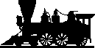
v
a
v
a
a
v
b
a
- Train set
You can move the train from point a to point b such that it has a negative velocity and a positive acceleration by running the train backwards, and having it slow down as it goes.

- Acceleration due to collision
t
a
v
v
The car slows down as it hits the sponge, and is bounced back. Hence it has a negative acceleration due to the impact, which acts during the collision with the sponge.

- Acceleration due to gravity
t
x
t
v
t
a
g
The ball slows as it climbs until it reaches its peak, then speeds up as it falls. The acceleration of the ball is constant once it leaves your hand, and is due to gravity only. See diagrams opposite.

C. Qualitative Questions:

- Brent is jumping on a trampoline. He leaps up into the air, and falls back again.
a. Brent always has the force of gravity acting on him. Whenever he is up in the air, that is the only force acting on him. When he is going up, the force of gravity pulls down on him and he slows down. When he is coming down again, gravity acts to speed him up. Brent is always accelerating downwards at about 9.8 m.s⁻² except when he is in contact with the trampoline. When he lands on the trampoline it stretches and applies a force to Brent, sending him up in the air again.
b. When Brent is moving downwards, he is speeding up - his velocity is in the same direction as the acceleration. But when he is moving upwards, his velocity is opposite to the direction of his acceleration - the acceleration is downwards due to gravity, yet the velocity is upwards. An acceleration opposite in direction to your velocity simply means that you are slowing down, not speeding up.

- You are driving west on Parramatta Road at peak hour, a graph of velocity vs time is shown.
- In the first 5 minutes the car has a positive but decreasing velocity. Hence the car is going forwards but slowing down before coming to a halt. It is then stationary for the next 5 minutes.  - In the next 10 minutes the car speeds up, reaching a constant velocity, and then slowing to a halt again.  - Acceleration is the rate of change of velocity. When the velocity is a straight, increasing line, the acceleration is positive and constant. A decreasing velocity gives a negative acceleration. See plot opposite.  - Displacement is the area under the velocity curve, or the integral of velocity with time. See plot opposite. | v  a  t  x

D. Quantitative Question:
A droplet of moisture, initially at rest in your mouth, travels 5 cm to be sneezed out at 150 km.h⁻¹.
- Average acceleration is change in velocity divided by change in time or in this case we can use the formula: v² – v_{o}² = 2a Δs , which we rearrange to get
a = ½ (v² – v_{o}²)/Δs = ½ (42 m.s⁻¹)²/0.05m = 17,640 m.s⁻². This is a huge acceleration, almost 2000 g’s!
- If your eyes are closed for 0.2 seconds and the droplet is travelling at 42 m.s⁻¹ then it travels
d = v × t = 42m.s⁻¹ × 0.2 s =8.4 m.
- If a droplet travels 3m before coming to a stop, its average deceleration is
a = ½ (v² – v_{o}²)/Δs = ½ (-42 m.s⁻¹)²/5m = 176 m.s⁻².
- The time it takes to travel this distance is Δt = Δv/a = 42 m.s¹/ 176 m.s⁻² = 0.24 s.
So by the time you open your eyes again, the droplets have already traveled a few metres and stopped.
MI2: Using Vectors

A. Review of Basic Ideas:

Use the following words to fill in the blanks:
always, magnitude, A_{y}$\hat{j}$, displacement , A_{y} + B_{y}, directions, far, pointing, 20 km, vectors, origin, Cartesian, Acosθ, home
A sense of direction
Every one has at some point asked someone else for _____ or given someone else directions to get somewhere. When you listen to someone describing how to get to a place they sometimes talk about how _____ to walk or drive, but they _____ describe which direction to travel in. They may do this by simply _____, or saying keep going straight, or go left, then right, or go west then north. If you live 20 km from university, then you need to travel at least _____ to get there. But if you go 20 km in the wrong direction, you will not get there. A knowledge of direction is something you use all the time.
Direction is very important in physics as well. A lot of the quantities that we talk about in physics have a direction. Common examples are _____, momentum, and force. To describe these quantities we use _____.
A vector has both a _____ (which tells you how big it is) and a direction. There are lots of different ways of representing vectors, some of which you regularly use already. If someone asks you where Hurstville is you might say “about 20km south west of the city”, or you might give them a map reference, such as “map 75, grid reference H6”. Usually we need to define some reference point, called an _____, so that we know where we’re measuring from, and some directions such as north, south, east and west, up and down. In physics we usually use _____ coordinates, which are commonly labeled x,y and z.
We can describe a vector by giving its components in each of the coordinate directions. To do this we need to define unit vectors. Unit vectors have a length or magnitude of 1, and point in the direction of the axes. The unit vector $\hat{i}$ points in the direction of the x axis and the unit vector $\hat{j}$ points in the y direction. In 2 dimensions, a vector $\vec{A}$ could be written as $\vec{A}$= A_{x}$\hat{i}$ + _____. The magnitude of the vector $\vec{A}$is
$$A=\sqrt{A_{x}^{2}+A_{y}^{2}}$$
Given the angle, θ, that the vector makes with the x axis and the magnitude of the vector, we can find the components:
A_{x} = _____ A_{y} = A sinθ
If you know what the components are it’s easy to add vectors. If you add a vector$\vec{A}$to a vector$\vec{B}$ you get a resultant vector, which we’ll call C,
$\vec{C}$ = $\vec{A}$ +$\vec{B}$ and C_{x} = (A_{x} + B_{x}) and C_{y} = (_____) so
$\vec{C}$ = C_{x} $\hat{i}$ + C_{y}$\hat{j}$ = (A_{x} + B_{x}) $\hat{i}$ + (A_{y} + B_{y}) $\hat{j}$.
If the vector $\vec{A}$describes how to get from home to the beach, and the vector $\vec{B}$describes how to get from the beach to Uni, then the sum,$\vec{C}$, tells you how to get directly from _____ to Uni.

A. Discussion question
Explain to your team (just one of you) how to get from your home to the local shop. Listen for vectors, and try to draw them.

B. Activity Questions:

- Battleship
Describe how vectors are used to give positions in this game.
How else could you describe the position of a ship?

- Map
How are vectors used on the maps?
You should be able to find at least two examples.

3. Vector Game
Appoint one group member to be a caller.
Everyone else chooses a starting position and walks the vectors as called.
When you get it wrong, you’re out!

4. Mirrors and reflections - Coordinate Systems
Look at your reflection in the mirror.
Move your right hand to the right. What does your reflection do?
Why is it that left and right are reversed in the mirror, but not up and down?

C. Qualitative Questions:

1. Barry the dog is running around the yard chasing a ball.
- Can the magnitude of Barry’s displacement be less than the distance he’s travelled?
- Can the displacement be more than the distance traveled?
Barry comes to rest in the yard, some distance from where he started. Consider the components of his displacement in perpendicular directions (such as north and east, or x and y.)
- Can the magnitude of any of these components be greater than the magnitude of the displacement vector itself?
- How could a component have the same magnitude as the magnitude of his displacement vector?

2. Vectors are very useful for describing velocities. Have you ever watched a bird trying to fly in a strong wind? They can appear to be standing still or even going backwards if flying against the wind.
Kevin the Tasmanian duck is heading north for winter over Bass Strait. He flies with a velocity $\vec{K}$ = K_{x}$\hat{i}$ + K_{y}$\hat{j}$. He gets almost within sight of the Victorian coast line when a strong wind begins to blow with a velocity$\vec{W}$ = W_{x}$\hat{i}$ + W_{y}$\hat{j}$, blowing Kevin off course.
- Write an expression for the resultant velocity, $\vec{V}$, of the bird.
- Draw a diagram showing the vectors $\vec{W}$, $\vec{K}$and $\vec{V}$.
- Are the components of $\vec{V}$ necessarily larger than the components of $\vec{K}$ and $\vec{W}$?

D. Quantitative Question:

A radar operator is tracking the movements of a ship. When she first notices the ship it is 20 km south of her. An hour later it is 10 km south and 10 km east of her.

- Draw a diagram showing the ship and radar station initially and an hour later.
- Take the radar station as the origin, and write vectors giving the initial position of the ship, and its position one hour later.
- What is the velocity of the ship (as a vector), in kilometers per hour, km.h⁻¹?

- What is the magnitude of the velocity?
The ship continues at a steady pace in the same direction.
- Write an expression for the displacement of the ship at any time.

Solutions to MI2: Using Vectors

A. Review of Basic Ideas:

A. sense of direction.
Every one has at some point asked someone else for directions or given someone else directions to get somewhere. When you listen to someone describing how to get to a place they sometimes talk about how far to walk or drive, but they always describe which direction to travel in. They may do this by simply pointing, or saying keep going straight, or go left, then right, or go west then north. If you live 20 km from university, then you need to travel at least 20 km to get there. But if you go 20 km in the wrong direction, you will not get there. A knowledge of direction is something you use all the time.
Direction is very important in physics as well. A lot of the quantities that we talk about in physics have a direction. Common examples are displacement, momentum, and force. To describe these quantities we use vectors.
A vector has both a magnitude (which tells you how big it is) and a direction. There are lots of different ways of representing vectors, some of which you regularly use already. If someone asks you where Hurstville is you might say “about 20km south west of the city”, or you might give them a map reference, such as “map 75, grid reference H6”. Usually we need to define some reference point, called an origin, so that we know where we’re measuring from, and some directions such as north, south, east and west, up and down. In physics we usually use Cartesian coordinates, which are commonly labeled x,y and z.
We can describe a vector by giving its components in each of the coordinate directions. To do this we need to define unit vectors. Unit vectors have a length or magnitude of 1, and point in the direction of the axes. The unit vector $\hat{i}$ points in the direction of the x axis and the unit vector $\hat{j}$ points in the y direction. In 2 dimensions, a vector $\vec{A}$ could be written as $\vec{A}$= A_{x}$\hat{i}$ + A_{y}$\hat{j}$. The magnitude of the vector $\vec{A}$is $A=\sqrt{A_{x}^{2}+A_{y}^{2}}$. Given the angle, θ, that the vector makes with the x axis and the magnitude of the vector, we can find the components: A_{x} = Acosθ, A_{y} = A sinθ
If you know what the components are it’s easy to add vectors. If you add a vector$\vec{A}$to a vector$\vec{B}$you get a resultant vector, which we’ll call $\vec{C}$, $\vec{C}$ = $\vec{A}$ +$\vec{B}$ and C_{x} = (A_{x} + B_{x}) and C_{y} = (A_{y} + B_{y}) so
$\vec{C}$ = C_{x} $\hat{i}$ + C_{y}$\hat{j}$ = (A_{x} + B_{x}) $\hat{i}$ + (A_{y} + B_{y}) $\hat{j}$.
If the vector $\vec{A}$describes how to get from home to the beach, and the vector $\vec{B}$describes how to get from the beach to Uni, then the sum,$\vec{C}$, tells you how to get directly from home to Uni.

Discussion question
Start by drawing a set of axis so you can define directions on your page. Listen for directions, such as north, south or left right, and distances.
B. Activity Questions:

1. Battleship
Battleship and similar games use vectors to determine the position of a ship. The vectors are usually written in terms of letter and number axes, rather than x, y axes, but are otherwise identical to vectors used in physics and mathematics. One way of describing the position of a pin is to give the lengths of perpendicular components, for example horizontal (numbers) and vertical (letters). Another way is to give the length of the vector and its angle to the horizontal. For example a pin at position C4 is also 5 units from the origin on a line 49º above the horizontal.

2. Maps
Vectors are used to define positions on the maps via a letter/number grid. Most maps will also show a vector pointing north to define compass directions on the map.

- Vector Game
The axes are chosen in advance and marked, so you know which direction is +x and which direction is +y. For example, forward may be +x and right may be +y. If the caller says “5x + 3y” you take 5 steps forwards and three steps to the right. If the caller says “-5x - 3y” you take five steps back and three steps left.
- Mirrors and reflections – Coordinate Systems
In a reflection left and right seem to be reversed, but not up and down. This is because we define left and right as relative to ourselves, not our surroundings. It is important to know how you are defining your coordinate system. For example, “towards the wall” and “away from the wall” are not reversed, just as up and
down are not reversed. Up and down directions in an externally defined coordinate system, as well as in your internally defined system of coordinates. They are defined externally, usually relative to the ground, hence are not reversed.

C. Qualitative Questions:

1. Barry is running around the yard chasing birds.
a. Barry’s displacement can be less than the distance he traveled. Imagine if Barry ran backwards and forwards across the yard twice and finished back in the same place. His displacement (the vector quantity representing the difference between the initial and final position) would be zero but he would have run a fair distance.
b. The displacement can never be more than the distance traveled. To travel from one point in space to another, the minimum distance Barry can travel is the straight line joining the two points. He can never travel less distance than that.
c. No component of his displacement vector can be greater than the magnitude of the vector itself. Components are defined in two directions at right angles to each other. Hence the displacement is the hypotenuse of a right angle triangle. The hypotenuse will be greater than either of the two sides.
d. If the directions of the components were taken such that one was in the same direction as the displacement then one component would have the same magnitude as the displacement vector and the other would be zero.

2. Kevin the duck flies north.
K_{x}
K_{y}
W_{y}
W_{x}
V_{x}
V_{y}
- Kevin’s resultant velocity is
$\vec{V}$= $\vec{K}$+$\vec{W}$= K_{x}$\hat{i}$ + K_{y}$\hat{j}$ + W_{x}$\hat{i}$ + W_{y}$\hat{j}$= (K_{x}+ W_{x})$\hat{i}$ + (K_{y}+ W_{y})$\hat{j}$.
- See diagram opposite.
- The components of $\vec{V}$ are not necessarily larger than the components of $\vec{K}$ and $\vec{W}$. If the components of $\vec{K}$ and $\vec{W}$ are in different directions, i.e. one is positive and one is negative, the resultant component of $\vec{V}$ will have a smaller magnitude than at least one of the components. For example, V_{x} opposite is smaller in magnitude than either K_{x} or W_{x}.
20 km
10 km
10 km
t = 1 h
D. Quantitative Question:
t = 0 h

- See diagram opposite.
- ${\vec{S}}_{0}$= S_{x0}$\hat{i}$ + S_{y0}$\hat{j}$ = (-20 km)$\hat{j}$.
${\vec{S}}_{1}$= S_{x1}$\hat{i}$ + S_{y1}$\hat{j}$ = (10 km) $\hat{i}$+ (-10 km)$\hat{j}$.
- The velocity is the change in position divided by the change in time. The change in position is:
${\vec{S}}_{1}$- ${\vec{S}}_{0}$ = (10 km) $\hat{i}$+ (-10 km)$\hat{j}$ - (-20 km)$\hat{j}$
= (10 km) $\hat{i}$+ (+10 km)$\hat{j}$

The time taken is one hour, so $\vec{V}$= (10 km.h⁻¹) $\hat{i}$+ (10 km.h⁻¹)$\hat{j}$
- The magnitude of $\vec{V}$ is V = $\sqrt{(V_{x^{2}}+V_{y^{2}})}$= $\sqrt{(\text{10} \text{km}\text{.}h^{\text{-1}})^{2}+(\text{10} \text{km}\text{.}h^{\text{-1}})^{2}}$= 14 km.h⁻¹.
- Given a steady velocity, the position at any time is
${\vec{S}}_{t}$= ${\vec{S}}_{0}$+ $\vec{V}$t = (10 km) $\hat{i}$+ (0 km)$\hat{j}$+ [(10 km.h⁻¹) $\hat{i}$+ (10 km.h⁻¹)$\hat{j}$] t.

MI3: Motion in a Plane

A. Review of Basic Ideas:

Use the following words to fill in the blanks:
resistance, constant, constant velocity, constant acceleration, projectile, zero, velocity, idealised, trajectory

Projectile motion
A _________ is any body that is given an initial velocity and then follows a path determined by the effects of gravitational acceleration. A batted cricket ball, a thrown football, a package dropped from an airplane, and a bullet shot from a rifle are all projectiles. The path followed by a projectile is its __________.
To analyse this common type of motion, we start with an ________ model, representing the projectile as a single particle with an acceleration (due to gravity) that is constant in both magnitude and direction. We neglect the effects of air ________ and the curvature and rotation of the earth. Like all models, this one has limitations. Nevertheless, we can learn a lot from analysis of this simple model.
Notice that projectile motion is always described within a vertical plane determined by the direction of the initial ________ and acceleration, g. We will call this plane the xy-coordinate plane, with the x-axis horizontal and the y-axis vertically upward. The key to analysis of projectile motion is the fact that we can treat motion in the x and y directions separately. The x-component of acceleration is _______, and the y-component is ______ and equal to -g. So we can think of projectile motion as a combination of horizontal motion with _______ _______ and vertical motion with _______ ______. The actual motion is the superposition of these separate motions.

Discussion questions:
1. Identify an example where the above model fails because air resistance can't be ignored.
2. Identify an example where the above model fails because the curvature and rotation of the earth can't be ignored.
3. The third paragraph talks of "vertical plane", "x-axis horizontal" and "y-axis vertically upward". Identify the above physical descriptions for an eraser thrown across your table (projectile). Throw the eraser in different directions, what happens to the physical descriptions?

B. Activity Questions:

- Projectile Launcher
Use the Projectile Launcher to answer the following questions.
What is the angle of launch corresponding to maximum range?
What is the angle of launch corresponding to maximum vertical height?
Explain your results qualitatively.

- Marble ejecting trolley
This system is designed such that the trolley is travelling with uniform velocity during the process of ejecting and catching the marble. What can you deduce about the horizontal and vertical components of the velocity of the marble after it has been ejected?
How could you repeat this experiment while traveling on a train?

3. Drop and Horizontal Throw
Examine the apparatus.
Predict which ball will hit the ground first when the balls are released.
What are the initial velocities of the two balls?
Which ball hit the ground first? Why?

C. Qualitative Questions:

- Chuck the Canine Cannonball is the star dog of the Sirius Circus. As the circus’s finale he is loaded into the cannon and fired out over the centre ring. His trajectory is shown below.

- At which point(s) is Chuck’s speed the greatest?
- At which point(s) is his speed the lowest?
- At which points is his the speed the same? Is the velocity the same at these points?
- What is the direction of the acceleration at point B?
- What is the direction of the acceleration at point D?

2. Brent drops a ball while running and at the same time Rebecca, who is standing still, also drops a ball.
- If the two balls are dropped at the same time and from the same height which ball, if either, will hit the ground first?
- The ball Rebecca drops will hit the ground next to her. Where will the ball Brent dropped land?
- If Brent (who is still running) wishes to drop the ball so that it falls into a bucket on the floor as he runs past, should he drop it before he reaches the bucket, when he reaches the bucket or after he passes the bucket? Why?

D. Quantitative Question:

Chuck the Canine Cannonball is fired from his cannon which is angled at 45º to the horizontal. He has a speed of 20 m.s⁻¹ as he leaves the barrel of the cannon. Chuck wears a special low-friction suit and a streamlined bike helmet to minimise air resistance (drag).
- What height does Chuck reach (neglecting air resistance)?
- How long is Chuck in the air?
- How far from the cannon does Chuck land?

Solutions to MI3: Motion in a Plane

A. Review of Basic Ideas:

Projectile motion
A projectile is any body that is given an initial velocity and then follows a path determined by the effects of gravitational acceleration. A batted cricket ball, a thrown football, a package dropped from an airplane, and a bullet shot from a rifle are all projectiles. The path followed by a projectile is its trajectory.
To analyse this common type of motion, we start with an idealised model, representing the projectile as a single particle with an acceleration (due to gravity) that is constant in both magnitude and direction. We neglect the effects of air resistance and the curvature and rotation of the earth. Like all models, this one has limitations. Nevertheless, we can learn a lot from analysis of this simple model.
Notice that projectile motion is always described within a vertical plane determined by the direction of the initial velocity and acceleration, g. We will call this plane the xy-coordinate plane, with the x-axis horizontal and the y-axis vertically upward. The key to analysis of projectile motion is the fact that we can treat motion in the x and y directions separately. The x-component of acceleration is zero, and the y-component is constant and equal to -g. So we can think of projectile motion as a combination of horizontal motion with constant velocity and vertical motion with constant acceleration. The actual motion is the superposition of these separate motions.

Discussion questions
- Air resistance cannot be ignored in sky diving or parachuting, where air resistance is used to slow down a falling object. It is also important in any sport where the aim is to go very fast, for example Olympic cyclists wear special streamlined helmets.
- The curvature of the Earth needs to be allowed for in the launching of missiles and rockets, and the motion of anything that travels far above the Earth’s surface, for example satellites.
- The physical description does not change when you change your axes.

B. Activity Questions:
45º
<45º
>45º

- Projectile launcher
Maximum range (horizontal displacement) occurs for an angle of launch of 45º. Maximum height occurs for a vertical throw provided the initial speeds are the same.

- Marble ejecting trolley  The horizontal component of the marbles velocity is constant and is equal to the velocity of the trolley. The vertical component of velocity is not constant, as the marble is subject to acceleration due to gravity.  You could see the same effect by watching someone throwing a ball up and catching it again as they rode past you on a moving train. | v  v
drop
throw
- Drop and horizontal throw
The dropped ball has an initial velocity of zero while the thrown one has an initial horizontal velocity only.
The balls hit the ground at the same time (depends on vertical motion which is the same for both balls) but in different places (depends on horizontal motion which is different for the two balls).

C. Qualitative Questions:

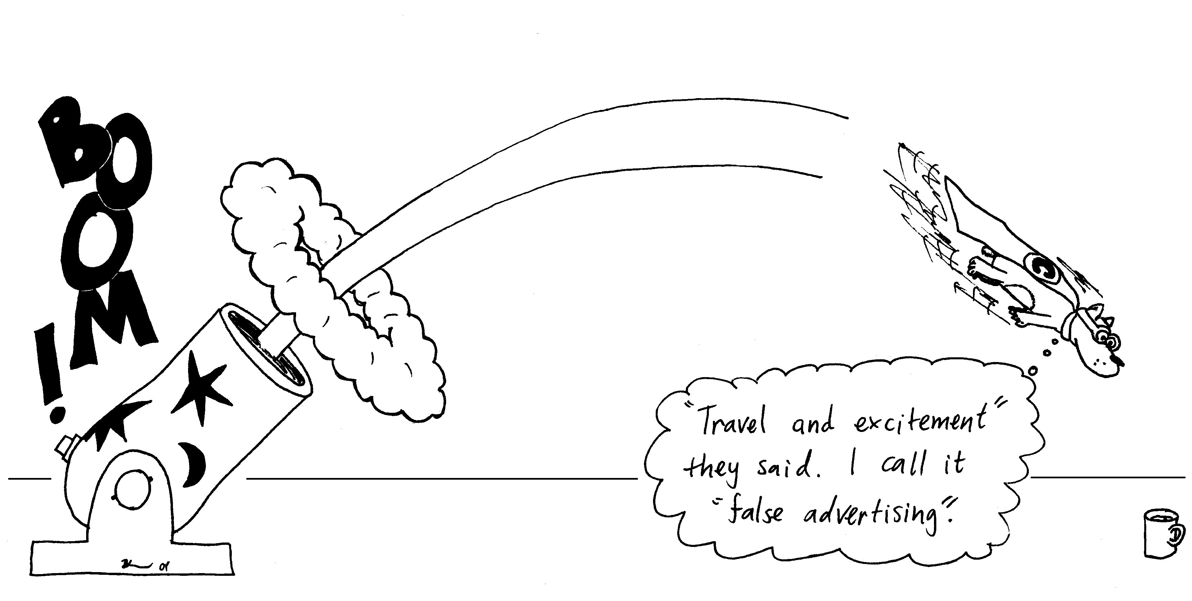
- Chuck’s speed has a horizontal component, which is constant if we ignore air resistance. The vertical component of his speed is not constant, it is a maximum (upwards) when he is ejected, a minimum (zero) at the top of his trajectory, and a maximum (downwards) just before he lands.
A
B
C
D
E
- His speed is greatest as he is ejected (A) and just before he lands (E).
- His speed is lowest at the top of his trajectory (horizontal only).
- His speed, the magnitude of his velocity, is the same at points A and E, and at B and D. His velocity is not the same at any two points because he is constantly accelerating towards the ground.
d and e. The direction of his acceleration is always downwards once he is ejected, until he lands, as gravity is the only force acting during his flight.

2. Dropping balls.
a. The balls hit the ground at the same time (depends on vertical motion which is the same for both balls) but in different places (depends on horizontal motion which is different for the two balls).
b. Brent's ball will also land next to him provided he doesn't change his horizontal velocity.
c. Brent should drop the ball before he reaches the bucket as the ball has a horizontal velocity which will continue to carry it forwards once he lets go of it.

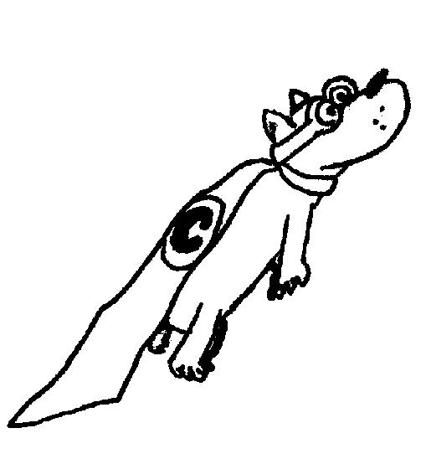
D. Quantitative Question:
θ = 45º
v_{y}
v_{x}
v = 20 m.s⁻¹

First separate his initial velocity into vertical and horizontal components:
v_{xi} = v_{o}cosθ = 20 m.s⁻¹ cos45º = 14 m.s⁻¹
v_{yi} = v_{o}sinθ = 20 m.s⁻¹ sin45º = 14 m.s⁻¹
v_{x} will be constant as there is no force in this direction.
The acceleration in y is due to gravity and is a = -9.8 m.s², taking down as the negative direction.
- Chuck will reach maximum height, y_{max}, when v_{y} = 0.
We can use v_{y}² = v_{yi}² + 2ay:
0 = (14 m.s⁻¹) ² + 2× -9.8 m.s⁻² × y_{max}, rearranging for y_{max} gives
y_{max} = -(14 m.s⁻¹) ² / 2× -9.8 m.s⁻² = 10 m.
(Note that we take down as the negative direction, so g = -9.8 m.s⁻²)
- The time he is in the air will be twice the time it takes to reach the maximum height.
We can use v = v_{i} + at, rearranging for t and setting v = 0, gives
t = -v_{i}/a = -14 m.s⁻¹ / -9.8 m.s⁻² = 1.43 s.
The total time of flight is 2 × 1.43 s = 2.9 s.
- The total distance Chuck is projected can be calculated using the x component of his velocity. He is in the air for a total of 2.9 s, moving with a horizontal velocity of 14 m.s⁻¹.
He travels a distance x = v_{x}t = 14 m.s⁻¹ × 2.9 s = 41 m.

MI4: Newton’s Laws I

A. Review of Basic Ideas:

Use the following words to fill in the blanks:
zero, vector, newton, scalar, acceleration, constant, gravitational, velocity, non-zero, contact, forces, quantitative

Forces
How can a tugboat pull a cruise ship that's much heavier than the tug? Why does it take a long distance to stop the ship once it is in motion? Why is it harder to control a car on an icy road than on dry concrete? The answers to these and similar questions take us into the subject of dynamics, the relationship of motion to the _____________ that cause it. We will use kinematic quantities - displacement, __________ and acceleration - to understand what makes bodies move the way they do.
All the principles of dynamics can be wrapped up in a neat package containing three statements called Newton's laws of motion. The first law states that when the net force on a body is ________, its motion doesn't change. The second law relates force to acceleration when the net force is not zero. The third law gives a relation between the forces that two interacting bodies exert on each other. Many other scientists before Newton contributed to the foundations of mechanics, including Copernicus, Brahe, Kepler and Galileo Galilei. Indeed, Newton himself said, "If I have been able to see a little farther than other men, it is because I have stood on the shoulders of giants."
The concept of force gives a ___________ description of the interaction between a system and its environment. There are forces, including ______________ and electrical forces, that act even when the bodies are separated by empty space. Force is a _____________ quantity; to describe a force we need to describe the direction in which it acts as well as its magnitude. The SI unit of the magnitude of force is the ____________, abbreviated N.

Discussion Questions
Can a car, with a zero net force, roll down a hill? Explain your answer.

B. Activity Questions:

- Gaining Weight
Can you change (and hold) the reading while standing on one scale, without touching anything else?
Can you change (and hold) the reading while standing on one scale, and holding a friend? Explain.
Does your friend feel you are pushing or pulling? and in which direction?
If you stand with your weight evenly distributed over two bathroom scales, what will be the reading on each scale compared to your weight? Why?
How will the readings change as you shift your weight to your right leg?

- Smooth variable ramp
Draw a free body diagram for the trolley.
What are the components of the forces acting parallel and perpendicular to the ramp?
Is the force on the trolley from the spring balance equal to mgsinθ? Comment on your answer.
What happens to the force needed to keep the trolley stationary on the ramp as the inclination of the ramp is increased?

- Constant velocity
Pull the trolley along a flat surface with the spring balance.
What does the spring balance indicate?
Set the ramp so that the trolley rolls down freely.
Pull the trolley up the ramp with constant velocity. This is not easy and may take several attempts.
What is the reading on the spring balance now? Is it what you expect it to be?
Is this reading different to that when pulling the trolley on a flat surface with constant velocity?

- Constant acceleration
Set the ramp so that the trolley rolls down freely.
When the trolley is released at the top it accelerates down the ramp. What net force is acting to accelerate the trolley?
Is the trolley in equilibrium?

- Newton’s Cradle (2 balls)
Swing one ball out and release it.
Draw a diagram showing the forces acting on the balls.
Is there an action-reaction pair here? If so, what is it?

C. Qualitative Questions:

1. Draw force diagrams (free body diagrams) for the situations described below. In which of the situations is the net force on the car zero?
- A car cruising at a constant speed of 100 km.h⁻¹ on a long straight stretch of highway.
- A car going around a curve of radius 20 m at a constant speed of 60 km.h⁻¹.
- A car accelerating uniformly at 1.3 m.s⁻² on a long straight stretch of highway.

- How can a tug boat move a cruise ship when the cruise ship exerts the same force on the tugboat as the tugboat exerts on the cruise ship? Draw a diagram showing the action-reaction force pair.

D. Quantitative Question:

Brent is trying to lift a piano of mass 150 kg using a rope and pulley as shown.  a. If the rope cannot sustain a tension of more than 2000 N, what is the maximum force with which Brent should pull?  b. What is the maximum acceleration of the piano? | 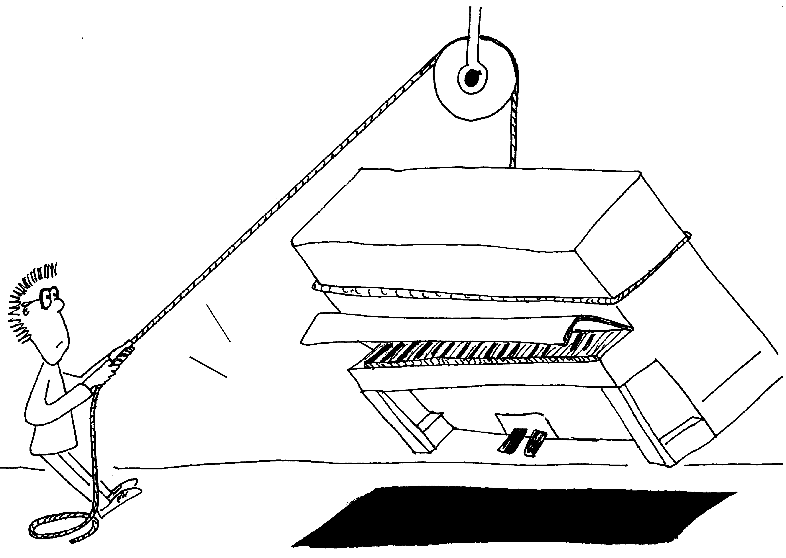

Solutions to MI4: Newton’s Laws I

A. Review of Basic Ideas:

Forces
How can a tugboat pull a cruise ship that's much heavier than the tug? Why does it take a long distance to stop the ship once it is in motion? Why is it harder to control a car on an icy road than on dry concrete? The answers to these and similar questions take us into the subject of dynamics, the relationship of motion to the forces that cause it. We will use kinematic quantities; displacement, velocity and acceleration, to understand what makes bodies move the way they do.
All the principles of dynamics can be wrapped up in a neat package containing three statements called Newton's laws of motion. The first law states that when the net force on a body is zero, its motion doesn't change. The second law relates force to acceleration when the net force is not zero. The third law gives a relation between the forces that two interacting bodies exert on each other. Many other scientists before Newton contributed to the foundations of mechanics, including Copernicus, Brahe, Kepler and Galileo Galilei. Indeed, Newton himself said, "If I have been able to see a little farther than other men, it is because I have stood on the shoulders of giants."
The concept of force gives a quantitative description of the interaction between a system and its environment. There are forces, including gravitational and electrical forces, that act even when the bodies are separated by empty space. Force is a vector quantity; to describe a force we need to describe the direction in which it acts as well as its magnitude. The SI unit of the magnitude of force is the newton, abbreviated N.

Discussion Questions
If a car is stationary then it will not move unless there is a net force acting on it. If it is already rolling it will continue to do so at the same rate unless a net force acts.

B. Activity Questions:

- Gaining Weight
A bathroom scale measures the force applied to it. They are calibrated to display mass (mislabeled weight).You cannot change and hold the reading without touching anything else.
You can change (and hold) the reading while holding a friend. You can push down on your friend so that they take some of your weight, and the scale will read lower. If your friend pushes you down, or you push upwards on your friend, the force exerted on the scale is greater and it reads a higher weight.
If you stand with your weight evenly distributed over two bathroom scales they will each read half your weight (really your mass), as half your weight force due to gravity is applied to each scale.
If you shift your weight to your right leg the scale under your right foot will read more, and the scale under your left foot will read less, as the weight force is redistributed.
mg sin θ
mg sin θ
θ
N
mg cos θ
mg
θ
N
pull of spring
- A variable ramp with stationary trolley
With no friction the force needed to keep the trolley on the ramp is a component of the weight: mgsinθ. The spring balance may read a little less than this as friction is also acting to prevent the trolley rolling down due to gravity.

As the angle of inclination, θ, is increased the force needed to hold the trolley increases, reaching a maximum of mg when θ = 90º.

- Constant velocity
To pull a trolley up a ramp at constant speed we need to apply a constant force of mgsinθ so that the net force is zero (ignoring friction). N balances the component of mg perpendicular to N, which is mgcosθ, so the pull must be equal to the component of gravity mgsinθ. On a flat surface the net force acting to give a constant velocity is zero. Hence at constant velocity the spring balance will read close to zero. On a flat surface we need just enough force to oppose frictional forces. There is always some friction, the force required to pull the trolley at constant velocity will be equal to the frictional force acting on it.

- Constant acceleration
When the trolley accelerates down the ramp it is not in equilibrium. The unbalanced force is the component of gravity parallel to the ramp

F_{AB}
F_{BA}
T
T
mg
mg
- Newton’s Cradle (2 balls.)
When one ball is held out and released it swings back, hitting the second ball and causing it to swing out. The action–reaction pair is the force of ball A on ball B and the force of ball B on ball A, F_{AB} and F_{BA}.

W
friction- push of ground on car.
friction- air resistance.
N
friction- air resistance.
centripetal force-
friction- push of ground on car (perpendicular to v).
W
friction- push of ground on car
(parallel to v).
N
W
friction- push of ground on car.
friction- air resistance.
N
C. Qualitative Questions:

- Force on a car in different situations.
a. A car cruising at constant speed in a straight line is not accelerating, and hence experiences no net force. All the forces acting on it, for example air resistance and the frictional force of the ground, add to zero.
b. A car going around a corner at constant speed is accelerating, and hence experiences a net force in towards the centre of the curve.
c. A car accelerating in a straight line experiences a net force. In this case, air resistance is less than the frictional force of the ground on the car.

F_{tug on cruiser}
F _{cruiser on tug}
- The force which the cruise ship applies to the tug boat does not affect the cruise ship because it is not applied to the cruise ship. The force applied by the tug to the cruise ship does accelerate it. Action–reaction force pairs act on different objects.

D. Quantitative Question:
mg
T
mg
T
stationary
accelerating up

a. The maximum tension in rope = 2000 N.
(Assume a frictionless pulley and mass-less rope.) The maximum pulling force is 2000 N because this is the maximum the rope can sustain. This force is transmitted through the rope to pull on the piano. So a force acting at an angle is transferred into an upward force via the pulley.

b. There are no forces acting in the horizontal direction on the piano. In the vertical direction the forces acting are T and mg. If piano is stationary (but off the ground) or moving with uniform velocity then T = mg. For an accelerating piano there must be a net force; F = T – mg = ma. Rearranging for a:
a = (T-mg)/m = (T/m ) – g = (2000 N / 150 kg) –9.8 m.s⁻² = 3.5 m.s⁻² (upwards).

MI5: Newton’s Laws II – Frictional Forces

A. Review of Basic Ideas:

Use the following words to fill in the blanks:
resistance, lumpy, constant, atoms, normal, experimentally, lubricants, static, reforming, kinetic, maximum, coefficients, feet

Friction
When you’re driving a car at _______ speed all the petrol or gas you’re burning is being used just to overcome frictional forces, such as air _______ and friction in the moving parts of the car. Friction is due to the interaction between _______ on the surfaces of materials. Even what looks like a very smooth surface, such as glass or polished metal, is actually very _______ on a microscopic scale.
When you first try to slide one surface across another you have to break many bonds. The force which prevents the surfaces sliding is the _______ frictional force, f_{s}. As the surfaces slide past each other there is a continuous tearing and _______ of bonds as chance contacts are made. The _______ friction, f_{k}, is the sum of the forces due to these contacts. Sometimes the surfaces briefly stick together then slip, giving a jerky motion, which can produce squeaking or squealing.
Consider a block sitting on a surface. The _______ magnitude of f_{s} is f_{smax} = μ_{s}N, where N is the _______ force. The direction of f_{s} is always parallel to the surface and opposite to the component of applied force parallel to the surface. Once the block starts to move the frictional force decreases to the kinetic frictional force, which is given by f_{k} = μ_{k}N. The constants μ_{s} and μ_{k} are called the _______ of friction and are determined _______. They depend on the properties of the two surfaces, and we usually assume that they don’t depend on the speed of the sliding. In contrast, air resistance does depend on the velocity of the moving object.
Around 20% of the petrol used by a car is used just to overcome friction in the moving parts, and oil companies spend a fortune developing new and better _______. But friction is also necessary to drive the car at all. If there was no friction between the tyres and the road the wheels would spin on the spot and the car wouldn’t go anywhere. And you wouldn’t be able to go for help without friction, because you couldn’t walk if there was no friction between your _______ and the ground.

Discussion questions
If air resistance didn’t increase with increasing speed, would sky divers ever reach a terminal velocity? Hint: draw force diagrams at less then terminal velocity and at terminal velocity.
In a game of tug of war, what is it that limits your ability to pull your opponents across the line?

B. Activity Questions:

- Shoes
Examine the shoes on display.
When would you use these types of shoe?
Why do they have different soles?

- Boxes on a Trolley
Several boxes of the same size, shape and material are packed so that they have different weights. These are placed on a stationary trolley.
If the trolley is accelerated, which box, if any, do you expect to slip off the trolley first? Why?
Do the masses of the boxes affect the falling and slipping in the situations described above?

- Block on a rough variable ramp
For a particular angle, is the force needed to keep a block stationary on the ramp larger, smaller or the same for a rough surfaced ramp in comparison to a smooth surfaced ramp. Why?
Draw a free body diagram for the block.
Adjust the angle of inclination and note when the box begins to slide.
How will this angle be different for a smooth ramp?


C. Qualitative Questions:

1. A passenger sitting in the rear of a bus claims that he was injured when the driver slammed on the brakes causing a suitcase to come flying toward the passenger from the front of the bus.
Can this occur when the bus is initially travelling forwards?
What if the bus is travelling backwards?

- A box is placed on the back of a truck and the truck drives away (forwards). The coefficient of friction between the surface of the truck and the box is μ.
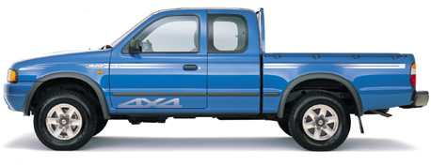

- Draw a sketch showing the box on the truck.
Add each piece of information, from the questions below, to your sketch.
- What is the direction of motion of the box relative to the ground?
- Under what circumstances will the box not move away with the truck?
- Identify each force, including frictional force, acting on the box.
- What is the direction of the net force acting on the box?
- What is the direction of acceleration of the box?
- What force causes the acceleration of the box?

D. Quantitative Question.

A box is placed on the back of a truck. The coefficient of static friction between the surface of the truck’s tray and the box is μs.
- What is the maximum acceleration of the truck before the box starts to slide? You will need to draw a free-body diagram.
The truck is moving at 10 m.s⁻¹ when it hits a tree and suddenly comes to a halt. The box slides 1.2 m before stopping.
- What is the coefficient of kinetic friction between the box and the tray of the truck?

Solutions to MI5: Newton’s Laws II – Frictional Forces

A. Review of Basic Ideas:

Friction
When you’re driving a car at constant speed all the petrol or gas you’re burning is being used just to overcome frictional forces, such as air resistance and friction in the moving parts of the car. Friction is due to the interaction between atoms on the surfaces of materials. Even what looks like a very smooth surface, such as glass or polished metal, is actually very lumpy on a microscopic scale.
When you first try to slide one surface across another you have to break many bonds. The force which prevents the surfaces sliding is the static frictional force, f_{s}. As the surfaces slide past each other there is a continuous tearing and reforming of bonds as chance contacts are made. The kinetic friction, f_{k}, is the sum of the forces due to these contacts. Sometimes the surfaces briefly stick together then slip, giving a jerky motion, which can produce squeaking or squealing.
Consider a block sitting on a surface. The maximum magnitude of f_{s} is f_{smax} = μ_{s}N, where N is the normal force. The direction of f_{s} is always parallel to the surface and opposite to the component of applied force parallel to the surface. Once the block starts to move the frictional force decreases to the kinetic frictional force, which is given by f_{k} = μ_{k}N. The constants μ_{s} and μ_{k} are called the coefficients of friction and are determined experimentally. They depend on the properties of the two surfaces, and we usually assume that they don’t depend on the speed of the sliding. In contrast, air resistance does depend on the velocity of the moving object.
Around 20% of the petrol used by a car is used just to overcome friction in the moving parts, and oil companies spend a fortune developing new and better lubricants. But friction is also necessary to drive the car at all. If there was no friction between the tyres and the road the wheels would spin on the spot and the car wouldn’t go anywhere. And you wouldn’t be able to go for help without friction, because you couldn’t walk if there was no friction between your feet and the ground.
mg
F_{air}
mg
F_{air}
v<v_{terminal}
v=v_{terminal}
Discussion questions.

See diagram opposite. At terminal velocity F_{air} = mg. If air resistance didn’t increase with increasing speed, sky divers would never reach a terminal velocity. They would continue to accelerate, and the heights from which they could jump would be limited by this.
In a tug of war it is the frictional force between the ground and a team’s shoes that determine how hard they can pull, and how much of a pull from the other team they can withstand.

B. Activity Questions:

- Shoes
Shoes with spiked soles, such as football boots are designed to help grip soft slippery surfaces, for example a muddy playing field. Sneakers and running shoes are also designed to grip, but do not have spikes as they are generally used on hard surfaces which are not as slippery as mud. Dancing shoes usually have smooth soles so that the wearer can slide a bit, but not too much. Dancers often put talc on their shoes (as weight lifters do on their hands) to give themselves a bit more grip.
mg
N
F_{fric}
a
slides off this way if not enough friction
- Boxes on a trolley
All boxes slip off together. If the trolley is accelerated forwards the boxes slip backwards, if it is decelerated the boxes slip forwards. The rougher the surfaces, the harder it is for slipping to occur, i.e. slipping occurs at a greater acceleration. The acceleration of the truck and μ, the coefficient of friction between the trolley and the box, determine if the box slips or not. The mass of the boxes don't affect their slipping.

3. Block on a rough variable ramp
N = mgcosθ
mgsinθ
F_{fric}
θ
mgcosθ
Consider forces up and down the inclined plane. Just before slipping the forces up the ramp (frictional forces ) must be equal to the forces down the ramp (component of weight ), so
F_{fric} = μmgcosθ = mgsinθ and μ=tanθ
If the F_{f} is greater (a rough surface), the angle for slipping is larger. A smoother ramp gives a smaller angle for slipping.

C. Qualitative Questions:
constant velocity
braking
constant velocity
braking

1. The case will only go backwards if the bus is accelerating forwards. A suitcase cannot fly backwards if the bus is moving forwards at constant speed or braking. If there is not enough friction to slow the case along with the bus then as the bus slows the case will continue to move forwards. At constant speed there is no net force on the bus or case, and the case will not move relative to the bus. Hence the passengers claim cannot be true if the bus was going forwards and braking.
A suitcase may fly towards the rear if a reversing bus decelerates. When the driver slams on the brakes the suitcase will continue to move backward, unless the force of friction between the case and the bus is enough to accelerate it along with the bus.

direction of
motion
mg
N
F_{fric}
2. Box on a truck.
- See diagram opposite.
- The box (the system) will move along with the truck, which is to the left unless the truck is reversing.
- If the tray and box are very smooth the box will slide off as the truck moves away, i.e. if there is not enough friction.
- The forces acting on the system (the box) are the weight force, mg, the normal force, N, and the frictional force of the truck’s tray on the box.
- The net force is the frictional force, which is to the left. The box is accelerating to the left, hence the net force must be to the left.
- The acceleration is in the direction of the net force.
- The only force acting in the horizontal direction is friction, this is the force which accelerates the box.

D. Quantitative Question:
mg
N
F_{fric}
- In the vertical direction: mg = -N or mg + N = 0.
In the horizontal direction: F_{fric} = net force = ma.
Using F_{fric} = μN = ma, the maximum acceleration is
a_{max} = μN / m = μmg / m = μg.

F_{fric}
v= 10 m.s⁻¹
v= 0
x= 2 m
- The box moves 1.2 m, while accelerating from 10 m.s⁻¹ to 0 m.s⁻¹. The acceleration can be found using v² = v_{o}² + 2ax.
Rearranging: a = ½ (v² - v_{o}²)/x = ½ (0-(10m.s⁻¹)²)/ 1.2 m = 42 m.s⁻²
The net force is F = ma = μ_{k}mg. Rearranging for μ gives:
μ_{k} = a/g = 42 m.s⁻² / 9.8 m.s⁻² = 4.3

MI6: Work, Power and Energy

A. Review of Basic Ideas:

Use the following words to fill in the blanks:
energy, work, positive, acceleration, powerful, force, kinetic, ½ mv², direction, gravitational, Power

Work energy and power
We use the words work, energy and power a lot in everyday life. You might tell someone to be quiet because you’re trying to _____ on an assignment. Sports drinks give you _____ to keep going for longer, and people brag about how ______ their cars are. We also use these words in physics, but with more precise meanings.
Work is the transfer of energy, to or from an object via a ______. When energy is transferred to an object then the work done on the object is ______, if energy is transferred from an object then the work done on the object is negative. (This means that the object has done positive work on something else.)
If a force changes the speed at which an object is moving then the object’s ______ energy changes. The kinetic energy of an object with mass m moving at speed v is defined as KE = _____. If the kinetic energy is the only type of energy changed by the action of a force then the work done is equal to the change in kinetic energy.
From Newton’s laws we know that force is mass times ________, F = ma, and from kinematics we know that v² = v₀² +2as. Using this we discover that
W = ΔKE = ½ m (v² - v₀²) = ½ m (2as) = mas = Fs
To be strictly correct, because force is a vector quantity (it has _______) we should say that
$W$ = ΔKE = Fs cosθ.= $\vec{F}$.$\vec{s}$
where θ is the angle between the direction of the force F and the displacement x.

Lifting things can be very hard work. In this case if the object is lifted from rest to a higher position and put down so it is again at rest, such as carrying a suitcase upstairs, then the work done is the change in the object’s _______ potential energy. If you lift a heavy suitcase, carry it around an airport for a while, then put it down again, you haven’t actually done any work, although you may feel like you have.
_______ is the rate at which work is done, or energy is transferred. The power rating on the back of an appliance tells you how quickly it turns electrical energy into some other form of energy, such as light or heat.

Discussion questions
Rebecca has asked Brent to move the television from one side of the room to the other. Brent grumbles that he’s been working all day and wants to relax a bit, to which Rebecca replies that as the TV will start at rest, end at rest and not change height, she’s not actually asking him to do any work! Is the total work done on the TV to move it really zero? Does Brent have to do any work to move it?

B. Activity Questions:

1. Pendulum
Draw a diagram showing the forces acting on the pendulum as it swings.
What forces are doing work?

2. Falling
What energy changes occur when you drop an object?
What work is being done, and on what?
What force or forces are doing the work?

3. Power
Look at the labels on the back of the appliances.
What power do they use? At what rate do they turn electrical energy into other forms of energy?
What energy conversions are taking place when these appliances are working?

C. Qualitative Questions:

1. How is it possible to do negative work? Give an example of this.

2. Two water slides come down from a single platform and finish in the same pool. One is quite steep and straight, and looks very scary. The other spirals gently down to finish at the opposite end of the pool to the first slide. The water makes the slide surface approximately frictionless.
Rebecca and Brent start at the same time, Brent goes down the steep slide and Rebecca goes down the other one.
- Who lands in the pool first?
Hint: think about the forces acting on both of them.
- Who has the greater velocity at the bottom?
- On which one of them has the greater amount of work been done by the gravitational force?

D. Quantitative Question:

Rebecca has gone shopping for new shoes at Miranda shopping centre. She rides an escalator up one floor, standing without walking, which carries her at 1 m.s⁻¹. The escalator makes an angle of 20º with the horizontal and takes her up a vertical distance of 4 m. Rebecca plus her shopping weigh 62 kg.
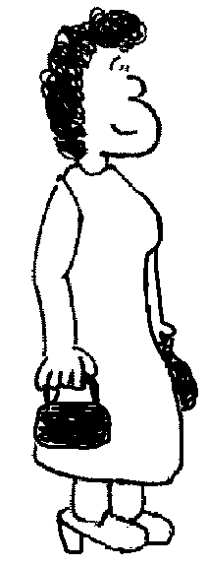
4 m
20º
1 m.s⁻¹

- How much work is done by the escalator in moving Rebecca and her shopping to the next floor?
- What power is required by the escalator to take her to the next floor?

Solutions to MI6: Work, Power and Energy

A. Review of Basic Ideas:

Work energy and power
We use the words work, energy and power a lot in everyday life. You might tell someone to be quiet because you’re trying to work on an assignment. Sports drinks give you energy to keep going for longer, and people brag about how powerful their cars are. We also use these words in physics, but with more precise meanings.
Work is the transfer of energy, to or from an object via a force. When energy is transferred to an object then the work done on the object is positive, if energy is transferred from an object then the work done on the object is negative. (This means that the object has done positive work on something else.)
If a force changes the speed at which an object is moving then the object’s kinetic energy changes. The kinetic energy of an object with mass m moving at speed v is defined as KE = ½ mv². If the kinetic energy is the only type of energy changed by the action of a force then the work done is equal to the change in kinetic energy.
From Newton’s laws we know that force is mass times acceleration, F = ma, and from kinematics we know that v² = v₀² +2as. Using this we discover that
W = ΔKE = ½ m (v² - v₀²) = ½ m (2as) = mas = Fs
To be strictly correct, because force is a vector quantity (it has direction) we should say that
$W$ = ΔKE = Fs cosθ.= $\vec{F}$.$\vec{s}$
where θ is the angle between the direction of the force F and the displacement x.
Lifting things can be very hard work. In this case if the object is lifted from rest to a higher position and put down so it is again at rest, such as carrying a suitcase upstairs, then the work done is the change in the object’s gravitational potential energy. If you lift a heavy suitcase, carry it around an airport for a while, then put it down again, you haven’t actually done any work, although you may feel like you have.
Power is the rate at which work is done, or energy is transferred. The power rating on the back of an appliance tells you how quickly it turns electrical energy into some other form of energy, such as light or heat.

Discussion questions
The total work done on the TV really is zero. It starts with no kinetic energy, ends with no kinetic energy, and assuming the floor is flat it will not change gravitational potential energy. However this does not mean that Brent does no work on the TV. He must accelerate it to move it, and increase its potential energy if he lifts it. This energy comes from chemical potential energy stored in Brent. When he decelerates the TV and puts it down he must absorb the energy he has put in. However this energy is not converted back to chemical potential energy, but is lost as heat. In addition, if Brent slides the TV then the energy he has put in to accelerate it and give it kinetic energy will be dissipated as heat due to friction by the floor and TV. So while the energy of the TV has not changed, and no work has been done on it, Brent must do work to move it.

B. Activity Questions:
mg
T
1. Pendulum
The forces acting on the pendulum are its weight (gravity), and the tension in the string. The tension is always at right angles to the path, hence it does no work. Ignoring friction, only the weight of the pendulum does work as it swings, converting gravitational potential energy into kinetic energy and back again.

2. Falling
When you drop an object it falls due to gravity, losing gravitational potential energy. As it falls this gravitational potential energy is converted to kinetic energy, and the object gains speed. The change in kinetic energy is equal to the work being done on the falling object, and is done by gravity. Air resistance may also do some negative work on the object, acting to reduce its kinetic energy and slow it down.

3. Power
The power used by the appliances is written on the back, and is measured in watts, W, or sometimes volts × current or VI. If an appliance is rated at X watts it converts X joules per second of energy.
A hairdryer converts electrical energy into thermal energy (heat) and kinetic energy, a lamp produces heat and light. All appliances convert at least some electrical energy into thermal energy.

C. Qualitative Questions:

1. Work is defined as the change in kinetic energy. When you decrease an object’s kinetic energy you do negative work, for example catching a ball.
2. Two approximately frictionless water slides come down from a single platform and finish in the same pool. One is steep and straight, the other spirals down. Rebecca and Brent start at the same time, Brent goes down the steep slide and Rebecca goes down the other one.
- Brent will land in the pool first. His slide is steeper hence the component of gravity acting along the direction of the slide to accelerate him is greater, his acceleration is greater (over a shorter distance) and he reaches the bottom first.
- They both start with the gravitational potential energy mgh, and as there is negligible friction they will have kinetic energy ½mv² when they reach the bottom. They will have the same velocity, v = (2gh)^{1/2}, at the bottom of the slide. (Brent has a greater acceleration, but it acts over a shorter time.)
- The amount of work done by the gravitational force is the change in kinetic energy, ½mv². They have the same velocity, v, so gravity does the greater work on which ever of them is heavier, ie the one with greater m.

D. Quantitative Question.
4.0 m
20º
1 m.s⁻¹
4.0 m / (sin 20º)
= 12 m.
Rebecca rides an escalator at 1 m.s⁻¹. The escalator makes an angle of 20º with the horizontal and takes her up a height of 4 m. Rebecca plus her shopping weigh 62 kg.
- The work done is that required to lift Rebecca plus shopping through a height of 4 m, which is equal to the change in potential energy.
W = Δmgh = mgΔh
= 62 kg × 9.8 m.s⁻² × 4.0 m
= 2400 J = 2.4 kJ
- The power required to take her to the next floor at a rate of 1 m.s⁻¹ is the energy used per second. We know the total energy used, so we want to find the time taken.
She has a velocity of 1 m.s⁻¹ at an angle of 20º to the horizontal. The distance she must travel is
d = 4.0 / (sin 20º) = 12 m. At a velocity of 1 m.s⁻¹ this will take t = d/v = 12 m / 1 m.s⁻¹ = 12 s.
The power required is therefore P = E/t = 2400 J / 12 s = 200 J.s⁻¹ = 200 W.
Note that this is only the power required to move Rebecca, the escalator must also move itself which requires a lot of power.

MI7: Conservation of Energy

A. Review of Basic Ideas:

Use the following words to fill in the blanks:
potential energy, conserved, motion, conservation, energy, transformed, total energy, gravitational, kinetic energy

Energy
Energy is defined in physics as the ability to do work. This is sensible, because the more _____ you have, the more work you can do, so we hope you’ve had a good breakfast!
In physics there are fundamental laws called _______ laws, which state that a certain physical quantity is conserved. Examples are conservation of energy and conservation of mass. Energy can change forms, or be ______, but the ______ ______is always conserved.
Two forms of energy we will be looking at are kinetic energy and potential energy. Kinetic energy is energy associated with ______, an object of mass m moving at velocity v, has kinetic energy ½ mv². The units of energy are joules (J).
Potential energy comes in several forms, for example gravitational potential energy. The ______ potential energy of an object of mass m at a height h is defined as mgh, where g is the acceleration due to gravity. There are other forms of potential energy also, such as elastic potential energy in a compressed spring and chemical potential energy in food.
Kinetic and potential energy can also be transformed into other forms of energy, such as heat and sound and light, but the total amount of energy is still always ______.
During the day you transform the chemical potential energy of your breakfast into other forms, such as ______ ______ when you move, and gravitational ______ ______ when you climb up stairs.

To represent the proportion of energy in different forms you can draw energy bar graphs like this:

kinetic
potential
other
kinetic
potential
other
kinetic
potential
other

Remember that the total energy is always conserved!

Discussion questions
- Can you think of what the “other” energy in the bar graph above might be?
- When a child goes down a very slippery slide, such as a water slide, does their velocity at the bottom depend on the shape or angle of the slide?

B. Activity Questions:

1. Pendulum
At what position is the kinetic energy maximum, minimum? At what position is the potential energy maximum, minimum? Draw energy bar graphs for the pendulum at different points in its swing.
2. Solar panel and electric circuit
Trace the energy conversions using a flow chart and identify which ones are "useful" and which are not.
Think of a case where this "not useful" energy may be useful.
Trace energy transformations from water stored in a dam, which supplies a hydro-electric power station, to turning on an appliance at home.

3. Bouncing balls I
Drop the balls from the same height. Why do some balls bounce higher than others?
Can you make any of the balls bounce higher than the original height? Does this contradict conservation laws? Explain your answer.

C. Qualitative Questions:
1. You throw a ball vertically into the air and catch it when it returns. Answer questions a and b first by ignoring air resistance, and then taking it into account.
- What happens to the ball's kinetic energy during the flight?
- What happens to the total energy of the ball?
- What happens to the energy of the ball as you catch it and it comes to rest?
- Why is it easier (and less painful) to catch a ball while moving your hands backwards?

2. Draw a set of diagrams for a situation which could be described by the following energy bar graphs or make up your own scenario and draw appropriate energy bar graphs (be creative!!)

Kinetic Kinetic Kinetic
Potential Potential Potential
Heat Heat Heat
Other Other Other

D. Quantitative Question:

A 60 kg skier starts from rest at the top of a 60 m high ski jump. She descends without using her poles.

60m

5 m

A
B
C
D

- What is her initial gravitational potential energy (at point A) with respect to the level ground at the bottom (point B or D)?
- Assuming friction is negligible at what speed will she ideally arrive at the bottom?
- The ramp at the bottom of the ski slope projects her to a height of 5 m (point C) before landing. Assuming negligible friction what speed will she ideally have at the bottom after using this ramp?
- She reaches the bottom of the run (point D), travelling at 25m.s⁻¹. What is the net energy transferred via friction to her, the skis, the slope, and the air?

Solutions to MI7: Conservation of Energy

A. Review of Basic Ideas:

Energy
Energy is defined in physics as the ability to do work. This is sensible, because the more energy you have, the more work you can do, so we hope you’ve had a good breakfast!
In physics there are fundamental laws called conservation laws, which state that a certain physical quantity is conserved. Examples are conservation of energy and conservation of mass. Energy can change forms, or be transformed, but the total energy is always conserved.
Two forms of energy we will be looking at are kinetic energy and potential energy. Kinetic energy is energy associated with motion, an object of mass m moving at velocity v, has kinetic energy ½ mv². The units of energy are joules (J).
Potential energy comes in several forms, for example gravitational potential energy. The gravitational potential energy of an object of mass m at a height h is defined as mgh, where g is the acceleration due to gravity. There are other forms of potential energy also, such as elastic potential energy in a compressed spring and chemical potential energy in food.

Kinetic and potential energy can also be transformed into other forms of energy, such as heat and sound and light, but the total amount of energy is still always conserved.
During the day you transform the chemical potential energy of your breakfast into other forms, such as kinetic energy when you move, and gravitational potential energy when you climb up stairs.

Discussion questions
- The “other” energy in the bar graph above might be thermal energy (heat) or sound.
- Ignoring friction, the velocity at the bottom of a slide depends only on the final and initial heights as potential energy is converted to kinetic energy.

B. Activity Questions:
max P.E.
max K.E.
max P.E.
PE KE
PE KE
PE KE

1 Pendulum
At the lowest point of the pendulum bob’s motion, its kinetic energy is maximum and potential energy is minimum.
At the highest point of its motion, kinetic energy is minimum (i.e. zero) and potential energy is maximum.

lamp- electrical energy to light energy and heat
solar cell- light energy to electrical energy and heat
motor- electrical energy to kinetic energy and heat
2. Solar panels and electric circuit
Energy as light is converted to electrical energy by the solar cell which is then converted to kinetic energy by the motor. Some energy is also converted to heat, which is usually not considered useful.
Heat is useful energy when you want to heat or cook something.
Dammed water has gravitational potential energy, which is converted to kinetic energy when the dam is open. This is converted to kinetic energy of a turbine placed in the flow, which is attached to a generator. The generator turns the kinetic energy into electrical energy which is converted into light, heat, sound or mechanical energy by a home appliance.

3. Bouncing balls I
a. Balls that lose less energy to non-mechanical forms rise higher than balls that lose more energy.
lots of energy lost
no energy lost
b. A ball can bounce higher than the original height if we throw the balls instead of just dropping them. These balls start off with kinetic energy and gravitational potential energy instead of just gravitational potential energy.

C. Qualitative Questions:
v = 0
v = v_{i}
v = v_{i}
PE = 0
KE = ½ mv_{i}²
PE = mgh
KE = 0
PE = 0
KE = ½ mv_{i}²
h

1. a. and b. With no air resistance:
The ball has an initial velocity, v_{i}, and kinetic energy KE_{i} = ½ mv_{i}². It also has an initial height h_{i} = 0 and potential energy PE_{i} = mgh_{i} = 0. As the ball goes up, its kinetic energy decreases and is zero at a height of h, its gravitational potential energy increases and is maximum at h. The reverse happens on the way down, such that the total energy of the ball is constant, i.e. at every instant PE + KE = total energy.
Or, in terms of work rather than potential energy, there is no change in kinetic energy of the ball between the initial and final positions thus the total work is zero. During the flight the work done by weight on the way up is W=-mgh and on the way down is W = mgh.
v = 0
PE = mgh’ < ½ mv_{i}²
KE = 0
h’
v = v_{i}
v < v_{i}
PE = 0
KE = ½ mv_{i}²
PE = 0
KE < ½ mv_{i}²
a. and b. With air resistance:
As the ball goes up, there is work done by air resistance, so the ball’s kinetic energy decreases and is zero at a height h' which is less than h. On the way down again there is work done by air resistance. Consequently the final kinetic energy is less than the initial kinetic energy, i.e. final speed is less than initial speed. The total energy of the ball-earth system is PE + KE + W_{air resistance}.
Total energy is constant but the ball has less mechanical energy when caught. Some of its energy has been converted into heat due to work done by air resistance.
c. The energy is converted into heat, sound and motion of the muscles in your hand..
d. Your hand must do work on the ball to change its kinetic energy from ½ mv² to 0. The work done is given by the force times the distance, so if you increase the distance over which your hand applies the force to stop the ball, the force required is less. If the force on the ball by your hand is less then the force by the ball on your hand will also be less.

2. One possible scenario is someone sliding down a hill with potential energy being converted to kinetic energy and heat due to friction, and hitting a tree at the bottom, the collision converting the kinetic energy into heat and sound. There is a virtually infinite number of possible scenarios!
D. Quantitative Question:
60m

5 m
PE = mgh_{i}
KE = 0
PE = 0
KE = mgh_{i}
PE = 0
KE = mgh_{i}
a. PE = mgh_{i} = 60 kg × 9.8 m.s⁻² × 60 m = 3.5 ×10⁴ J.
b. With no work done against friction, total mechanical energy remains constant, final energy = initial energy
Hence
c. Again 34 m.s-1 because mechanical energy is conserved.
d. She reaches the bottom of the run, with v = 25m.s⁻¹, which gives KE = ½ mv² = 1.9 × 10⁴ J.
Thus the energy lost via friction is 3.5 ×10⁴ J (KE_{i}) - 1.9 × 10⁴ J (KE_{f}) = 1.6 × 10⁴ J.

MI8: Momentum

A. Review of Basic Ideas:

Use the following words to fill in the blanks:
bus, specific, opposite, force, direction, mv, acceleration, third, conservation

Momentum
Momentum is one of those words that is used in different contexts. In politics you may hear about a political movement gaining momentum when it becomes more popular and powerful, while in physics it has a similar, but very _______ meaning. In physics the momentum of a body is the product of its mass and velocity, p = _____. Momentum is important because it tells you how hard something is going to hit you. If an object is coming towards you at 50 m.s⁻¹ it helps to know whether that object is an air molecule (momentum of around 10⁻²⁴ kg.m.s⁻¹) or a _____ (momentum around 10⁵ kg.m.s⁻¹), so you can take appropriate action. The more momentum an object has, the harder it hits. Like velocity, momentum is a vector, it has both magnitude and _______.
When Newton wrote his second law he didn’t actually write it as $\vec{F}$_{net} = m $\vec{a}$, which is how we usually remember it. He wrote it down as
$\vec{F}$ = $\frac{d}{\text{dt}}$$(m\vec{v})$= $\frac{d\vec{p}}{\text{dt}}$
which means that the force is the rate of change of the momentum with time. If the mass is constant then this reduces to F_{net} = ma, because the change in velocity with time is the ________. But sometimes the mass changes, for example a vehicle which burns fuel changes mass as it uses the fuel.
If no external ______ is acting on a system, then according to Newton’s second law its momentum is constant. This is called the law of _________ of momentum. Conservation laws are extremely useful for understanding how even quite complicated systems work.
Consider a cosmonaut making repairs on a space station. If she drifts away from the space station, how can she get back to it? There’s nothing to push against, so she can’t apply a force to the surrounding space and use a reaction force (Newton’s _____ law) to get back to the station. But she can use conservation of momentum, if she throws something in the _________ direction to the space station, then she must move towards the space station.

Discussion question
Is it possible to change the momentum of an object, say a tennis ball, without changing its speed or mass?

B. Activity Questions:

- Pendulum on Trolley
Swing the pendulum bob.
What happens to the trolley? Why does it behave like this?

- Balloons
Blow up a balloon, and do not tie off the neck.
Now let it go. What does the balloon do?
Explain what happens in terms of conservation of momentum.
- Newton’s Cradle – 2 steel balls
Swing one of the balls out and release it.
What happens when it hits the other ball?
What has happened to the momentum of the first ball?
What has happened to the momentum of the second ball?
Explain how this is also consistent with Newton’s third law- that for every action there is an equal and opposite reaction, which can be written as F_{AB} = - F_{AB}.

C. Qualitative Questions:

- Astronauts use a strong line to attach themselves to the outside of a space craft when they go outside. Draw a diagram showing what happens when an astronaut pulls on the line to get back to the space craft. How does the momentum of the astronaut change? How does the momentum of the space craft change? What about the astronaut and space craft combined?

- A group of students are designing a roller coaster. They want to be able to make it go faster along a straight, frictionless length of track. Brent suggests putting some water in the bottom half of the carriage and a plug in the bottom, which can be removed. His theory is that when the plug is removed the carriage will speed up. Rebecca tells him not to be silly, the carriage will slow down. Julia doesn’t think it will make any difference, but lets them go ahead and try it just to prove her point. Who is right and why?

D. Quantitative Question.

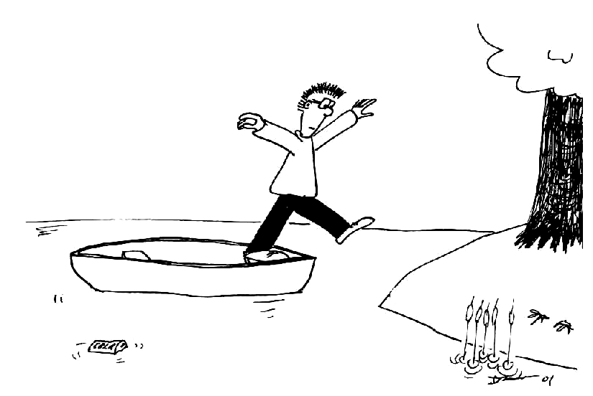
Brent is standing in a canoe and wishes to jump ashore without getting wet. The canoe has a mass of 60 kg and Brent has a mass of 70 kg. The canoe is 1 m from the shore. Brent jumps with a horizontal velocity of 2.5 m.s⁻¹ towards the shore.
- Draw a diagram showing the movement of Brent and the canoe.
- At what velocity does the canoe initially move away from Brent?

Solutions to MI8: Momentum

A. Review of Basic Ideas:

Momentum
Momentum is one of those words that is used in different contexts. In politics you may hear about a political movement gaining momentum when it becomes more popular and powerful, while in physics it has a similar, but very specific meaning. In physics the momentum of a body is the product of its mass and velocity, p = mv. Momentum is important because it tells you how hard something is going to hit you. If an object is coming towards you at 50 m.s⁻¹ it helps to know whether that object is an air molecule (momentum of around 10⁻²⁴ kg.m.s⁻¹) or a bus (momentum around 10⁵ kg.m.s⁻¹), so you can take appropriate action. The more momentum an object has, the harder it hits. Like velocity, momentum is a vector, it has both magnitude and direction.
When Newton wrote his second law he didn’t actually write it as $\vec{F}$_{net} = m $\vec{a}$, which is how we usually remember it. He wrote it down as
$\vec{F}$ = $\frac{d}{\text{dt}}$$(m\vec{v})$= $\frac{d\vec{p}}{\text{dt}}$
which means that the force is the rate of change of the momentum with time. If the mass is constant then this reduces to F_{net} = ma, because the change in velocity with time is the acceleration. But sometimes the mass changes, for example a vehicle which burns fuel changes mass as it uses the fuel.
If no external force is acting on a system, then according to Newton’s second law it’s momentum is constant. This is called the law of conservation of momentum. Conservation laws are extremely useful for understanding how even quite complicated systems work.
Consider a cosmonaut making repairs on a space station. If she drifts away from the space station, how can she get back to it? There’s nothing to push against, so she can’t apply a force to the surrounding space and use a reaction force (Newton’s third law) to get back to the station. But she can use conservation of momentum, if she throws something in the opposite direction to the space station, then she must move towards the space station.

Discussion question
It is possible to change the momentum of an object, say a tennis ball, without changing its speed or mass. Momentum is a vector, like velocity, so you can change momentum by changing the direction a ball is moving but not the speed. For example, an elastic collision off a wall changes the direction but not speed.

B. Activity Questions:

1. Pendulum on Trolley
When you raise the bob and hold the base still the total momentum of the pendulum-trolley system is zero. When you release the bob it swings down, gaining momentum. In order for momentum to be conserved the trolley must move the opposite way, which it does. As the pendulum swings back and forth the trolley will roll back and forth in the opposite direction, until friction eventually stops it.

v_{balloon}
v_{air}
2. Balloons
When the balloon is released the air inside it rushes out because it is under pressure. The air comes out the neck of the balloon. For momentum to be conserved the balloon (and remaining air) must move in the opposite direction. This is what happens, and the balloon whizzes around the room, moving in the opposite direction to the air flow.

- Newton’s cradle – 2 steel balls  When the first ball (ball A) swings back and hits the second ball (B) it stops. The second ball swings out.  Momentum is conserved, so the change in momentum of ball A must be equal in magnitude and opposite in direction to the change in momentum of ball B. We can write this as Δp_{A} = - Δp_{B.} | A  B
We also know that $\vec{F}$= $\frac{d\vec{p}}{\text{dt}}$, so as the change in momentum, $\frac{d\vec{p}}{\text{dt}}$, of the two balls are equal in magnitude and opposite in sign, the forces acting on them must also be equal in magnitude and opposite in sign. This is equivalent to Newton’s third law which states that the force exerted by ball A on ball B must be equal and opposite to the force exerted by ball B on ball A, written as F_{AB} = - F_{AB}.
C. Qualitative Questions:
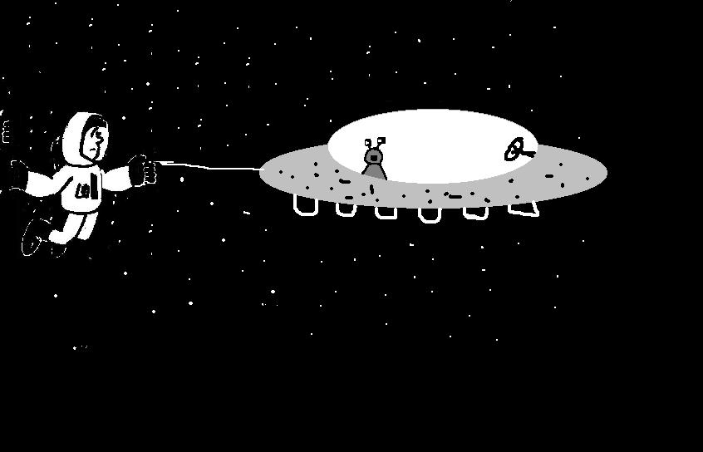
- Astronauts use a strong line to attach themselves to the space craft when they go outside. When an astronaut pulls on the line to get back to the space craft he moves towards the space ship and it moves towards him. He applies a force to the ship, via the rope. The ship applies a reaction force, equal in magnitude but opposite in direction, to the astronaut. | p  p
The rate of change of momentum is equal to the net force applied, and so assuming no other forces the change in momentum of the space ship is equal to that of the astronaut, and they move towards each other. As no external forces are acting the total change in momentum is zero. Note that the mass of the ship is much larger than the astronaut’s mass, hence the astronaut accelerates rapidly towards the ship, while the ship accelerates only slowly towards the astronaut.

2. Julia is correct. Pulling the plug will not change the speed of the roller-coaster. The water flows out with the same horizontal velocity as the roller coaster. Since no external horizontal forces are acting, the horizontal component of the momentum of both water and roller coaster are conserved, and the horizontal component of the roller coaster’s velocity does not change. | v  v  v  v  v  v

D. Quantitative Question.

The canoe has a mass of 60 kg and Brent has a mass of 70 kg. The canoe is 1 m from the shore. Brent jumps with a horizontal velocity of 2.5 m.s⁻¹ towards the shore.
a. See diagram opposite.  b. We can use conservation of momentum to find the velocity of the canoe.  p_{i} = p_{f.}  p_{i} = p_{B} + p_{C} = m_{B}v_{B} + m_{C}v_{C}  = 70 kg × 0 m.s⁻¹ + 60 kg × 0 m.s⁻¹ = 0 kg.m.s¹.  p_{f} = m_{B}v_{B} + m_{C}v_{C} = p_{i} = 0 kg.m.s¹.  so v_{C} = - m_{B}v_{B} / m_{C} = -70 kg × 2.5 m.s⁻¹ / 60 kg  v_{C} = -2.9 m.s⁻¹ | 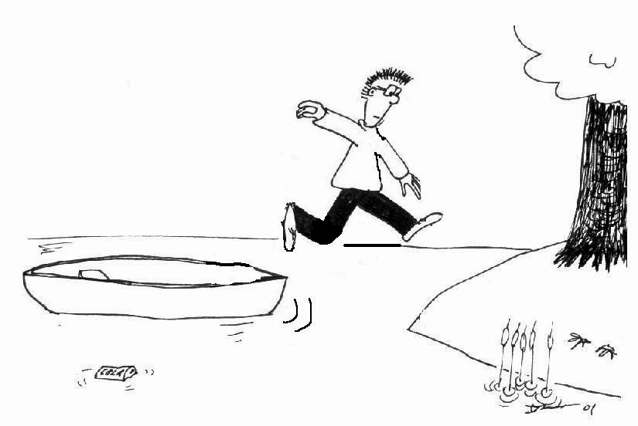  v_{B}  v_{C}

MI9: Collisions

A. Review of Basic Ideas:

Use the following words to fill in the blanks:
push, kinetic, inelastic, conservation, larger, short, friction, conservative, elastic, momentum

Collisions
A .22 rifle bullet and a pitched baseball have roughly the same ________ energy - a hundred or so joules. Which would you rather catch? How can a rocket engine accelerate a space shuttle in outer space where there's nothing to _______ against? To answer these and similar questions we need two new concepts, momentum and impulse, and a new conservation law, conservation of momentum. The validity of this ________ principle extends far beyond the bounds of classical mechanics to include relativistic mechanics (the mechanics of the very fast) and quantum mechanics (the mechanics of the very small).
To most people the term 'collision' is likely to mean some sort of automotive disaster. We'll use it in that sense, but we'll also broaden the meaning to include any strong interaction between two bodies that lasts a relatively ________ time. So we include not only car accidents but also balls hitting on a billiard table, the slowing down of neutrons in a nuclear reactor, a bowling ball striking the pins, and the impact of a meteor on the surface of the Earth.
Conservation of momentum is true for any isolated system. If the interaction forces are much ________ than the net external force, we can model the system as an isolated system, neglecting the external forces entirely. Two cars colliding at an icy intersection provides a good example. Even two cars colliding on dry pavement can be treated as an isolated system during the collision if, as happens all too often, the interaction forces between the cars are much larger than the ________ forces of pavement against tyres.
If the interaction forces between the bodies are ________, the total kinetic energy of the system is the same after the collision as before. Such a collision is called an elastic collision. A collision between two hard steel balls or two billiard balls is almost completely ________, and collisions between subatomic particles are often, though not always, elastic. A collision in which the total kinetic energy after the collision is less than that before the collision is called an ________collision. If the colliding bodies stick together and move as one body after the collision, for example the fenders of two colliding cars lock together, then kinetic energy is not conserved and these collisions are often referred to as completely inelastic. In an isolated system the ________, unlike the mechanical energy, is conserved regardless of whether the collision is elastic or inelastic.

Discussion question
Do you think a collision between cars is usually elastic or inelastic?

B. Activity Questions:
1. Newton's cradle – different balls
Examine the two sets of Newton’s cradle on display. Explain the difference between the two types (one with steel balls and one with lead balls) of apparatus on display.
Can you explain the behaviour of the balls with only energy conservation or do you need conservation of momentum as well? Discuss your answer.
- Air track
What happens when a moving object collides with an identical stationary one? Why does this happen?
What if they have different masses?
What purpose do the metal loops serve?

- Bouncing balls II
Hold a little ball in contact with and directly above a big ball. Drop the balls together.
Describe what happens. Why does this happen?
Do you get the same behavior if the big ball is above the little ball?

C. Qualitative Questions:

1. One of the first things that physicists do when approaching a problem is identify the system that they are investigating, and determine whether it is isolated or not.
a. Why is the collision between two cars on an icy intersection a better approximation to an isolated system than a collision on a dry intersection?
b. What are the forces on each car during the collision? Are these external or internal forces? Draw a diagram showing these forces.
c. Which of the forces are conservative and which are non-conservative?
d. What is the net force on each car during the collision?

2. Why is it easier and less painful to catch a fast moving ball by moving your hand back with the ball, rather than keeping your hand still?

D. Quantitative Question:

A steel wrecking ball of mass 200 kg is fastened to a 10 m long chain which is fixed at the far end to a crane. The ball is released when the chain is horizontal as shown. At the bottom of its path, the ball strikes a 1000 kg car initially at rest on a frictionless surface. The collision is completely inelastic so that the ball and car move together just after the collision.
What is the speed of the ball and car just after the collision?

Hint: First find the velocity v of the ball at the bottom using conservation of mechanical energy, then use conservation of linear momentum to solve the problem.

Solutions to MI9: Collisions

A. Review of Basic Ideas:

Collisions
A .22 rifle bullet and a pitched baseball have roughly the same kinetic energy - a hundred or so joules. Which would you rather catch? How can a rocket engine accelerate a space shuttle in outer space where there's nothing to push against? To answer these and similar questions we need two new concepts, momentum and impulse, and a new conservation law, conservation of momentum. The validity of this conservation principle extends far beyond the bounds of classical mechanics to include relativistic mechanics (the mechanics of the very fast) and quantum mechanics (the mechanics of the very small).

To most people the term 'collision' is likely to mean some sort of automotive disaster. We'll use it in that sense, but we'll also broaden the meaning to include any strong interaction between two bodies that lasts a relatively short time. So we include not only car accidents but also balls hitting on a billiard table, the slowing down of neutrons in a nuclear reactor, a bowling ball striking the pins, and the impact of a meteor on the surface of the Earth.
Conservation of momentum is true for any isolated system. If the interaction forces are much larger than the net external force, we can model the system as an isolated system, neglecting the external forces entirely. Two cars colliding at an icy intersection provides a good example. Even two cars colliding on dry pavement can be treated as an isolated system during the collision if, as happens all too often, the interaction forces between the cars are much larger than the friction forces of pavement against tyres.
If the interaction forces between the bodies are conservative, the total kinetic energy of the system is the same after the collision as before. Such a collision is called an elastic collision. A collision between two hard steel balls or two billiard balls is almost completely elastic, and collisions between subatomic particles are often, though not always, elastic. A collision in which the total kinetic energy after the collision is less than that before the collision is called an inelastic collision. If the colliding bodies stick together and move as one body after the collision, for example the fenders of two colliding cars lock together, then kinetic energy is not conserved and these collisions are often referred to as completely inelastic. In an isolated system the momentum, unlike the mechanical energy, is conserved regardless of whether the collision is elastic or inelastic.

Discussion question
Collisions between cars are usually highly inelastic, as the cars deform and lose a lot of mechanical energy as heat and sound.
mgh₁
mgh₂
h₂ < h₁
½ mv₁²
collisions
between
the balls
½ mv₂²

B. Activity Questions:
1. Newton's cradle – different balls
Steel balls have almost elastic collisions, in which both kinetic energy and momentum are conserved. The lead balls have inelastic collisions in which only momentum is conserved.
Both energy and momentum conservation are needed to explain the behaviour of the balls. Energy conservation is needed to account for the KE of the ball at the time of impact. The collisions obey conservation of momentum.
v
v
before
after
2. Air track
See opposite. The second, initially stationary, glider will move away. If the two gliders have equal masses the first glider will stop, transferring all its momentum to the second glider.

If the first glider has a smaller mass than the second it will bounce
back, if it has a greater mass it will continue to move forward but at a lower speed.
The metal loops help make the collisions elastic and prevent the gliders sticking to each other.

3. Bouncing balls II  a. The small ball held over the big ball bounces off higher as some momentum is transferred from the big ball to the small ball, increasing its velocity. Momentum has been conserved during the collision and the change in momentum of the small ball is large.  b. If the balls are switched around the momentum is still conserved, but the transfer of momentum from the small to the big ball makes little difference to the big ball’s velocity due to its large mass. | v  v  v

C. Qualitative Questions:
1. Cars colliding.
a. Two cars on an icy intersection is a better approximation of an isolated system than cars on a dry intersection because the external forces due to friction are very small, and the vertical forces (gravity and the normal force) balance. This means that the external forces are very small compared to the internal forces due to the collision, and the only important interactions are those between the cars.
b. See diagram. The forces are all internal forces, if the system is the two cars and the road. If you take the system as the two cars, then N and W are external forces, but they cancel out giving no net external force.
N
W
N
W
force of
car 1
force of
car 2
c. The normal and weight forces are conservative forces. The force of one car on the other is non-conservative. (Any frictional forces due to the road are also non-conservative.)
d. The net force on each car during the collision is that due to the other car.

2. Your hand must do work on the ball to change its kinetic energy from ½ mv² to 0. The work done is given by the force times the distance, so if you increase the distance over which your hand applies the force to stop the ball, the force required is less. If the force on the ball by your hand is less then the force by the ball on your hand will also be less. You can also consider this in terms of impulse – which is the change in momentum - Δp = FΔt – make the time bigger then the force is smaller for the same Δp.

D. Quantitative Question:
v_{f}
m₁ + m₂
v_{1i}
v_{2i} = 0
m₁
m₂
A
B
h
Just before collision:
Just after collision:
At position A, the ball has no kinetic energy and potential energy = m₁gh
At position B, just before the collision, the ball's gravitational potential energy is zero and the kinetic energy is ½ m₁v_{1i} ².
Using conservation of energy, m₁gh = ½ m₁v_{1i} ²
and $v_{1i}=\sqrt{2\text{gh}}$
$=\sqrt{2×9\text{.}8 m\text{.}s^{−2}×\text{10} m}$ = 14 m.s⁻¹.
The collision is inelastic so we cannot use conservation of mechanical energy, but momentum is still conserved.
We know that the ball and car move off together, so from conservation of momentum : $m_{1}v_{1i}=(m_{1}+m_{2})v_{f}$
Rearranging we obtain
$v_{f}=\frac{m_{1}v_{1i}}{m_{1}+m_{2}}=\frac{\text{200}\text{kg}\text{.}\text{14}m\text{.}s^{−1}}{\text{200}\text{kg}+\text{1000}\text{kg}}=2\text{.}\text{33} m\text{.}s^{\text{-1}}$

MI10: Equilibrium

A. Review of Basic Ideas:

Use the following words to fill in the blanks:
vertical, pivot, force, shoulder, equilibrium, distance, torque, closer, dangerous.

Torque
When lifting a heavy object it is recommended to keep the back almost _______, lifting from the knees, rather than bending over and lifting from the waist. The concept of torque allows us to estimate forces on the spinal column when lifting objects and thus justify the above recommendation.
We can model the human spinal column as a pivoted rod. The _______ corresponds to the joint between the sacrum and the lowest lumbar vertebra.
The various muscles of the back are equivalent to a single muscle producing a force T, at a point two thirds up the spine. The sacrum exerts a _______ R on the spine.
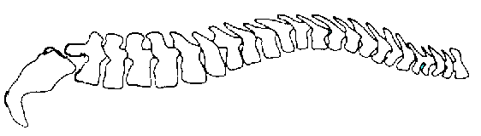  sacrum  Weight of upper body  Weight being lifted  T  pivot  R  12º | When you bend over to lift something with the spine horizontal, the force T acts at an angle of 12.0º to the horizontal.  The weight of the upper body, which is about 65% of your body weight, acts about halfway along the spine. The weight which you are lifting acts near the top of your spine, from where the _______ is.
If the spine is to be in _______, so there is no net torque or force, then the torque due to T must balance the torques due to the weights. These weights are about 0.5 m to 1 m away from the pivot point, so they will exert a large torque. (Remember that torque is force × _______). The force due to the muscles, T, must be large to balance these torques.
This force, T, has a large horizontal component which must be balanced for the spine to be in equilibrium. The force R of the sacrum on the spine acts through the pivot so it exerts no _______ about the pivot. It balances the horizontal component of R so the net force is zero. The forces T and R are large, and can damage the disk which separates the sacrum from the spine.
When you bend your knees to lift a weight, keeping your back straight, the weight of the body is almost directly over the pivot and hence exerts little or no torque. The _______ you hold the weight to your body, the smaller the torque that it will exert.
A 10 kg weight lifted against your body will exert a torque of only a few N. The same weight, lifted with the back horizontal, will exert a torque of around 100 N. To balance this torque, the muscles must exert a force of more than 1000 N! This is why lifting incorrectly is so _______, and results in so many back injuries.

Discussion questions
There is a disc between the sacrum and the spine. What effect will the force R have on this disc when you pick things up?
What would you need to do to a vertical spine to experience a similar force to one experienced when lifting incorrectly?

B. Activity Questions:

- Tools
On display are tools that use 'torque' in their design and application. Identify their pivots, axes of rotation and direction of forces on the tools.
Why is it easier to loosen a tight screw with a thick handled screw driver than a skinny one?

- The human body
On display are a few diagrams showing the use of torques around joints in the human body. Identify the pivot and direction of forces on the body parts shown

- Centre of mass and stability
Examine the various displays to get a feel for the centre of mass and stability.
Stand with your back against the wall and try to touch your toes. What happens, and why?

- Finding your own centre of mass
Use the two bathroom scales and the long plank to find your centre of mass.
Is it where you expect it to be? Is it different for other people in your group?

C. Qualitative Questions:

- You’re sitting with a friend at the Olympics and watching the pole vaulting, amazed at how high they can throw themselves. Your friend tells you that a good pole vaulter sends their centre of gravity under the bar. How is this possible? Use a diagram to explain your answer.

- "Sometimes I see a woman walking down the street with high heels and a two-ton bag, and I want to stop her and make her aware of what she is doing to her body," Dr. Jerome McAndrews, national spokesperson for the American Chiropractic Association.
- How does wearing high heels affect the posture? Draw diagrams showing the centre of mass and forces acting on the body when standing still, both flat footed and in high heels.
- What effects might long term wearing of high heels have that so annoy Dr McAndrews (and many other chiropractors)?

D. Quantitative Question:

The biceps muscle is connected from the shoulder (scapula) to the radius bone at a point around 5.0 cm from the elbow, as shown below. Its contractions flex the arm. The biceps muscle acts approximately vertically to pull the arm up. The weight of the hand and forearm is around 4.0 kg for a 70 kg person, and is typically around 35 cm long, with a centre of mass about halfway along.
- Show the pivot on the diagram.
- Mark where the force of the biceps is applied.
- Draw a diagram of the arm as a rod. Indicate the forces acting on it and the position of the pivot.
- Calculate the force exerted by the biceps of a 70 kg person holding their arm horizontally
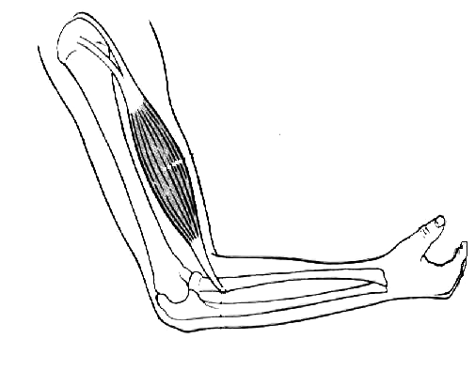
- How would this force increase if they were holding a weight, such as a heavy handbag in their hand?
biceps muscle
humerus
radius
ulna

Solutions to MI10: Equilibrium

A. Review of Basic Ideas:

Torque
When lifting a heavy object it is recommended to keep the back almost vertical, lifting from the knees, rather than bending over and lifting from the waist. The concept of torque allows us to estimate forces on the spinal column when lifting objects and thus justify the above recommendation.
We can model the human spinal column as a pivoted rod. The pivot corresponds to the joint between the sacrum and the lowest lumbar vertebra. The various muscles of the back are equivalent to a single muscle producing a force T, at a point two thirds up the spine. The sacrum exerts a force R on the spine.
sacrum
Weight of upper body
Weight being lifted
T
pivot
R
12º
When you bend over to lift something with the spine horizontal, the force T acts at an angle of 12.0º to the horizontal.
The weight of the upper body, which is about 65% of your body weight, acts about halfway along the spine. The weight which you are lifting acts near the top of your spine, from where the shoulder is.
If the spine is to be in equilibrium, so there is no net torque or force, then the torque due to T must balance the torques due to the weights. These weights are about 0.5 m to 1 m away from the pivot point, so they will exert a large torque. (Remember that torque is force × distance). The force due to the muscles, T, must be large to balance these torques.
This force, T, has a large horizontal component which must be balanced for the spine to be in equilibrium. The force R of the sacrum on the spine acts through the pivot so it exerts no torque about the pivot. It balances the horizontal component of R so the net force is zero. The forces T and R are large, and can damage the disk which separates the sacrum from the spine.
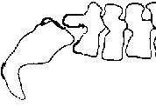
When you bend your knees to lift a weight, keeping your back straight, the weight of the body is almost directly over the pivot and hence exerts little or no torque. The closer you hold the weight to your body, the smaller the torque that it will exert. A 10 kg weight lifted against your body will exert a torque of only a few N. The same weight, lifted with the back horizontal, will exert a torque of around 100 N. To balance this torque, the muscles must exert a force of more than 1000 N! This is why lifting incorrectly is so dangerous, and results in so many back injuries.
R
T
20 kg
230kg

Discussion questions
The force T and the force R act in opposite directions on either
side of the disk between the sacrum and the spine, pushing the
sacrum and spine together. The forces push towards each other,
thus compressing the disk.
To get an equivalent force on the disk when lifting vertically
you would have to lift a weight more than 10 times as great.

B. Activity Questions:
- Tools
The forces shown are those applied by the hands of the person applying the tool, and the object which the tool is being applied to. A thick handled screwdriver is easier to use because you can apply a greater torque for the same applied force – just like having a longer lever.
F (object)
pivot
F (hands)
F (object)
F (hands)
pivot
F (object)
F (object)
F (hands)
F (hands)
pivot
F (hands)

2. The human body
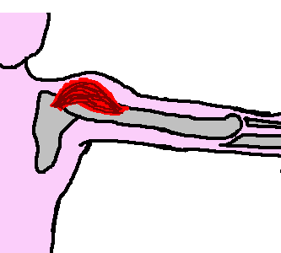
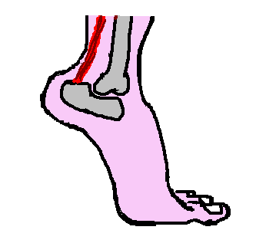
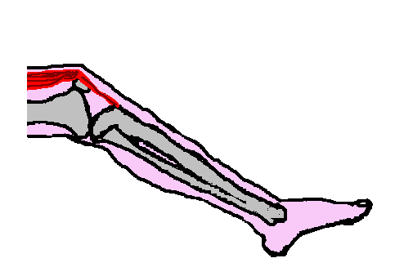
pivot
W_{arm}
T_{deltoid}
pivot
N_{ground}
W_{body}
T_{tendon}
pivot
W_{leg}
W_{foot}
T_{tendon}

3. Centre of mass
As long as the centre of mass is over the base, an object will be stable. When you try to touch your toes you lean back and put your bottom out. The wall behind you prevents this so you cannot touch your toes and maintain your balance.
scale
scale
centre of mass

4. Finding your own centre of mass
When the reading on the scales is the same, your centre of mass is half way between them. Your centre of mass should be about hip height for females, and a little higher for males.

C. Qualitative Questions:
centre of mass
centre of mass
below bar
- The centre of mass of the human body can be outside the body, for example if you touch your toes your centre of mass is outside your body. A high jumper bends their body so that the centre of mass is outside the body. It follows a curve through the air which passes below the bar.

- "Sometimes I see a woman walking down the street with high heels and a two-ton handbag”.
a. Wearing high heels tips the body forward so that the centre of mass moves forward and the body becomes less stable. A body is most stable if the centre of mass lies near the centre of the area of contact of the feet with the floor. To keep the body upright, muscles have to do extra work and this puts a strain on the body. See diagram opposite.  b. Long term wearing of high heels means that the constant strain could cause permanent damage. High heels have been linked to arthritis in the knees.  normal posture | W  W  W  tilt due to high heels – cannot balance  adjust posture to balance

D. Quantitative Question:
force from biceps
m_{arm}g
pivot
arm’s centre of mass

m_{sphere}g
pivot
bicep applies force here
x
X

a, b, c. see opposite.
- The biceps provide a force to counteract the weight of the arm. Considering torques about the pivot point (the elbow joint), in equilibrium τ_{biceps} = τ_{arm} so τ_{biceps} = F_{biceps}x.
τ_{arm} = m_{arm}gX = 4.0 kg × 9.8 m.s⁻² × ½(0.35 m) = 6.9 N.m.
So F_{biceps} = τ_{arm} / 0.05 m = 140 N.
- Holding a weight in the hand adds a large extra torque, as the distance from the hand to the pivot is large (35 cm). Even a small extra weight means the bicep has to apply a large extra force to keep the arm horizontal.

MI11: Rotational Dynamics

A. Review of Basic Ideas:

Use the following words to fill in the blanks:
distance, maximum, conserved, v / r, different, ω, velocity, torque, I, second, force, angle

Spinning around
When we want to describe the movement of an object we can talk about its velocity and its acceleration. But what about something like a CD which stays in the same place but spins around? Different points on the CD are moving at ______ velocities, but they all trace out the same _____, θ, in a given time. For spinning objects we can define an angular velocity and an angular acceleration.

The angular velocity, ____, is the change in angle divided by the time taken, which for a given point is also equal to the velocity, v, of that point divided by its distance, r, from the centre.
ω = Δθ / Δt = ______
The angular acceleration, α, is the rate of change of the angular ______, just like linear acceleration is the rate of change of linear velocity. To make something accelerate you need to apply a ______, and to give something an angular acceleration you need to apply a ______. The torque is equal to the force times the ______ from the pivot point. We also need to allow for the angle at which the force is applied. If the force is applied pointing directly towards the pivot point then it won’t make the body rotate. A force applied at right angle to this direction will have the _____ effect. The torque is given by
τ = r×F= rF sinθ.
When we want to calculate the acceleration of a body subject to a force we use Newton’s ______ law, F_{net} = ma. To find the angular acceleration of a body subject to a torque we use the rotational equivalent to Newton’s second law which is τ_{net} = Iα. The quantity _____ is called the moment of inertia of a body, and is a measure of how hard it is to change the rotational motion of the body.
We can define a rotational energy and an angular momentum associated with the rotation. If there is no net torque these are _______, just like energy and momentum are conserved in linear motion.

Discussion questions
List the terms used to describe linear motion in the paragraph and their rotational counterparts.
Give the relationships between the linear and rotational terms.

B. Activity Questions:

- Clocks
What is the angular speed of the second hand?
What are the angular speeds of the minute and hour hands?
Does the size of the clock affect the angular speeds of the hands?
Does it affect the linear speed of the ends of the hands?

- The rotating stool
Sit on the stool and start rotating with equal weights held in your hands.
Start with the hands in close to your chest and slowly stretch your hands outwards.
What do you observe?
What happens when you pull them back in again? Why?

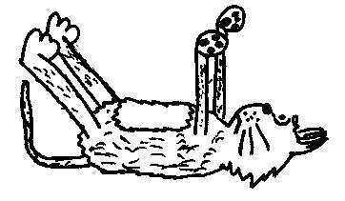
- Falling cats
The diagram on display shows how a cat can rotate itself around so that it always lands on its feet. Sit on the rotating stool and see if you can turn yourself around the way a cat does.
How is it possible to do so without violating conservation of angular momentum?

- Rotation platform
What affects the 'slipping off' of the block?
Which way does the block go as it slips off?
Where is it more likely to slip, and why?

C. Qualitative Questions:

- Rebecca has gone to a conference in Cairns in north Queensland, leaving Brent at home in Sydney to look after Barry the dog.
  - Which one of them has the greater angular velocity, ω?
  - Which of them has the greater velocity, v?
Use a diagram showing their positions on the Earth to explain your answers.

- Most bicycles have spoked wheels, with thin spokes holding the rim and tyre. In the Olympic cycling events there are restrictions on the weight and diameter of the wheels used on the bicycles.
Discuss why solid wheels rather than spoked wheels are used in the Olympics. What are the advantages? Why are spoked wheels commonly used on ordinary bicycles?

D. Quantitative Question:

Many bacteria have flagella or cilia, tiny little waving appendages, which they use to propel themselves. These were always believed to just wave around to move the bacteria, but it turns out that some of them actually act as tiny propellers. However the smallest natural propeller is part of an ATPase molecule. An ATPase is an enzyme which either breaks down or builds up an ATP (Adenosine tri-phosphate) molecule. ATP is the energy currency of cells: energy is liberated by breaking one of the phosphate bonds, or stored by attaching a phosphate. The FI-ATPase molecule has seven sub-units, six of which form a ring around the seventh sub-unit, as shown below. This middle piece actually spins around like the rotor of an electric motor, but it was only by attaching another molecule like a propeller blade that it was possible to observe this movement.
FI-ATPase molecule
propeller
actin molecule
- If each rotation takes 100 ms, what is the angular velocity of the attached actin molecule?
- If the actin molecule is 1 μm long and has a mass of 2 × 10⁻²²kg, what is the moment of inertia of the propeller?
- What is the angular momentum of the actin at this velocity?
- Assuming constant angular acceleration, if it takes 100 ms to perform a rotation starting from rest, what is the angular acceleration of the actin?

I_{rod} = $\frac{1}{3}$ml².

Solutions to MI11: Rotational Dynamics

A. Review of Basic Ideas:

Spinning around
When we want to describe the movement of an object we can talk about its velocity and its acceleration. But what about something like a CD which stays in the same place but spins around? Different points on the CD are moving at different velocities, but they all trace out the same angle, θ, in a given time. For spinning objects we can define an angular velocity and an angular acceleration.
The angular velocity, ω, is the change in angle divided by the time taken, which for a given point is also equal to the velocity, v, of that point divided by its distance, r, from the centre.
ω = Δθ / Δt = v / r
The angular acceleration, α, is the rate of change of the angular velocity, just like linear acceleration is the rate of change of linear velocity. To make something accelerate you need to apply a force, and to give something an angular acceleration you need to apply a torque. The torque is equal to the force times the distance from the pivot point. We also need to allow for the angle at which the force is applied. If the force is applied pointing directly towards the pivot point then it won’t make the body rotate. A force applied at right angle to this direction will have the maximum effect. The torque is given by
τ = r×F= rF sinθ.
When we want to calculate the acceleration of a body subject to a force we use Newton’s second law, F_{net} = ma. To find the angular acceleration of a body subject to a torque we use the rotational equivalent to Newton’s second law which is τ_{net} = Iα. The quantity I is called the moment of inertia of a body, and is a measure of how hard it is to make the body rotate, or to stop it from rotating.
We can define an energy associated with rotation and an angular momentum. If there is no net torque these are conserved, just like energy and momentum are conserved in linear motion.

Discussion question
Linear variable | Rotational variable | relationship
velocity | angular velocity | ω = v/r
acceleration | angular acceleration | α = a/r
force | torque | τ = r×F= rF sinθ
mass | moment of inertia | I = Σ_{i}m_{i}r_{i}²
momentum | angular momentum | L = r× p = rpsinθ
kinetic energy | rotational kinetic energy | K = ½ Iω² = ½ Σ_{i} m_{i} v_{i}²

B. Activity Questions:

- Clocks
The second hand goes around the clock face, that is through 2π radians, in 1 min.
So its angular speed is 2π radian/60 seconds, that is 0.105 rad.s⁻¹.
The minute hand goes around the clock face in one hour, so ω = 2π / 3600 rad.s⁻¹ = 1.75 × 10⁻³ rad.s⁻¹.
The hour hand goes around in 12 hours, 12 hours is 12 hours × 60 min/hour × 60 s/min = 43200 s.
So its angular speed is 2π rad / 43200s = 1.45 × 10⁻⁴ rad.s⁻¹.
The larger the clock the bigger the linear speed of the hands, but the angular speed is the same.

- Rotating Stool
The angular momentum of the system (person and weights) is conserved. When you stretch your hands out the system has a larger rotational inertia and a smaller angular velocity. When the hands are pulled inward towards the body the rotational inertia decreases and hence the angular velocity increases.

- Falling cats
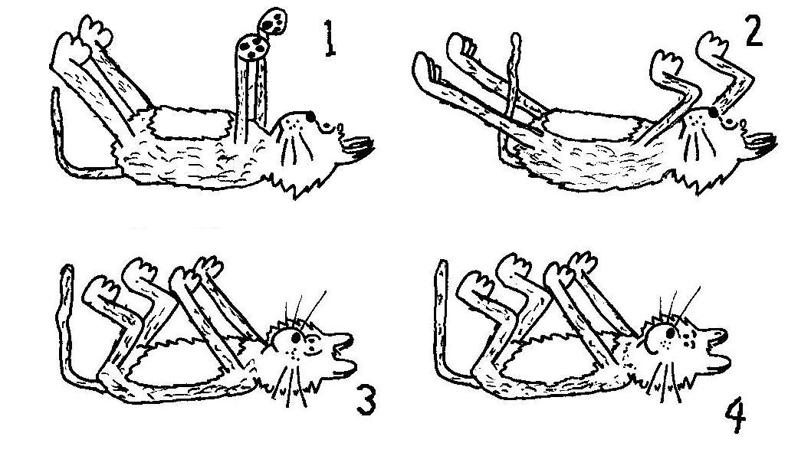
Conservation of angular momentum is not violated, at any time your total angular momentum is zero.
The procedure is as follows:
- Falling with all four limbs sticking straight out.
- Pull in front legs (arms) and rotate them 60º clockwise. Outstretched rear legs have to rotate 30⁰ anti-clockwise.
- Extend front legs (arms) and rotate them 30ºanti-clockwise, and pull in back legs which have to rotate 60º clockwise.
You should now be rotated 30º clockwise. Repeat this 5 times and you’ll be facing the right way and ready to land!

- Objects on a rotation platform
mg
N
F_{fric}
Speed of rotation, distance from the centre and friction affect slipping; mass doesn't affect slipping
The box will slide off at a tangent to the curve, in the direction of its velocity vector. At the edges of the platform the linear acceleration is greatest, hence it is most likely to slip off when close to the edge.

C. Qualitative Questions:

- Rebecca is in Cairns, Brent is in Sydney.
  - Both Rebecca and Brent move 2π radians (one rotation) in 24 hours as the Earth spins, so they have the same angular velocity.
  - Rebecca is further north than Brent, and closer to the equator (Southern hemisphere), hence her distance from the axis of rotation of the Earth is greater than Brent’s. She travels a greater distance in the same time, 24 hours, so she must have a greater linear velocity, v.

2. A spoked wheel has a moment of inertia twice that of a solid wheel, so it takes twice the torque to achieve a given angular acceleration. If you accelerate the wheel while riding, while putting a given amount of energy into it, more energy goes into translational motion for the solid wheel than for the spoked wheel, for a given mass and radius, hence the solid wheel will go faster (greater v). This is why solid wheels are used in the Olympics. However the wheel also has to take half the weight of the bicycle plus rider, so it needs to be strong, but it also needs to be very light, so the bike doesn’t get too heavy. A spoked wheel is a good compromise for strength and weight, unless you have access to expensive modern materials which are both very strong and very light.

D. Quantitative Question:
- One complete rotation takes 100 ms, so the angular velocity is
ω = 2πf = 2π(1/T) = 2π(1/0.100s) = 62.8 rad.s⁻¹
(This is 6000 rpm, about the red-line on the tachometer of most 4 cylinder cars.)
- If we treat the actin molecule as a rod 1 μm long with a mass of 2 × 10⁻²²kg, pivoted at one end, the moment of inertia of the actin propeller is I = ml²/3 = 2 × 10⁻²²kg ×( 1.0 × 10⁻⁶m)² / 3 = 7 × 10⁻³⁵ kg.m².
- The angular momentum is L = Iω = 7 × 10⁻³⁵ kg.m² × 62.8 rad.s⁻¹ = 4.4× 10⁻³³ kg.m² rad.s⁻¹
- Assuming constant angular acceleration, if it takes 100 ms to perform a rotation starting from rest, the angular acceleration of the actin is α = Δω/Δt = (62.8 rad.s⁻¹ – 0) /0.100s = 628 rad.s⁻²

MI12: Gravity and Kepler’s Laws

A. Review of Basic Ideas:

Use the following words to fill in the blanks:
solar, Galileo, all, Earth, astronomers, gravitation, areas, elliptical, Sun, Cr³, force, Gm₁m₂ / r², Moon

Gravity and Kepler’s laws
Our view of the universe and our _____ system has evolved greatly over the past five hundred years. In 1543 when Copernicus wrote a description of the universe that put the Sun rather than the ______ at the centre, he was largely ignored and his theories considered implausible. Worse than this, they were in contradiction with scripture, and the church was liable to punish any who supported Copernicus’ views. About a century later his supporter _____ was interviewed by the Inquisition and put under house arrest for the rest of his life and forbidden to publish. He got off lightly. But despite the best efforts of the church, _______ could observe the motions of the planets, and soon it became known that the planets did indeed orbit the Sun.
Kepler described the orbits of the planets and was the first to recognise that the orbits were not necessarily circular, but could be, and in fact they are, _______. Kepler came up with three laws, now known as Kepler’s laws. The first is that all the planets move in an elliptical orbit with the _____ at one focus. The second is that a line joining any planet to the Sun sweeps out equal _____ in equal times. The third is that the square of a planet’s period, T, is proportional to the cube of its orbit’s semi-major axis, r, or T² =_____, where C is a constant which has the same value for all planets.
Kepler’s laws were based on observation, and offered no explanation as to why the planets behaved as they did. What _____ kept the planets orbiting? Newton’s law of _______ provided the explanation. Newton postulated that there is a force of attraction between any two bodies, and this force is proportional to the masses of the bodies and inversely proportional to the square of the distance between the bodies; F = _______ . The constant G is the universal gravitational constant. It is possible to derive Kepler’s laws from Newton’s law of gravitation, and it turns out the constant C is equal to 4π²/GM_{s} , where M_{s} is the mass of the Sun.
Newton’s law of gravitation applies to ______ objects in the universe, and Kepler’s laws apply to any orbiting body, or satellite. Kepler’s laws describe the motion of our natural satellite, the _____, and all the man made satellites orbiting the Earth. They describe the motions of comets and asteroids and the moons of Jupiter.

Discussion questions
Why don’t you feel the gravitational attraction of a large building when you walk near it?
Why is G so difficult to measure accurately?

B. Activity Questions:

- Drawing orbits
Place one pin at the sun position, and another at the other focus for one of the planets.
How do you know where the other focus should be?
Now cut a piece of string to a (scaled down) length equal to twice the sum of the aphelion and perihelion distances (l = 2(a+p)). Tie the string in a loop and put it around the pins. Hold the pen in the loop so that it pulls the loop taut and use the string to guide the pen to draw the orbit.
Repeat for one or two other planets.
Which planets have the most eccentric orbits? Which have the least eccentric?

- Models of the solar system
Compare the different models of the solar system.
In what ways are they different? How are they similar?

- Kepler’s Second Law
Move the “planet” around the Sun.
Note the line joining the planet to the Sun and observe the area that it sweeps out.
What happens to the velocity of the planet as it moves
further away from the Sun (towards aphelion)?
What happens as it moves closer to the Sun (towards perihelion)?

C. Qualitative Questions:

- The radius of the Earth is approximately 6,400 km. The International Space Station orbits at an altitude approximately 400 km above the Earth’s surface, or at a radius of around 6,800 km from the Earth’s centre. Hence the force of gravity experienced by the space station and its occupants is almost as great as that experienced by people on the surface of the Earth.
So why do astronauts and cosmonauts feel weightless when orbiting the Earth in a space station?

- If you throw a ball up in the air, it falls back to the ground. However if launched at the right angle and speed, a satellite can stay in orbit indefinitely. Briefly explain in terms of the relevant physics principles how a communications satellite can stay apparently suspended high above the Earth's surface, and not fall to the ground as a ball does.

D. Quantitative Question:

Many science fiction stories feature men going to mars and meeting Martians. In some stories the space travelers are able to walk around quite comfortably and even breathe the Martian atmosphere.
- Given the table of information below, what is the acceleration due to gravity on Mars?
(Hint: use F = ma = Gm₁m₂ / r².)
For an object to escape the gravitational attraction of a planet it needs to have a velocity away from the planet equal to or greater than the escape velocity. This velocity can be calculated using conservation of energy. Consider throwing a ball into the air with velocity v, it initially has some kinetic energy and some gravitational potential energy. When it reaches its maximum height it has only gravitational potential energy, so we can write:
E_{initial} = ½ mv² - GM_{Earth}m/R_{Earth} = E_{final} = - GM_{Earth}m/R_{max}.
If we take the case of the ball actually leaving the Earth’s gravitational field totally then R_{max} = ∞, and substituting this into the equation above we can find the necessary velocity to achieve this. This is called the escape velocity.
- Find the escape velocity at the surface of the Earth.
- Find the escape velocity at the surface of Mars.
- Which planet would it be easier to use as a launching base for interstellar travel?

Useful data.
 | Earth | Mars
Mass (× 10²⁴ kg) | 5.97 | 0.642
Diameter (km) | 12,756 | 6794
g (m.s⁻²) | 9.8 | 23.1
Escape velocity (km.s⁻¹)
Solutions to MI12: Gravity and Kepler’s Laws

A. Review of Basic Ideas:

Gravity and Kepler’s laws
Our view of the universe and our solar system has evolved greatly over the past five hundred years. In 1543 when Copernicus wrote a description of the universe that put the Sun rather than the Earth at the centre, he was largely ignored and his theories considered implausible. Worse than this, they were in contradiction with scripture, and the church was liable to punish any who supported Copernicus’ views. About a century later his supporter Galileo was interviewed by the Inquisition and put under house arrest for the rest of his life and forbidden to publish. He got off lightly. But despite the best efforts of the church, astronomers could observe the motions of the planets, and soon it became known that the planets did indeed orbit the Sun.
Kepler described the orbits of the planets and was the first to recognise that the orbits were not necessarily circular, but could be, and in fact they are, elliptical. Kepler came up with three laws, now known as Kepler’s laws. The first is that all the planets move in an elliptical orbit with the Sun at one focus. The second is that a line joining any planet to the Sun sweeps out equal areas in equal times. The third is that the square of a planet’s period, T, is proportional to the cube of its orbit’s semi-major axis, r, or T² = Cr³, where C is a constant which has the same value for all planets.
Kepler’s laws were based on observation, and offered no explanation as to why the planets behaved as they did. What force kept the planets orbiting? Newton’s law of gravitation provided the explanation. Newton postulated that there is a force of attraction between any two bodies, and this force is proportional to the masses of the bodies and inversely proportional to the square of the distance between the bodies; F = Gm₁m₂ / r². The constant G is the universal gravitational constant. It is possible to derive Kepler’s laws from Newton’s law of gravitation, and it turns out the constant C is equal to 4π²/GM_{s} , where M_{s} is the mass of the Sun.
Newton’s law of gravitation applies to all objects in the universe, and Kepler’s laws apply to any orbiting body, or satellite. Kepler’s laws describe the motion of our natural satellite, the Moon, and all the man made satellites orbiting the Earth. They describe the motions of comets and asteroids and the moons of Jupiter.

Discussion questions
The mass of a building is negligible compared to the mass of the Earth. Hence the gravitational force of attraction which depends on both your mass and the mass of the attracting object is negligible when compared to that of the Earth (your weight).
G has a very small value (6.67 × 10⁻¹¹ N.m².kg⁻²) which in a laboratory situation is difficult to measure.

B. Activity Questions:

- Drawing orbits
The planets move in elliptical orbits around the Sun. The closest point to the Sun is called the perihelion and the furthest point is called the aphelion. The Sun is at one focus of the ellipse. The string should be a length equal to the sum of the aphelion and the perihelion, so that the pencil is at most the aphelion distance from the Sun. The distance between the foci is equal to the difference between the aphelion and perihelion distances. The eccentricity of the orbit is the ratio of the distance between the foci to the length of the major axis, which is (aphelion – perihelion) / (aphelion + perihelion), which is equal to 0 for circle and is between 0 and 1 for an ellipse.

Planet | Mercury | Venus | Earth | Mars | Jupiter | Saturn | Uranus | Neptune | Pluto
Aphelion | 70 | 109 | 152 | 249 | 817 | 1515 | 3004 | 4546 | 7304
Perihelion | 46 | 108 | 147 | 206 | 741 | 1353 | 2741 | 4445 | 4435
Distances × 10⁶ km

- Models of the solar system
Our understanding of the motion of the planets has changed greatly over the last few hundred years.
You may see some of these changes by noting the differences between the models – the most obvious is that early models had the Earth at the centre of the solar system with everything else, including the Sun, orbiting around it. Modern models of the solar system place the Sun at the centre.

- Kepler’s Second Law
The area swept out per unit time by the line joining the planet and the Sun is constant. The distance between the Sun and planet varies, because the orbit is elliptical, hence the length of this line varies in time. For the area swept out per unit time to be constant the velocity must vary, decreasing as the planet moves further from the Sun (towards aphelion) and increasing as it moves closer (towards perihelion).

C. Qualitative Questions:

- The radius of the Earth is approximately 6,400 km. The International Space Station orbits at an altitude approximately 400 km above the Earth’s surface, or at a radius of around 6,800 km from the Earth’s centre. Hence the force of gravity experienced by the space station and its occupants is almost as great as that experienced by people on the surface of the Earth. Astronauts and cosmonauts feel weightless when orbiting the Earth because there is no contact force between them and the space station. An astronaut standing on the floor in the space station is accelerating towards the Earth at the same rate and with the same velocity as the space station, hence he or she is not “pushed” against the floor the way someone on Earth is, and they feel “weightless” because they are in free fall, although the astronaut still has almost the same weight as on Earth.

- The communications satellite is falling and a gravitational force is acting on it. The difference between it and the ball is that the satellite has sufficient tangential speed so that it moves sideways at such a rate as to fall “past” the Earth and so continue in an orbit around the Earth.

D. Quantitative Question:

Many science fiction stories feature men going to Mars and meeting Martians. In some stories the space travelers are able to walk around quite comfortably and even breathe the Martian atmosphere.
- The gravitational force between two bodies is given by F = Gm₁m₂ / r². Using Newton’s second law, F = ma, we can write for the acceleration due to gravity at the surface of Mars:
g_{Mars} = GM_{Mars} / r_{Mars}² = (6.67 × 10⁻¹¹ N.m².kg⁻² × 0.642 × 10²⁴ kg ) / (3397 × 10³ m)² = 3.7 m.s⁻².
(Hint: use F = ma = Gm₁m₂ / r².)
- The escape velocity can be calculated using conservation of energy. Consider throwing a ball into the air with velocity v, it initially has some kinetic energy and some gravitational potential energy. When it reaches its maximum height it has only gravitational potential energy, so we can write:
E_{initial} = ½ mv² – GM_{Earth}m/R_{Earth} = E_{final} = - GM_{Earth}m/R_{max}.

If we take the case of the ball actually leaving the Earth’s gravitational field totally then R_{max} = ∞, and substituting this into the equation above gives: ½ mv² – GM_{Earth}m/R_{Earth} = - GM_{Earth}m/∞ = 0.
Rearranging for v² gives:
v² = 2GM_{Earth}/R_{Earth} = 2 × 6.67 × 10⁻¹¹ N.m².kg⁻² × 5.97 × 10²⁴ kg / 6378 × 10³ m = 1.25 × 10⁸ m².s⁻²
so v = 1.12 × 10⁴ m.s⁻¹ = 11.2 km.s⁻¹.
- On Mars:
v² = 2GM_{Mars}/R_{Mars} = 2 × 6.67 × 10⁻¹¹ N.m².kg⁻² × 0.642 × 10²⁴ kg / 3397 × 10³ m = 2.52 × 10⁶ m².s⁻².
and v = 5.02 × 10³ m.s⁻¹ = 5.02 km.s⁻¹.
- The escape velocity on Mars is less than half that on Earth, hence the amount of energy needed to launch a space ship from Mars is less than ¼ that needed to launch a space ship from Earth, hence Mars would make a better launching base for interstellar travel.

