Properties of Matter

Regular Properties of Matter Worksheets and Solutions

PR1B: | Pressure | 3
PR1T: | Pressure | 7
PR2B: | Buoyancy | 11
PR2T: | Buoyancy | 15
PR3B: | Fluid Flow 1 | 19
PR3T: | Fluid Flow 1 | 23
PR4B: | Fluid Flow 2 | 27
PR4T: | Fluid Flow 2 | 31
PR5B: | Surface Tension | 35
PR5T: | Surface Tension | 39
PR6B: | Solids I – Stress, Strain and Elasticity | 43
PR6T: | Solids I – Stress, Strain and Elasticity | 47
PR7: | Solids II – Crystals and Bonding | 51

Workshop Tutorials for Biological and Environmental Physics
PR1B: Pressure

A. Qualitative Questions:

1. The diagram shows a reservoir wall.
- Why is the wall thicker at the bottom than at the top?
- Two reservoirs of the same depth are to be joined to form a single much larger reservoir. Is it necessary to reinforce the dam wall?

2. You are about to set out on a scuba diving trip, and are having a medical check. The doctor measures your blood pressure to be a healthy120/80 mmHg. The 120 mmHg is the maximum pressure at the peak of each pulse, called the systole, and the 80 mmHg is the lowest pressure between pulses, called the diastole.
- Given that normal atmospheric pressure is around 760 mmHg, why does blood spurt from a deep cut?
You check the weather report, and it’s going to be a fine weekend, with a high pressure front of 102 kPa bringing warm weather. You pack up and head off. You check your tyre pressure when you fill up with petrol, and inflate them to 25 psi (17.2 kPa).
- Which of the pressures given above are absolute and which are gauge pressures?
You arrive at the diving class and are issued with instructions and equipment.
- Why does the diving instructor tell you not to hold your breath when surfacing?
- Why are you issued with lead belts and inflatable packets?

B. Activity Questions:
- Suction cups and Magdeburg plates
How can you make the suction cup stick to a surface?
Explain what happens when it sticks and when it fails to stick.
When are the Magdeburg plates hard to pull apart?
When are the Magdeburg plates easy to pull apart? Explain why.

- Hydrostatic paradox
Water is poured to the same level in each of the vessels shown below, all having the same base area. If the pressure is the same at the bottom of each vessel, the force experienced by the base of each vessel is the same. Why do the vessels have different weights when put on a scale? This apparently contradictory result is commonly known as the hydrostatic paradox. Use the activity to solve this issue.

- Squirting
Use the activity to show that a fluid exerts an outward force on the walls of its container.
Observe the way water 'squirts' out of the holes. What can you say about the direction of the water just as it leaves the holes?
Push a drinking straw into the water and then put your finger over the top. Lift the straw out of the water. What happens? Why?

- Hollow tube and disc
Hollow tube and disk: Why does the disk fall away in air but stay attached to the tube when there is air in the tube and water outside the tube?
- The lungs
What happens to the pressure surrounding the lungs when you pull the diaphragm down?
What happens to the lungs (balloons)? Explain why they behave as they do.

C. Quantitative Questions:

1. In a simple geological model, the pressure at some horizontal level far below the earth’s surface, regardless of what is above, is the same over a large region. The pressure is equal to that exerted by the overlying material; mountains, lakes, valleys, etc. This level at which the pressure is equal is called the level of compensation. This model requires that mountains have roots, so that the pressure at some point below them will be equal to that below surrounding plains and valleys.
The density of the rocks which make up continents, including the mountains, is 2.9 g.cm⁻³, the density of the mantle is 3.3 gm.cm⁻³. The mean depth of the continental plate is around 30 km.
  - Mount Kosciuszko, Australia’s tallest mountain, is 2228m tall. How deep are Kosciuszko’s roots?
  - What would happen if the pressure was not the same at all points at the level of compensation?
  - Does it matter what height you choose the compensation level to be? Does it actually have a physical depth?
Level of
compensation
y
mountain
Depth of root
30km
continent
root
mantle
2.2km

2. The first recorded measurement of blood pressure was in 1733 by the Rev. Stephen Hales. He connected a 9 foot vertical glass tube to an artery of a horse using the trachea of a goose as a flexible connection. The blood rose in the tube to a height of 8 feet (2.4 m)!
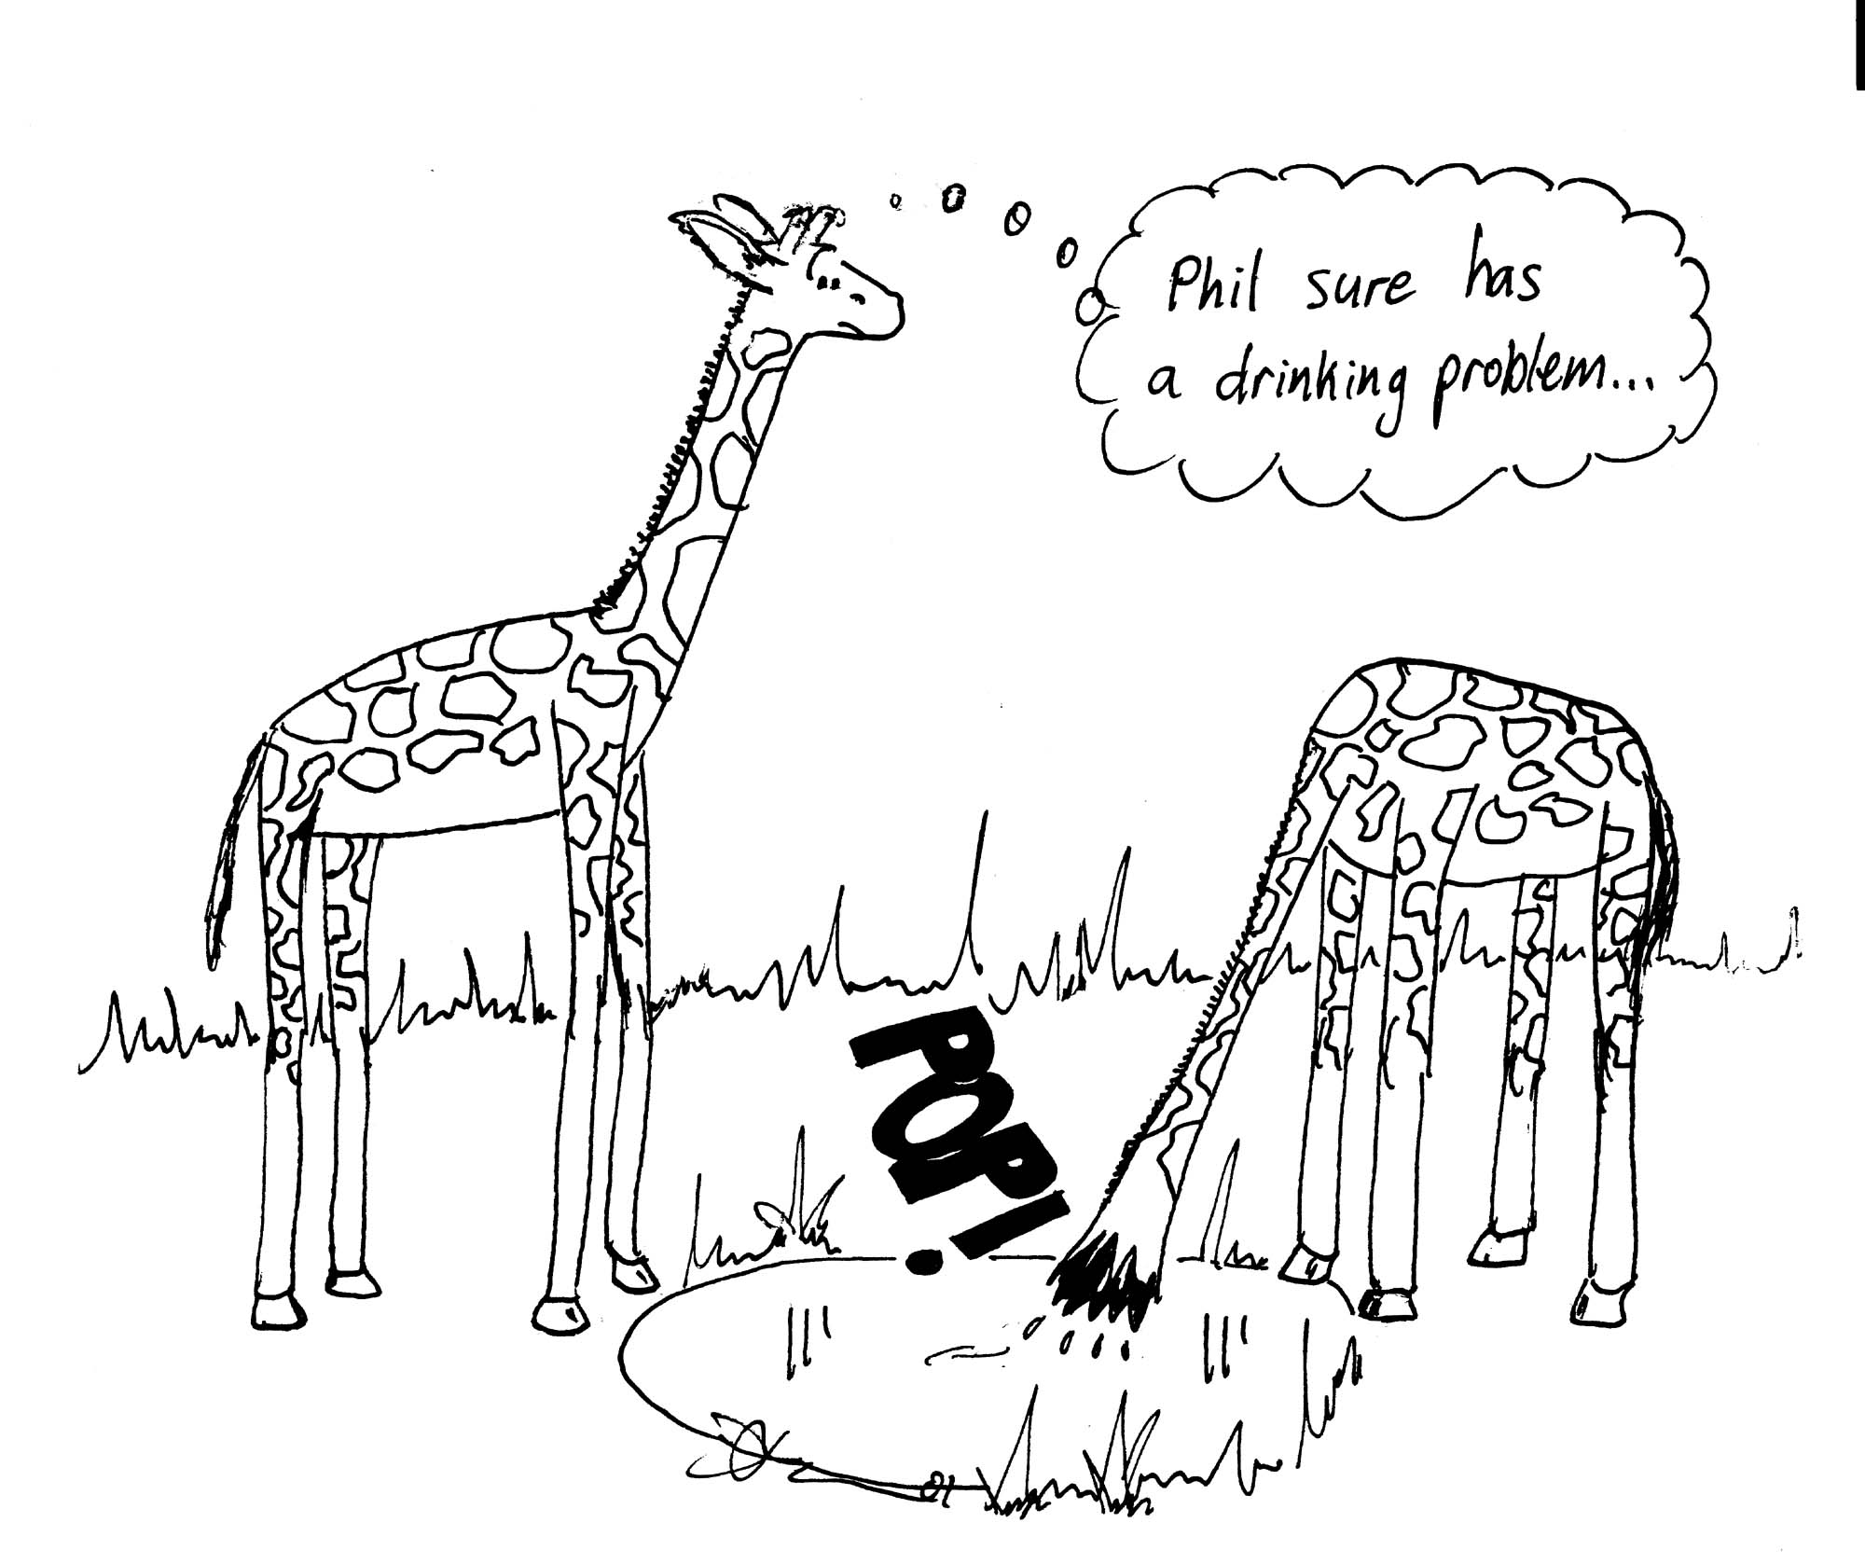
- During a blood transfusion the needle is inserted into a vein where the pressure is 1000 Pa. The density of blood is 1060 kg.m⁻³. What is the minimum height the transfusion bag needs to be raised to for a successful transfusion?
- What would happen if the bag was lower than this?
- If a giraffe is 5m tall, with his heart at approximately half that height, what pressure does the heart need to produce to keep the brain supplied with oxygen?
- How does the blood pressure in his head change when he dips his head to drink?
- Why do giraffes spread their front legs to drink (apart from making it easier to reach the water)? What would happen if they didn’t?

Workshop Tutorials for Biological and Environmental Physics
Solutions to PR1B: Pressure

A. Qualitative Questions:

1. Pressure and depth.
- Pressure increases with depth as P=ρgh. Pressure = (force/area) so the wall needs to withstand greater force at the bottom, hence it is built to be thicker at the bottom.
- Changing the surface area does not change the pressure because it does not change the depth, hence there is no need to further reinforce the wall.

2. Absolute and gauge pressures.
- Blood pressure is a measure of pressure above atmospheric, it is a relative or gauge pressure.
- Atmospheric pressure is the only absolute pressure given here, both blood pressure and tyre pressure are gauge pressures, i.e. pressure above atmospheric.
Deep water,
P_{water}=P_{lung}
Shallow water,
P_{water} << P_{lung}
- You are told not to hold your breath when surfacing because as you rise the external pressure from the water decreases. The air in your lungs exerts a pressure outwards on your lungs, while the water outside you exerts an inward pressure. As you rise and the water pressure decreases, the air in your lungs expands. If there is too much air pushing outwards, and not enough pressure outside, they could rupture!
- The lead belts and inflatable packets are to adjust your buoyancy; lead to make you more dense, allowing you to sink, inflatable packets to make you less dense, allowing you to float.

B. Activity Questions:

- Suction cups and Magdeburg plates
The Magdeburg plates are hard to pull apart when there is a vacuum between them, but easy to pull apart when there is air. A fluid exerts a force perpendicular to a surface it comes in contact with: F=PA. If there is a difference in pressure across a surface this results in a net force which is directed from the region of greater to lower pressure. In the case of the Magdeburg plates, when air is removed from the region between the plates the pressure between the plates is less than the atmospheric pressure outside the plates. This difference in pressure results in a net force inwards, holding the plates together.
The suction cup must have the air squeezed out of it and make a complete seal with the surface to stick to it. If the seal isn’t complete, air can enter the cup, removing the pressure difference and allowing the cup to fall off.

- Hydrostatic paradox
The containers have different masses (because they contain different amounts of water), so they must have different weights. Another argument goes as follows: the pressure is the same at the bottom of each container (because they are filled to the same height). But they all have the same base area, so the force experienced by the base of each container is the same. Therefore, they should all give the same reading on the scale. This second argument is wrong because we have only considered the force of the water on the base of the containers. When calculating the force of the water on the container, we must include the forces on the sides, which may have a component in the vertical direction.

- Squirting
The water will come out perpendicular to the container wall, as this is the direction of the net force.
In each of these activities the liquid is held in by the low pressure in the tube or bottle, when this pressure is increased to atmospheric pressure, by opening the lid or removing the finger, the water will come out.

- Hollow tube and disc
The disc stays attached when there is a pressure difference exerting a force which holds it in place. When the pressure difference decreases such that the force falls below mg of the disc, the disc falls.

- The lungs
When you pull the diaphragm on the bottom of the bottle the volume of the bottle increases. This lowers the pressure in the bottle. Inside the balloons it is approximately atmospheric pressure, while outside is now lower. The balloons inflate due to the pressure difference, their volume increases, lowering their internal pressure and drawing air into them. This is how we breathe - increasing the volume of our chest cavity to lower the pressure in our lungs and draw air in

C. Quantitative Questions:

- The density of the rocks which make up the continent (including the mountain) is ρ_{c} = 2.9 g.cm⁻³, and the continent is 30 km deep, with a 2.2 km high mountain on top, which has a root of depth d. The density of the mantle is ρ_{m} = 3.3 gm.cm⁻³. The pressure is to be equal at the compensation level, so choose two points, one below the mountain, one not, labelled p and q. At each point the pressure is equal to ρgh of the material above. See the figure below.
- Set the pressures at the two points equal: P_{p} = (y-d).ρ_{m}.g + (d + 2.2 + 30).ρ_{c}.g = P_{q} = y.ρ_{m}.g + 30.ρ_{c}.g
y.ρ_{m}.g - d.ρ_{m}.g +d.ρ_{c}.g + 32.2.ρ_{c}.g = y.ρ_{m}.g + 30.ρ_{c}.g
solve for depth, d:
Level of
compensation
y
mountain
Depth of root,
d
2.2km
30km
continent
root
p
q
ρ_{m}
ρ_{c}
mantle
d.ρ_{m} - d.ρ_{c} = 2.2.ρ_{c}.
d = 2.2.ρ_{c}/( ρ_{m} - ρ_{c})
d = 2.2 × 2.9/(3.3-2.9) = 16 km.

- If the pressure were not the same at all points along this level, there would be a movement of the mantle from areas of high pressure to areas of low pressure and mountains would rise and fall, and the continents would move, which in fact does slowly happen.
- It doesn’t matter what depth you take as the depth of compensation, as long as it is below the depth of the root.

2. Blood pressures.
- You need a pressure greater than 1000 Pa. The density of blood is 1060 kg.m⁻³.
Using P=ρgh, the minimum height will be h = P/ρg = 1000/(1060×9.8) = 0.1m.
- If the bag was lower than this blood would flow into the bag instead.
- The heart needs to pump blood up by 2.5m, again using P=ρgh,
P=ρgh = 1060 × 9.8 × 2.5 = 26 kPa. This is the minimum pressure the heart must supply to get blood to the brain, in practice it would need to be a bit higher to get it to circulate once there.
- When the giraffe drinks he will have double this pressure at his head if the heart is still supplying this pressure.
- If he didn’t bend down and thus lower his heart with respect to his head, he’d get a terrible headache (at least) from the high pressure at his head, and possibly burst capillaries. Fortunately the giraffe compensates for the pressure changes by having very tight skin on his legs and strong blood vessels. The heart also adjusts its pressure to suit the giraffe’s posture.
Workshop Tutorials for Technological and Applied Physics
PR1T: Pressure

A. Qualitative Questions:

- Draw a diagram and explain how each of the following contribute to atmospheric pressure:
- the weight of the air in the atmosphere
- the molecular bombardment of the air molecules in the atmosphere
- convection currents in the atmosphere (circulation of air masses resulting in weather patterns)

- You are about to set out on a scuba diving trip, and are having a medical check. The doctor measures your blood pressure to be a healthy120/80 mmHg. The 120 mmHg is the maximum pressure at the peak of each pulse, called the systole, and the 80 mmHg is the lowest pressure between pulses, called the diastole.
- Given that normal atmospheric pressure is around 760 mmHg, why does blood spurt from a deep cut?
You check the weather report, and it’s going to be a fine weekend, with a high pressure front of 102 kPa bringing warm weather. You pack up and head off. You check your tyre pressure when you fill up with petrol, and inflate them to 25 psi (17.2 kPa).
- Which of the pressures given above are absolute and which are gauge pressures?
You arrive at the diving class and are issued with instructions and equipment.
- Why does the diving instructor tell you not to hold your breath when surfacing?
- Why are you issued with lead belts and inflatable packets?

B. Activity Questions:

- Suction cups and Magdeburg plates
How can you make the suction cup stick to a surface?
Explain what happens when it sticks and when it fails to stick.
When are the Magdeburg plates hard to pull apart?
When are the Magdeburg plates easy to pull apart? Explain why.

- Hydrostatic paradox
Water is poured to the same level in each of the vessels shown below, all having the same base area. If the pressure is the same at the bottom of each vessel, the force experienced by the base of each vessel is the same. Why do the vessels have different weights when put on a scale? This apparently contradictory result is commonly known as the hydrostatic paradox. Use the activity to solve this issue.

- Pascal's vases
The bases of the vases are linked to a common reservoir. Why is the water level the same in each column? What would happen if the pressure in one column is increased and the others were still open?

- Squirting
Use the activity to show that 'a fluid exerts an outward force on the walls of its container'.
Observe the way water 'squirts' out of the holes. What can you say about the direction of the water just as it leaves the holes?
Push a drinking straw into the water and then put your finger over the top. Lift the straw out of the water. What happens? Why? Observe what happens when you undo the lid of the “watering bottle”. Explain your observations.

- Hollow tube and disc
Hollow tube and disk: Why does the disk fall away in air but stay attached to the tube when there is air in the tube and water outside the tube?

C. Quantitative Questions:

- A hydraulic lift is used to raise a dentist’s chair which weighs 150 kg. The chair rests on a piston of area 1500cm². A force is applied to a small piston of area 75 cm² to raise the chair.
- How much force must be applied to the small piston to raise the chair?
- What distance must the small piston be moved to raise the chair by 10 cm?
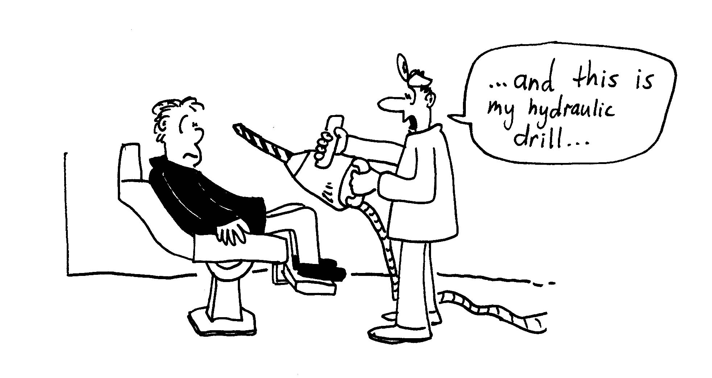

- Your diving instructor has been asked to investigate the integrity of a dam wall. The reservoir is about to be enlarged to cope with Sydney’s growing population and the water authority may need to reinforce the holding wall. The dam is 30 m deep and has a pipe 6m below the surface of the water. The diameter of the pipe is 20 cm and it is blocked by a plug.
30m
6m

- Why is the wall thicker at the bottom than at the top?
- If two reservoirs of the same depth are to be joined to form a single much larger reservoir, is it necessary to reinforce the dam wall?
- What is the friction force between the plug and the pipe wall?

Workshop Tutorials for Technological and Applied Physics
Solutions to PR1T: Pressure

A. Qualitative Questions:

- Air pressure.
- The weight of the air in the atmosphere is a major factor in determining atmospheric pressure on earth on a global scale. It is the constant motion of the air molecules that gives the atmosphere the density we are accustomed to and the variations in pressure with height.
- Microscopically, the pressure is due to the bombardment of molecules. Let us imagine the extreme: If the air molecules were not constantly moving they would fall down, changing the density and keeping the pressure at the surface of the earth the same. However the pressure would change drastically with height! | mg  mg
- Convection currents in the atmosphere are part of the weather pattern. Warm air rising, cool air sinking and the motion of air masses horizontally are part of low and high pressure systems in the atmosphere.

- Absolute and gauge pressures.
- Blood pressure is a measure of pressure above atmospheric, it is a relative or gauge pressure.
- Atmospheric pressure is the only absolute pressure given here, both blood pressure and tyre pressure are gauge pressures, i.e. pressure above atmospheric.
Deep water,
P_{water}=P_{lung}
Shallow water,
P_{water} << P_{lung}
- You are told not to hold your breath when surfacing because as you get higher, the external pressure from the water decreases. The air in your lungs exerts a pressure outwards on your lungs, while the water outside you exerts an inward pressure. As you rise and the water pressure decreases, the air in your lungs is able to expand. If there is too much air in them pushing outwards, and not enough pressure outside them, they could rupture!
- The lead belts and inflatable pack are to adjust your buoyancy; lead to make you more dense, allowing you to sink, inflatable packs to make you less dense, allowing you to float.

B. Activity Questions:

- Suction cups and Magdeburg plates
The suction cup must have the air squeezed out of it and make a complete seal with the surface to stick to it. If the seal isn’t complete, air can enter the cup, removing the pressure difference and allowing the cup to fall off.
The Magdeburg plates are hard to pull apart when there is a vacuum between them, but easy to pull apart when there is air. A fluid exerts a force perpendicular to a surface it comes in contact with: F=PA. If there is a difference in pressure across a surface this results in a net force which is directed from the region of greater to lower pressure. In the case of the Magdeburg plates, when air is removed from the region between the plates the pressure between the plates is less than the atmospheric pressure outside the plates. This difference in pressure results in a net force inwards, holding the plates together.

- Hydrostatic paradox
The containers have different masses (because they contain different amounts of water), so they must have different weights.
Another argument goes as follows: the pressure is the same at the bottom of each container (because they are filled to the same height). But they all have the same base area, so the force experienced by the base of each container is the same. Therefore, they should all give the same reading on the scale. This second argument is wrong because we have only considered the force of the water on the base of the containers. When calculating the force of the water on the container, we must include the forces on the sides, which may have a component in the vertical direction.

- Pascal's vases
An increase in the pressure in one tube will be transmitted to the other tubes, and the liquid level in these tubes will rise. This is possible because the vases are all connected and hence are really a single vessel.

- Squirting
The water will come out perpendicular to the container wall, as this is the direction of the net force.
In each of these the liquid is held in by the low pressure in the tube or bottle, when this pressure is increased to atmospheric pressure by opening the lid or removing the finger the water will come out.

- Hollow tube and disc
The disc stays attached when there is a pressure difference exerting a force which holds it in place. When the pressure difference decreases such that the force falls below mg of the disc, the disc falls.

C. Quantitative Questions:

- A hydraulic lift is used to raise a dentist’s chair which weighs 150 kg. The chair rests on a piston of area 1500cm². A force is applied to a small piston of area 75 cm² to raise the chair.
- The force needed to just overcome the weight of the chair is 150 kg × g = 1470 N. This is the force needed on the chair. The pressure will be the same at all points in the fluid, so we need a force applied to the small piston which will give enough pressure to produce this force at the large piston. Hence we need a pressure of P = F/A = 1470 N/ 1500 × 10⁴ m² = 9800 Pa.
At the small piston we must apply a force to produce this pressure, which will be
F = PA = 9800 Pa × 75 × 10⁻⁴ m² = 73.5 N.
This is the minimum force which must be applied to move the chair.
- To raise the chair by 10 cm a volume of V = 10 cm × 1500 cm² = 15000 cm³ of the fluid must be displaced into the area beneath the chair. This volume must come from the fluid beneath the small piston, hence it must move downwards a height of h = V / area = 15000 cm³ / 75 cm² = 200 cm = 2m.

- Pressure and depth.
- Pressure increases with depth as P=ρgh. Pressure = (force/area) so the wall needs to withstand greater force at the bottom, hence it is built to be thicker at the bottom.
- Changing the surface area does not change the pressure because it does not change the depth, hence there is no need to further reinforce the wall.
- The plug is not moving so it is a static frictional force holding it in place. The force will be equal to the pressure × the area, F = P×A, and the pressure is P = P_{atm} + ρgh. However both sides of the plug will have the same contribution from atmospheric pressure, so we can ignore this contribution as it will cancel out anyway.
F = ρ_{water}gh(πr²) = 1000 kg.m⁻³ × 9.8 m.s⁻² ×6 m ×π× (0.02 m)² = 74 N.

Workshop Tutorials for Biological and Environmental Physics
PR2B: Buoyancy
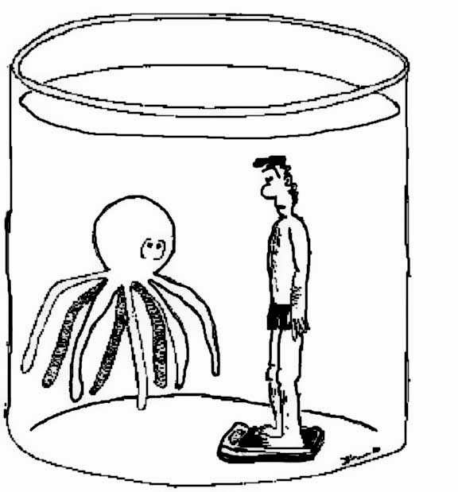
A. Qualitative Questions:

- When you join a gym you may have a skin fold test done to tell you how much of your body is fat. A more accurate, but less pleasant, means of measuring body composition is via submersion in water. The person is weighed in air and then weighed again when completely submerged in water. (Don’t try this at home!)
- Explain how this process can be used to measure average density.
The body density gives an indication of body composition, as fat is much less dense than either muscle or bone.
- Why is it important to breathe out as much as possible when doing such a test?
- Why do women float better than men?
Why is it easier to float in very salty water, for example the Dead Sea, than in fresh water.
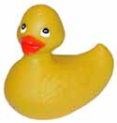
1
2
3
4
- The figure shows four identical open-top containers. One container has just water. A cork floats in another container and a toy duck floats in the third. The fourth container has a steel marble in it. All four containers are filled to the brim with water. Which container weighs the most? Which container weighs the least? Explain your answer.

B. Activity Questions:

- Buoyant force I
An object is suspended from a spring balance.
What is the reading on the spring balance when the object is in air?
Now immerse the object in water?
How will the reading change?
Explain what happens and draw a diagram showing the forces acting on the object to help explain your answer.

- Buoyant force II
A container of water is placed on a weighing scale. An object, suspended from a spring balance, is immersed in the container of water. Will the reading on the weighing scale change? Draw a diagram showing the forces acting to help explain your answer.

- Hydrometers
There are hydrometers and several liquid samples on the demonstration benches. Walk over and take a few measurements. Can you identify the samples from the table of densities given?
Identical hydrometers are placed in three different liquids. They float at different levels. Is the buoyant force on the hydrometers the same or different? Why?
Why is the scale on the hydrometer marked the way it is?

- Cartesian diver
What happens to the diver as you push on the bottle? Why?
What controls the motion of the diver?

C. Quantitative Questions:

- A fish maintains its depth in water by adjusting the air content of porous bone or swim bladders to make its average density the same as that of the water. The swim bladder (also called the gas bladder or air bladder) is a flexible-walled, gas-filled sac. This organ controls the fish's buoyancy and is also used for hearing in some species.
brain
liver
stomach
intestines
swim bladder
skull

Suppose that with its swim bladder collapsed, a mackerel has a density of 1.08 g.cm⁻³. By what fraction of its original body volume must the fish inflate the air sacs to reduce its density to that of the water? Density of sea water is 1.02 g.cm⁻³.

- In February 1995, an iceberg so big the entire Sydney region from the coast to the Blue Mountains could fit on its surface broke free of Antarctica. The iceberg was approximately rectangular with a length of 78 km, a width of 37 km and 200 m thick.
- What fraction of this iceberg was underwater?
- Do you actually need the shape and size of the iceberg to determine this fraction?
- The “unsinkable” Titanic was sunk by an iceberg. Why do icebergs present such a problem for shipping?
- Would icebergs be a problem if water density increased on freezing, like most other liquids?

TABLE OF DENSITIES

Ice | 917 kg.m⁻³ (at 1 atm and 0 °C)
Sea water | 1024 kg.m⁻³ (at 1 atm and 20 °C)
Water | 998 kg.m⁻³ (at 1 atm and 20 °C)

Workshop Tutorials for Biological and Environmental Physics
Solutions to PR2B: Buoyancy
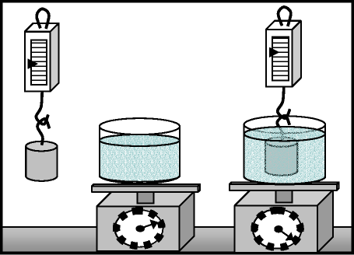
A. Qualitative Questions:
1. Using buoyancy to estimate body fat.
a. The body is weighed in air and then in water. The difference is equal to the buoyant force, which is equal to the weight of water displaced. As long as the body is properly submerged, the volume of displaced water will be equal to the volume of the body. You know that the weight of displaced water = (body weight in air – body weight in water), then the volume of water displaced = mass of water /density of water = volume of body. This gives you the volume and the mass, from which you can calculate the
density using ~ = m / V.
b. Air has a very low density, and hence the more air in your lungs, the lower your average density. Hence having a lot of air in your lungs would lead to too high an estimate of your fat content.
c. Women usually have a higher fat content than men, approximately 20% : 12%, and fat is less dense than muscle, water or bone, hence women are less dense and float better.
d. Very salty water is more dense than pure water, hence the amount of water you displace you float higher.
1
2
3
4

Containers 2 and 3 both contain objects which are floating and hence displace a weight of water equal to the object’s weight, so the total weight of containers 2 and 3 is the same as container 1 which has only water in it. Container 4 has a steel marble, which has sunk, and displaced a volume of water equal to the marble's volume.
However the marble is more dense than water, and hence weighs more than the volume of water it displaced. So container 4 weighs more than the other three containers.
B. Activity Questions:
mg
T
F_{B}
T
mg
F_{B}

1. Buoyant force I
The object will weigh less in water than air because water is
more dense than air and hence the buoyant force is greater.
In both cases FB + T = mg, and the scale measures te tension,
T. FB is greater in water, hence T is less.

2. Buoyant force II
The bucket will weigh more with the object in it because even though the object is not resting on the bottom, it has raised the level of water, hence increased the pressure at the bottom and increased the weight of the bucket.

3. Hydrometers
The buoyant force is equal to the weight of displaced liquid. The weight of displaced liquid is equal to the weight of the hydrometer, hence the buoyant force will be the same in each case as long as the hydrometers float and do not sink to the bottom.

A hydrometer floats higher in denser liquids. When the hydrometer is floating the buoyant force, which is equal to the weight of water displaced, must be equal to the weight of the hydrometer. A denser liquid needs less water displaced to give the same buoyant force, hence the hydrometer floats higher the denser the fluid is.
PUSH

4. Cartesian Diver
When you push the bottle the pressure you apply is transmitted
evenly and without loss to all parts of the fluid. Water is
almost incompressible, but air is very compressible, hence
the air bubble in the diver is compressed, changing his average
density. You should be able to see the bubble get smaller. The
more you squeeze, the denser he becomes, and the faster he sinks.
When you let go, he decompresses and rises again.

C. Quantitative Questions:
1. Before the fish inflates its air-sacs it has a density of ~i = m/V = 1.08 g.cm⁻³.
After inflating the sacs to lower its density its density is ~f = m/(V +~V) = 1.02 g.cm⁻³. We are trying to find the fractional change in volume, ~V/V.
The actual mass is not important, and can be removed from the equations by dividing ~I by ~f, which gives:
~i / ~f = (V+~V)/V = 1.08 g.cm⁻³ / 1.02 g.cm⁻³.
We can rewrite this as 1 + (~V/V) = 1.06, and hence ~V/V = 0.06 = 6%.

2. Icebergs and the Titanic.
a. For a floating body, such as an iceberg in the sea, the weight of displaced water is equal to the weight of the iceberg.
mg
F_{B}
Wwater displaced = Wiceberg
mwater displaced × g = _{miceberg} × g
now using m = ~V:
~water × Vwater displaced × g = _{~iceberg} × _{Viceberg} × g
The volume of water displaced must be equal to the volume of the iceberg which is submerged.
Vsubmerged / _{Viceberg} = _{~iceberg} / ~water
Vsubmerged / _{Viceberg} = 917 kg.m⁻³ / 1024 kg.m⁻³ = 0.896 = 89.6%
So 90% of the iceberg is submerged.
b. As can be seen from examining the calculation, this proportion does not depend on the shape or size of the iceberg, only the density of the ice and the water.
c. Most of the iceberg is underwater, and it may be much longer beneath than above, making it difficult to see.
d. If water density increased on freezing, like most other liquids, icebergs would sink and not be a hazard. However this would lead to other problems, like aquatic plants and creatures being frozen and a gradual build-up of ice at the bottom of lakes, rivers and seas.
Workshop Tutorials for Technological and Applied Physics
PR2T: Buoyancy

A. Qualitative Questions:

- State whether you agree or disagree with each of the choices given below and write a brief explanation of why you agree or disagree.
A ship built of steel can float on sea-water because:
- Sea-water is denser than steel.
- The buoyant force on the ship is greater than its weight.
- The buoyant force on the ship is greater than the weight of sea-water displaced.
- Archimedes' principle is not applicable to a hollow body like a ship.
- The ratio of the mass of the ship to its volume is less than the density of sea water.

1
2
3
4
- The figure shows four identical open-top containers. One container has just water. A cork floats in another container and a toy duck floats in the third. The fourth container has a steel marble in it. All four containers are filled to the brim with water.
Which container weighs the most?
Which container weighs the least?
Explain your answer.

B. Activity Questions:

1. Buoyant force I
An object is suspended from a spring balance. Will the reading on the spring balance be different when the object is in air to when the object is immersed in water? Draw a diagram showing the forces acting to help explain your answer.

2. Buoyant force II
A container of water is placed on a weighing scale. An object, suspended from a spring balance, is immersed in the container of water. Will the reading on the weighing scale change? Draw a diagram showing the forces acting to help explain your answer.

- Hydrometers
There are hydrometers and several liquid samples on the activity benches. Walk over and take a few measurements. Can you identify the samples from the table of densities given?
Identical hydrometers are placed in three different liquids. They float at different levels.
Is the buoyant force on the hydrometers the same or different? Why?
Why is the scale on the hydrometer marked the way it is?

- Cartesian diver
What happens to the diver as you push on the bottle? Why?
What controls the motion of the diver?

C. Quantitative Questions:

- In February 1995, an iceberg so big the entire Sydney region from the coast to the Blue Mountains could fit on its surface broke free of Antarctica. The iceberg was approximately rectangular with a length of 78 km, a width of 37 km and 200 m thick.
- What fraction of this iceberg was underwater?
- Do you actually need the shape and size of the iceberg to determine this fraction?
- The 'unsinkable' Titanic was sunk by an iceberg. Why do icebergs present such a problem for shipping?
- Would icebergs be a problem if water density increased on freezing, like most other liquids?

TABLE OF DENSITIES

Ice | 917 kg.m⁻³ (at 1 atm and 0 °C)
Sea water | 1024 kg.m⁻³ (at 1 atm and 20 °C)
Water | 998 kg.m⁻³ (at 1 atm and 20 °C)

2. In the 1930’s a new way to cross the Atlantic was by air zeppelin. The zeppelins were like gigantic steerable blimps, with rigid frames which contained gas bags, which were filled with hydrogen or helium to give the ship buoyancy. They were a peaceful and luxurious way to travel. Most of these zeppelins were built in Germany, and one of the biggest and most luxurious was the “Hindenburg”. It had a library, dining room, a lounge and hot water in all cabins. It was the world's first transatlantic commercial airliner and was kept overhead by up to 200,000 cubic meters of hydrogen in 16 cells.
- The density of air at 20ºC is 1.2 kg.m⁻³, the density of hydrogen is 0.090 kg.m⁻³. What volume of hydrogen was required to lift the Hindenburg if its total mass, including payload, was 12,000kg?
On May 6th, 1937 the Hindenburg crashed in Lakehurst, New Jersey, a year after its first flight. The hydrogen of the airship was ignited while maneuvering to land and the Hindenburg was destroyed and 35 passengers and crew died.
- Helium is now used by airships such as blimps and hot air balloons, however at the time of the Hindenburg the helium gas, produced almost entirely in the USA, was extremely expensive and not readily available.
- The density of helium is 0.17 kg.m⁻³. What mass could be lifted by the same volume of helium?
- Given your answers to a and b, why do you think helium is now used in preference to hydrogen?
- Why do helium balloons gradually go flat and stop floating? What eventually happens to the helium gas?

Workshop Tutorials for Technological and Applied Physics
Solutions to PR2T: Buoyancy

A. Qualitative Questions:

- Density and buoyancy, and how ships float.
  - Sea-water is not denser than steel.
  - The buoyant force on the ship is not greater than its weight, if this was the case there would be a net force upwards, and the ship would accelerate up.
  - The buoyant force on the ship is not greater than the weight of sea-water displaced, it is equal to the weight of sea water displaced.
  - Archimedes’ principle is applicable to a hollow body like a ship, but you must use the total volume of the body, including the cavity.
  - The ratio of the mass of the ship to its volume is less than the density of sea water, the density of the ship is less than that of the water, this is true if the ship is to float. Note again that this is the total volume of the ship, including airspaces, not just the volume of the steel.
1
2
3
4
2. Containers 2 and 3 both contain objects which are floating and hence displace a weight of water equal to the objects weight, so the total weight of containers 2 and 3 is the same as container 1 which has only water in it. Container 4 has a steel marble, which has sunk, and displaced a volume of water equal to the marble's volume.
However the marble is more dense than water, and hence weighs more than the volume of water it has displaced. So container 4 weighs more than the other three containers.
mg
T
F_{B}
T
mg
F_{B}

B. Activity Questions:

- Buoyant force I
The object will weigh less in water than air because water is more dense than air and hence the buoyant force is greater.
In both cases F_{B} + T = mg, and the scale measures the tension, T. F_{B} is greater in water, hence T is less.

- Buoyant force II
The bucket will weigh more with the object in it because even though the object is not resting on the bottom, it has raised the level of water, hence increased the pressure at the bottom and increased the weight of the bucket.

- Hydrometers
The buoyant force is equal to the weight of displaced liquid.
The weight of displaced liquid is equal to the weight of the hydrometer, hence the buoyant force will be the same in each case as long as the hydrometers float and do not sink to the bottom. A hydrometer floats higher in denser liquids. When the hydrometer is floating the buoyant force, which is equal to the weight of water displaced, must be equal to the weight of the hydrometer. A denser liquid needs less liquid displaced to give the same buoyant force, hence the hydrometer floats higher the denser the fluid is.

- Cartesian Diver
PUSH
When you push the bottle the pressure you apply is transmitted evenly and without loss to all parts of the fluid. Water is almost incompressible, but air is very compressible, hence the air bubble in the diver is compressed, changing his average density. You should be able to see the bubble get smaller. The more you squeeze, the denser he becomes, and the faster he sinks. When you let go, he decompresses and rises again.

C. Quantitative Questions:

- Icebergs and the Titanic.
- For a floating body, such as an iceberg in the sea, the weight of displaced water is equal to the weight of the iceberg: W_{water displaced} = W_{iceberg} or m_{water displaced} × g = m_{iceberg} × g,
mg
F_{B}
and now using m = ρV:
ρ_{water} × V_{water displaced} × g = ρ_{iceberg} × V_{iceberg}× g
The volume of water displaced must be equal to the volume of the iceberg which is submerged.
V_{submerged} / V_{iceberg} = ρ_{iceberg} / ρ_{water} = 917 kg.m⁻³ / 1024 kg.m⁻³
= 0.896 = 89.6%. So 90% of the iceberg is submerged.
- As can be seen from examining the calculation, this proportion does not depend on the shape or size of the iceberg, only the density of the ice and the water.
- Most of the iceberg is underwater, and it is much bigger beneath than above, and also difficult to see.
- If water density increased on freezing, like most other liquids, icebergs would sink and not be a hazard. However this would lead to other problems, like aquatic plants and creatures being frozen and a gradual build-up of ice at the bottom of lakes, rivers and seas.
- If water density increased on freezing, like most other liquids, icebergs would sink and not be a hazard. However this would lead to other problems, like aquatic plants and creatures being frozen.
mg
F_{B}
- Buoyancy and the Hindenburg.
- For the airship to float and maintain its position we require that the weight force (mg) must be equal to or less than the buoyant force (F_{B}).
The total weight of the ship, M, is the weight of the hydrogen plus the weight of the ship with payload, (W=mg). Again we use m=ρV.
Mg = ρ_{H}.V_{H} .g + m_{ship}.g
as above, this must be equal to the weight of air displaced, which is m_{air} g = ρ_{air}V_{air}.g
ρ_{H}.V_{H} .g + m_{ship}.g = ρ_{air}V_{air}.g
The volume of air displaced will be approximately the volume of the hydrogen as the hydrogen cells are enormous compared to the cabin which sits below them, so we can set V_{H}=V_{air}, and cancelling the g’s gives: ρ_{H}.V + m_{ship} = ρ_{air}V and V = M/(ρ_{air}-ρ_{H}) = 12,000/(1.2-0.09) = 10,800m³.
- Repeat the above calculation using the volume just found and the density of helium rather than hydrogen, but now we solve for mass: ρ_{He}.V_{He} .g + m_{ship}.g = ρ_{air}V_{air}.g
m_{ship} = (ρ_{air} - ρ_{He}.)V_{He} = 11,200kg
- Helium is used in preference to hydrogen because it is inert. Hydrogen is highly flammable, as was dramatically demonstrated by the Hindenburg.
- The helium gradually leaks out between the molecules of the balloon skin and goes into the atmosphere. Helium is lighter than air and at typical atmospheric temperatures has enough kinetic energy to escape the atmosphere and the gravitational attraction of the earth (many of the atoms have a velocity greater than the escape velocity). It leaves the atmosphere and goes into outer space.
Workshop Tutorials for Biological and Environmental Physics
PR3B: Fluid Flow I

A. Qualitative Questions:

- Water flows through the pipe shown below from left to right.
B
C
D
A

- Rank the volume rate of flow at the four points A, B, C and D.
- Rank the velocity of the fluid at the points A, B, C and D. Explain your answer.
- Rank the pressure in the fluid at points A, B, C and D. Explain your answer.

- Bernoulli’s equation follows from Newton’s laws and is essentially a statement of conservation of energy for fluid flow.
  - Write down Bernoulli’s equation and, referring to each term, explain how it is a statement of conservation of energy.
  - Using Bernoulli’s equation, explain how raising a mound around a burrow entrance can help to ventilate an animal’s burrow. Draw a diagram showing the air flow.

B. Activity Questions:

- Ball in an air jet
How is the Ping-Pong ball kept in midair by a jet of air?
Draw a diagram showing the streamlines around the ball.

- Chimney effect
Use the air jet to make the polystyrene balls rise up the tube.
Why do they rise?
Can you think of a use for this effect?

- Blowing and lifting
How is it possible to lift the foam block off the table by blowing down a hollow tube onto it?
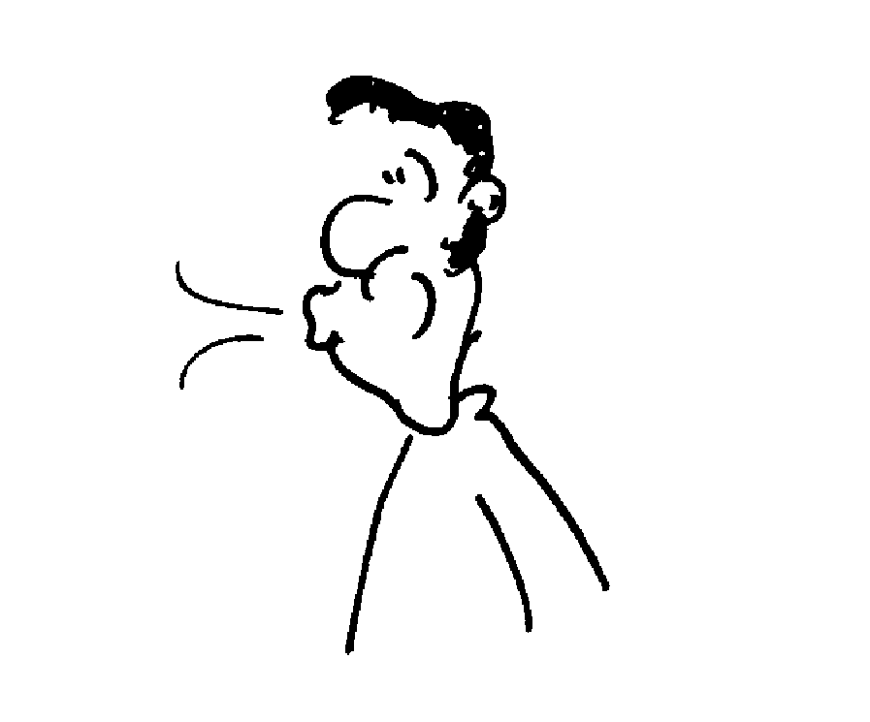
Draw a diagram showing how this works.

- Two sheets of paper
What happens if you blow between two sheets of paper held approximately parallel and about 2 cm apart?
Hold a flat sheet of paper horizontally in front of you and blow along it. What happens? Why?

C. Quantitative Questions:

- Smoking causes inflammation of the bronchioles, the small air passages in the lungs, which tends to decrease the flow of air into the lungs and hence the oxygen supply to the blood. Air is flowing down a normal section of a bronchiole with a diameter of 1.0 mm at a velocity of 0.5 m.s⁻¹.
1mm
0.7mm

- Part of the bronchiole is narrowed due to inflammation, and has a diameter of only 0.77 mm. What is the velocity of the air in this section of the bronchiole?
- What are the consequences of this for gas exchange in the lung?

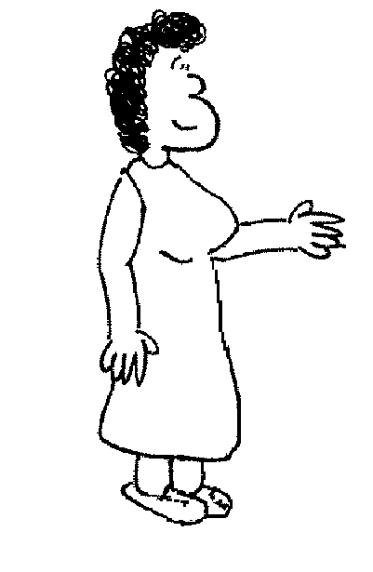
1.0 m
60 cm

- Rebecca and Brent are brewing their own ginger beer and have set up a large vat with a narrow pipe near the bottom to take samples so they can tell when its ready for bottling. The vat has a diameter of 60 cm, is open at the top, and has a pressure gauge mounted on the pipe 1.0 m below the top of the vat. The vat is full, and as Rebecca takes a sample the fluid level falls at a rate of 1.0 cm.s⁻¹ and flows out the bottom of the pipe at 50 cm.s⁻¹. The density of the ginger beer is 1.0 × 10³ kg.m⁻³.
What pressure reading (absolute) does the gauge show? (Hint: use Bernoulli’s equation.)

Workshop Tutorials for Biological and Environmental Physics
Solutions to PR3B: Fluid Flow I

A. Qualitative Questions:

- Water flows through the pipe from left to right.
- Water is incompressible, and as there is no water either entering or leaving between points A and D the volume flow rate must be same at all points, just as current must be the same at all points along an arm of a circuit. This is called the principle of continuity- A×v = constant. | B  C  D  A
- As the water flows from A to B the area increases, hence to maintain continuity v must decrease, therefore v_{A} > v_{B}. As the water then flows downhill to point C it will gain energy, however the area has not changed so we know, because of continuity, that the velocity has not changed, v_{B} = v_{C}. When the water flows from C to D the area increases again, so the velocity will decrease again, v_{C}> v_{D}. The ranking is therefore v_{A} > v_{B} = v_{C}> v_{D}.
- When the water flows from A to B there is no change in gravitational potential energy, however the velocity has decreased which means that the kinetic energy of the water has decreased. By conservation of energy we know that if kinetic energy decreases, some other form of energy must increase. If we look at Bernoulli’s equation, ρgh+ ½ ρv² + P = constant, (which is a statement of conservation of energy density), we can see that the pressure must have increased, P_{B} > P_{A}. When the water flows downhill from B to C it loses gravitational potential energy, but the velocity and hence kinetic energy does not change. The pressure must again increase in going from B to C, P_{C} > P_{B}. Finally, as the water flows from C to D the velocity decreases again and the pressure must once more increase, P_{D} > P_{C}. So the final pressure ranking will be P_{A} < P_{B} < P_{C} < P_{D}

  - Bernoulli’s equation follows from Newton’s laws and is essentially a statement of conservation of energy for fluid flow.
- Bernoulli’s equation says that for an incompressible fluid of density ρ: P + ρgh + ½ ρv ² = constant, where P is the pressure in the fluid, h is the height of the fluid and v is the velocity. This is a statement of conservation of energy. But, as fluids are usually considered to be continuous, rather than simple objects, the equation states the conservation of energy density. Energy density is the energy per unit volume. If we look at the terms in the equation and multiply by a volume we indeed end up with energies. Pressure × volume gives work (force per unit area times a volume gives a force × distance), pgh is the gravitational potential energy per unit volume and ½ ρv² is the kinetic energy per unit volume.
- Many animals which live in communal burrows have a mound around one entrance to the burrow. The air flows faster over the mound, giving a lower pressure over this burrow entrance. The air inside the burrow will flow out of the burrow due to the pressure difference, and this will draw air in at other entrances, keeping the air fresh inside the burrows and preventing the animals from suffocating.
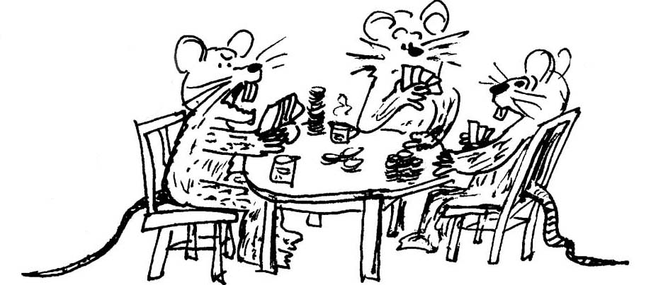
low v, high P
high v, low P

B. Activity Questions:
All the activity questions can be explained in terms of Bernoulli’s Principle. For a simple model in which air is moving horizontally, P + ½ ρv² = constant. Thus if speed of flow increases then the pressure must decrease. A pressure difference produces a force F = ΔP.A directed from the region of high pressure to the region of low pressure.
v₂, P₂
v₁, P₁

- Ball in an air jet  The air jet has a velocity profile with the air in the middle having greater velocities than the air near the edges. So if the ball is balanced in the air jet as shown, v₁ > v₂ and P₁< P₂. This pressure difference results in a 'lift' force up which is equal and opposite to the weight of the ball. | air flow  P_{atm}  P < P_{atm}  smoke

- Chimney effect  The air rushing past the top of the chimney has lower pressure than the air in the chimney. There is a net upward force on the air and foam balls in the chimney, and the air and the balls rise. This effect is also used by burrowing animals to ventilate their burrows | .

air flow
P_{atm}
P < P_{atm}
- Blowing and lifting
As air rushes through the narrow gap it speeds up and the pressure drops. There is atmospheric pressure under the polystyrene so the pressure difference results in a force up, equal and opposite to the weight of the polystyrene.

P_{atm}
P_{atm}
P < P_{atm}
v
- Two sheets of paper
There is reduced pressure between the sheets of paper and they move inwards. Other examples are passing vehicles, lower end of a shower curtain curling towards the water.

C. Quantitative Questions:

- Smoking causes inflammation of the bronchioles, the small air passages in the lungs, which tends to decrease the flow of air into the lungs and hence the oxygen supply to the blood. Air is flowing down a normal section of a bronchiole with a diameter of 1 mm at a velocity of 0.5 m.s⁻¹.
- Part of the bronchiole is narrowed due to inflammation, and has a diameter of only 0.7 mm. We can use continuity to find the flow rate in this region: A₁v₁ = A₂v₂.
v₂ = A₁v₁ / A₂ = πr₁ ² × v₁ / πr₂ ² = π(½ × 1.0 × 10⁻³ m) ² × 0.5 m.s⁻¹ / π(½ × 0.7 × 10⁻³ m) ² = 1.0 m.s⁻¹.
- If the air moves past the surfaces much faster then the oxygen spends less time in contact with the gas exchange surfaces and is less likely to be absorbed, decreasing the oxygen supply to the body. To compensate for this the lungs and heart have to work harder to get more oxygen and move it around more effectively.

- We can use Bernoulli’s equation to solve this, taking the top of the tank as one point A in the flow, and the gauge as point B. We can call the height at B h_{B} = 0, then the height at A is h_{A} = 1.0m. We have:
P_{A} + ρgh_{A} + ½ ρv_{A} ² = P_{B} + ρgh_{B} + ½ ρv_{B} ², and the pressure at B is now:
P_{B} = P_{A} + ρgh_{A} + ½ ρ(v_{A} ² – v_{B} ²)
= 100 kPa + 1 × 10³ kg.m⁻³ × 9.8 m.s⁻² × 1.0 m + 1 × 10³ kg.m⁻³((0.01 m.s⁻¹)² – 0.5 m.s⁻¹)²)
= 100 kPa + 9.8 kPa – 0.25 kPa = 110 kPa.
Workshop Tutorials for Technological and Applied Physics
PR3T: Fluid Flow I

A. Qualitative Questions:

1. Four arrangements of pipes are shown below, in each of them water flows from left to right. The cross sectional area at point X is A, and at Y the cross sectional area is A or ½A as shown.
a. For each arrangement, draw streamlines and comment on the velocity and pressure at points X and Y.
X
Y
A
A
A
X
Y
A
A
X
Y
A
½A
X
Y
A
½A
½A

b. Use your answers from part a to explain how closely spaced tall buildings can cause wind tunnel effects at ground level, producing very strong winds.
c. How can this effect cause windows to blow outwards when a wind is blowing?

2. Why do aeroplane pilots prefer to take off into the wind?
Draw a diagram showing the wing of an aeroplane in flight and label the forces acting on it.

B. Activity Questions:

- Ball in an air jet
How is the Ping-Pong ball kept in midair by a jet of air?
Draw a diagram showing the streamlines around the ball.

- Chimney effect
Use the air jet to make the polystyrene balls rise up the tube.
Why do they rise? Can you think of a use for this effect?

- Blowing and lifting
How is it possible to lift the foam block off the table by blowing down a hollow tube onto it?
Draw a diagram showing how this works.
- Two sheets of paper
What happens if you blow between two sheets of paper held approximately parallel and about 2 cm apart?
Hold a flat sheet of paper horizontally in front of you and blow along it. What happens? Why?

C. Quantitative Questions:

1. A tank is filled with water to a height H. A hole is punched in one of the walls at a depth h below the water surface (see figure below).
v
x
h
H
- Show that the velocity v with which the water leaves the hole is given by v =√(2gh)
- Show that the distance x from the base of the tank to the point where the stream of water hits the ground is given by x = 2√(h(H-h))
- Could a hole be punched at another depth to produce a second stream which would have the same range? If so, at what depth?
- At what depth should the hole be placed to make the emerging stream strike the ground at the maximum distance from the base of the tank?
- The picture is from a text book. Can you identify a flaw in it?

2. A jet aeroplane is climbing at an angle of 25º to the horizontal at a constant speed. The plane has 2 wings, each with a surface area of 10.0 m². Air flows over the upper wing surfaces at 48.0 m.s⁻¹ and under the lower wing surfaces at 40.0 m.s⁻¹.
- Estimate the pressure difference between the upper and lower wing surfaces. Is the pressure greater above or below the wing? Why?
- Draw a free body diagram showing and naming all the forces acting on the plane, including air resistance, but neglecting buoyancy.
- Estimate the mass of the plane.
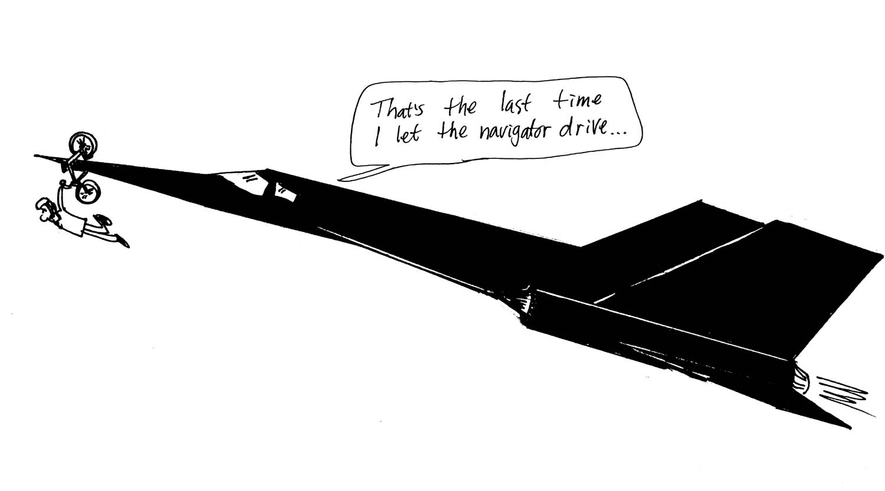
25º

Data: density of air is 1.20 kg.m⁻³.

Workshop Tutorials for Technological and Applied Physics
Solutions to PR3T: Fluid Flow I

A. Qualitative Questions:

1. Four arrangements of pipes are shown below, in each of them water flows from left to right.
a. See diagram. Where the streamlines are close together the velocity is high, and the pressure is low, and where they are far apart the velocity is low and the pressure is high.
X
Y

Y
X

low v, high P
high v, low P
Total cross sectional area remains the same, so v and P do not change.

Total cross sectional area remains the same, so v and P do not change.
X
Y
X
Y
high v, low P
low v, high P

b. When wind flows between tall buildings its velocity increases because the cross sectional area of the flow decreases. If you drew the streamlines they would look like the upper left flow.
c. The greatly increased velocity of the airflow results in a lower pressure. If the difference in pressure between the inside and outside of the building is great enough, the windows will pop out.
low v, high P
high v, low P
lift
2. Aeroplane pilots prefer to take off into the wind to maximize the velocity of the air passing over and under the wing, to get more lift. The higher velocity air above the wing is at lower pressure than the air below, giving a pressure difference ΔP = ½ ρ(v_{above}² – v_{below}²). This pressure provides the upwards force, called a lift, on the wing.

B. Activity Questions:
All the activity questions can be explained in terms of Bernoulli’s Principle. For a simple model in which air is moving horizontally, P + ½ ρv² = constant. Thus if speed of flow increases then the pressure must decrease. A pressure difference produces a force F = ΔP A directed from the region of high pressure to the region of low pressure.
v₂, P₂
v₁, P₁

- Ball in an air jet  The air jet has a velocity profile with the air in the middle having greater velocities than the air near the edges. So if the ball is balanced in the air jet as shown, v₁ > v₂ and P₁< P₂. This pressure difference results in a 'lift' force up which is equal and opposite to the weight of the ball. | air flow  P_{atm}  P < P_{atm}  smoke

- Chimney effect  The air rushing past the top of the chimney has lower pressure than the air in the chimney. There is a net upward force on the air and foam balls in the chimney, and the air and the balls rise. This effect is also used by burrowing animals to ventilate their burrows | .

- Blowing and lifting
air flow
P_{atm}
P < P_{atm}
As air rushes through the narrow gap it speeds up and the pressure drops. There is atmospheric pressure under the polystyrene so the pressure difference results in a force up, equal and opposite to the weight of the polystyrene.

P_{atm}
P_{atm}
P < P_{atm}
v
- Two sheets of paper
There is reduced pressure between the sheets of paper and they move inwards. Other examples are passing vehicles, lower end of a shower curtain curling towards the water.

C. Quantitative Questions:

- Water flowing out of a tank.
a. The water flows out of the hole with a horizontal velocity of and zero vertical velocity. It free falls (ignoring air resistance) ie falls with acceleration of 9.8m.s⁻². We can treat this as projectile motion.
Consider the vertical motion:
where so that
Substitute time into equation for horizontal motion:
so and substituting for where
- From the symmetry of this equation a second hole can be at a depth of .
c. To find the velocity with which water is coming out of the hole we use Bernoulli's equation
Now At the top surface of the water while the water flowing out of the hole has .Thus the water flows out with .
d. To get the maximum range, x, we need to maximise the function .
Set and then the maximum range occurs when (H-2h) = 0, h = H/2.
e. Falling water, as described here, does not spread out, it gets narrower as speed increases because the pressure is lower. If we consider the equation of continuity, increasing the velocity of the flow as it falls also means a decrease in the cross sectional area of the flow. (High pressure flows may spread out due to turbulence.)

- Bernouilli’s equation and aeroplanes.
a. Bernouilli’s equation says P + ρgh + ½ ρv ² = constant, in this case the height, h will be almost the same while velocity will be different: P₁ + ½ ρv₁ ² = P₂ + ½ ρv₂ ²
Which we can rearrange to get P₁ –P₂ = ½ ρ.(v₁² -v₂²) = ½ . 1.20 (48.0² – 40.0²) = 422 Pa.
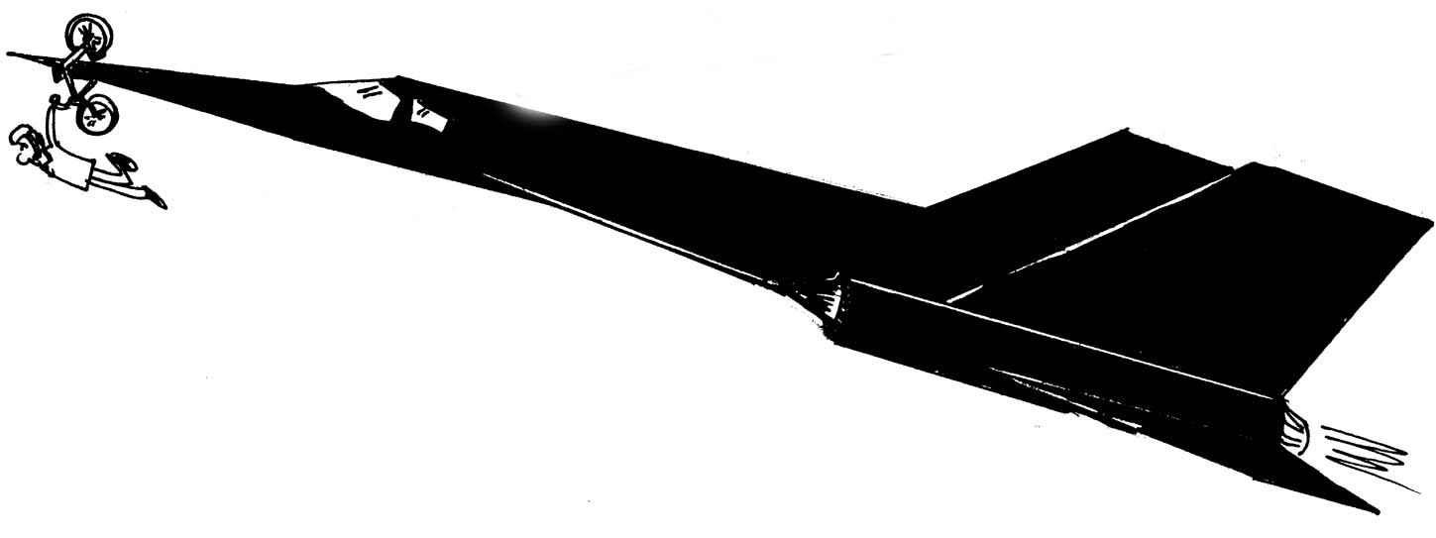
The pressure is greater beneath the wing, as the air is moving more slowly here. Also, if it was the other way around the plane would be pushed downwards by the air instead of lifted.
T
W
L
D
b. Thrust, T, is in the direction of motion. Drag, D, (air resistance) is in the opposite direction to the motion.
Weight force, W, (mg) is down.
Lift, L, is perpendicular to the direction of motion.
c. The net force is zero. We neglect the buoyancy of the plane (which is not very much).
Lift force is L = 2 PA = 8448 N. Resolving forces in the direction of lift, we see that L = mg cosθ , so the mass of the plane is m = L/g cosθ = 8448/ 9.8.cos15º = 892 kg.
Workshop Tutorials for Biological and Environmental Physics
PR4B: Fluid Flow II

A. Qualitative Questions:

- The behaviour of fluids depends on their viscosity and density, and these properties also influence the way animals and machines can move through fluids.
- How would rowing be different if water had zero viscosity and what would birds be like if air had zero viscosity?
- How would skydiving and hot air ballooning be different if air had zero viscosity? What if it had much greater viscosity?
- How would skydiving and hot air ballooning be different if air had zero density? What if it had much greater density?
- Spiders move by pumping fluid into and out of their legs. Why are spiders slower moving in winter?

- Blood carries oxygen to our organs, it transports nutrients and white blood cells which help to fight infection and removes waste products such as carbon dioxide from our tissues. It is important that the flow of blood is consistent and that the supply is not reduced or cut off as tissues which are deprived of blood are quickly damaged.
  - Why should turbulence mean that the volume rate of flow is less than in streamlined flow?
Use the graphs below to answer the following questions.
  - For a given flow rate, QA, why does the heart work harder when there is an obstructed artery than when the artery is normal?
  - How do the requirements on the heart change if the flow rate increases from QA to QB when there is an obstructed artery and when the artery is normal?
Q_{A}
Q_{B}
Flow rate (Q)
Pressure
turbulent
laminar
normal
obstructed
normal
obstructed

  - Some people have an excessive number of red blood cells, effectively increasing the viscosity of the blood. What effect would this have on their heart?

B. Activity Questions:

- Hot honey
Honey is a good example of a viscous fluid.
Explain what happens to the density and viscosity when the honey is heated. Does one change more than the other?

- Measuring flow rate
How does the diameter of the needle affect the flow rate?
What about the length of the needle?

- Rheological Materials
Examine the various materials on the table. Are they fluids? What defines a fluid?
Measure the flow rates of the various fluids.
Which ones are Newtonian? How can you tell?
What is happening to the ones which are non-Newtonian? How is the viscosity of these fluids changing with flow rate?

C. Quantitative Questions:

1. An elephant with a trunk 2.0 m long is squirting water (η = 1.005×10⁻³ Pa.s) at a tourist. The trunk contains two nostrils (tubes) which are the length of the trunk and have an internal diameter of 2.0 cm. The flow rate is 5.0 litres per second total from the two nostrils.
- Draw a diagram of this situation.
- What is the average velocity of the water in the trunk?
- Why is the term average velocity rather than velocity used in part a?
- With what pressure is the elephant blowing to squirt the water?
- How hard would the elephant have to blow if he were to squirt custard (η= 2.5 Pa.s)
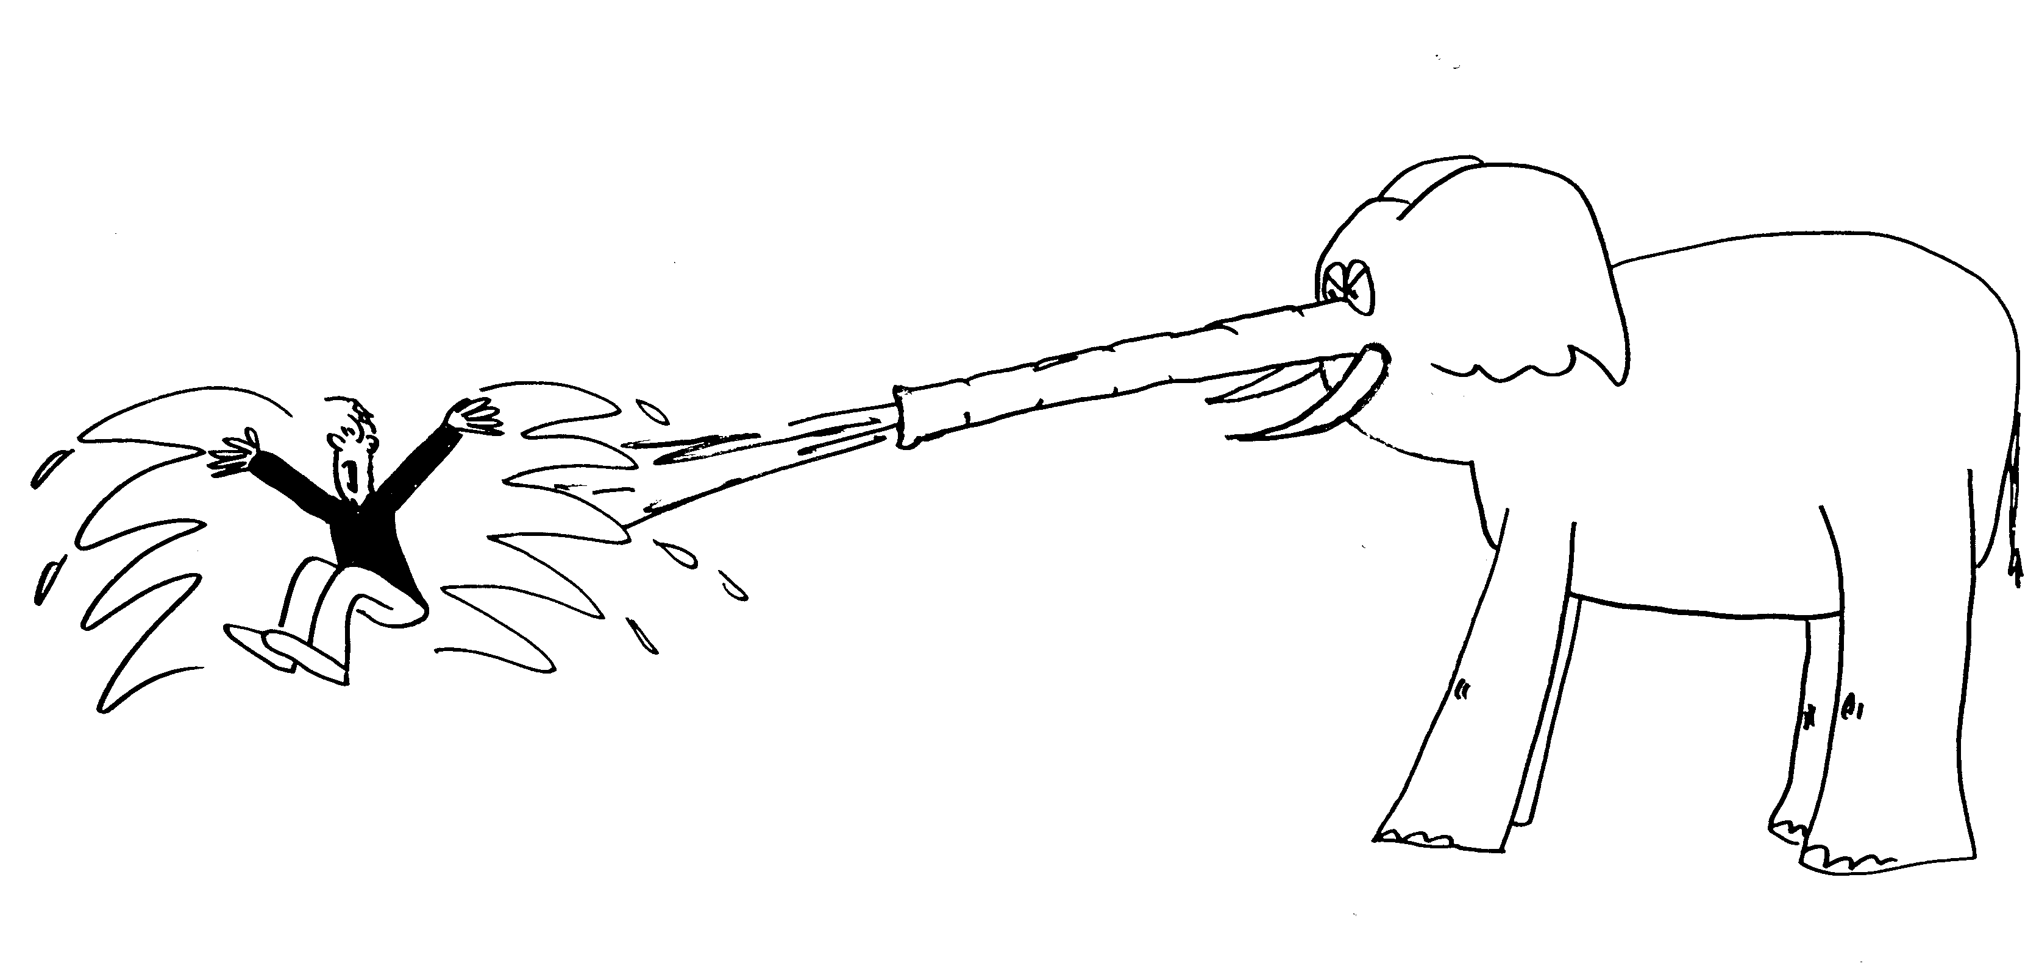
- Calculate the Reynold’s number, N_{R} = vρr/η, to find whether the water and custard flows are laminar or turbulent. ρ_{water} = 1000 kg.m⁻³, ρ_{custard} = 900 kg.m⁻³.
- Does one need to assume laminar flow for answering b?

2. The main artery which takes oxygenated blood from the left ventricle of the heart to the body is the aorta. It has a mean radius of around 1 cm, before branching into smaller arteries which supply blood to the various organs. The viscosity of normal blood is around 2.1 × 10⁻³ Pa.s at body temperature.
- If the flow rate along the aorta is 25 l.min⁻¹, what is the pressure drop per centimetre along the aorta?
- What would be the pressure drop if the flow rate was maintained, but the mean radius of the artery was reduced to 0.9 cm?
- Smoking, a poor diet and lack of exercise contribute to hardening of the arteries, making them less able to flex to allow greater blood flow. A diet high in fat and cholesterol can also lead to the formation of fatty deposits in the arteries. Why are these contributing factors to heart disease?

Workshop Tutorials for Biological and Environmental Physics
Solutions to PR4B: Fluid Flow II

A. Qualitative Questions:

- Viscosity and density.
- Rowing would not be possible, just as walking would not be possible if there were no friction. You would have a very limited reaction force, and not get very far. Like rowing, flying would be impossible by flapping. Birds could glide (or use jet propulsion!).
- If air had zero viscosity you’d never reach terminal velocity. Skydiving would be very exciting until you reached the ground because parachutes wouldn’t work either. Hot air ballooning would be much the same at zero viscosity, as balloons move relatively slowly. However steering would be difficult. At very high viscosity you’d reach terminal velocity very quickly (and maybe even burn up like a meteorite) and ascending in a hot air balloon would be much slower.
- Skydiving would not change much if air had lower density, except that breathing would be difficult. Hot air ballooning would be difficult because buoyancy would be much reduced. If air was denser buoyancy would increase and balloons would ascend faster and be able to carry more weight. If it was dense enough you wouldn’t be able to skydive, you’d just hang in the air.
- Spiders move more slowly in winter because the viscosity of the fluid in their legs increases when it gets colder. Most fluids, including blood, become more viscous when they are cooled.

- Blood flow.
- Turbulence means that the volume rate of flow for a given pressure is less than in streamlined flow because much of the pressure difference (force per unit area) is being used to push the fluid in directions other than straight along the tube.
- When there is an obstructed artery the effective radius of the tube is lower. For viscous fluids flow rate goes like r⁴, so even a small change in radius has a big effect on flow rate. Obstructions also tend to cause turbulence, further decreasing the flow rate. To keep the same flow rate, the heart has to work harder to provide a greater driving pressure.
- For the flow rate to increase from Q_{A} to Q_{B} when there is an obstructed artery the heart has to increase it’s pressure from P₃ to P₄, when the artery is normal it only has to increase from P₁ to P₂.
Flow rate ,Q
Q_{A}
Q_{B}
P₁
P₂ P₃
Pressure
turbulent
laminar
P₄
Increasing viscosity also requires the heart to work harder as it takes more force to push the blood around. Several cyclists have died from taking performance enhancing drugs which increase their number of red blood cells.

B. Activity Questions:

- Hot honey
The density of the honey changes very little when it is heated. However the viscosity changes a lot, the honey goes from flowing very slowly to very quickly as its viscosity decreases.

- Measuring flow rate
For real fluids which have a non-zero viscosity, flow rate increases with r⁴, so larger diameter needles give much greater flow rate. Flow rate decreases with increasing length.
- Rheological Materials
A fluid is a substance which will flow to take the shape of its container. Some fluids, sometimes called super cooled fluids, flow extremely slowly so it is very hard to tell that they are flowing at all. Glass is an example of a super cooled fluid.
Newtonian fluids have constant viscosity with changing applied stress. Water and water-glycerine mixes are Newtonian fluids. Pseudo-plastics have a coefficient of viscosity, η, which falls with applied shear stress. A solution of starch will flow quickly, and then the flow rate will slow down. The force due to the fluid above drops as the fluid level drops. As the force drops, η rises, so the flow rate decreases. Dilatant fluids do the opposite, they have a viscosity which increases with increasing stress. A corn-flour water mix is a good example of a dilatant fluid. Other examples include printing inks and wet sand. The flow rate of a dilatant fluid increases with time as the shear forces drop. Toothpaste does not flow until a large enough stress is applied, then its viscosity drops suddenly. Hence it will sit on a brush without spreading out and dropping off, but can still be squeezed out of the tube easily.

C. Quantitative Questions:

- An elephant with a trunk 2.0 m long is squirting water (η= 1.005×10⁻³ Pa.s) at a tourist. The flow rate is 5.0 litres per second total, from the two nostrils each with an internal diameter of 2.0 cm.
2 cm  v | - Flow rate = 5 litre.s⁻¹ = 5 × 10⁻³m³.s⁻¹. The cross sectional area is 2×π×r² (2 nostrils) = 2×π×0.01²=6.3×10⁻⁴m².  v _{ave}= flow rate/area = 5 × 10⁻³m³.s⁻¹/ 6.3×10⁻⁴m² = 8 m.s⁻¹.  - The fluid is viscous so the velocity is greatest at the centre of the trunk and less towards the edges, hence we use average velocity.
  - ΔP = Q.8.ηl / πr⁴ = 8v_{ave}ηl/r² = 8 × 8.0 m.s⁻¹.× 1.005×10⁻³ Pa.s × 2.0 m/(0.01m)² ~ 1kPa.
  - Now η = 2.5 Pa.s : ΔP = 8v_{ave}ηl/r² = 8 × 8.0 m.s⁻¹.× 2.5 Pa.s × 2.0 m/(0.01m)² = 3.2×10⁶ Pa ~ 3MPa!
  - N_{R} = vρr/η. For water: N_{R} =vρr/η=8.0 m.s⁻¹×1000kg.m⁻³×0.01m/1.005×10⁻³Pa.s= 80000. This is very turbulent!
For custard: N_{R} =vρr/η=8m.s⁻¹×900kg.m⁻³×0.01m/2.5 Pa.s = 30. This is not turbulent.
  - No, you don’t need to assume laminar flow, average velocity is still flow/area.

- The aorta has a mean radius of ~1 cm, the viscosity of blood is ~ 2.1 × 10⁻³ Pa.s at body temperature.
  - The flow rate along the aorta is 25 l.min⁻¹ = 0.025 m³.min⁻¹ = 4.2 × 10⁻⁴ m³.s¹ We can use Poisueille’s law, flow rate, Q, = $\frac{{πr}^{4}ΔP}{8ηl}$ ,to find the pressure drop, ΔP along a length l in a tube of radius r. We want ΔP/l so we rearrange to get:
ΔP/l = $\frac{8Qη}{{πr}^{4}}$=$\frac{8×4\text{.}2×{\text{10}}^{−4}m^{3}s^{\text{-1}}×2\text{.}1×{\text{10}}^{−3}\text{Pa}\text{.}s}{π(0\text{.}\text{01}m)^{4}}$ = 220 Pa.m⁻¹ = 2.2 Pa.cm⁻¹.
  - If the mean radius of the artery was reduced to 0.9 cm, then the pressure drop would be
ΔP/l = $\frac{8Qη}{{πr}^{4}}$=$\frac{8×4\text{.}2×{\text{10}}^{−4}m^{3}s^{\text{-1}}×2\text{.}1×{\text{10}}^{−3}\text{Pa}\text{.}s}{π(0\text{.}\text{009}m)^{4}}$ = 340 Pa.m⁻¹ = 3.4 Pa.cm⁻¹.
This is a 50% increase in pressure difference for only a 10% decrease in radius!
  - As seen in part b, a small decrease in the average radius of the aorta means a massive increase in pressure difference is needed to maintain flow rate. Given that the length of the arteries is approximately constant, so that the length l does not change, the total pressure difference to move the blood from the heart to the organs must drastically increase if an adequate flow rate is to be maintained. This means that the heart must work much harder to maintain this flow rate, and will not be able to easily supply an increased rate when required, for example during stress or activity. It is likely that the flow rate will be reduced, and the oxygen supply to organs, including the heart itself, will be reduced.
Workshop Tutorials for Technological and Applied Physics
PR4T: Fluid Flow II

A. Qualitative Questions:

- The behaviour of fluids depends on their viscosity and density, and these properties also influence the way animals and machines can move through fluids.
  - Why are different grade motor oils used in warm and cold countries?
  - How would rowing be different if water had zero viscosity and what would birds be like if air had zero viscosity?
  - How would skydiving and hot air ballooning be different if air had zero viscosity? What if it had much greater viscosity?
  - How would skydiving and hot air ballooning be different if air had zero density? What if it had much greater density?

- In the picture below, a non-ideal (viscous) liquid flows steadily through a tube which is constricted at the middle. Three vertical standpipes, protruding from the tube, have liquid at the heights indicated.
- In which direction is the liquid flowing?
- In which section, if either, is the fluid moving faster, the left or the right?
- Why is the liquid column in the right standpipe higher than the one in the middle?
- Why is the liquid at the left lower than at the right, even though the horizontal tube has the same dimensions at these two points?

B. Activity Questions:

- Hot honey
Honey is a good example of a viscous fluid.
Explain what happens to the density and viscosity when the honey is heated. Does one change more than the other?

- Measuring flow rate
How does the diameter of the needle affect the flow rate?
What about the length of the needle?

- Rheological Materials
Examine the various materials on the table. Are they fluids? What defines a fluid?
Measure the flow rates of the various fluids.
Which ones are Newtonian? How can you tell?
What is happening to the ones which are non-Newtonian? How is the viscosity of these fluids changing with flow rate?

C. Quantitative Questions:

1. Two stroke engines, such as those used to power many lawn mowers and motorbikes, run on a mixture of fuel and oil. Brent is pulling apart his lawn mower to service it, and is trying to remove a piston. The piston has a diameter of 10 cm and a length of 8.0 cm. It sits snugly into the cylinder with a gap of 0.10 mm and a film of fuel and oil filling this gap. The fuel/oil mix has a viscosity of η = 0.01 Pa.s.
- What force does Brent need to apply to pull the piston through the cylinder at 1.0 m.s¹?
- What will happen when the piston starts to come out of the cylinder?
Rebecca suggests that as water is much less viscous than oil he should consider using a fuel/water mix instead of the traditional fuel/oil mix. Not only would this make the engine easier to pull apart, but it would run better as it would be fighting less friction to move the pistons.  - What force would be necessary if the space was filled with a fuel/water mix with η= 1.05×10⁻³ Pa.s?  - Why might oil be preferable to water as a lubricant? | 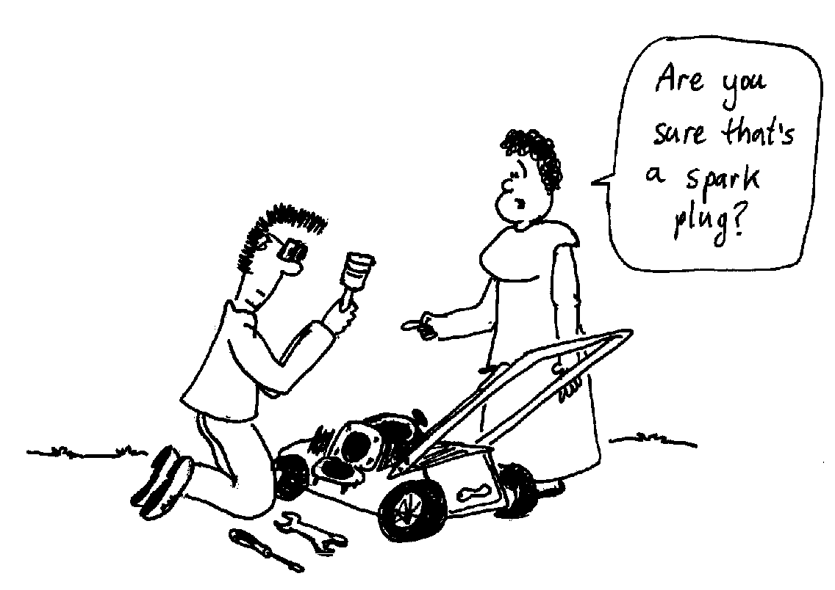

2. A fuel injector can inject 300 ml of fuel per minute into an engine cylinder. The injector is cylindrical, with a length of 5.0 mm and diameter 1.0 mm. The fuel has a viscosity of η= 1.2×10⁻³ Pa.s.
- Draw a diagram of this situation.
- What is the average velocity of the fuel in the injector?
- Why is the term average velocity rather than velocity used in part b?
- What is the pressure drop necessary to achieve this flow rate?

Workshop Tutorials for Technological and Applied Physics
Solutions to PR4T: Fluid Flow II

A. Qualitative Questions:

- Viscosity and density.
- Different grade motor oils are used in warm and cold countries because the viscosity of oil, and many other fluids, changes with temperature. The grade of a motor oil is a measure of its viscosity. In cold climates an oil with lower viscosity is used, as viscosity increases when oil cools. In hot climates a more viscous oil is used.
- Rowing would not be possible, just as walking would not be possible if there were no friction. You would have a very limited reaction force, and not get very far. Like rowing, flying would be impossible by flapping. Birds could glide (or use jet propulsion!).
- If air had zero viscosity you’d never reach terminal velocity. Skydiving would be very exciting until you reached the ground because parachutes wouldn’t work either. Hot air ballooning would be much the same at zero viscosity, as balloons move relatively slowly. However steering would be difficult. At very high viscosity you’d reach terminal velocity very quickly (and maybe even burn up like a meteorite) and ascending in a hot air balloon would be much slower.
- Skydiving would not change much if air had lower density, except that breathing would be difficult. Hot air ballooning would be difficult because buoyancy would be much reduced. If air was denser buoyancy would increase and balloons would ascend faster and be able to carry more weight. If it was dense enough you wouldn’t be able to skydive, you’d just hang in the air.

- Flow of a viscous fluid.
- The liquid is flowing from right to left.
- The areas of the left and right sections are the same, so by continuity the velocity in these two sections must be the same.
- As the liquid moves into the narrow section it speeds up (area × velocity = constant). If area decreases velocity increases. Since the liquid in the narrower section had higher velocity, it has lower pressure than the liquid in the wider section Hence the level in the middle is lower than the levels on the right or left.
- If the liquid were an ideal fluid, the pressure would be the same at the left and right point because the tube has the same size. The loss in pressure, as seen by comparing the left and right levels, is due to internal friction in the liquid, which mostly occurs when it rushes through the narrow section. This is a non-ideal fluid and so Bernoulli’s equation does not apply. Some energy (pressure) is lost as heat.

B. Activity Questions:

- Hot honey
The density of the honey changes very little when it is heated. However the viscosity changes a lot, the honey goes from flowing very slowly to very quickly as its viscosity decreases.

- Measuring flow rate
For real fluids which have a non-zero viscosity, flow rate increases with r⁴, so larger diameter needles give much greater flow rate. Flow rate decreases with increasing length.

- Rheological Materials
A fluid is a substance which will flow to take the shape of its container. Some fluids, sometimes called super cooled fluids, flow extremely slowly so it is very hard to tell that they are flowing at all. Glass is an example of a super cooled fluid. Newtonian fluids have constant viscosity with changing applied stress. Water and water-glycerine mixes are Newtonian fluids. Pseudo-plastics have a coefficient of viscosity, η, which falls with applied shear stress. A solution of starch will flow quickly, and then the flow rate will slow down. The force due to the fluid above drops as the fluid level drops. As the force drops, η rises, so the flow rate decreases. Dilatant fluids do the opposite, they have a viscosity which increases with increasing stress. A corn-flour water mix is a good example of a dilatant fluid. Other examples include printing inks and wet sand. The flow rate of a dilatant fluid increases with time as the shear forces drop. Toothpaste does not flow until a large enough stress is applied, then its viscosity drops suddenly. Hence it will sit on a brush without spreading out and dropping off, but can still be squeezed out of the tube easily.

C. Quantitative Questions:

1. Pulling a piston out.
  - To find the force we can use the definition of viscosity. If two plates are separated by a layer of fluid, then a force F is needed to move one plate relative to the other at a velocity v, and this force is given by
F = $\frac{η\text{Av}}{y}$ where η is the viscosity of the fluid, A is the area of the plates and y is the thickness of the fluid separating them. In this case we have a piston, which is separated from the cylinder by a thin fluid filled gap. The thickness of the gap is very much smaller than the diameter of the piston, so we can consider the surfaces of the cylinder and the piston as two plates. The area of the plates is A = 2πr×l where l is the length of the piston and r is the radius of the piston,
A = 2π×5 × 10² m × 8 × 10² m = 0.025 m².
We can now find the force:
F = $\frac{η\text{Av}}{y}$= $\frac{0\text{.}\text{01}\text{Pa}\text{.}s×0\text{.}\text{025}m^{2}×1\text{.}0m\text{.}s^{−1}}{0\text{.}1×{\text{10}}^{−3}m}$= 2.5 N.
  - As Brent pulls the piston out the area, A, decreases, so the force needed to maintain that velocity decreases also. Unless Brent decreases the force the piston is liable to accelerate rapidly as it comes out, and could fly out of his hand. This often happens when people pull something out of a tight fitting container or wrapping – they pull and then suddenly the item pops out unexpectedly. This also happens when babies are born, the mother is pushing as hard as she can even though the actual force required once the baby starts to emerge is much less.
  - If the space between the piston and cylinder was filled with water the force needed would be
F = $\frac{η\text{Av}}{y}$= $\frac{1\text{.}\text{05}×{\text{10}}^{−3}\text{Pa}\text{.}s×0\text{.}\text{025}m^{2}×1\text{.}0m\text{.}s^{−1}}{0\text{.}1×{\text{10}}^{−3}m}$= 0.26 N.
  - From a and c we can see that the force needed to move the piston using water as a lubricant is very much less than that required when using oil. The reason that oil is used instead is that it does not interact with the surface of the piston and cylinder causing them to rust, and damaging the seal. In addition, oil remains liquid under a much greater range of temperatures and pressures, while water would evaporate or freeze, damaging the engine.
5mm
1mm

2. A fuel injector can inject 300 ml of fuel per minute into an engine cylinder. The injector is cylindrical, with a length of 5.0 mm and diameter 1.0 mm. The fuel has a viscosity of η= 1.2×10⁻³ Pa.s.
- See diagram.
- The average flow rate is the area × the average velocity, Q = Av. The flow rate is 300 ml per minute, which is 300 × 10^{–6} m³ per minute = 5.0 × 10⁶ m³.s⁻¹.
The area of the flow is A = πr² = π × (0.5 × 10⁻³ m)² = 7.9 × 10⁻⁷ m².
So the average velocity is v = Q/A = 5.0 × 10⁶ m³.s⁻¹ / 7.9 × 10⁻⁷ m² = 6.4 m.s⁻¹.
- The fluid is viscous so the velocity is greatest at the centre of the injector and less towards the edges, hence we use the average velocity. The flow rate for the injector is the average velocity × the area.
- We can use Poisueille’s law, flow rate, Q, = $\frac{{πr}^{4}ΔP}{8ηl}$ ,to find the pressure drop, ΔP along a length l in a tube of radius r. We want ΔP so we rearrange to get:
ΔP= $\frac{8Qηl}{{πr}^{4}}$=$\frac{8×5\text{.}0×{\text{10}}^{−6}m^{3}s^{−1}×1\text{.}2×{\text{10}}^{−3}\text{Pa}\text{.}s×5×{\text{10}}^{−3}m}{π(0\text{.}5×{\text{10}}^{−3}m)^{4}}$= 1200 Pa = 1.2 kPa.

Workshop Tutorials for Biological and Environmental Physics
PR5B: Surface Tension

A. Qualitative Questions:

- Chromatography is used by chemists, physicists and biologists to separate components of a gas or liquid. For example, this is how DNA fingerprinting is done to determine parentage or in forensic medicine to determine who was the criminal.
A simple undergraduate biochemistry practical uses chromatography to do simple DNA finger printing. The DNA is extracted from the cells and put into a solution. The DNA in solution is then broken into fragments using an enzyme. Droplets of the solution containing the DNA fragments are put onto a piece of paper which is suspended in a beaker with the end just dipping into a solvent as shown.
solvent
DNA mixture
paper

- Explain how the fragments of the DNA are separated by the movement of the solvent.
- Why is paper used for this rather than plastic?

- Laplace’s law states that at equilibrium r(P_{i}-P_{o}) = 2γ.
- What does each of these symbols mean?
r
Pleura chest cavity
bronchiole
alveoli
The diagram shows the alveoli, the smallest branches of a bronchiole and the site of gas exchange in the lungs. The pressure inside the lungs is fairly constant and close to atmospheric pressure. The alveoli are lined with a surfactant, although many premature babies have an inadequate layer of surfactant which makes breathing very difficult for them.
The surfactant is made up of long molecules called lipoproteins. The lipoproteins lie almost side by side close together until you inhale, expanding the alveoli and puling them apart, and increasing the wall tension. When you exhale the lipoproteins slide back together and the wall tension decreases.
- Draw a simple diagram showing the lungs and chest cavity (pleural cavity). Label P_{i} and P_{o} on your diagram and on the diagram shown above.
When you inhale the alveoli expands, and the pleural pressure decreases.
- By what mechanism do you change P_{o} as you breathe?
- What must happen to the surface tension, γ, to allow inhalation to take place?
When you exhale, r decreases and P_{o} increases.
- What must happen to the surface tension now?

B. Activity Questions:

- Capillarity
Explain why water rises to different heights in different diameter capillary tubes.
Is this how water rises to the leaves in plants?
Water rises up between two glass plates but not between perspex plates. Explain why.

- Surface tension I- floating
Is it possible for a needle that is initially wet to float on water?
An extra-large needle will not float on water while a small one will. Explain why.
Matchsticks are made of wood, and float.
Would you expect an extra-large matchstick to float on water just as well as a small one?
Explain why or why not.

- Surface tension II- detergents
Fill a cup with water and sprinkle some pepper on top.
Add a drop of liquid soap. Explain what happens.

- Surface tension III – paintbrush
The bristles of a paintbrush look different when they are submerged in water to when they are out of the water but still wet. How are they different and why?

- Soap films
The wire loop has a piece of thread across it.
Dip the loop into the soap solution so that you get a soap film across the entire loop.
Now puncture the film on one side of the thread.
What happens to the thread and the remaining film? Explain your observations.
Experiment with forming bubbles in the different frames.
What do you notice about the surfaces of the bubbles?

C. Quantitative Questions:

- Water is transported up trees by the xylem, which are dead hollow tubes. The xylem are rigid tubes, with a typical diameter of around 20 μm, which also give a plant structural support. The inside of the xylem are effectively wetted by water so that the contact angle is zero. The surface tension of water is 0.073 N.m⁻¹ and it has a density of 1000 kg.m⁻³.
- What is the maximum height that capillary pressure can raise water through the xylem of a tree?
- How does this compare to the typical heights of trees?
- What other factors or mechanisms may be necessary to raise water from the ground to the leaves of a tree?

- At the end of exhalation the radius of an alveoli is 0.05 mm. The gauge pressure inside the alveoli is
–400 Pa, outside in the pleural cavity the pressure is –534Pa.
  - What is the wall tension in the alveoli?
  - How does this compare to a wall tension of 0.05 N.m⁻¹ without surfactant?

Workshop Tutorials for Biological and Environmental Physics
Solutions to PR5B: Surface Tension

A. Qualitative Questions:

- DNA fingerprinting using chromatography.
- The moving water carries the fragments of DNA along with it. There is an upward force due to the water and a downward force, mg, due to gravity. The force due to the water decreases with increasing height, while the gravitational force remains (approximately constant). Hence lighter fragments of DNA are carried further up the paper.
- Paper is used rather than plastic because paper is fibrous. The small gaps between the fibres act as capillary tubes, causing the water to rise. Other porous media such as a special gel coated plastic can also be used, but normal plastics are not porous and water will not rise on them.

2. Laplace’s law states that at equilibrium r(P_{i}-P_{o}) = 2γ.
- r is the radius of the bubble or drop, P_{i} is the internal pressure, P_{o} is the external pressure and γ is the surface tension, which is the force per unit length exerted by a surface.
Pleurachest cavity
r
P_{i}
P_{o}
- see diagrams.
lungs, P_{i}
chest cavity, P_{o}

- You change P_{o} by expanding your chest. This increases the volume so the pressure in the pleural cavity must decrease. When you relax it again the volume decreases, increasing the pressure inside.
- If r increases and at the same time P_{o} decreases while P_{i} remains approximately constant, then the left hand side has increased. To maintain equilibrium γ must also increase, otherwise the alveoli would increase in size and rupture.
- This is the opposite to d, r decreases as does the pressure difference, so γ must also decrease. If it didn’t, the lungs would collapse.
The surfactant is made up of long molecules called lipoproteins. The lipoproteins lie almost side by side close together until you inhale, expanding the alveoli and puling them apart, and increasing the wall tension. When you exhale the lipoproteins slide back together and the wall tension decreases.

B. Activity Questions:

  - Capillarity
Water molecules are attracted to glass more than to each other. When the glass tubes are dipped in water the adhesion between the glass and water causes a thin film of water to be drawn up over the glass (a). Surface tension causes this film to contract (b). The film on the inner surface continues to contract, raising water with it until the weight of the water is balanced by the adhesive force (c).
Capillary rise helps, but it does not allow great enough water rise for plants, they rely on pressure difference between the top of the water column (the leaves) and the bottom (the roots).
Water does not adhere to perspex, hence it will not rise between perspex plates, but it will rise between glass plates.
a
b
c

- Surface tension I- floating
When a needle floats on water the surface of water acts like a stretched skin (trampoline) and the needle sits on it. The skin lowers if the needle is heavier. If the needle is too heavy and the skin cannot support the weight of the needle, the skin ruptures. The skin can also rupture if it is pricked. So if the needle is light enough to be supported by the skin but the skin is pricked in the process of making it float the needle sinks. The needle should go on parallel to the water surface so that the pressure, P = F/A, is minimised by maximising the area A. If the needle is initially wet the water on the needle joins the water in the container and is equivalent to a pricked skin, so a wet needle will not float. The weight of an extra-large needle cannot be supported by the surface tension.
Wood floats in water due to buoyancy because it is less dense than water, so an extra-large matchstick will float. A needle can only float on water due to surface tension.

- Surface tension II- detergents
The motion of the pepper is due to the lowered surface tension with the detergent film. The detergent film is like a stretched membrane which is weak in the middle. When a hole forms it expands and the pepper is moved away from the centre with the retracting film.

- Surface tension III – paintbrush
When the paint brush is pulled out of the water the surface tension of the water on the bristles pulls them together. When it is in the water there is no force due to surface tension pulling the bristles together, and the buoyant force and small currents in the water fluff out the bristles.

- Soap films
When the film inside the loop of thread is punctured, the loop takes up a circular shape. This is the shape with the maximum inside surface area the thread can form. The surface area is the total area minus that in the thread, so this gives the minimum total surface area. Surface tension is a measure of energy per unit area to create a surface, the bigger the surface the more energy required. When given a chance, a surface (like anything else, including people) will go to its lowest energy state, which is the minimum possible surface area. Hence “free” bubbles are spherical, giving the minimum surface area for the volume of air.

C. Quantitative Questions:

- Xylem in trees.
- We want to find the maximum height that capillary pressure can raise water through the xylem of a tree. The force due to the surface tension is F = γL = γ2πr for a circular tube such as the xylem. The vertical component of this force is F_{v} = γ2πr cosφ = γ2πr if the contact angle is small.
The other force acting on the water is gravity, W = mg = ρVg = ρπr²hg. When the water reaches its maximum height the two forces are in equilibrium, and W = = ρπr²hg = γ2πr.
rearranging for the height h gives: h = $\frac{2γ}{ρgr}=\frac{2 × 0\text{.}\text{073}N\text{.}m^{−1}}{\text{1000} \text{kg}\text{.}m^{−3}× 9\text{.}8m\text{.}s^{−2}× \text{20} × {\text{10}}^{−6}m}$ = 0.74 m.
- Most trees are much taller than 0.74 m, many are well over ten times this height. So capillary rise can not account for the rise of water to the tops of trees, some other mechanism is necessary.
- Trees have pores in their leaves through which water evaporates, creating a lower pressure at the top of the xylem. This pressure difference also helps to draw water up the xylem.

- At the end of exhalation the radius of an alveoli is 0.05 mm. The gauge pressure inside the alveoli is – 400 Pa, outside in the pleural cavity it is –534Pa.
- We can use Laplace’s law : r(P_{i}-P_{o}) = 2γ, to find the wall tension, γ.
γ = : ½ r(P_{i}-P_{o}) = ½ × 0.05 × 10⁻³ m (-400 Pa - - 534 Pa) = 3.4 × 10⁻³ N.m^{–1} = 0.003 N.m⁻¹.
- A wall tension of 0.05 N.m⁻¹ without surfactant is more than 10 times greater than the wall tension with surfactant. It would be very hard to expand an alveoli with such a large tension, making breathing very very difficult.
Workshop Tutorials for Technological and Applied Physics
PR5T: Surface Tension

A. Qualitative Questions:

- The underground water table is very important in many places where bores are used to supply water, for example in many regional areas where there is no town water and unreliable rainfall. The depth of bores varies from place to place. Even over quite short distances the depth of the water table can vary substantially due to soil type, and a deeper bore is more expensive to dig, and requires a larger pump which uses more energy to run. Why is the water table higher in fine grained soils than in coarse grained soils?

- Most car wash bottles recommend waxing (with a wax of the same brand as the detergent of course) after you have washed your car and dried it thoroughly.
How does waxing a car help to keep it clean? Draw a diagram showing the contact angles of water droplets with and without wax to help explain your answer.

B. Activity Questions:

- Surface tension I- floating
Is it possible for a needle that is initially wet to float on water? An extra-large needle will not float on water while a small one will. Explain why this is the case.
Matchsticks are made of wood. Would you expect an extra-large matchstick to float on water just as well as a small one? Explain why or why not.

- Surface tension II- detergents
Fill a cup with water and sprinkle some pepper on top.
Add a drop of liquid soap. Explain what happens.

- Surface tension III – paintbrush.
The bristles of a paintbrush look different when they are submerged in water to when they are out of the water but still wet. Why?

- Capillarity
Explain why water rises to different heights in different diameter capillary tubes.
Water rises up between two glass plates but not between perspex plates. Explain why this is the case.
Hold the plates together at one end and use a paper clip or lump of blu-tack to hold them slightly apart at the other side. What happens when you put the bottom of the plates into the water? Describe and explain what you observe.

C. Quantitative Questions:

- A needle floats on water while a much larger piece of metal of exactly the same shape does not.
- Consider a simple geometric shape for the needle, say a cylindrical bar. Take the length to be 40 mm and diameter 0.25 mm. Calculate its weight (density of iron is 7.8 × 10³ kg.m⁻³).
- Assume it is on top of the water with an angle φ as shown. Calculate the total upward force. Can the weight of the needle be supported?
Surface tension of water = 7.28 × 10⁻² N.m⁻¹
(Remember the force associated with surface tension acts right around the line between the needle and water. However, the length of the needle is much greater than the diameter so one can use twice the length only.)
φ

- How does the angle depend on the weight?
- Will a needle 4m long and 5 cm thick be supported by the surface tension of water?
- If the same needle is repeatedly placed and removed from the surface of the water, it does not necessarily float in all the attempts? Explain why.

solvent
drops of solution
paper or
other medium

2. Chromatography is used by chemists, physicists and biologists to separate components of a gas or liquid. For example, this is how DNA fingerprinting is done to determine parentage or in forensic medicine to determine who the criminal was. This is also how complex solutions of chemicals can be separated into their components, a very valuable technique for identifying “secret ingredients”.
Droplets of the solution are put onto a piece of paper which is suspended in a beaker with the end just dipping into a solvent as shown.
- Explain how the different components in the solution are separated by the movement of the solvent.
- Why is paper used for this rather than plastic?
- You have invented a new fibrous medium for chromatography, which has close packed fibres, with only around 1μm diameter spaces between the fibres. Approximating the spaces between the fibres as cylindrical, how high will water rise in this medium?
Water has a surface tension of 0.073 N.m⁻¹ and a density of 1000 kg.m⁻³. Assume the medium is effectively wetted by water so that the contact angle is zero.
Workshop Tutorials for Technological and Applied Physics
Solutions to PR5T: Surface Tension

A. Qualitative Questions:

- The underground water table is very important in many places where bores are used to supply water, for example in many regional areas where there is no town water and unreliable rainfall. The water table is higher in fine grained soils than in coarse grained soils because the spaces between the soil particles are smaller. Smaller grained particles will pack together more closely leaving smaller gaps. The amount of capillary rise varies inversely with the length of the interface between the water and the solid. Hence with smaller gaps between particles there is greater capillary rise and the water will be closer to the surface.

- Most car wash bottles recommend waxing (with a wax of the same brand as the detergent) after you have washed your car and dried it. When you wax a car you decrease the “wetting” of the surface by water. The adhesive forces between the water molecules and the surface of the paint are decreased, while the cohesive forces between the water molecules remain the same.
φ
φ
no wax
with wax
small contact angle
large contact angle
This means that the contact angle between the surface and water droplets on the car becomes greater, and the droplets sit like little balls rather than spreading out. The droplets will run off easily, rather than sitting on the surface and evaporating there. Rainwater (and tap water) contains lots of impurities, such as dust, pollen and pollutants, which will remain on the surface of the paint after the water has evaporated. If the surface is effectively waxed the water will roll off taking the dirt with it.

B. Activity Questions:

- Surface tension I - floating
When a needle floats on water the surface of water acts like a stretched skin and the needle sits on it. If the needle is too heavy and the skin cannot support the weight of the needle, the skin ruptures. The skin can also rupture if it is pricked. So if the needle is light enough to be supported by the skin but the skin is pricked in the process of making it float the needle sinks. The needle should go on parallel to the water surface so that the pressure, P = F/A, is minimised by maximising the area A. If the needle is initially wet the water on the needle joins the water in the container and is equivalent to a pricked skin, wet needle will not float. The weight of an extra-large needle cannot be supported by the surface tension.
Wood floats in water due to buoyancy because it is less dense than water, so an extra-large matchstick will float. A needle can only float on water due to surface tension.

- Surface tension II- detergents
The motion of the pepper is due to the lowered surface tension with the detergent film. The detergent film is like a stretched membrane which is weak in the middle. When a hole forms it expands and the pepper is moved away from the centre with the retracting film.

- Surface tension III – paintbrush
When the paint brush is pulled out of the water the surface tension of the water on the bristles pulls them together. When it is in the water there is no force due to surface tension pulling the bristles together, and the buoyant force plus small currents in the water fluff out the bristles.
- Capillarity
Water molecules are attracted to glass more than to each other. When the tubes are dipped in water the adhesion between the glass and water causes a thin film of water to be drawn up over the glass (a). Surface tension causes this film to contract (b). The film on the inner surface continues to contract, raising water with it until the weight of the water is balanced by the adhesive force (c).
a
b
c

Water does not adhere to perspex, hence it will not rise between perspex plates, but water will rise between glass plates. If you hold a pair of plates together at one end and slightly apart at the other then the distance, r, between them increases as you move from the closed side to the open side. If you dip this into water it will rise between the plates to a height, h, proportional to 1/r, giving a neat hyperbola (1/r curve). | closed  end  open  end  r  h

C. Quantitative Questions:

- Floating needles.
- Weight of the needle = mg = ρVg = ρ × π × r² × l× g
= (7.8 ×  10³ kg.m⁻³  ) × π × (0.125 × 10⁻³m)² × (40 × 10³ m) ×  9.8 m.s⁻² = 1.5 ×  10⁻⁴ N
- The total upward force = vertical component of the force associated with surface tension
= force associated with surface tension × cos φ =2 × needle length ×  surface tension ×  cos φ
= 2 ×  (40 × 10⁻³ m) × ( 7.28 ×  10⁻² N.m⁻¹) ×  cos φ = 5.8 × 10⁻³ N cos φ
The total upward force must be large enough to balance the weight of the needle;
5.8 × 10⁻³ N cos φ = 1.5 ×  10⁻⁴ N
φ = 88 °, so yes the weight of the needle will be supported.
- As the weight increases φ decreases until the two vertical forces balance for φ =0. Any further increase in weight causes the needle to sink.
- This needle weighs 600 N and will not be supported by the surface tension of water.
- If the surface of water is ruptured or the needle is wet, it will not float.

- Separating solutions using chromatography.
- The moving solvent carries the different molecules along with it. There is an upward force due to the water and a downward force, mg, due to gravity. The upward force depends on the adhesive forces between the water and the paper, and the water and the different components in the solution. The stronger the adhesive forces between a component and the solvent, the higher that component will rise. There is also a downwards force acting – gravity. The molecules will rise until the upwards force and downwards force are equal. Hence lighter molecules are also carried further up the paper.
- Paper is used rather than plastic because paper is fibrous. The small gaps between the fibres act as capillary tubes, causing the water to rise. Other porous media such as a special gel coated plastic can also be used, but normal plastics are not porous and water will not rise on them.
- We want to find the maximum height that capillary pressure can raise water through the medium. The force due to the surface tension is F = γL = γ2πr for a cylindrical tube. The vertical component of this force is F_{v} = γ2πr cosφ = γ2πr if the contact angle is small, which we assume that it is.
The other force acting on the water is gravity, W = mg = ρVg = ρπr²hg. When the water reaches its maximum height the two forces are in equilibrium, and W = = ρπr²hg = γ2πr.
rearranging for the height h gives: h = $\frac{2γ}{ρ\text{gr}}=\frac{2×0\text{.}\text{073}N\text{.}m^{−1}}{\text{1000}\text{kg}\text{.}m^{−3}×9\text{.}8m\text{.}s^{−2}×0\text{.}5×{\text{10}}^{−6}m}$ = 30 m.
This should be more than enough!
Workshop Tutorials for Biological and Environmental Physics
PR6B: Solids I – Stress, Strain and Elasticity

A. Qualitative Questions:

- Many birds have hollow bones, and many large mammalian bones are also partly hollow because they contain marrow in the middle. The marrow is important because it produces red and white blood cells, but it does not play a major role in supporting the weight of the body.
- Explain in terms of stress and strain why hollow bones are very strong while still being light.
- Give another example of the use of hollow structures for strength and support.

  - Examine the stress-strain diagram below for compact bone and tendon.
strain
stress
bone
tendon

- Which is the closer to Hookean?
- What does the graph tell you about the behaviour of bone and tendon under stress?
- Which has the larger Young’s modulus? Explain your answer.

B. Activity Questions:

  - Rubber bands
Which rubber band has the largest spring constant? How could you estimate the elastic modulus of the rubber bands?
Cut a rubber band to form a strip, and hang a weight off it. What would happen if you cut the strip in half and hung a weight from it?
What if you joined two strips together in parallel?

  - Elasticity – bouncy balls
Rank the balls in order of bounciness.
- Explain why some balls bounce better than others.
- What characteristics of objects (materials) do you need to know to answer question a?
- A steel ball bounces extremely well off a steel/glass sheet but not off the carpet. Why?

  - Breaking chalk
Can you break the chalk by compressing or stretching it?
What about by bending or twisting it?
What is the easiest way to break it and why?

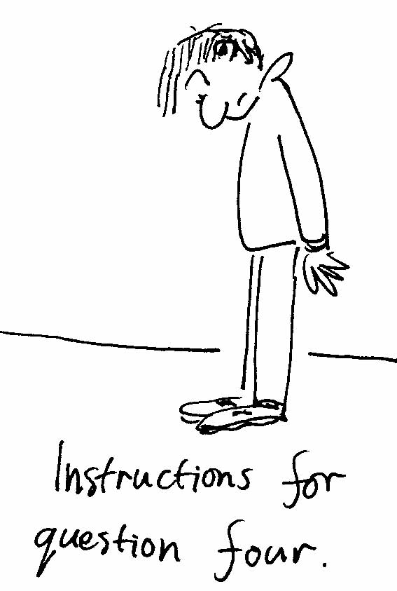
  - Shoes
Look at your shoes.
While standing still, what forces are acting on the soles of your shoes? What sort of deformation would you expect to occur?
When you are walking what forces are acting on the soles of your shoes?
What sort of deformation would you expect to occur?
Draw a diagram showing the forces and resulting deformations.

  - Rolling paper
Roll the papers to make columns of various heights and radii.
Which columns can support the weight of a heavy text book?
How do radius and length affect the strength of the column?
What happens when a column fails? What causes it to fail?

C. Quantitative Questions:

- A tibia (shin bone) is approximately 40cm long with an average cross sectional area of 3.0 cm². This tibia bone has a Young’s modulus of approximately 1.8×10¹⁰ Nm⁻², and an ultimate compression strength of 17 × 10⁷ N.m⁻².
- What is the total weight that the legs can support?
- If these were the legs of an 85 kg man, by how much would the tibias shorten when he gets out of bed in the morning and stands up?

- When you land from a fall or jump your muscles and bones have to absorb energy, and can be subject to large forces. The force required to fracture a bone is the ultimate strength of the bone times the area over which the force is applied.
- Find an expression for the compression that occurs at the breaking point in terms of the Young’s modulus of the bone.
- Find an expression for the energy stored in the compressed bone at the point of fracture.
(Hint: treat the bone as a compressed spring.)
A 75 kg man’s tibias have a Young’s modulus of approximately 1.8×10¹⁰ Nm⁻², and an ultimate compression strength of 17 × 10⁷ N.m⁻². They have a combined length of 90 cm and an average cross sectional area of 6.0 cm².
- From what maximum height can he fall and land straight legged on his feet without breaking his legs?
- Why should you bend your knees when landing from a fall or jump?
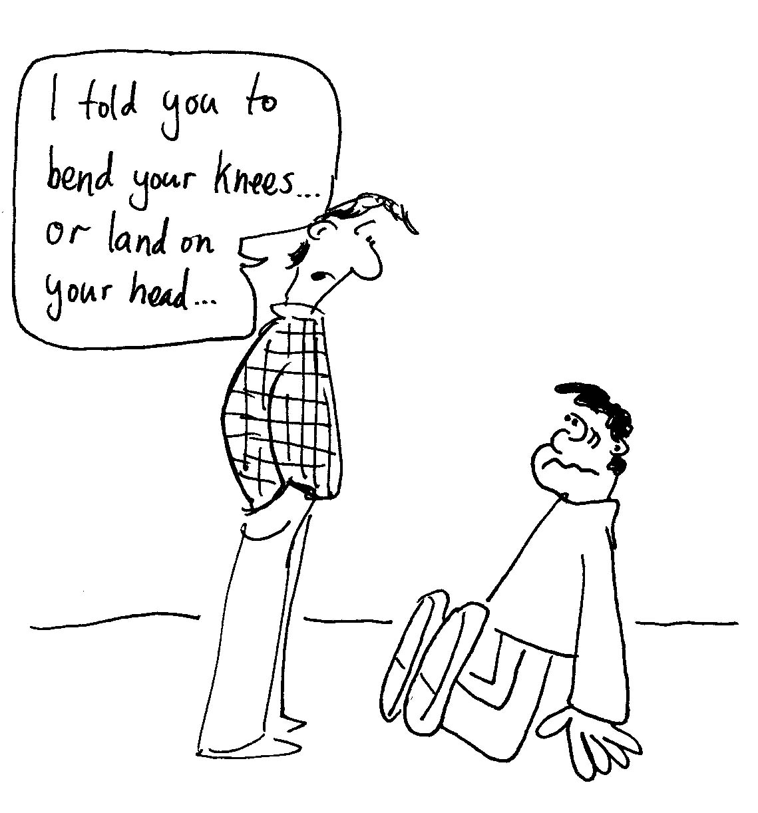
Workshop Tutorials for Biological and Environmental Physics
Solutions to PR6B: Solids I – Stress, Strain and Elasticity

A. Qualitative Questions:

1. Many birds have hollow bones, and many large mammalian bones are also partly hollow.
- When a cylinder is bent the areas that are under the most stress are along the outside of the structure. As the diagram shows, on one side the cylinder is being stretched and on the other it is being compressed. It is these regions which need to be strong, and removing the inside of the cylinder to leave a hollow tube has little effect on the strength of the cylinder. | stretched  compressed
Hence hollow bones are still strong, but are much lighter, making it easier for birds to fly, and leaving space for the marrow. In twisting it is again the outside of the cylinder which is under the greatest stress.
- Many plants also have hollow stems which provide support, for example bamboo and some kelps.
strain
stress
bone
tendon
2.
- The behaviour of the bone is closer to Hookean, as Hooke’s law predicts a linear response (strain) to an applied force (stress).
- Bones are more rigid than tendons, and do not stretch as much for a given force, tendons are “stretchier”, but will break at lower applied stress.
Using the relationship stress = Young’s modulus × strain, bone has the greater Young’s modulus as it has the steeper slope on the stress-strain graph.

B. Activity Questions:
  - Rubber bands
The rubber band that stretches the least for a given weight (applied force) has the greatest spring constant. If you had rubber bands of the same cross sectional area then the one that stretches the least also has the greatest elastic modulus. The area is the width times the thickness, so if the thickness is similar the area can be estimated from the width of the band. If you cut a strip of rubber in half it would stretch less for a given weight, so its spring constant will have decreased, but it will stretch by the same proportion. The modulus of elasticity depends on the material, and will not have changed. If you joined two rubber strips or bands together in parallel they would also stretch less, but again the modulus of elasticity has not changed. Effectively you will have doubled the spring constant by doubling the cross sectional area. Note that rubber bands only show linear behaviour for small applied strain, and are very nonlinear for large applied strains.

  - Elasticity – bouncy balls
- In energy terms, the more efficient the ball is at converting kinetic energy to potential energy and back to kinetic energy again, the better it will bounce as less energy is lost.
stress
strain
In terms of stress and strain, the more linear the relationship the less energy is lost. Most materials show hysteresis, and during the collision the stress-strain curve is different for the compressing phase and the expanding phase. The difference between the two curves (shaded region) gives the energy lost. The less difference between the curves, the less energy is lost and the more bouncy the ball is.
- To know how bouncy an object will be you need to know the stress strain relationship for the object, so you need to know about its Young’s modulus for compression and tension
- How high a ball bounces will also depend on the energy absorbing properties of the surface it bounces off, steel absorbs less energy than carpet when a ball bounces off it.
  - Breaking chalk
The chalk is much easier to break by twisting or bending, as it has a greater ultimate compression strength than either torsional or shearing strength. This is also the case for bones. Bending, twisting and stretching the chalk opens up micro-cracks in the material, allowing it to “come apart”, compression tends to close these cracks.
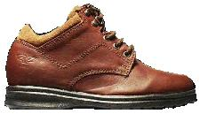
mg
N
standing
walking
  - Shoes
When standing you exert a compressive force on the soles of the shoes. Most materials are very strong to compressive forces. When walking the shoes are also subject to shearing forces, you apply a force at the upper surface of the sole, and the ground applies a force at the lower surface. The shoes are also subject to bending, which can cause cracks in the soles. It is these shearing and bending forces that wear shoes out.

  - Rolling paper
The paper rolls with smaller radius in which the paper forms multiple layers have thicker walls and are hence stronger. Shorter rolls are also stronger than taller ones as the torque will be less.
Thin walled structures tend to buckle, so there is a limit to the advantage to be gained by using hollow beams rather than solid beams. When a cylinder fails it is because the weight of the load and the cylinder itself is not precisely over the base of the cylinder, hence a torque is exerted on the cylinder. If the walls are strong enough, the internals forces in the material will balance the torque, otherwise it will buckle and collapse.

C. Quantitative Questions:

1. Weight supported by tibias.
a. The maximum weight the legs can support standing vertically is
17 × 10⁷ N.m⁻² × 3.0 cm² = 17×10⁷× 3.0×10⁻⁴ = 51k N or 5100 kg each. For two legs: 100,000 N.
b. We can use F/A = E Δl/l where F is the force applied, A is the cross sectional area of the bone, E is the Young’s modulus and l is the length of the bone. Rearranging this equation gives:
Δl = Fl/AE = 85 kg ×9.8 ms⁻² ×0.40 m / (2× 3.0×10⁻⁴m²) × 1.8×10¹⁰ Nm⁻² = 3.0×10⁻⁵m = 0.03 mm..

2. Energy absorbed on landing from a jump or fall.
- The force required to fracture the bone is F = S_{U} A where A is the area and S_{U} is the ultimate strength, which is S_{U} = Y $\frac{Δl}{l}$, so we can write the force as F = S_{U} A = Y $(\frac{Δl}{l})$A,
which we can rearrange for the compression, Δl = $\frac{S_{U}l}{Y}$.
- A compressed spring stores a potential energy of E = ½ kx². By analogy, a compressed bone will store E = ½ k(Δl)² where k is the spring constant for bone. The spring constant is the applied force divided by the resultant length change, k = F / Δl.
We have F = Y $(\frac{Δl}{l})$A from above, which we can rearrange to give F/ Δl = YA/l = k.
Putting this into our expression for the maximum energy stored gives E = ½ k(Δl)² = ½ $(\frac{\text{YA}}{l})$(Δl)².
- The maximum energy the man’s leg bones can store without breaking is E = ½ $(\frac{\text{YA}}{l})$(Δl)². The energy that must be absorbed when landing will be equal to the kinetic energy just before landing, which will be equal to the gravitational potential energy (mgh) of the man at the top of his fall (ignoring air resistance). If we take the case of him landing straight legged so that most of the energy is absorbed by the legs, then the maximum height will be: h = E / mg = [½ $(\frac{\text{YA}}{l})$(Δl)² ] / mg and using Δl = $\frac{S_{U}l}{Y}$:
h =[½ $(\frac{\text{Al}}{Y})$S_{U} ² ] / mg = [½ $(\frac{0\text{.}9m×6\text{.}0×{\text{10}}^{−4}m^{2}}{1\text{.}8×{\text{10}}^{\text{10}}N\text{.}m^{\text{-2}}})$(17 × 10⁷ N.m⁻²)² ] / 75 kg × 9.8 m.s⁻² = 0.58 m.
This is a very small fall indeed! (However we have not allowed for any energy being absorbed by the feet.)
- You should always bend your knees when landing from a fall or jump so as to lengthen the time over which the energy must be absorbed (decreasing the force), and to allow your muscles to help in absorbing some of the energy. Landing straight legged from even a small fall can result in serious injury.
Workshop Tutorials for Technological and Applied Physics
PR6T: Solids I – Stress, Strain and Elasticity

A. Qualitative Questions:
strain
stress
steel
aluminium
- The graph shows the stress-strain relationship for steel and aluminium.

- In which region does each of these materials obey Hooke’s law?
- Explain the main features of the stress- strain curves for the two metals.
- What does the graph tell you about the strength and ductility of the two metals?

2. Bending can be described as a combination of compression and tension.
- Draw a diagram showing why this is the case. Your diagram should show the direction of applied force and where stretching and compressing takes place.
I-beams are often used in constructing buildings. They have a strength almost as great as a solid beam, but weigh considerably less and use less steel so are usually cheaper. Hollow cylindrical beams may also be used when the force may come from any direction.
Cross sections of different beam types:
solid
I-beam
hollow cylindrical

- Use your diagram from a to explain why I-beams and hollow cylindrical beams are very strong while still being light.

B. Activity Questions:

- Rubber bands
Which rubber band has the largest spring constant? How could you estimate the elastic modulus of the rubber bands?
Cut a rubber band to form a strip, and hang a weight off it. What would happen if you cut the strip in half and hung a weight from it?
What if you joined two strips together in parallel?

- Breaking chalk
Can you break the chalk by compressing or stretching it?
What about by bending or twisting it?
What is the easiest way to break it and why?

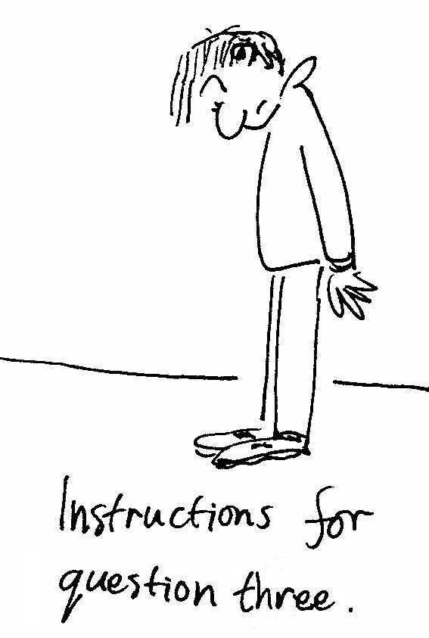
- Shoes
Look at your shoes.
While standing still, what forces are acting on the soles of your shoes? What sort of deformation would you expect to occur?
When you are walking what forces are acting on the soles of your shoes? What sort of deformation would you expect to occur?
Draw a diagram showing the forces and resulting deformations.

- Rolling paper
Roll the papers to make columns of various heights and radii.
Which columns can support the weight of a heavy text book?
How do radius and length affect the strength of the column?
What happens when a column fails? What causes it to fail?

- Elasticity – bouncy balls
Rank the balls in order of bounciness.
- Explain why some balls bounce better than others.
- What characteristics of objects (materials) do you need to know to answer question a?
- A steel ball bounces extremely well off a steel or glass sheet but not off the carpet. Why not?

C. Quantitative Questions:

- A 150 m long tunnel 2.2 m high and 5.8 m wide (with a flat roof) is to be constructed 60 m beneath the ground (see figure below). The tunnel roof is to be supported entirely by square steel columns, each with a cross-sectional area of 960 cm² (0.0960 m²). The density of the ground material is 2800 kg m⁻³. (Ultimate strength of steel = 400 × 10⁶ N.m⁻².)
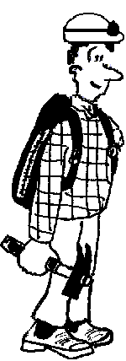

- What is the total weight that the columns must support?
- How many columns are needed to keep the compressive stress on each column at one-half of its ultimate strength?

2. Brent has rigged up a trailer for his bike so that he can carry shopping home from the supermarket without having to take the car. The trailer is attached by a hitch, the weakest link of which is a steel pin 1 mm in diameter. The maximum shearing stress of the steel is 1.0 × 10⁸ N.m⁻². The trailer has a mass of 40 kg and it is loaded up with 15 kg of groceries.
- Brent accelerates slowly, taking a minute to get from 0 to 20 km an hour. What shearing stress is the pin under while he is accelerating?
- Barry the dog unexpectedly runs out in front of him as he approaches his home. What minimum stopping distance does Brent need to avoid breaking the pin?
(Hint: You will need to use v² = v_{o}² + 2a(x-x_{o}). )
Workshop Tutorials for Technological and Applied Physics
Solutions to PR6T: Solids I – Stress, Strain and Elasticity

A. Qualitative Questions:
strain
stress
steel
aluminium
yield strength
linear (Hookean) region
S_{U}
(steel)
1. Stress-strain relationship for steel and aluminium.  - Both of these materials obey Hooke’s law in the linear regions (low stress). See diagram.  - The two metals have a linear region, in which they will return to their original length when the stress is removed. Beyond the yield strength (see diagram) permanent deformation occurs. If the stress exceeds the ultimate strength, S_{U}, the material will break or rupture.  - For a given stress the strain of the aluminium is greater, it will stretch more, hence it is more ductile. The steel has greater yield and ultimate strength, hence it is the stronger material. | S_{U}  (aluminium)
stretched
compressed
F
F
F

2. Bending is a combination of compression and tension.
- When a beam (in this case a cylinder) is bent the areas that are under the most stress are along the outside of the structure. As the diagram shows, on one side the beam is being stretched and on the other it is being compressed.
- It is these outside regions which need to be strong, and removing the inside of the cylinder to leave a hollow tube has little effect on the strength of the cylinder.
Hence hollow beams are still strong, but are much lighter, making them easier to work with and cheaper to manufacture. In twisting it is again the outside of the beam which is under the greatest stress.

B. Activity Questions:

  - Rubber bands
The rubber band that stretches the least for a given weight (applied force) has the greatest spring constant. If you had rubber bands of the same cross sectional area then the one that stretches the least also has the greatest elastic modulus.
If you cut a strip of rubber in half it would stretch less for a given weight, so its spring constant will have decreased, but it will stretch by the same proportion. The modulus of elasticity depends on the material, and will not have changed. If you joined two rubber strips or bands together in parallel they would also stretch less, but again the modulus of elasticity has not changed. Effectively you will have doubled the spring constant by doubling the cross sectional area. Note that rubber bands only show linear behaviour for small applied strain, and are very nonlinear for large applied strains.

  - Breaking chalk
The chalk is much easier to break by twisting or bending, as it has a greater ultimate compression strength than either torsional or shearing strength. This is also the case for bones. Bending, twisting and stretching the chalk opens up micro-cracks in the material, allowing it to “come apart”, compression tends to close these cracks.
  - Shoes
When standing you exert a compressive force on the soles of the shoes. Most materials are very strong to compressive forces. When walking the shoes are also subject to shearing forces, you apply a force at the upper surface of the sole, and the ground applies a force at the lower surface. The shoes are also subject to bending, which can crack the soles. It is these shearing and bending forces that wear shoes out.
mg
N
standing
walking

  - Rolling paper
The paper rolls with smaller radius in which the paper forms multiple layers have thicker walls and are hence stronger. Shorter rolls are also stronger than taller ones as the torque will be less.
Thin walled structures tend to buckle, so there is a limit to the advantage to be gained by using hollow beams rather than solid beams. When a cylinder fails it is because the weight of the load and the cylinder itself is not precisely over the base of the cylinder, hence a torque is exerted on the cylinder. If the walls are strong enough, the internal forces in the material will balance the torque, otherwise it will buckle and collapse.
stress
strain

  - Elasticity – bouncy balls
- In energy terms, the more efficient the ball is at converting kinetic energy to potential energy and back to kinetic, the better it will bounce as less energy is lost.
In terms of stress and strain, the more linear the relationship the less energy is lost. Most materials show hysteresis, and during the collision the stress-strain curve is different for the compressing phase and the expanding phase. The difference between the two curves (shaded region) is the energy lost. The smaller this is, the less energy lost and the bouncier the ball.
- To answer question a. you need to know the stress strain relationship for the object, so you need to know about its Young’s modulus for compression and tension
- How high a ball bounces will also depend on the energy absorbing properties of the surface it bounces off, steel absorbs less energy than carpet when a ball bounces off it.

C. Quantitative Questions:

- The total weight that the columns must support is:
mass × g = volume × ρ × g = 150 m × 5.8 m × 60 m × 2800 kg.m⁻³ × 9.8 m.s⁻² = 1.43 × 10⁹ N.
- To keep the compressive stress on each column at ½ of its ultimate strength, S_{U}, each column can bear a force: F_{column} = stress × area = 0.5 × S_{U} × area = 0.5 × 400 × 10⁶ N.m⁻² × 0.0960 m² = 1.92 × 10⁷ N.
The number of columns needed is: F_{total} / F_{column} = 1.43 × 10⁹ N / 1.92 × 10⁷ N per column = 75 columns.

2. The weakest link is a 1 mm diameter steel pin with maximum shearing stress of 1.0 × 10⁸ N.m⁻². The trailer has a total mass of 55 kg, Brent takes a minute to get from 0 to 20 km an hour.
- The cart is accelerated by being pulled via the pin. The cart’s initial velocity is 0 km.h⁻¹ = 0 m.s⁻¹, the final velocity is 20 km.h⁻¹ = 5.6 m.s⁻¹. The acceleration is a = dv/dt = 5.6 m.s⁻¹ / 60 s = 0.093 m.s⁻².
The force provided by the pin is therefore F = ma = 55 kg × 0.093 m.s⁻² = 5.1 N.
So the shearing stress on the pin is Stress = F/A = F / πr² = 5.1 N / π (0.5 × 10³m)² = 6.5 × 10⁶ N.m⁻².
- The maximum shearing force the pin can take is S_{U} A = 1.0 × 10⁸ N.m⁻² × π(0.5 × 10³m)² = 79 N.
The maximum possible acceleration is hence a = F/m = 79 N / 55 kg = 1.4 m.s⁻².
The starting velocity is v_{o} = 5.6 m.s⁻¹, and the final velocity will be v = 0 m.s⁻¹.
We want to find the stopping distance Δx = (x-x_{o}), so we use v² = v_{o}² + 2a(x-x_{o}). Rearranging for Δx :
Δx = v² / 2a = (5.6 m.s⁻¹)² / (2 × 1.4 m.s⁻²) = 11 m.
Workshop Tutorials for Physics
PR7: Solids II – Crystals and Bonding

A. Qualitative Questions:

- The three types of strong bonds that form between atoms are ionic, covalent and metallic bonds.
- In which regions of the periodic table are the elements that form ionic bonds? Why?
- Why do covalent solids not have long range interactions, but ionic solids do?
- Why is it that solids which have ionic bonds, like salt, tend to be brittle, but metals are usually quite plastic?
- Why are metals like copper such good conductors compared to ionic and covalent solids like salt and chalk?

  - Why is it that metals tend to be more dense than ionic or covalent solids? Explain your answer in terms of bond type and packing.

B. Activity Questions:

- Lenard - Jones potential
The graph shows a plot of potential as a function of inter-atomic distance.
- Where is the potential energy positive and where is it negative for this pair of atoms?
- Where is the force between them repulsive? Where is it attractive? How do you know?
- What is the equilibrium distance for this pair of atoms?
- Explain what the term binding energy means. How would you find the maximum binding energy for this pair of atoms?

- Crystal structures
Can you identify the basis cell for the crystal structures shown?
What is the coordination number for each lattice?

- Bend and Stretch
What sort of bond holds the atoms together in chalk?
Can you break the chalk by compressing or stretching it?
What about by bending or twisting it? What is the easiest way to break it and why?
Now try to break the piece of metal.
How do the metallic bonds affect its elastic properties?

C. Quantitative Question:

- The potential energy function for two ions, one with a charge of +e and the other with a charge of –e is given by
$V(r)=−\frac{{\text{Ae}}^{2}}{r}+\frac{B}{r^{9}}$.
potential energy
separation distance
which looks like this:

Find an expression for the equilibrium separation distance, r_{o}, for these two ions.

- A face centred cubic crystal has atoms arranged as shown.
Each face of the cubic unit cell has an atom at its middle,
and one at each corner.

Modelling the atoms as rigid spheres sitting up against their nearest neighbours, calculate the packing density in the face centred cubic structure.
Workshop Tutorials for Physics
Solutions to PR7: Solids II – Crystals and Bonding

A. Qualitative Questions:

1. The three types of strong bonds that form between atoms are ionic, covalent and metallic bonds.
- Elements that form ionic bonds are those which will easily lose or gain an electron. These are those to the far left and right of the periodic table (but not the last column). Those to the left have only one or two electrons in their outer shells, which can easily be removed, and those to the far right have an almost full outer shell and will easily accept an extra electron. (The last column has a full outer shell and will not readily form bonds at all.)
- In an ionic solid some atoms are negatively charged from gaining electrons while others are positively charged from donating electrons. Charges interact via an electric field, and the strength of interaction decreases with the square of the distance between them, hence all the atoms in an ionic solid interact with all the others (within a reasonable distance), giving long range Coulomb interactions. In a covalent solid the atoms share the electrons, so they are not charged, and there is no long range interaction.
- Metals from bonds by sharing many electrons with many atoms, hence the electrons are approximately free. The metallic bonds have neither charge nor direction restrictions, so the atoms can move relatively easily relative to each other, making metals very malleable. Ionic solids, such are salt, have charge restrictions on their bonds, so small movements tend to bring positive ions nearer to other positive ions, while moving them further away from negative ions, which can break down many bonds, making these solids brittle.
- Metals like copper have free electrons, which can move in response to an electric field, making them good conductors. Ionic and covalent solids have electrons localized, and bound so that they are not free to move about, hence they are poor conductors.

2. In ionic solids there are charge and directional restrictions because the atoms are charged, like charges repel, so nearest neighbours have to be oppositely charged. In covalent solids there are directional restrictions because the electron clouds which form the bonds between atoms are charged and repel, so that the angle between bonds is maximized. These restrictions limit how the atoms can be arranged, and prevent the atoms from being packed very closely together. In metals there are no direction or charge restrictions on the bonds, so that the atoms can be packed very closely together, making metals very dense compared to ionic and covalent solids.

B. Activity Questions:
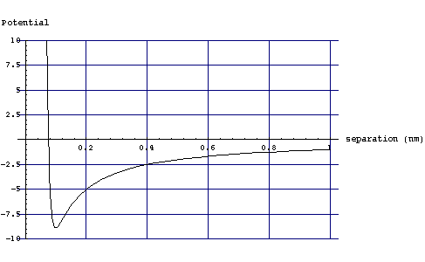
force in towards the other particle
force away from the other particle
b.
- Lenard - Jones potential
PE is +ve in this region
PE is -ve in this region
a.

- See diagram above right. The force is the negative of the gradient of the potential, F = -dP/dr, so where the slope is positive the force is negative, ie towards r = 0. If you look at the graph it’s easy to tell which way the force is because the particle will move down hill on the potential plot, in the direction of the force.
- The equilibrium distance for this pair of atoms is where the potential energy is a minimum, ~0.1 nm. See diagram.
- Binding energy is the difference in energy between being bound together and completely separated (infinitely far apart). It is the amount of energy you have to put into a system to unbind it. The maximum binding energy is at the point of minimum potential energy, where the equilibrium position is.

- Crystal structures
Some typical crystal structures are shown. The coordination number is the number of nearest neighbour atoms.
face centred cubic,
coordination number 12
body centred cubic,
coordination number 8
simple cubic,
coordination number 6

- Bend and Stretch
Chalk is held together by covalent bonds, so it is brittle. Chalk is strong to compression, but breaks easily when stretched, bent or twisted because the atoms cannot move easily relative to each other. Stretching, bending and twisting the chalk also opens up micro-cracks in the material, which compression tends to close.
The bonds in ionic solids have charge requirements, and those in covalent solids have directional requirements, making them both generally brittle.
The metal is much more plastic, it can be bent without breaking. This is because the metallic bonds have fewer restrictions than ionic or covalent bonds, they have neither charge nor direction requirements.

C. Quantitative Questions:

1. The potential energy function for two ions, one with a charge of +e and the other with a charge of –e is given by
$V(r)=−\frac{{\text{Ae}}^{2}}{r}+\frac{B}{r^{9}}$.
The equilibrium separation distance, r_{o}, is at the equilibrium position, ie where the force is zero on the ions. This happens when the potential energy is a minimum, as the force is the gradient of the potential energy. To find this point we take the derivative of the potential energy with respect to distance: $\text{dV}(r)/{\text{dr}}=\frac{d}{\text{dr}}(−\frac{{\text{Ae}}^{2}}{r}+\frac{B}{r^{9}})=$$\frac{{\text{Ae}}^{2}}{r^{2}}−\frac{9B}{r^{\text{10}}}$. The minimum value of the potential energy, where the force is equal to zero, occurs when dV/dr = 0, ie when:
$\frac{{\text{Ae}}^{2}}{r^{2}}−\frac{9B}{r^{\text{10}}}$= 0 or $\frac{{\text{Ae}}^{2}}{r^{2}}=\frac{9B}{r^{\text{10}}}$rearranging for r gives r= r_{o} = $(\frac{9B}{{\text{Ae}}^{2}})^{\frac{1}{8}}$.
r
a
a

2. A single side of a face centred cubic crystal has atoms arranged as shown if we model the atoms as rigid spheres sitting up against their nearest neighbours. The diagonal distance across the square is 4 atomic radii, r, and the length of the unit cell is a.
The volume of the unit cell is V_{cell} = a³.
Each unit cell encloses 4 complete atoms, hence the volume taken up by the spherical atoms is V_{atoms} = 4 × $\frac{4}{3}$πr³.

By trigonometry we can say that a² + a² = r². We can rearrange this for r = a/2√2 and write the volume taken up by the atoms as
V_{atoms} = 4×$\frac{4}{3}$π($\frac{a}{2\sqrt{2}}$ )³ =$\frac{\text{16}}{3}$π$\frac{1}{\text{16}\sqrt{2}}$a³ = $\frac{π}{3\sqrt{2}}$a³ = $\frac{π}{3\sqrt{2}}$V_{cell} = 0.74 V_{cell}.
Hence the packing fraction is 74%.

