Waves and Optics

Regular Waves and Optics Worksheets and Solutions

WR1B: | Simple Harmonic Motion | 3
WR1T: | Simple Harmonic Motion | 7
WR2B: | Waves | 11
WR2T: | Waves | 15
WR3B: | Interacting Waves | 19
WR3T: | Interacting Waves | 23
WR4B: | Sound | 27
WR4T: | Sound | 31
WR5: | Electromagnetic Waves | 35
WR6B: | Reflection and Refraction | 39
WR6T: | Reflection and Refraction | 43
WR7: | Mirrors | 47
WR8B: | Lenses | 51
WR8T: | Lenses | 55
WR9: | Optical Instruments | 59
WR10: | Physical Optics | 63

Workshop Tutorials for Biological and Environmental Physics
WR1B: Simple Harmonic Motion
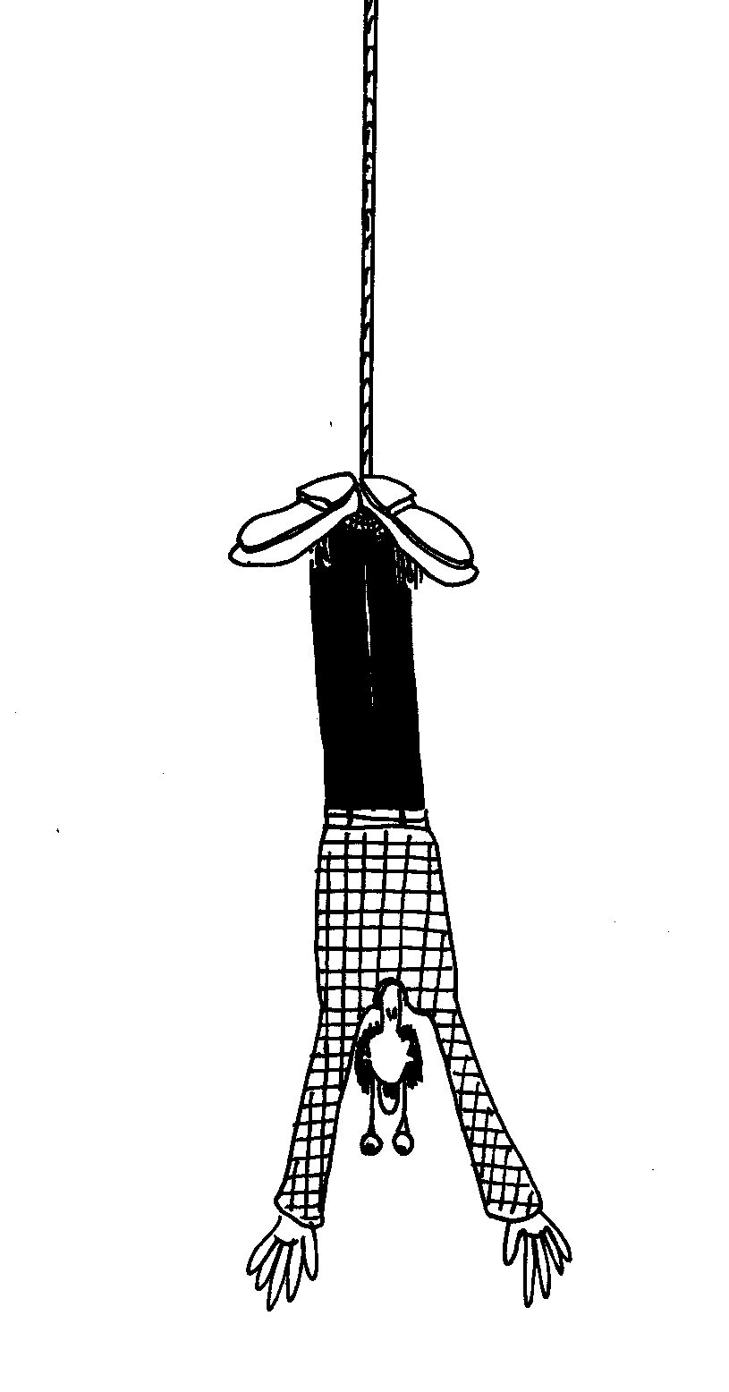
A. Qualitative Questions:

- Bungy jumping is an increasingly popular sport, with a growing clientele of “adrenalin junkies” and an increasing number of facilities around the world.
- Plot a graph with displacement on the vertical axis and time on the horizontal axis for a bungee jump. Zero displacement corresponds to your final equilibrium position.
- Mark on your graph the region which is approximately simple harmonic motion.
- Mark on your graph the period and positions of maximum speed, zero speed, maximum acceleration and zero acceleration.
- Do you momentarily stop at any position?
- Some people’s retinas become detached when they bungy jump. When is this most likely to happen?
- Is there a position where the net force on the bungy jumper is zero? If yes, does this contradict our earlier understanding that objects with zero net force are either stationary or travelling with uniform velocity?

- If you stand leaning against a desk and allow one leg to swing freely, you will find that it swings at a particular frequency. The natural frequency at which your legs swing determines your natural (comfortable) walking pace.
  - What factors do you think influence the natural frequency at which a persons leg swings, and hence their natural walking pace?
  - Do you think the frequency would be higher or lower for tall people?
  - Do you think the frequency would change with age? Why or why not?

B. Activity Questions:

- Oscillations of a spring-mass system
Two identical objects are attached to identical springs
If the mass of one of the objects is increased will there be any difference in the periods of the two systems? Explain your answer.
If one of the springs is replaced with one with a larger spring constant, how will this affect the period of oscillation?
If one spring is stretched more than the other, will the periods be the same?

2. Damped oscillations
Observe the oscillation of the spring when the attached object is immersed in water.
Draw displacement-time graphs for oscillations of the object in air and in water.
Investigate the damping of your knee joint by sitting on the edge of a bench and allowing it to swing freely.

3. Charting pendulum motion
Swing the pendulum so that it draws a line on the moving paper.
How would you describe the shape of the trace that it produces?
Write an equation to describe the trace drawn. Define all the symbols that you use.

4. Total energy of a spring-mass system
When mass m1 is hung from spring A and a smaller mass m2 is hung from spring B, the springs are stretched by the same distance.
Now if the systems are put into vertical simple harmonic motion with the same amplitude, which spring will have more energy? What energy transfers take place during the oscillations?
How will the periods of the two systems compare?

C. Quantitative Questions:

- Brent has caught a fish and in his excitement to show Rebecca he swings the line towards her to show her his great catch. The line hangs 1.2 m from Brents hand with the 500 g fish at the other end. It swings out 15 cm before swinging back towards him. The sideways displacement of the fish will closely approximate simple harmonic motion where and will vary according to x = Asin(ωt) ω is the angular frequency of the fish pendulum.
- What is the velocity of the fish at its lowest point?
- What is its acceleration at the ends of its path?
- At which point in its path should Rebecca grab the fish to stop it swinging so that she has to exert the least force?

- A car can be considered to be mounted on four identical springs as far as vertical oscillations are considered.
You will need to estimate some masses!
Four Sumo wrestlers get into their Hyundai Excel and it sinks on its suspension by about 8cm. They take off down the road and hit a speed bump which causes the car to oscillate.
- What is the frequency the car oscillates at?
- The Sumos head off for a drive in the country. Many unsealed country roads are corrugated (have regular bumps). How is it possible to drive such that the car oscillates with maximum amplitude?
- If the bumps are 3 m apart, what speed should they do to oscillate with maximum amplitude?
Vibrations from machinery and vehicles can cause various unpleasant and dangerous physiological effects.
- How can vibrations, such as those caused by driving on corrugated roads, be minimized?
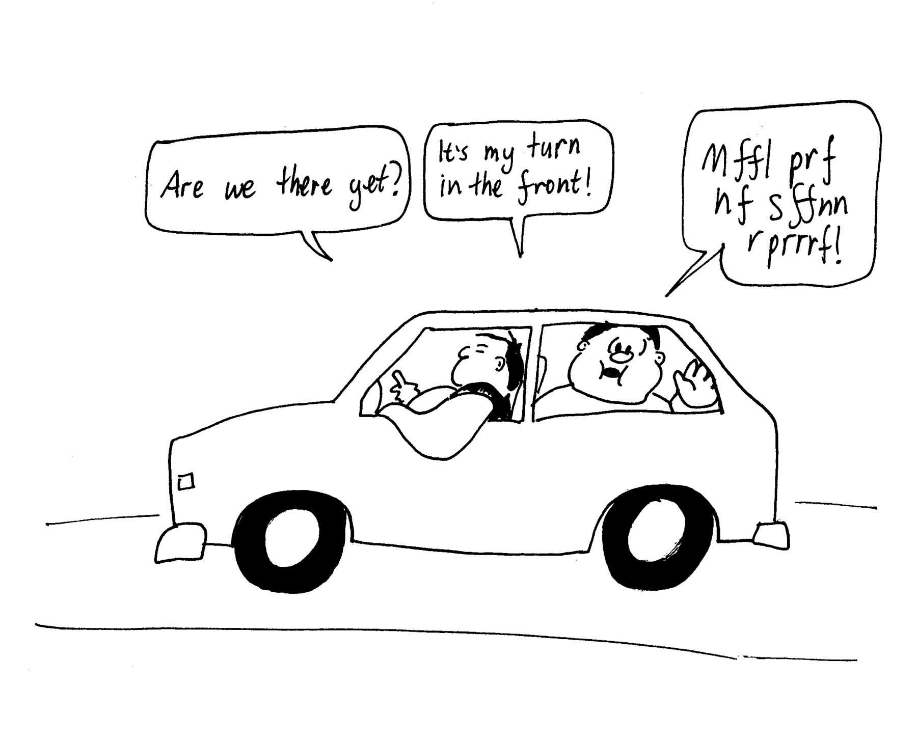

Workshop Tutorials for Biological and Environmental Physics
Solutions to WR1B: Simple Harmonic Motion

A. Qualitative Questions:
x
t
max a ↓
max v, zero a
max a ↑,
retinas detach here,
zero v.
approx. SHM
zero v, max a.
period,
T.
- Bungy jumping is an increasingly popular sport.
- See plot opposite.
- See opposite, the region which is approximately simple harmonic motion is after the initial jump when you oscillate up and down before being untied.
- See opposite. The speed is greatest as you pass through the equilibrium position, the acceleration is greatest as the maximum and minimum displacements.
- You momentarily stop at the top and bottom of each oscillation. At these points your acceleration is maximum, and hence the force you experience will be maximum at these points.
- When you jump you go head first, and the first minimum is where you are most likely to have your retinas detach, as this is where the acceleration and hence the force will be greatest.
- The net force is zero when the acceleration is zero, this happens as the person passes through the equilibrium position, at which point speed is neither increasing nor decreasing, i.e. for just a moment, dv/dt = 0, which means that the instantaneous acceleration and hence net force is zero, at this point.

- The natural frequency at which your legs swing determines your natural (comfortable) walking pace.
  - The leg behaves like a pendulum. The frequency at which a simple pendulum swings depends only on gravity and the length of the pendulum, using this model, or the leg as a rigid rod, the mass of the leg does not affect the period. However if we model the leg more realistically as a physical pendulum, then the frequency depends on the moment of inertia and on the mass.
  - Tall people are likely to have longer legs, and hence their legs will swing with a longer period as the period of a simple pendulum is T = 2π$\sqrt{Lg}$, so a longer length, L gives a longer period, and hence a lower frequency. This will still be true if we model the leg as a physical pendulum, where T = 2π$\sqrt{I\text{mgh}}$, where I is the moment of inertia of the leg, m is the leg mass and h is the distance from the pivot (the hip) to the center of mass of the leg. For a similar weight distribution, this gives a longer period for a longer leg (bigger h).
  - The frequency is not likely to change much with age, as the length is determined by the bones. For a simple pendulum model, the frequency will not change at all. Even for the more realistic model, I and m will tend to change proportionally, and hence there will be little change in the period. Damping due to reduction in the lubricating fluid around joint may occur, but this will effect the amplitude of the swings, not the period, the steps may get shorter, but the frequency is similar.

B. Activity Questions:

Oscillations of a spring-mass system
Two identical objects are attached to identical springs, hence they both have mass m attached to a spring with spring constant k, so the periods are the same and are equal to .
If one of the springs has a bigger mass attached to it, the period will be longer; if m₂ > m₁ then T₂ > T₁
Changing the spring constant also changes the period, if k₂ > k₁ then T₂ < T₁
For simple harmonic motion the period is independent of amplitude, i.e. extension does not affect the period of oscillation.
2. Damped oscillations
x
t
When the object is allowed to oscillate in air it takes a long time to stop, and the amplitude decreases very slowly. See top plot opposite. In water, the motion is strongly damped, and the oscillations decay and stop very quickly, as shown in the lower plot opposite.  Your knee joint is damped, as are all your joints. As you get older the damping usually increases as the joints are less lubricated. | x  t

Charting pendulum motion
The line drawn is sinusoidal, and can be described by the equation x = Acosωt, where A is the initial, and maximum, displacement, ω is the angular frequency of the motion and is equal to 2πf where f is the frequency of oscillation, t is the time, and x is the displacement at that time t.

Total energy of a spring
When mass m₁ is hung from spring A and a smaller mass m₂ is hung from spring B, the springs are stretched by the same distance. Using F = mg = kΔx, if Δx is the same for both springs, but the mass on A is greater, then the spring constant of A, k_{A,} must be greater than that for B, k_{B}.
The elastic potential energy is ½ kx². As both systems are at the same extension, x, but A has a greater k, spring A has more elastic potential energy than B.
When the springs are stretched then released and allowed to oscillate, the initial elastic potential energy is converted to kinetic energy and gravitational potential energy, but the total energy is conserved.
The period is , but Δx = mg/k was the same for both springs, therefore T will be the same.

C. Quantitative Questions:
- Brent has caught a fish and swings the line towards Rebecca to show her.
- We assume the motion of the fish can be represented by simple harmonic motion,
The period is T = 2π$\sqrt{Lg}$ = 2π$\sqrt{1\text{.}2 m9\text{.}8 m\text{.}s^{\text{-2}}}$= 2.2 s. So ω = 2π/T = 2 × π / 2.2 s = 2.8 s⁻¹.
The equation for simple harmonic motion is given by x = Asin(ωt).
The speed is given by v = ωA cos(ωt). At the lowest point the speed is a maximum (t = 0),
hence v = ωA = 2.8 s⁻¹ × 0.15 m = 0.42 m.s⁻¹.
- The acceleration is a = dv/dt = -ω²A sin(ωt). At the end of its path the acceleration is a maximum,
x = A and so sin(ωt) = 1. So a = -ω²A =( 2.8 s⁻¹)² × 0.15 m =1.0 m.s⁻².
- The best place to catch the fish is at the end of its swing where the velocity is zero. Here she has to exert no force to bring the fish to rest.

- Sumos have a mass around 200 kg (150 kg is considered minimum weight for a sumo), and a small car has a mass around 700 kg.
  - Force on car = 4 × 200 kg × 10 m.s⁻² = 8,000 N. k = F/x = 8,000N / 0.08m = 100,000 N.m⁻¹.
The car and Sumos oscillate, so use the mass of (car + 4 × sumo) to get the frequency:
f = (1/2π) √(k/m) = (1/2π) √(100,000 N.m⁻¹/1500 kg) = 1.3 Hz
  - They want to drive such that they hit the bumps with the natural frequency of the car, so they need to drive at a particular speed.
  - Natural frequency of car/Sumo system is ~ 1.3 Hz, so want to hit 1.3 bumps per second,
v = bumps per second/bumps per metre ~1.3 b.s⁻¹/0.33 b.m⁻¹ ~ 4 ms⁻¹ ~ 14 km.h⁻¹.
  - The vibrations can be minimized by driving at a speed such that the frequency of hitting the bumps does not match the resonant frequency of the car. Ideally, the car should have a well damped suspension system, this is the function of the shock absorbers.

Workshop Tutorials for Technological and Applied Physics
WR1T: Simple Harmonic Motion

A. Qualitative Questions:

- Imagine you have a spring and you cut it into two pieces, one a third the length of the original spring and one two thirds the length of the original.
- If you attach equal masses to each new spring, will the extension be the same for each spring? If not, will it be greater for the shorter or longer spring?
- What can you say about the spring constants of the two new springs?
- What is it that makes a spring a spring? Describe the function of a spring and how it responds to a force.

- You have several lengths of copper wire, from which you are making springs.
  - What would happen if you used thicker wire to make the spring?
  - What effect would winding the wire in wider coils have?
  - If you joined two identical springs in parallel, and two in series, what would be the relationship between the spring constants for these arrangements and that for a single spring?

B. Activity Questions:

Charting pendulum motion
Swing the pendulum so that it draws a line on the moving paper.
How would you describe the shape of the trace that it produces?
Write an equation to describe the trace drawn. Define all the symbols that you use.

Oscillations of a spring-mass system
Two identical objects are attached to identical springs
If the mass of one of the objects is increased will there be any difference in the periods of the two systems? Explain your answer.
If one of the springs is replaced with one with a larger spring constant, how will this affect the period of oscillation?
If one spring is stretched more than the other, will the periods be the same?

Damped oscillations
Observe the oscillation of the spring when the attached object is immersed in water.
Draw displacement-time graphs for oscillations of the object in air and in water.
Investigate the damping of your knee joint by sitting on the edge of a bench and allowing it to swing freely.

Total energy of a spring
When mass m1 is hung from spring A and a smaller mass m2 is hung from spring B, the springs are stretched by the same distance.
Now if the systems are put into vertical simple harmonic motion with the same amplitude, which spring will have more energy? What energy transfers take place during the oscillations?
How will the periods of the two systems compare?

C. Quantitative Questions:

- A car can be considered to be mounted on four identical springs as far as vertical oscillations are considered.
You will need to estimate some masses!
Four Sumo wrestlers get into their Hyundai Excel and it sinks on its suspension by about 8cm. They take off down the road and hit a speed bump which causes the car to oscillate.
- What is the frequency the car oscillates at?
- The Sumos head off for a drive in the country. Many unsealed country roads are corrugated (have regular bumps). How is it possible to drive such that the car oscillates with maximum amplitude?
- If the bumps are 3 m apart, what speed should they do to oscillate with maximum amplitude?
Vibrations from machinery and vehicles can cause various unpleasant and dangerous physiological effects.
- How can vibrations, such as those caused by driving on corrugated roads, be minimized?

2. The motion of a piston in a car engine is approximately simple harmonic motion.
- If the stroke (2x_{m}) is 0.1 m and the car is revving at 3500 rpm = 3500 revolutions.min⁻¹, what is the acceleration of the piston at the end point of its cycle?
- If the piston has a mass of 450g, what net force must be exerted on it at this point?
- What are the speed and kinetic energy of the piston at its midpoint?
- What average power is required to accelerate the piston from rest to its maximum speed?

Workshop Tutorials for Technological and Applied Physics
Solutions to WR1T: Simple Harmonic Motion

A. Qualitative Questions:

- Imagine you have a spring and you cut it into two pieces, one a third the length of the original spring and one two thirds the length of the original.
  - The more coils a spring has the easier it is to stretch it. The shorter spring, with only half as many coils, will not stretch as much as the longer spring when the same force is applied to it by hanging a mass on it.
  - The spring constant, k, is given by the extension, Δx, for a given applied force F:
F = -kΔx or k = F /Δx. For the same force the longer spring has a greater extension, therefore it has a smaller spring constant.
  - A spring is an object that can be compressed or stretched away from equilibrium length, and which exerts a restoring force in the opposite direction of the compressing or extending force. This force is proportional to change in length of the spring.

- You have several lengths of copper wire, from which you are making springs.
  - If you used thicker wire to make the spring it would take a greater force to stretch or compress the spring, hence the spring constant would be greater.
  - Winding the wire in wider coils would give a stretchier spring, with a smaller spring constant.
  - Two identical springs in parallel would have twice the spring constant of a single spring as it would take twice the force to get a given extension (or compression). Two springs in series would have half the k of a single spring.

B. Activity Questions:

Charting pendulum motion
The line drawn is sinusoidal, and can be described by the equation x = Acosωt, where A is the initial, and maximum, displacement, ω is the angular frequency of the motion and is equal to 2πf where f is the frequency of oscillation, t is the time, and x is the displacement at that time t.

Oscillations of a spring-mass system
Two identical objects are attached to identical springs, hence they both have mass m attached to a spring with spring constant k, so the periods are the same and are equal to .
If one of the springs has a bigger mass attached to it, the period will be longer; if m₂ > m₁ then T₂ > T₁
Changing the spring constant also changes the period, if k₂ > k₁ then T₂ < T₁
For simple harmonic motion the period is independent of amplitude, i.e. extension does not affect the period of oscillation.

Damped oscillations
x
t
When the object is allowed to oscillate in air it takes a long time to stop, and the amplitude decreases very slowly. See top plot opposite. In water, the motion is strongly damped, and the oscillations decay and stop very quickly, as shown in the lower plot opposite.  Your knee joint is damped, as are all your joints. As you get older the damping usually increases as the joints are less lubricated. | x  t

Total energy of a spring
When mass m₁ is hung from spring A and a smaller mass m₂ is hung from spring B, the springs are stretched by the same distance. Using F = mg = kΔx, if Δx is the same for both springs, but the mass on A is greater, then the spring constant of A, k_{A,} must be greater than that for B, k_{B}.
The elastic potential energy is ½ kx². As both systems are at the same extension, x, but A has a greater k, spring A has more elastic potential energy than B.
When the springs are stretched then released and allowed to oscillate, the initial elastic potential energy is converted to kinetic energy and gravitational potential energy, but the total energy is conserved.
The period is equal to , but we know that Δx = mg/k was the same for both springs, therefore T will be the same.

C. Quantitative Questions:

- Sumos have a mass around 200 kg (150 kg is considered minimum weight for a sumo), and a small car has a mass around 700 kg.
a. Force on car = 4 × 200 kg × 10 m.s⁻² = 8,000 N.
k = F/x = 8,000N / 0.08m = 100,000 N.m⁻¹.
The car and Sumos oscillate, so use the mass of (car + 4 × sumo) to get the frequency:
f = (1/2π) √(k/m) = (1/2π) √(100,000 N.m⁻¹/1500 kg) = 1.3 Hz
- They want to drive such that they hit the bumps with the natural frequency of the car, so they need to drive at a particular speed.
- Natural frequency of car/Sumo system is ~ 1.3 Hz, so want to hit 1.3 bumps per second,
v = bumps per second/bumps per metre ~1.3 b.s⁻¹/0.33 b.m⁻¹ ~ 4 ms⁻¹ ~ 14 km.h⁻¹.
Vibrations from machinery and vehicles can cause various unpleasant and dangerous physiological effects.
- The vibrations can be minimized by driving at a speed such that the frequency of hitting the bumps does not match the resonant frequency of the car. Ideally, the car should have a well damped suspension system, this is the function of the shock absorbers.

2. The motion of a piston in a car engine is approximately simple harmonic motion.
    - The stroke (2x_{m}) is 0.1 m and the car is revving at 3500 rpm = 3500 revolutions.min⁻¹ = 58 Hz.
ω = 2πf = 2 × π × 58 s⁻¹ = 370 rads⁻¹so now we can find the maximum acceleration:
a_{max}= ω²x_{max} = (370 rads⁻¹)² × 0.05 m = 6700 ms⁻²
    - We can use Newton’s second law to find the force: F = ma = 0.45 kg × 6700 ms⁻² = 3000 N.
    - The maximum velocity is v_{max}= ωx_{max} = 370 rads⁻¹× 0.05 m = 18 ms⁻¹,
giving a kinetic energy of KE = ½mv² = ½ × 0.45 kg × (18 ms⁻¹)² = 76 J
d. It takes ¼ T for the piston to move from rest at the end of the cylinder to the center where its velocity is maximum, so t = ¼ (1/f) = 0.0043 s, and the power is P = KE/t = 76 J / 0.0043 s = 18 kW.
Workshop Tutorials for Biological and Environmental Physics
WR2B: Waves

A. Qualitative Questions:

1. Sound is a longitudinal wave. The diagram below shows air particles, A to M, in their equilibrium positions in the top line. The lower line shows the particles as a sound wave moves through the air.
J
A
A
B
B
C
C
D
D
E
E
F
F
G
G
H
H
I
I
J
K
K
L
L
M
M

- In the lower line, identify two particles which are in phase.
- Where is the displacement a maximum?
- Where is the pressure a maximum? Where is the pressure a minimum?

2. Many animals, such as scorpions and ant lions, use the movement of waves through the ground to find their prey. An animal along on the ground produces both a transverse travelling wave and a longitudinal travelling wave. The longitudinal waves travel faster than the transverse waves, and a scorpion can tell where an insect is by detecting the difference in arrival time for the two waves.
- What is the difference between a transverse wave and a longitudinal wave? Use diagrams to explain your answer.
- For transverse waves transmitted through the ground, is the wave speed the same as the maximum speed of any part of the ground?
- What about for longitudinal waves?
- Why do longitudinal waves travel faster in the ground than transverse waves?
- How would you check if this were true of other media?

B. Activity Questions:

Transverse waves
Examine the wave machine, and send a wave from the bottom to the top.
This is a torsional or “twisting wave”. Explain why this is called a transverse wave.
How is it different to the transverses waves you are familiar with?

Longitudinal Waves
Send a wave along the length of the slinky.
Does the amplitude of the wave affect the speed at which it moves?
How can you change the wave speed?

Waves in rubber tubes
One tube is filled with water and the other with air.
Can you tell which is which by observing waves on these tubes?

Ripple tank I – making waves
Experiment with the different oscillators. What sort of shaped waves can you produce?
Using one oscillator and the stroboscope, try to measure the wavelength of the waves.
How does the wavelength change when you change the frequency of the oscillations?
Do you think the wave speed changes when you change the frequency?

C. Quantitative Questions:

1. Earthquakes generate sound waves in the earth, which can be detected by some animals, such as elephants. Unlike in air, in the ground there are both transverse (S) and longitudinal (P) sound waves. The figure below shows the seismogram for a magnitude 3.8 earthquake recorded in Bickley, Western Australia for an earthquake at Minilya, nearly 800 km away.
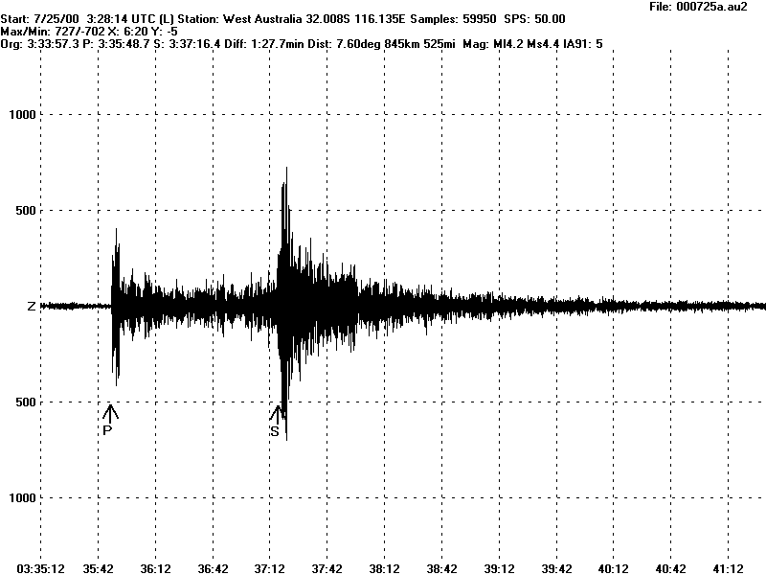

Typically the speed of S waves is about 4.5 km.s⁻¹ and that of P waves 8.0 km.s⁻¹. A seismograph records P and S waves from an earthquake. The first P waves arrive 3.0 minutes before the first S waves.
Assuming the waves traveled in a straight line, how far away did the earthquake occur?

2. Brent and Rebecca are trying to teach Barry the dog to jump over a rope. They each hold one end of the rope, keeping it stretched out taut. Brent suddenly jiggles the rope at his end sending a wave traveling along it towards Rebecca with a wavelength of 10 cm, a frequency of 400 Hz, and an amplitude of 2.0 cm.
- Write an equation describing this wave.
- What is the velocity of the wave?
When the wave reaches Rebecca it is reflected back along the rope towards Brent, without loss of amplitude.
- Write the equation for this reflected wave.

Workshop Tutorials for Biological and Environmental Physics
Solutions to WR2B: Waves

A. Qualitative Questions:

- The diagram shows air particles in their equilibrium positions in the top line. The lower line shows the particles as a sound wave moves through the air.
J
A
A
B
B
C
C
D
D
E
E
F
F
G
G
H
H
I
I
J
K
K
L
L
M
M

- The pairs C and I, B and H are in phase, each pair has the same displacement over the time interval.
- The displacement is a maximum for particles C and I.
- The pressure is a maximum where the displacement is a minimum, this is around particles D and J. The pressure is a minimum where the displacement is a maximum, which is around particles B, C and H, J. You can tell visually where pressure is greatest or least by looking at the density of the particles.

- An animal moving along on the ground produces both a transverse travelling wave and a longitudinal travelling wave.
- In a transverse wave (below, left) the displacement of the medium is perpendicular to the direction the waves are traveling in. In longitudinal waves (below, right), the displacement of the medium is in the same direction as the waves are traveling. The dotted lines show the equilibrium positions.
v
x
x
v

- The wave speed is not the same as the maximum speed of any particle, often it is much greater. The wave speed depends on the properties of the medium, the particle speed depends on the wave frequency and amplitude.
- The same is true for longitudinal waves.
- Wave speed is proportional to the elastic property over the inertial property. The inertial property (mass, density), has to be the same for both longitudinal and transverse waves in the ground – they’re both traveling through the same medium. However the elastic property (tension), is greater for longitudinal waves – the particles can move up and down more easily than side to side, which requires compression. (Ground has a lower shear modulus than compression.)
- To check if the longitudinal wave speed was greater than the transverse wave speed in other media you would need to look up and compare the values of elastic and shear modulus for the given medium.
twist
B. Activity Questions:

Transverse waves
The torsional wave is a transverse wave because the direction of displacement of the particles (the rods) is perpendicular to the direction of travel of the wave. It is different to more familiar transverse waves, such as waves on a vibrating string, in that the displacement is due to twisting, and the amplitude would be described by an angle rather than a linear displacement.

Longitudinal Waves
The amplitude of the wave does not affect the speed of the wave. The speed is determined by the medium it travels through, in particular it depends on the elastic and inertial properties of the medium, i.e. the tension and mass. You can change the wave speed on the slinky by stretching it more, and increasing the tension.

Waves in rubber tubes
The tube filled with water is much heavier, and hence the waves travel more slowly along it as velocity decreases with increasing mass per unit length.
λ
λ

Ripple tank I – making waves
You should be able to produce circular wave fronts using the point oscillator, and plane waves using the long rod oscillator. Changing the frequency changes the wavelength, λ, of the waves produced, but does not affect the speed. The speed depends only on the medium, which is not changing.

C. Quantitative Questions:

1. Earthquakes generate both transverse (S) and longitudinal (P) sound waves in the Earth.
Typically the speed of S waves is about 4.5 km.s⁻¹ and that of P waves 8.0 km.s⁻¹. A seismograph records P and S waves from an earthquake. The first P waves arrive 3.0 minutes before the first S waves.
v_{s} = speed of S wave = 4.5 km.s⁻¹ and v_{p} = speed of P wave = 8.0 km.s⁻¹,
Δt = time difference between arrival of waves = 3 mins = 180 s.
If the velocities are constant then t = x/v where x is the distance from the earthquake to the seismograph. The time difference is
Δt = t_{s} – t_{p} = $\frac{x}{v_{s}}−\frac{x}{v_{p}}$ = $\frac{x\left(v_{p}−v_{s}\right)}{v_{p}v_{s}}$so now we can write
x = $\frac{Δt\left(v_{p}v_{s}\right)}{v_{p}−v_{s}}$ = (180 s× 4.5 km.s⁻¹ × 8.0 km.s⁻¹ ) / (8.0 km.s⁻¹ – 4.5 km.s⁻¹) = 1.9 × 10³ km.

2. Brent suddenly jiggles the rope at his end sending a wave traveling along it towards Rebecca with a wavelength of 10 cm = 0.10 m, a frequency of 400 Hz, and an amplitude of 2.0 cm = 0.02 m.
- A traveling wave can be described by the equation y = A sin(kx-ωt) .
In this case, the amplitude of the wave is A = 0.02 m, k = 2π/λ = 2π / 0.10 m = 63 m⁻¹ and the frequency is ω = 2πf = 2π× 400 Hz = 2500 Hz.
So we can write y = 0.02 m sin (63 m ^{–1} × x - 2500 Hz × t).
- The velocity of the wave is v = f × λ = 400 Hz × 0.10 m = 400 s⁻¹ × 0.10 m = 40 m.s⁻¹.
When the wave reaches Rebecca it is reflected back along the rope towards Brent, without loss of amplitude.
- The equation for this reflected wave is y = 0.02 m sin (0.63 cm ^{–1} × x + 2500 Hz × t).
The + sign means that it is traveling in the –ve x direction, back towards Brent.

Workshop Tutorials for Technological and Applied Physics
WR2T: Waves

A. Qualitative Questions:

1. Sound is a longitudinal wave. The diagram below shows air particles, A to M, in their equilibrium positions in the top line. The lower line shows the particles as a sound wave moves through the air.
J
A
A
B
B
C
C
D
D
E
E
F
F
G
G
H
H
I
I
J
K
K
L
L
M
M

- In the lower line, identify two particles which are in phase.
- Where is the displacement a maximum?
- Where is the pressure a maximum? Where is the pressure a minimum?

2. Dynamite is used in road building to break up rocky areas, so that a road can be built fairly flat even in steep areas, for example the Princes highway north of Sydney. A blast sends waves traveling through the ground for kilometers. A travelling wave caused by such a blast is described by the equation:
y =A sin (kx - ω t +φ)
a. Define and give the units for each symbol in the above equation.
b. Is this a transverse or longitudinal wave? How can you tell?
Two otherwise identical waves from a pair of blasts are out of phase by 120º. Draw graphs of these waves on the same axes at:
c. a moment in time and
d. a point in space.

B. Activity Questions:

Transverse waves
Examine the wave machine, and send a wave from the bottom to the top.
This is a torsional or “twisting wave”. Explain why this is called a transverse wave.
How is it different to the transverse waves you are familiar with?

Longitudinal Waves
Send a wave along the length of the slinky.
Does the amplitude of the wave affect the speed at which it moves?
How can you change the wave speed?

Waves in rubber tubes
One tube is filled with water and the other with air.
Can you tell which is which by observing waves on these tubes?

Ripple tank I – making waves
Experiment with the different oscillators. What sort of shaped waves can you produce?
Using one oscillator and the stroboscope, try to measure the wavelength of the waves.
How does the wavelength change when you change the frequency of the oscillations?
Do you think the wave speed changes when you change the frequency?

C. Quantitative Questions:

- The Darling Harbour area, including the convention center and surrounding areas is built on reclaimed land. Large piles were needed to help form the foundations for the area, as the land is not stable. These piles reach down to the bedrock many metres below the surface. To test the integrity of the piles a wave pulse is sent from the top of the pile down, it reflects from the bedrock at the bottom, and is observed when it reaches the top again.
  - Is the wave speed the same as the maximum speed of any particles of the pile? (Does it matter whether this is a longitudinal or transverse wave?)
  - The top of the pile is 35 m above the bedrock, and it takes 14 ms for the reflected wave to be detected after the initial transmitted wave is produced. What is the speed of the wave in the pile?
  - When the next pile along is tested, the reflected wave is detected only 6.2 ms after the initial transmitted wave is sent. What does this tell you about the pile, and where is the potential problem?

- Brent and Rebecca are trying to teach Barry the dog to jump over a rope. They each hold one end of the rope, keeping it stretched out taut. Brent suddenly jiggles the rope at his end sending a wave traveling along it towards Rebecca with a wavelength of 10 cm, a frequency of 400 Hz, and an amplitude of 2.0 cm.
- Write an equation describing this wave.
- What is the velocity of the wave?
When the wave reaches Rebecca it is reflected back along the rope towards Brent, without loss of amplitude.
- Write the equation for this reflected wave.

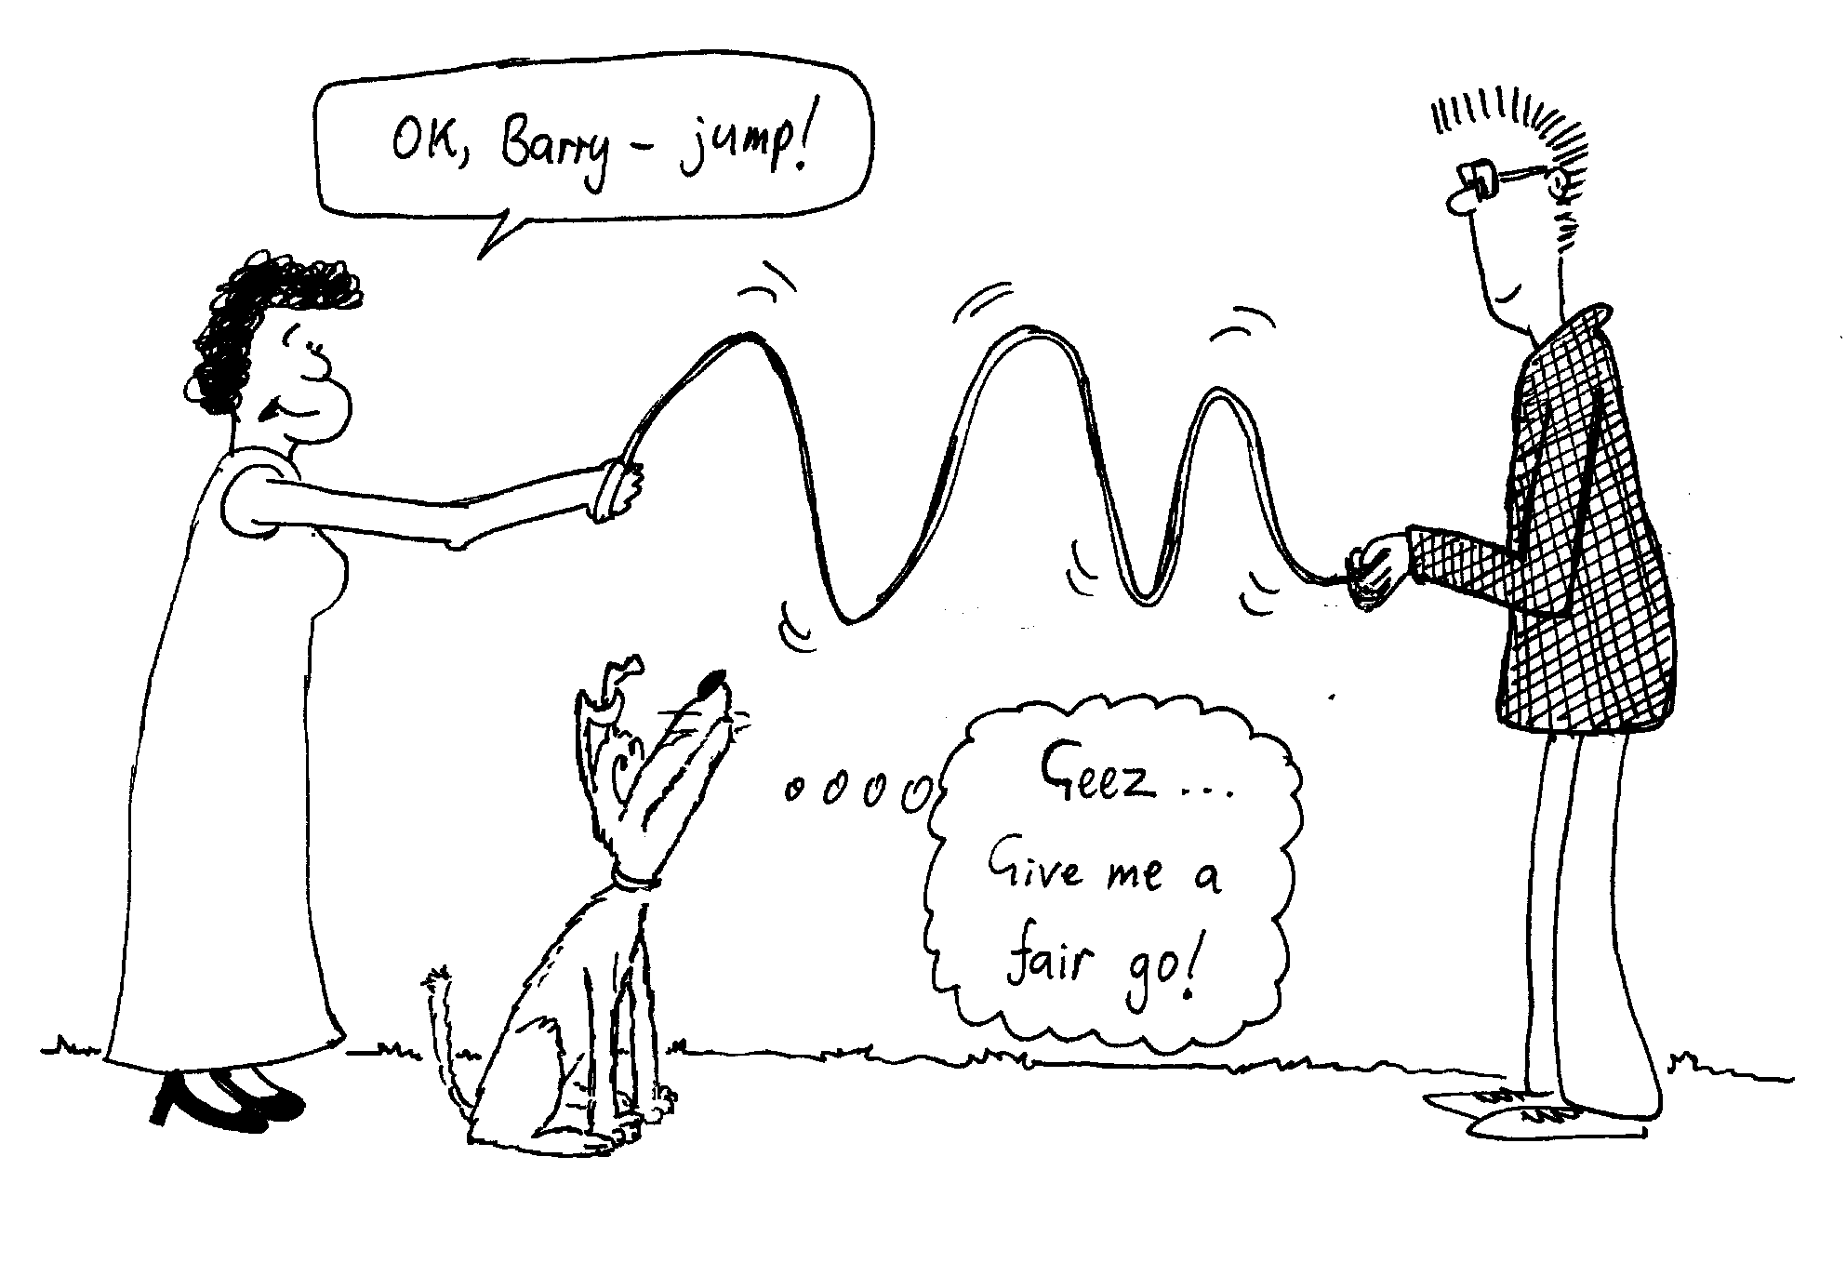
Workshop Tutorials for Technological and Applied Physics
Solutions to WR2T: Waves

A. Qualitative Questions:

- The diagram shows air particles in their equilibrium positions in the top line. The lower line shows the particles as a sound wave moves through the air.
J
A
A
B
B
C
C
D
D
E
E
F
F
G
G
H
H
I
I
J
K
K
L
L
M
M

- The pairs C and I, B and H are in phase, each pair has the same displacement over the time interval.
- The displacement is a maximum for particles C and I.
- The pressure is a maximum where the displacement is a minimum, this is around particles D and J. The pressure is a minimum where the displacement is a maximum, which is around particles B, C and H, J. You can tell visually where pressure is greatest or least by looking at the density of the particles.

2. A blast sends waves traveling through the ground for kilometers. A travelling wave caused by such a blast is described by the equation: y =A sin (kx - ω t +φ)
c. moment in time
d. point in space.
y
y
x
t
- y- the displacement in the y direction of a particle at time t and position x. units: m.
A- maximum displacement in y direction. units: m.
k – angular wave number, = 2π/λ, units: rad.m⁻¹
x- position in the x direction. units: m.
ω - angular frequency, = 2π/period, units: rad.s⁻¹
t - time, units: s
φ - phase angle, tells you that the wave did not start at zero amplitude at t and x = 0. units: rad.
b. Assuming the usual convention of x perpendicular to y, this is a transverse wave, the displacement is perpendicular to the direction of travel.
c, d. see plots opposite. For a moment in time, t is constant, so we plot against x, like a photo. For a point in space we plot against time, t, for a given set point, x.

twist

B. Activity Questions:

Transverse waves
The torsional wave is a transverse wave because the direction of displacement of the particles (the rods) is perpendicular to the direction of travel of the wave. It is different to more familiar transverse waves, such as waves on a vibrating string, in that the displacement is due to twisting, and the amplitude would be described by an angle rather than a linear displacement.

Longitudinal Waves
The amplitude of the wave does not affect the speed of the wave. The speed is determined by the medium it travels through, in particular it depends on the elastic and inertial properties of the medium, i.e. the tension and mass. You can change the wave speed on the slinky by stretching it more, and increasing the tension.

Waves in rubber tubes
The tube filled with water is much heavier, and hence the waves travel more slowly along it as velocity decreases with increasing mass per unit length.
λ
λ

Ripple tank I – making waves
You should be able to produce circular wave fronts using the point oscillator, and plane waves using the long rod oscillator. Changing the frequency changes the wavelength, λ, of the waves produced, but does not affect the speed. The speed depends only on the medium, which is not changing.

C. Quantitative Questions:

- The Darling Harbour area, including the convention center and surrounding areas is built on reclaimed land. Large piles were needed to help form the foundations for the area, as the land is not stable. These piles reach down to the bedrock many metres below the surface. To test the integrity of the piles a wave pulse is sent from the top of the pile down, it reflects from the bedrock at the bottom, and is observed when it reaches the top again.
  - The wave speed is not the same as the maximum speed of any particles of the pile, either for a longitudinal or transverse wave. The wave speed depends only on the characteristics of the material. The particle speed depends on the amplitude and frequency of the wave.
  - The top of the pile is 35 m above the bedrock, and it takes 14 ms for the reflected wave to be detected after the initial transmitted wave is produced. The speed of the wave is therefore
v = s/t = (2 × 35 m) / 14 × 10⁻³ s = 5.0 × 10³ m.s⁻¹ = 5.0 km.s⁻¹.
  - When the next pile along is tested, the reflected wave is detected only 6.2 ms after the initial transmitted wave is sent. There must be boundary that has caused a reflection before the bedrock. There may be a crack in the pile at this point. The potential problem, the boundary, is at a distance
s = ½ (v/t) = ½ (5.0 × 10³ m.s⁻¹ / 6.2 ms) = 15.3 m below the top of the pile.

2. Brent suddenly lifts the rope at his end sending a wave traveling along it towards Rebecca with a wavelength of 10 cm = 0.10 m, a frequency of 400 Hz, and an amplitude of 2.0 cm = 0.02 m.
- A traveling wave can be described by the equation y = A sin(kx-ωt) .
In this case, the amplitude of the wave is A = 0.02 m, k = 2π/λ = 2π / 0.10 m = 63 m⁻¹ and the frequency is ω = 2πf = 2π× 400 Hz = 2500 Hz.
So we can write y = 0.02 m sin (63 m ^{–1} × x - 2500 Hz × t).
- The velocity of the wave is v = f × λ = 400 Hz × 0.10 m = 40 m.s⁻¹.
When the wave reaches Rebecca it is reflected back along the rope towards Brent, without loss of amplitude.
- The equation for this reflected wave is y = 0.02 m sin (63 m ^{–1} × x + 2500 Hz × t).
The + sign means that it is traveling in the –ve x direction, back towards Brent.

Workshop Tutorials for Biological and Environmental Physics
WR3B: Interacting Waves

A. Qualitative Questions:

- Why is it that if you hide behind a large tree you can not be seen, but if you make a noise, you can still be heard?

- In the Mexico city earthquake of 19th September 1985, areas with high damage alternated with areas of low damage. Also, buildings between 5 and 15 stories high sustained the most damage.
Discuss these effects in terms of standing waves and resonance.

B. Activity Questions:

- Ripple tank II – Interference and Diffraction
Use the long wave source to produce parallel wavefronts.
What happens when you put a small object in front of the wave?
What about a larger object?
What happens when these waves pass through a small gap in a barrier?
Explain your observations.

- Interference
Observe the interference patterns with the HeNe laser and the double slits.
Why does this pattern occur?
What happens to the pattern on the screen as the slit width is changed?

- Standing waves on a string.
What happens when you adjust the frequency?
Sketch the patterns formed by the string, noting the frequency at which they occur.
What happens when you change the tension in the string?

- Chladni's plates.
Sprinkle sand or cork dust on the plates. With a well resined bow excite the plate by bowing with a long firm stroke at an edge. What do you observe? How many patterns can you form on a given plate?
Sketch one of the patterns you produce and label the nodes and antinodes.
Why are the patterns different on different plates?
Try damping a point on the edge of a plate while bowing. What do you observe and why?

C. Quantitative Questions:

- Many bats have very poor eyesight, hence the expression “blind as a bat”. Some species of bats use sound to navigate and to hunt. A member of the Verspertilionidea family of bats typically emits a sequence of chirps (wavetrains) lasting about 3.0 ms, with a carrier frequency varying from about 100 kHz to 30 kHz. The bat chirps approximately every 70 ms.
- How far away can an object be to be detected without being masked by the next chirp? Take the velocity of sound to be 340 m.s⁻¹?
- Why do you think the bats emit a chirp of varying frequency?
- What is the smallest object these bats can detect with their chirps?

- Rebecca and Brent each have hold of one end of a rope, which they are unsuccessfuly trying to get Barry to jump over. Barry watches them for a while then lies down to have a snooze. Brent starts to send pulses down the rope to Rebecca, who sends identical pulses back. These pulses form two identical transverse waves which travelling along the rope towards each other. Each wave has an amplitude of 15 cm and a wavelength of 6.0 cm. The speed of the waves is 1.5 m.s⁻¹.
- Write the equation for each of the travelling waves.
- Describe the waveform that results from the superposition of the two travelling waves.
- Write down the equation for the superposed resultant wave.
(Hint : Use the following trigonometric identity: sin(A+B)= 2sin $\frac{A+B}{2}$ cos$\frac{A−B}{2}$)
- Plot the shape of the string at times t = 0 (arbitrary), t = 5.0, t = 10, t = 15, and t = 20 ms.
Workshop Tutorials for Biological and Environmental Physics
Solutions to WR3B: Interacting Waves

A. Qualitative Questions:

- If you hide behind something, such as a large tree, you cannot be seen, but if you make a noise you can still be heard. This is because sound waves have wavelengths of a few centimetres to a a few metres, so they diffract around objects likes trees. Visible light has a wavelength of around 500 nm, much smaller than a tree trunk. The light that reflects off you, that allows you to be seen by other people, cannot diffract enough to allow someone on the other side of the tree to see you. If visible light had wavelengths similar to the wavelength of sound, you wouldn’t be able to hide behind trees.

- In an earthquake the energy travels away from the epicentre as waves. Rock, sand and dirt can transmit or reflect the waves. When the waves reflect, they may superimpose with the original waves to form standing waves. The standing waves have nodes and antinodes, at the nodes there is little destruction, at the antinodes there may be a great deal of destruction.
Multistoried buildings have their own resonance frequencies, and if this matches the driving frequency of the waves from the earthquake, then the building will resonate. In the case of the New Mexico earthquake, buildings between 5 and 15 stories high had a natural frequency close to that of the waves from the earthquake.

B. Activity Questions:

- Ripple tank II - Interference and Diffraction
The waves will difract around a small object forming an inteference pattern where the waves from either side meet. Waves will be blocked by large objects, leaving a shadow or wake behind the object.
When plane waves pass through a narrow slit the slit acts as a point source, and semi-circular wave fronts are produced. You may also see an inteference pattern, due to diffraction effects at the edges of the slit. This is most commonly seen with light, for example try looking at a light source through a pinhole in a piece of paper – you will be able to see bright maxima and dark minima.
interference

shadow

intensity

- Interference
The waves from the two slits interfere to give light and dark fringes, as shown opposite
The greater the slit separation, the closer together the fringes are.

fundamental

first harmonic

- Standing waves on a string.
You should see nodes and antinodes when at the fundamental frequency, and multiples of the fundamental. Changing the tension changes the wave speed which changes the frequencies at which standing waves occur, as v = fλ, and the values of λ are fixed by the string length.

- Chladni's plates.
damp

When you bow on the plate it will vibrate. The sand gathers in the nodes as it is shaken from the antinodes. The pattern depends on where you bow, and on the shape and size of the plate. Damping forces a node where you put your finger and the pattern changes.

C. Quantitative Questions:

- A member of the Verspertilionidea family of bats typically emits a sequence of chirps (wavetrains) lasting about 3.0 ms, with a carrier frequency varying from about 100 kHz to 30 kHz. The bat chirps approximately every 70 ms.
- A chirp lasts 3.0 ms and the bat chirps every 70 ms, so there are 63 ms between one chirp ending and the next starting. So the sound emitted can travel for half this time before being reflected, and just make it back to the bat before the next chirp. So the one-way travel time is ½ × 63ms = 31.5 ms. At a velocity of 330 m.s⁻¹, the sound will travel d = v × t = 330 m.s⁻¹ × 31.5 × 10⁻³ s = 11 m. So an object can be up to 11 m away to be detectable by the bat.
- Emitting a chirp of varying frequency means that the bat can detect objects and insects in a range of sizes, and also tell how large the object is by the frequency range which is reflected by it.
- The smallest object these bats can detect with their chirps will be about the same size as the shortest wavelength they produce. The highest frequency is 100 kHz, so the smallest wavelength is
λ = v/f =340 m.s⁻¹ / 100 × 10³ Hz = 3.4 mm. The bat can detect objects such as insects only a few millimetres long.

- Brent starts to send pulses down the rope to Rebecca, who sends identical pulses back. These pulses form two identical transverse waves which travelling along the rope towards each other. Each wave has an amplitude of 15 cm and a wavelength of 6.0 cm. The speed of the waves is 1.5 m.s⁻¹.
- Given that these are transverse waves, we can write y₁ = A sin(kx-ωt) for the wave travelling to the right and the wave travelling to the left can be written as y₂ = A sin(kx+ωt).
We are also told that A = 0.15 m, λ = 0.06 m, v = 1.5 m.s¹, from which we can find k and ω :
k = 2π/λ = 105 m⁻¹, ω = 2π/T, where T = λ/v = 0.04 s, so ω = 157 rad.s⁻¹.
So we can write
y₁ = 0.15 m sin(105 m⁻¹x-157 rad.s⁻¹t) and y₂ = 0.15 m sin(105 m⁻¹x+157 rad.s⁻¹t)
- Superposing these two travelling waves will give a standing wave.
- The resulting waveform from the superposition of these two waves is the sum of the two,
y = y₁+ y₂ = A sin(kx-ωt) + A sin(kx+ωt).
We now use the identity sinA+sinB= 2sin $\frac{A+B}{2}$ cos$\frac{A−B}{2}$) to write
y = A sin(kx-ωt) + A sin(kx+ωt)
= 2A [sin$\frac{(\text{kx}−ωt)+(\text{kx}+ωt)}{2}$cos $\frac{(\text{kx}−ωt)−(\text{kx}+ωt)}{2}$] = 2Asin(kx)cos(wt)
= 0.15 m sin(105 m⁻¹x)cos(157 rad.s⁻¹t)
y
x
t = 20 ms
t = 15 ms
t = 5 ms
t = 0 ms

Workshop Tutorials for Technological and Applied Physics
WR3T: Interacting Waves

A. Qualitative Questions:

- Interference phenomena are all around us. Swirls of colour on puddles in car parks, “ghosting” on your TV when a plane flies overhead, bad TV and radio reception when someone nearby uses power tools. If you hold two fingers up and look between them at a light source, and slowly bring them together you can see an interference pattern. As your fingers get very close together, light and dark bands appear between them. Explain how interference patterns are formed, and why concert halls may have “dead spots”?

- Musicians often use tuning forks or electronic sound generators which produce a pure tone. They sound the tone, and at the same time play a note on their instrument, while listening for beats.
- Explain how two notes can produce beats. Draw diagrams to help explain your answer.
- How does beat production help a musician to tune their instrument? What does the musician do?

B. Activity Questions:

- Ripple tank II - Interference and Diffraction
Use the long wave source to produce parallel wavefronts.
What happens when you put a small object in front of the wave?
What about a larger object?
What happens when these waves pass through a small gap in a barrier?
Explain your observations.

- Interference
Observe the interference patterns with the HeNe laser and the double slits.
Why does this pattern occur?
What happens to the pattern on the screen as the slit width is changed?

- Standing waves on a string.
What happens when you adjust the frequency?
Sketch the patterns formed by the string, noting the frequency at which they occur.
What happens when you change the tension in the string?

- Chladni's plates.
Sprinkle sand or cork dust on the plates. With a well resined bow excite the plate by bowing with a long firm stroke at an edge. What do you observe? How many patterns can you form on a given plate?
Sketch one of the patterns you produce and label the nodes and antinodes.
Why are the patterns different on different plates?
Try damping a point on the edge of a plate while bowing. What do you observe and why?

C. Quantitative Questions:

  - LASER stands for Light Amplification by Stimulated Emission of Radiation. In a laser, atoms or ions of a suitable material are excited. The excited atoms release electromagnetic waves (light) as they relax. These electromagnetic waves stimulate other excited atoms to release electromagnetic waves in phase with the stimulating electromagnetic waves. This is called stimulated emission. All these electromagnetic waves are contained in a tube which has a mirror at one end and a partial mirror at the other, which allows some photons through. These waves form the laser beam.
a. How would you expect intensity to vary with frequency for a monochromatic laser? Sketch a graph of your prediction.
Δf = 120 MHz
intensity
frequency
Shown opposite is a very high resolution spectrum of a monochromatic laser.
b. Why do you think the laser has a line spectrum?
- What is the length of the tube?

  - A group of engineering students have built a small suspension bridge across a creek as a group project. The creeek runs through a park and past a playground, and they have built the bridge near the playground as a generous donation to the local community. One of the requirements for the project is that the structure must be strong enough to be safe for normal use. They test the strength and find that the bridge can carry a load of several hundred kilograms – more than enough for a few people to walk across at a time. However they notice that children tend to jump up and down on things, and one student raises the potential problem of resonance effects – citing the example of the Tacoma Narrows Bridge in America, and more recently the Millenium Bridge across the Thames in London.
To test for resonace effects one student stands at each end of the bridge and jumps up and down sending pulses along the bridge. These pulses form two identical transverse waves travelling along the bridge towards each other. Each wave has an amplitude of 15 mm and a wavelength of 6.0 cm. The speed of the waves is 1.5 m.s⁻¹.
  - Write the equation for each of the travelling waves.
  - Describe the waveform that results from the superposition of the two travelling waves.
  - Write down the equation for the superposed resultant wave.
(Hint : You will need the following trigonometric identity: sin(A+B)= 2sin $\frac{A+B}{2}$ cos$\frac{A−B}{2}$)
  - Plot the shape of the bridge at times t = 0 (arbitrary), t = 5.0, t = 10, t = 15, and t = 20 ms.
Workshop Tutorials for Technological and Applied Physics
Solutions to WR3T: Interacting Waves

A. Qualitative Questions:

- Interference patterns are formed when waves interact. If two waves exist at the same place, then the amplitude of the resultant wave is the sum of the amplitudes of the two individual waves. If two peaks occur at the same point at the same moment in time then they will add to give a very large peak, this is constructive interference. If a peak and a trough meet at a point, then if they have the same magnitude, they will cancel out to give nothing, this is destructive interference. Concert halls may have “dead spots” where sound waves meet and add to give nothing, i.e. points of destructive interference.
f₁

f₂

f_{beat}

2. Musicians often use tuning forks or electronic sound generators which produce a pure tone.
- The beat frequency you hear from two notes is the difference between the frequencies of the two notes, f_{beat} = f₁ –f₂. The closer the frequencies, the slower the beats.
- Musicians tune their instruments by sounding a known note, for example with a tuning fork, then adjusting their instrument’s tuning until the frequency from their instrument is the same as the pure note. When this happens no beats can be heard.

B. Activity Questions:

- Ripple tank II - Interference and Diffraction
The waves will difract around a small object forming an inteference pattern where the waves from either side meet. Waves will be blocked by large objects, leaving a shadow or wake behind the object.
When plane waves pass through a narrow slit the slit acts as a point source, and semi-circular wave fronts are produced. You may also see an inteference pattern, due to diffraction effects at the edges of the slit. This is most commonly seen with light, for example try looking at a light source through a pinhole in a piece of paper – you be able to see bright maxima and dark minima.
interference
shadow

- Interference
intensity

The waves from the two slits interfere to give light and dark fringes, as shown opposite
The greater the slit separation, the closer together the fringes are.

- Standing waves on a string.
fundamental

first harmonic

You see nodes and antinodes at the fundamental frequency and at multiples of the fundamental. Changing the tension changes the wave speed which changes the frequencies at which standing waves occur, as v = fλ, and the values of λ are fixed by the string length.

Chladni's plates.
damp

When you bow on the plate it will vibrate. The sand gathers in the nodes as it is shaken from the antinodes. The pattern depends on where you bow, and on the shape and size of the plate. Damping forces a node where you put your finger and the pattern changes.

C. Quantitative Questions:

- LASER stands for Light Amplification by Stimulated Emission of Radiation.
intensity
frequency
- See diagram opposite. You probably sketched something like this for the frequency vs intensity plot of a monochromatic laser. Which is a reasonable guess, because monochromatic means one colour.  - The laser has a line spectrum because it sets up standing waves in the tube. The tube has mirrors at each end which reflect the light, which is made up of electromagnetic waves. The reflected waves add up to produce standing waves, with nodes at the ends. The first three standing wave patterns are shown opposite.  - The first standing wave pattern (top) has λ = 2L, f = c/2L.  The second standing wave pattern (middle) has λ = L, f = c/L.  The third (bottom) has λ = 2L/3, f = 3c/2L.  So the wavelengths go λ = 2L, L, 2L/3, L/2 ….  and the frequencies go f = c/2L, c/L, 3c/2L, 2c/L…  or f= n(c/2L), n = 1, 2, 3, …. This means the difference between successive frequencies is Δf = c/2L, and  L = c/2.Δf = 3. 0 × 10⁸ m.s⁻¹ / 2 × 120 × 10⁶ s⁻¹ = 1.25 m.  The tube is 1.25 m long. | L

- One student stands at each end of the bridge and jumps up and down sending pulses along the bridge. Each wave has an amplitude of 1.5 mm and a wavelength of 6.0 cm. The speed of the waves is 1.5 m.s⁻¹.
- These are transverse waves, so we can write y₁ = A sin(kx-ωt) for the wave travelling to the right and the wave travelling to the left can be written as y₂ = A sin(kx+ωt).
We can find k and ω : k = 2π/λ = 105 m⁻¹, ω = 2π/T, where T = λ/v = 0.04 s, so ω = 157 rad.s⁻¹.
We can write y₁ = 1.5× 10⁻³ m sin(105 m⁻¹x-157 rad.s⁻¹t) and y₂ = 1.5× 10⁻³ m sin(105 m⁻¹x+157 rad.s⁻¹t)
- Superposing these two travelling waves will give a standing wave.
- The resulting waveform from the superposition of these two waves is the sum of the two,
y = y₁+ y₂ = A sin(kx-ωt) + A sin(kx+ωt).
We now use the identity sinA+sinB= 2sin $\frac{A+B}{2}$ cos$\frac{A−B}{2}$) to write
y = A sin(kx-ωt) + A sin(kx+ωt) = 2A [sin$\frac{(\text{kx}−ωt)+(\text{kx}+ωt)}{2}$cos $\frac{(\text{kx}−ωt)−(\text{kx}+ωt)}{2}$]
= 2Asin(kx)cos(wt) = 0.15 m sin(105 m⁻¹x)cos(157 rad.s⁻¹t)
y
x
t = 20 ms
t = 15 ms
t = 5 ms
t = 0 ms

Workshop Tutorials for Biological and Environmental Physics
WR4B: Sound

A. Qualitative Questions:

- The human voice is in some ways like a musical instrument, and is used as such in many choral works, such as Mozart’s requiem.
  - Discuss the role of the vocal cords and resonant chambers in the throat and head in producing speech. How is the voice analogous to other stringed instruments?
  - When someone inhales helium, their voice becomes very high pitched, and they sound like Mickey Mouse. Explain why this happens? How is the sound wave they produce changed by the presence of helium?

2. The outer ear canal is open to the air at one end and closed by the ear drum at the other end.
- Sketch the pressure distribution wave in the ear canal for the fundamental frequency.
- Sketch the displacement distribution wave in the ear canal for the fundamental frequency and write the wavelength in terms of the length l of the ear canal.
- Sketch the displacement distribution waves in the ear canal for the next two resonant frequencies and write the wavelengths in terms of l.
The outer ear canal is approximately 2.5 cm long, which gives a first resonant frequency of approximately 3 kHz. Humans can hear frequencies in the range 20 –20kHz, but are most sensitive to frequencies of a few kHz, near to the resonant frequency of the ear canal.
The ear drum has its own resonant frequency determined by its spring constant and mass, which is close to the first resonant frequency of the ear canal.
- How do the spring characteristics of the ear drum limit the range of human hearing even though the ear canal can sustain resonant frequencies much higher than we hear?
(Hint: what happens when you try to drive a spring system at frequencies much higher than the natural frequency?)

B. Activity Questions:

Tuning forks and beats.
Listen to the beats when you tap the two tuning forks.
What happens when you adjust the frequency of one of the forks?
How do musicians use tuning forks to tune their instruments?

Resonance in a tube.
When the tube is the right length, the column of air inside it will resonate with the tuning fork. Vary the length of the air column in the tube to find the wavelength of the sound.
Can you think of a musical instrument which produces different notes by varying the length of an air column?

Look and listen
The CRO (cathode ray oscilloscope) draws a graph showing variations in amplitude with time (also used to measure heart rhythms).
Describe what happens to the sound you hear and the pattern on the CRO as the frequency is increased/ decreased? Remember that the audible frequency range is from 20Hz to 20 kHz.
What happens to the sound and the pattern as you turn the amplitude control?

Visualising Speech
A microphone is connected to an oscilloscope (CRO). As you speak into the microphone the pattern on the CRO depicts the sound waves generated by you.
How does the pattern change when you whistle, scream, sing a note, speak softly, speak loudly?
A wave appears on the screen if you lightly 'tap' the microphone. Explain why this happens.

C. Quantitative Questions:

- There are noise ordinances restricting the maximum sound intensity that an aircraft may produce on take-off, and that it may produce as it passes over residential areas. A certain aircraft produces a sound intensity of 100dB when it flies overhead at 100m altitude.
- If the maximum allowable sound intensity is 98.5 dB as measured by a sound meter in Leichardt, at what minimum height can the aircraft fly to be within legal limits as it passes overhead?
- What will be the sound intensity in dB if two identical aircraft of this type fly overhead (approximately) simultaneously at this height?

- The Doppler effect is used in hospitals to measure the rate of blood flow by bouncing ultrasound waves off red blood cells. A pocket Doppler Ultrasound machine is shown below.
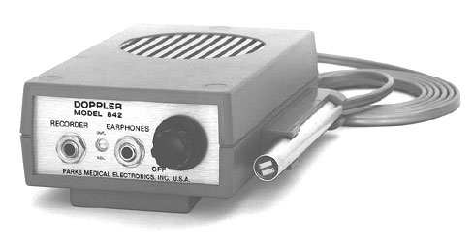
v
emitter
detector
emitted ultrasound
Blood cells in capillary
reflected ultrasound

Pocket Doppler machine for measuring blood flow.

- If the blood flow is away from the emitter, will the frequency received by the red blood cells be higher or lower than the emitted frequency?
- Will the frequency measured at the detector (attached to the emitter) be higher or lower?
A source with a frequency of 5×10⁶ Hz is used to measure a patients blood flow rate. The speed of sound in blood is 1570ms⁻¹.
- If the average frequency difference between the received and transmitted waves is 140Hz, what is the velocity of the blood?
- Given this average blood velocity, how is it possible that the pulse pressure wave produced by the heart reaches the feet in less than 1 s?

Workshop Tutorials for Biological and Environmental Physics
Solutions to WR4B: Sound

A. Qualitative Questions:

- The human voice is in some ways like a musical instrument, and is used as such in many choral works, such as Mozart’s requiem.
  - The vocal cords are like a violin’s strings, they need the resonance chambers in the throat and nose to produce speech or song. The vocal chords vibrate setting up standing waves in the resonance chambers such as the throat. The shape and size of the resonance chambers determines the sound that is produced.
  - When someone inhales helium, their voice becomes very high pitched, and they sound like Mickey Mouse. This is because helium is much less dense than air, and the velocity of sound, which depends on density of the medium, is much greater in helium. The wavelengths of the standing waves supported by the resonance chambers is the same, so the greater speed means a greater frequency (v= f×λ) and hence a higher pitched sound.

- The outer ear canal is open to the air at one end and closed by the ear drum at the other end.
ear drum
air
a.
pressure
b.
displacement L=λ/4; λ=4L

c.
L=3/4 λ; λ = 4L/3
L = 5/4 λ; λ = 4L/5

d. The ear drum behaves like a spring which is being driven by the oscillations of the air in the ear canal. It has a natural frequency of only a few kHz, hence it will not oscillate very much in response to driving frequencies which are very much higher than this.
However, even if it did, the cochlear would not respond to frequencies above about 20 kHz anyway.

B. Activity Questions:

Tuning forks and beats.
f₁

f₂

f_{beat}

The beat frequency you hear from two notes is the difference between the frequencies of the two notes, f_{beat} = f₁ –f₂. The closer the frequencies and hence the notes, the slower the beats.
Musicians tune their instruments by sounding a known note, for example with a tuning fork, then adjusting their tuning so beats frequency decreases until the beats stop, and the note from their instrument is the same as the tuning fork.

Resonance in a tube.
When the tube is the right length, the air column inside it will resonate with the tuning fork, producing a louder sound. See diagram opposite. A trombone produces different notes by varying the length of the air column inside it.

Look and listen
Increasing amplitude increases volume (below left), increasing frequency increases pitch (below right).

Visualising Speech
The microphone has a diaphragm (transducer) that converts vibrations in the air (sound) into an electrical signal. If this diaphragm is vibrated by other means it still produces an electrical signal.
You should see a complicated wave-form, because when you speak you produce many frequencies simultaneously. A whistle gives an approximately sinusoidal signal.

C. Quantitative Questions:

- A certain aircraft produces a sound intensity of 100dB when it flies over at 100m altitude.
- Intensity obeys the 1/r² law, so the ratio of the intensity at h m to that at 100 m is  I_{h}/I₁₀₀ = 100²/h².  The ratio of intensities, I, is equal to the difference in sound level in dB.  The change in intensity in dB is  Change = 10 log (h/100)² = 1.5 dB  20 log (h /100) = 1.5 dB  h /100= 10^{1.5/20} = 1.19 so h = 100 × 1.19 = 119 m.  - If two identical aircraft fly overhead at 119 m the sound intensity will be 98.5 + 3 dB = 101.5 dB. | h= 100m  I = 100 dB  h= ?m  I = 98.5 dB

2.The Doppler effect is used in hospitals to measure the rate of blood flow by bouncing ultrasound waves off red blood cells.
  - If the cells are moving away from the emitter, the frequency “detected” by the cells will be lower.
  - The cells are now acting as the source and moving away from the detector, the machine, which will detect a lower frequency again.
  - The sound is emitted by the machine, then reflected by the red blood cells. So taking the case of cells moving away from the machine (the other case would be equally valid) we use
f_{obs} = f_{emitted} × $\frac{v_{\text{sound}}−v_{\text{blood}}}{v_{\text{sound}}+v_{\text{blood}}}$
Δf = f_{obs} - f_{emitted} = (f_{emitted} × $\frac{v_{\text{sound}}−v_{\text{blood}}}{v_{\text{sound}}+v_{\text{blood}}}$)- f_{emitted} which after a lot of rearranging gives:
Δf = 2. f_{obs}( $\frac{v_{\text{blood}}}{v_{\text{sound}}}$) and v_{blood} = 1.6 cm.s⁻¹.
  - The wave speed does not depend on the particle speed, only on the medium!
Workshop Tutorials for Technological and Applied Physics
WR4T: Sound

A. Qualitative Questions:

- The way humans produce sound is similar to the way in which a stringed instrument like a violin or guitar produces a sound.
- Discuss the role of the vocal cords and resonant chambers in the throat and head in producing speech. How is the voice analogous to other stringed instruments?
- When someone inhales helium their voice becomes very high pitched, and they sound like Mickey Mouse. Explain why this happens? How is the sound wave they produce changed by the presence of helium?

- Resonance is a remarkably useful phenomenon. For example, it is used to create images of body tissues using Magnetic Resonance Imaging, and to heat up food in a microwave. However resonance can also be quite destructive, and marching soldiers always break step crossing bridges, just in case they make the bridge collapse.
- Explain how a wine glass can be shattered by a sustained note from an opera singer.
- How is the shattering of a shop window by an explosion some kilometres away different to the shattering of the wine glass, and what sort of wave is involved in this case?

B. Activity Questions:

Tuning forks and beats.
Listen to the beats when you strike the two tuning forks at the same time.
What happens when you adjust the frequency of one of the forks?
Draw a diagram showing how the two waves from the tuning forks add to give the wave that you hear.

Resonance in a tube.
When the tube is the right length, the column of air inside it will resonate with the tuning fork. Vary the length of the air column in the tube to find the wavelength of the sound.
Can you think of a musical instrument which produces different notes by varying the its length?

Look and listen
The CRO (cathode ray oscilloscope) draws a graph showing variations in amplitude with time (also used to measure heart rhythms).
Describe what happens to the sound you hear and the pattern on the CRO as the frequency is increased/ decreased? Remember that the audible frequency range is from 20Hz to 20 kHz.
What happens to the sound and the pattern as you turn the amplitude control?

Visualising Speech
A microphone is connected to an oscilloscope (CRO). As you speak into the microphone the pattern on the CRO depicts the sound waves generated by you.
How does the pattern change when you whistle, scream, sing a note, speak softly, speak loudly?
A wave appears on the screen if you lightly 'tap' the microphone. Explain why this happens.

C. Quantitative Questions:

- There are noise ordinances restricting the maximum sound intensity that an aircraft may produce on take-off, and that it may produce as it passes over residential areas. A certain aircraft produces a sound intensity of 100dB when it flies overhead at 100m altitude.
- If the maximum allowable sound intensity is 98.5 dB as measured by a sound meter in Leichardt, at what minimum height can the aircraft fly to be within legal limits as it passes overhead?
- What will be the sound intensity in dB if two identical aircraft of this type fly overhead (approximately) simultaneously at this height?

- The Doppler effect is used by fish finders on fishing boats to locate schools of fish. The fish finders send out an ultrasonic pulse, which is reflected by a large enough school of fish, and detected back at the fish finder. Some models even include a dual frequency transmitter/receiver, so that both the speed of the boat relative to the water and the speed of the fish can be calculated and displayed.
- If a school of fish is moving away from the fish finder, will the frequency received by the fish be higher or lower than the emitted frequency?
- Will the frequency measured at the detector be higher or lower?
The speed of sound in water is 1.5 km.s⁻¹ and the fish finder emits a frequency of 100 kHz. A school of fish is passing a boat equipped with a fish finder as shown below. The fish are moving along the path shown with a speed of 2.4 m.s⁻¹.
A
B
C
30 m
15 m
15 m

- When the fish are at point A, what frequency will be received at the fish finders detector?
- What frequency will be received when the fish are at point B?
- What frequency will be received when the fish are at point C?

Workshop Tutorials for Technological and Applied Physics
Solutions to WR4T: Sound

A. Qualitative Questions:

- The human voice is in some ways like a musical instrument, and is used as such in many choral works, such as Mozart’s requiem.
  - The vocal cords are like a violin’s strings, they need the resonance chambers in the throat and nose to produce speech or song. The vocal chords vibrate setting up standing waves in the resonance chambers such as the throat. The shape and size of the resonance chambers determines the sound that is produced.
  - When someone inhales helium, their voice becomes very high pitched, and they sound like Mickey Mouse. This is because helium is much less dense than air, and the velocity of sound, which depends on density of the medium, is much greater in helium. The wavelengths of the standing waves supported by the resonance chambers is the same, so the greater speed means a greater frequency (v= f×λ) and hence a higher pitched sound.

- Resonance is a remarkably useful phenomenon, but can also be quite destructive.
- A wine glass may shatter if the frequency is right because the sound waves set up standing waves in the glass at the resonant frequency, which causes it to dramatically shake apart. The frequency needs to be just right, but the intensity (volume) can be quite low.
- When an explosion shatters a window, the window is shattered by a shock wave, which transmits a large amount of energy in a very short time. This is not due to resonance.

B. Activity Questions:

Tuning forks and beats.
f₁

f₂

f_{beat}

The beat frequency you hear from two notes is the difference between the frequencies of the two notes, f_{beat} = f₁ –f₂. The closer the frequencies and hence the notes, the slower the beats. Musicians tune their instruments by sounding a known note, for example with a tuning fork, then adjusting their instruments tuning so beats frequency decreases until the beats stop, when the note from their instrument is the same as the tuning fork.

Resonance in a tube.
When the tube is the right length, the air column inside it will resonate with the tuning fork, producing a louder sound. See diagram opposite. A trombone produces different notes by varying the length of the air column inside it.

Look and listen
Increasing amplitude increases volume (below left), increasing frequency increases pitch (below right).

Visualising Speech
The microphone has a diaphragm (transducer) that converts vibrations in the air (sound) into an electrical signal. If this diaphragm is vibrated by other means it still produces an electrical signal.
You should see a complicated wave-form, because when you speak you produce many frequencies simultaneously. A whistle gives an approximately sinusoidal signal.

C. Quantitative Questions:

- A certain aircraft produces a sound intensity of 100dB when it flies over at 100m altitude.
- Intensity obeys the 1/r² law, so the ratio of the intensity at h m to that at 100 m is  I_{h}/I₁₀₀ = 100²/h².  The ratio of intensities, I, is equal to the difference in sound level in dB.  The change in intensity in dB is  Change = 10 log (h/100)² = 1.5 dB  20 log (h /100) = 1.5 dB  h /100= 10^{1.5/20} = 1.19 so h = 100 × 1.19 = 119 m.  - If two identical aircraft fly overhead at 119 m the sound intensity will be 98.5 + 3 dB = 101.5 dB. | h= 100m  I = 100 dB  h= ?m  I = 98.5 dB

- The Doppler effect is used by fish finders on fishing boats to locate schools of fish.
- If a school of fish is moving away from the fish finder, the frequency received by the fish will be lower than the emitted frequency.
- The frequency measured at the detector will also be lower, and will be lower than the frequency detected by the fish.
The speed of sound in water is 1.5 km.s⁻¹ and the fish finder emits a frequency of 100 kHz. The fish are moving along the path shown with a speed of 2.4 m.s⁻¹. The path makes an angle of 63º to a line between the fish and the boat at points A and C.
A
15 m
30 m
63⁰
C
B
2.4 m.s⁻¹
A
2.4 m.s⁻¹
63⁰
1.1 m.s⁻¹
2.4 m.s⁻¹
1.1 m.s⁻¹
C
63⁰
- At point A, the fish are moving towards the boat. We can decompose their velocity into a component along the line between the fish and the boat, and a component perpendicular to this line. The component of the fish’s velocity directly towards the boat is 1.1 m.s⁻¹. The frequency received by the fish is: f_{fish}=(1+ $v_{\text{fish}}v_{\text{wave}}$)f_{emitted} =(1+$1\text{.}1 m\text{.}s^{−1}1\text{.}5×{\text{10}}^{3} m\text{.}s^{−1}$) 100 × 10³ Hz = 100.1 kHz
The frequency received by the fish finder, with the fish now acting as a moving source, is:
f_{finder} = ($\frac{1}{1−v_{\text{fish}}v_{\text{wave}}}$)f_{fish} =($\frac{1}{1−(1\text{.}1m\text{.}s^{−1}1\text{.}5×{\text{10}}^{3} m\text{.}s^{−1})}$)100.1kHz =100.2 kHz.
- At point B the velocity of the fish has no component along the line joining the fish and the boat, hence the fish are neither moving towards or away from the boat at this point, and the frequency received will be the same as that emitted.
- At point C the fish are now moving with a velocity component of 1.1 m.s⁻¹ directly away from the boat. The frequency received by the fish is:
f_{fish} = (1- $v_{\text{fish}}v_{\text{wave}}$)f_{emitted} = (1-$1\text{.}1 m\text{.}s^{−1}1\text{.}5×{\text{10}}^{3} m\text{.}s^{−1}$) 100 × 10³ Hz = 99.9 kHz
The frequency received by the fish finder, with the fish now acting as a moving source, is: f_{finder} = ()f_{fish} =($\frac{1}{1+(1\text{.}1m\text{.}s^{−1}1\text{.}5×{\text{10}}^{3} m\text{.}s^{−1})}$) 99.9 kHz =99.8 kHz.
Workshop Tutorials for Physics
WR5: Electromagnetic Waves

A. Qualitative Questions:

- Rebecca and Brent are sitting inside watching TV one evening when Brent notices a lightning flash. A few moments later they hear a peal of thunder. Brent says they’d better go bring the washing in off the line because there’s a storm coming. Rebecca’s says to wait until the next ad’ break. “hmm…” say’s Brent, as he listens to the next peal of thunder, “that storm is getting pretty close, the thunder was only a second after the lightning”.
“How can you tell?” asks Rebecca, as the first drops of rain start to fall…
How can Brent tell that the storm is getting closer? Explain your answer.

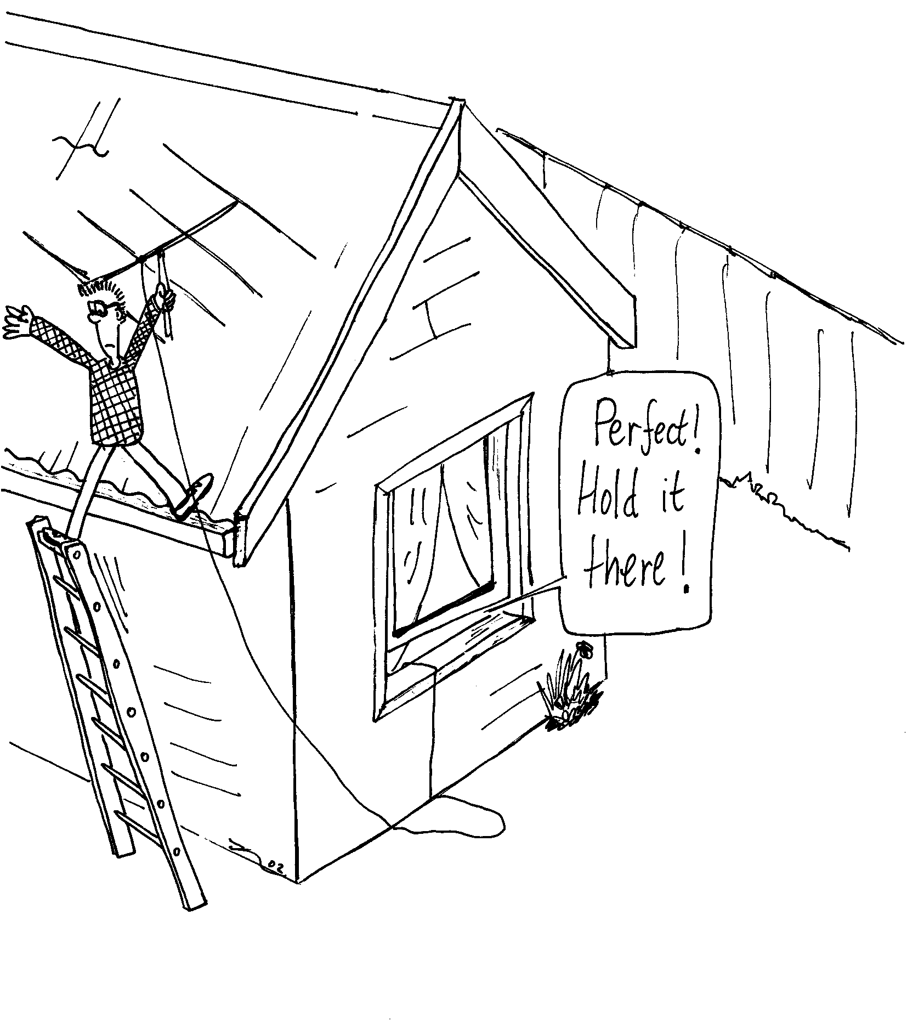
- Brent and Rebecca have bought a new TV antenna because their old one was blown off the roof in a storm. Brent is up on the roof putting up the antenna while Rebecca looks at the TV to see when the reception is the best.
It doesn’t seem to make much difference which way Brent angles it, so Rebecca goes out to see what he’s doing. She looks up and calls “Brent! You’ve set it up the wrong way! The bars should be horizontal!”
Why would it matter which way the bars of the antenna go? Draw a diagram to help explain your answer.

B. Activity Questions:

Speed of Light
Microwave the marshmallows to find the speed of light!
Read the frequency of the microwave radiation produced from the back of the microwave.
Microwave the marshmallows, watching carefully, and stopping the oven when they first begin to melt.
Measure the distance between melted bits to find the wavelength, and use this to calculate the speed of light.
Warning – very hot! Do not touch the molten marshmallows!

Prism
Shine the light through the prism.
What do you see going into the prism?
What do you see coming out?
Which is refracted (bends) more – light of long or short wavelength?

Sunset in a jar
Look at the light transmitted through the top of the beaker.
What do you notice about its colour?
What do you notice about the light coming out the sides of the beaker?
Explain the difference in these colours.
Explain why the sky on Earth is blue. What colour do you think the sky is on Mars? Why?

Polaroid glasses
Examine the glasses. How can you tell which ones are polaroid?
Which way are the lenses polarized? Why do you think they are polarised this way?

Stress lines
Examine the stressed perspex between the sheets of polaroid.
What happens when you increase the stress?
If someone in your group wears glasses, ask them to let you see them between the sheets of polaroid.
Can you see stress lines in the glasses?
Can you think of a use for this effect?

C. Quantitative Question:

- FM radio stations broadcast signals which have frequencies in MHz, for example 106.5MHz.
a. Find the wavelength of the signal broadcast by this station.
AM radio stations broadcast in the “medium wave” range, which is much lower frequency than FM stations.
b. Which radio station in Sydney broadcasts a signal with a wavelength of 521m?
There are two ways in which radio stations transmit signals to your car radio – one is AM or amplitude modulation, the other is FM or frequency modulation.
- Draw a diagram showing the difference between amplitude modulated and frequency modulated waves.

- The refractive indices for ordinary and extraordinary waves traveling at right angles to the optic axis in quartz are n_{o} = 1.544 and n_{e} = 1.553. A quarter wave plate is one for which the two waves get exactly one quarter of a wavelength out of step after passing through it.
- What is the thickness of the thinnest possible quarter wave plate for a wavelength of 600nm?
- Will such a quarter wave plate be thicker or thinner for light of wavelength 500nm?

Workshop Tutorials for Physics
Solutions to WR5: Electromagnetic Waves

A. Qualitative Questions:

- Rebecca and Brent are sitting inside watching TV one evening when Brent notices a lightning flash. A few moments later they hear a peal of thunder. When there is a storm, lightning and thunder are emitted at the same time and from the same source. The lightning, which is light waves, travels much faster (around 3 × 10⁸ m.s⁻¹) than thunder which is a sound wave (and travels at around 3 × 10² m.s⁻¹). So the light reaches Brent and Rebecca sooner than the sound. If the storm is far away the time difference between the arrival of the two is large. As the storm gets closer, the distance traveled by both waves is less, so the time difference gets smaller, and when the storm is right overhead the time difference is no longer noticeable. Brent has noticed that the time difference is getting smaller, so the storm is getting closer. If the time difference was getting greater the storm would be moving away.

- Brent and Rebecca have bought a new TV antenna. Rebecca say’s “Brent! You’ve set it up the wrong way! The bars should be horizontal!” The bars should be horizontal because the signals from the TV station’s transmitting towers are horizontally polarised in Australia.
The electromagnetic waves which carry the signal have an oscillating electric and magnetic field. The oscillating electric field causes the electrons in the receiving antenna to oscillate, producing a current in the antenna, which is decoded into pictures and sound by the TV. If the antenna is vertical, the electrons cannot oscillate back and forth further than the width of the antenna, so no signal is received. | E  nothing happens  current induced and signal received  E  current

B. Activity Questions:

Speed of LightΔ
The melted patches occur at antinodes in the standing wave pattern inside the microwave. The distance between two antinodes is ½ λ. The speed of light can then be found using c = λf, where the frequency, f, is read off the compliance plate on the back of the microwave.

Prism
rainbow
white light
When light moves from air into the prism the light is refracted or bent, and it is bent again as it leaves the prism. The prism has a refractive index which varies for different wavelengths. The refractive indexis greater for shorter wavelengths, and hence the blue component of the incident white light bends more than the red component.
white light
white – some blue = yellowish
blue

Sunset in a jar
The milky water scatters the blue light more than other colours, so you should be able to see a faint blue tinge to the light coming from the sides of the beaker. This is like a very small but condensed version of the atmosphere scattering the light from the sun. The sky on Earth is blue because we are seeing light scattered by the atmosphere. If you looked directly at the sun (which you should never do!) it would look yellow, like the light coming out the top of the beaker.
The sky on Mars is black because there is no atmosphere to scatter any light – hence in the daytime you would see the sun, and other stars.

Polaroid glasses
A pair of polaroid glasses can be found by holding two pairs of glasses at right angles and looking at a light source. When a pair is found such that light does not pass through them when the lenses are at right angles, both are polaroids. Once one pair is identified, one of the sets of polaroid glasses can be used to test the others.
Sunglasses are useful for cutting out glare. Glare from water or shiny horizontal surfaces is effectively reduced by good sunglasses. The glare is due to light reflected from the horizontal surface, which is mostly horizontally polarised. Hence the transmission axis for the glasses must be vertical.

Stress lines
The molecules in the perspex are stretched by the applied stress, and align like the molecules in the sheets of polaroid. When viewed between two crossed polaroids, the light areas show where the material between is rotating the polarisation axis of the light coming through the first polaroid. This is a very useful technique, and is called optical stress analysis. Engineers use it to look for stress in models of structures. You will probably be able to see stress lines in the lenses of a pair of spectacles, showing the lenses have been stressed to fit them into the frames, or where the lenses are stressed due to damage to the frames, for example by dropping or sitting on the glasses.

C. Quantitative Question:

- FM radio stations broadcast signals which have frequencies in MHz, for example 106.5MHz.
- To find the wavelength of the signal broadcast you use the relationship c = λf. We know that the frequency is f = 106.5 × 10⁶ Hz, and c = 3.0 × 10⁸ m.s⁻¹, so:
λ = c/f = 3.0 × 10⁸ m.s⁻¹ / 106.5 × 10⁶ Hz = 2.8 m.
- A wavelength of 521 m gives f = c/λ = 3.0 × 10⁸ m.s⁻¹ / 521 m = 576 × 10³ s⁻¹ = 576kHz.
This is ABC radio national in Sydney.
- See diagram opposite.  An FM signal carries information in the way the frequency varies, while the amplitude remains constant. An AM signal carries the information in the variation of the amplitude, while the frequency stays the same. | amplitude modulated  frequency modulated

- The refractive indices for ordinary and extraordinary waves traveling at right angles to the optic axis in quartz are n_{o} = 1.544 and n_{e} = 1.553. A quarter wave plate is one for which the two waves get exactly one quarter of a wavelength out of step after passing through it. The ordinary wave is one which passes straight through, the extraordinary is split off from the incident beam.
- The thickness of the thinnest possible quarter wave plate corresponds to a path difference for the two beams of ¼ λ. The distance traveled will be the thickness, t, We require that if one beam goes through x wavelengths in this distance, then the other must travel through x + ¼ wavelengths. The number of wavelengths for a given thickness, t, is t/λ, so we require that:
t/λ_{o} = x and t/λ_{e} = x + ¼, which gives t/λ_{e} = t/λ_{o} + ¼.
The wavelengths are related to the refractive indices for the waves: λ_{e} = λ/n_{e} and λ_{o} = λ/n_{o}, putting this in to the expression for t gives: tn_{e} /λ = tn_{o} /λ + ¼,
which can be rearranged to give: tn_{e} /λ - tn_{o} /λ = ¼,
t (n_{e} - n_{o} )/λ = ¼ or t = λ/ 4 (n_{e} - n_{o}) = 600 × 10⁻⁹ m / 4(1.553-1.544) = 1.7 × 10⁻⁵ m = 17 μm.
- The thickness is proportional to the wavelength, so a smaller wavelength will require a thinner plate. A quarter wave plate will be thinner for light of wavelength 500 nm than for light of wavelength 600 nm.
Workshop Tutorials for Biological and Environmental Physics
WR6B: Reflection and Refraction

A. Qualitative Questions:

- A ray of white light travelling in water strikes a plane surface of the water with an angle of incidence θ as shown.
- Is it possible for the internally reflected beam to appear bluish or reddish?
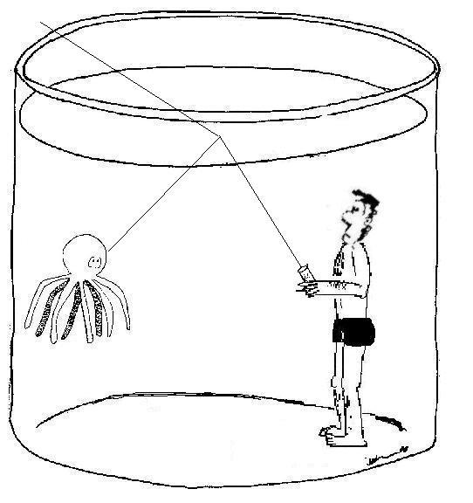
- What about the transmitted beam?
θ

- Brent and Rebecca are out fishing on the bay in their boat. Rebecca is relaxing and watching the ripples behind the boat. “Look at that nice interference pattern from the waves going around the boat”. “That’s a diffraction pattern” replies Brent.
“No, its definitely an inteference pattern, diffraction is when light bends going from one medium into another.” says Rebecca.
“Huh? didn’t you learn anything in optics last semester? That’s refraction.”
- What is the difference between diffraction and interference, and what is Rebecca observing as she watches the waves going around their boat?
- What do diffraction and interference have in common?
- How is refraction different from either?

B. Activity Questions:

Prism
Shine the light through the prism.
What do you see going into the prism?
What do you see coming out?
Which is refracted (bends) more – light of long or short wavelength?
Sometimes after rain or when there is a break in the clouds you may see a rainbow. On a sunny day if you stand with the sun behind you , you can make a rainbow by spraying a mist of water from a hose.
Draw a diagram showing how the rainbow is formed by the droplets of water.

Bent pencil
Why does the pencil appear to be bent?
Draw a diagram showing how the light is bending in this case.

Losing your marbles
Pour the liquid into the container with the marbles in it.
Why do they appear to disappear?
What can you conclude about the refractive index of the marbles and the liquid?

Total internal reflection
Shine the light into the cable.
Can you see the light through the sides of the cable?
Where is the light going, and why?

C. Quantitative Questions:

- The picture below shows a fish and the fisherman who is hoping to catch him. It is a calm clear day and the surface of the water is perfectly smooth. The refractive index of water is 1.33.
- What is the critical angle for the air water interface?
- Draw a diagram showing what the fish sees.
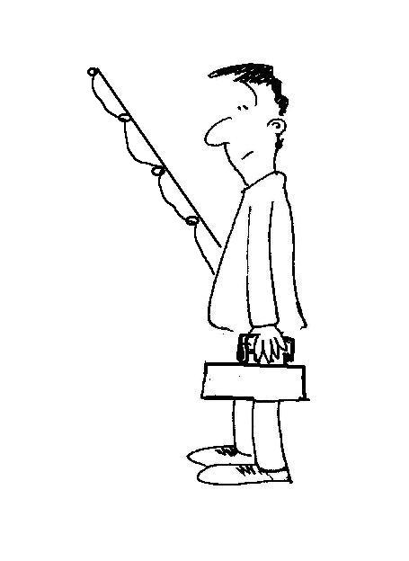

- Sharks can be a danger to swimmers and surfers in Australian waters, however environmental protection groups consider it unfair to simply kill any sharks which stray too close to populated waters. One way to get rid of a shark which is a potential danger is to tranquillise it and remove to a distant location. A laser targeting system is being used by a diver to aim a tranquilizer gun at a shark. The laser emits a beam with wavelength 630 nm (under the water). The refractive index of water is 1.33.
- What is the speed of the light in the targeting beam above the water?
- What is the speed of the light in the targeting beam in the water?
- What is the frequency of the light in the water?
- What is the frequency of the light in the air?
- What is the wavelength of the light in the air?
- Would you be able to see the beam in the air? What about in the water?
Workshop Tutorials for Biological and Environmental Physics
Solutions to WR6B: Reflection and Refraction

A. Qualitative Questions:

- A ray of white light travelling in water strikes the surface of the water with an angle θ as shown.
  - If the angle of reflection, θ, exceeds the critical angle, then the light will be totally internally reflected. The critical angle is given by sinθ_{c} = n₂/n₁. In this case n₁ is the refractive index of water, and n₂ is the refractive index of air, as the beam starts in the water and passes into the air. Refractive index varies with wavelength in water and is greater for shorter wavelengths, ie at the blue end of the spectrum.
θ
n₂
n₁
So n₁ decreases with increasing wavelength, giving a higher critical angle, θ_{c}, for longer wavelengths. For any angle θ, there is a wavelength, λ, below which all wavelengths will be totally internally reflected. Above this wavelength light will be partly transmitted and partly reflected. Hence it is possible for the internally reflected beam to appear bluish (or white) as some red can be transmitted while the blue is totally reflected, but it cannot appear reddish, as red cannot be totally internally reflected unless blue is also internally reflected.
  - The transmitted beam can be red or white, but not blue.

- Brent and Rebecca are out fishing on the bay in their boat. Rebecca is relaxing and watching the ripples behind the boat. “Look at that nice interference pattern from the waves going around the boat”.
- Interference is the interaction of waves with the same frequency and phase to form a pattern of large and small wave amplitudes. At any point the amplitude of the resultant wave is the sum of the amplitudes of the two individual waves. If two peaks occur at the same point at the same moment in time then they will add to give a very large peak, this is constructive interference. If a peak and a trough meet at a point, then if they have the same magnitude, they will cancel out to give nothing, this is destructive interference. Diffraction occurs when a wave passes around an object or through a gap. The wave passing around their boat is split as it goes past, and the waves from either side form an interference pattern when they meet on the other side of the boat. This is both an interference pattern and a diffraction pattern.
- Diffraction patterns are a result of waves interfering as they pass around an object or through a gap. Diffraction is a special case of interference.
- Refraction is the bending of waves (e.g. light) when they move from one medium into another. It is not a result of interference. When light travels from air into glass or water it slows down and its path is bent towards the normal to the surface of the medium it is entering. We usually only talk about refraction when we are talking about light.

B. Activity Questions:
rainbow
white light

Prism
When light moves from air into the prism the light is refracted or bent, and it is bent again as it leaves the prism. The prism has a refractive index which varies for different wavelengths. The refractive index is greater for shorter wavelengths, and hence the blue component of the incident white light bends more than the red component.  This is how rainbows are produced. The raindrops act as prisms, but the light doesn’t just pass through the drops, it is reflected off the back surface of the drop and comes out the front separated into different wavelengths. |  | white  blue  red
Bent pencil  The light from the pencil is refracted when it passes from the water into air, bending away from the normal as it moves from high to low refractive index. The light coming from the pencil tip appears to be coming from the apparent pencil tip as shown opposite. | actual position of pencil tip  apparent position of pencil tip

Losing your marbles
The refractive index of the marbles and the liquid is the same, so light passing through the beaker will not be bent as it moves from water to marble to water again. If the marbles are transparent, they will be invisible in the liquid.
θ_{i}

Total internal reflection
The light ray that enters the cable is totally internally reflected provided the incident angle, θ_{i}, is greater than the critical angle. Light is trapped inside the cable and almost none gets out the sides.

C. Quantitative Questions:
- It is a calm day and the surface of the water is perfectly smooth. Refractive index of water is 1.33.
- The critical angle for the air water interface can be found using Snell’s law: n₁sinθ₁ = n₂sinθ₂. The critical angle is when total internal reflection occurs, ie the fish would only see a reflection from the surface of the water, and not anything outside the water. This occurs when θ₁ = 90º, so:
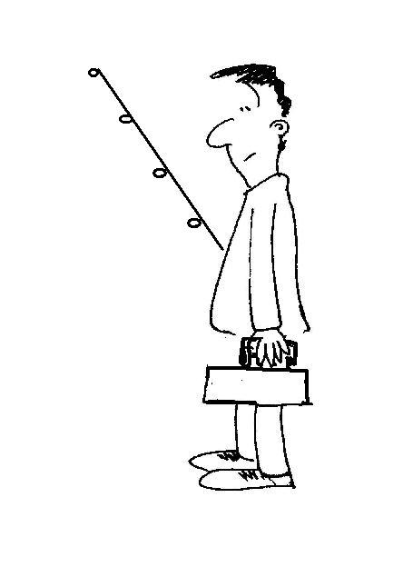
n₁sinθ₁ = n₂sinθ₂, or 1× sin(90º) = 1.33 × sinθ₂, which gives sinθ₂ = 1/1.33, and θ₂ = 49º. Any rays incident angle greater than 49º never make it to the fish.
actual light path
fisherman
perceived position of fisherman
bird
perceived position
of bird
actual light path
perceived light paths
- See diagram below. Light coming from the bird and the fisherman is diffracted, or bent, making them appear higher up and further away than they actually are. Some fish, such as angler fish, allow for this effect. Angler fish can accurately spit a stream of water at an insect a few feet above the water, allowing for refraction.

- The laser emits a beam with wavelength 630 nm under water. The refractive index of water is 1.33.
- The speed of the light above the water is the speed of light in air, c = 3. 00 × 10⁸ m.s⁻¹.
- The speed of the light in the targeting beam in the water is
v_{in water} = c(n_{air}/n_{water}) = 3. 00 × 10⁸ m.s⁻¹ × (1.00/1.33) = 2.26 × 10⁻⁸ m.s⁻¹.
- The frequency of the light is f = v/λ = 2.26 × 10⁻⁸ m.s⁻¹ / 630 × 10⁻⁹m = 3.6 × 10¹⁴ Hz.
- The frequency of the light in the air is the same as the frequency in water, i.e. 3.6 × 10¹⁴ Hz.
- The wavelength of the light in the air is different to the wavelength in water,
λ_{in air} = v_{in air}/f = c/f = 3. 00 × 10⁸ m.s⁻¹ / 3.6 × 10¹⁴ Hz = 830 nm.
- This is in the infrared region in air, so you would not be able to see this beam. Our eyes can only pick up light with energy in the visible region, and energy is proportional to frequency. As the frequency does not change from one medium to another, if the light is not visible to us in air, it will not be visible in water either.
Workshop Tutorials for Technological and Applied Physics
WR6T: Reflection and Refraction

A. Qualitative Questions:

- Modern communication relies on optical fibres- for example high speed internet connections, phone lines and cable TV, all use fibre optic cables.
  - Explain how light is transmitted along optical fibres so that you can watch cable TV.
  - For an optical fibre cable to work, it must have a cladding. What can you say about the relative sizes of the refractive indices of the fibre core and the cladding? Which must be greater for the cable to work?
  - You have had a cable TV box installed and the cable guy has attached too long a cable. He rolls up the excess and pokes it under the TV, leaving just enough hanging out to reach the wall socket. Explain using diagrams why the cable will not work if it is too tightly wound up.

- It is possible to see the sun or even a distant boat on the ocean when it is below the physical horizon. Explain, using a diagram, how this is possible.

B. Activity Questions:

Prism
Shine the light through the prism.
What do you see going into the prism?
What do you see coming out?
Which is refracted (bends) more – light of long or short wavelength?
Sometimes after rain or when there is a break in the clouds you may see a rainbow. On a sunny day if you stand with the sun behind you , you can make a rainbow by spraying a mist of water from a hose.
Draw a diagram showing how the rainbow is formed by the droplets of water.

Bent pencil
Why does the pencil appear to be bent?
Draw a diagram showing how the light is bending in this case.

Losing your marbles
Pour the liquid into the container with the marbles in it.
Why do they appear to disappear?
What can you conclude about the refractive index of the marbles and the liquid?

Total internal reflection
Shine the light into the cable.
Can you see the light through the sides of the cable?
Where is the light going, and why?

C. Quantitative Questions:

- A novelty beer glass has a very thick bottom with a fake fly imbedded in it 1.2 cm below the surfac of the glass, as shown below. The refractive index of the glass is 1.6, and the refractive index of the beer is 1.35. Draw a diagram showing the path of a light ray from the fly to a person looking into the glass. When the fly is viewed from above, with 6.0 cm of beer in it, what is the apparent depth of the fly below the surface of the beer?
6.0 cm
1.2 cm

air
n₁
n₂

- A fibre optic cable which is to carry a signal for an internet connection has a cladding with a refractive index of 1.52. The core glass fibre has a refractive index of 1.57.
At the connection to the computer, a beam of light enters the fibre from air at an angle θ to the axis of the cable.
θ
n_{core}
n_{cladding}

What is the maximum angle, θ, that will allow the beam to propagate down the cable?
Workshop Tutorials for Technological and Applied Physics
Solutions to WR6T: Reflection and Refraction

A. Qualitative Questions:

- Modern communication relies on optical fibres- for example high speed internet connections, phone lines and cable TV, all use fibte optic cables.
Light is transmitted along optical fibres with almost no loss of intensity. The light ray that enters the core from the transmitter is totally internally reflected provided the incident angle, θ_{i}, is greater than the critical angle. Light is trapped inside the core and almost none gets out the sides, so the signal carried by the light arrives at your TV with very little loss, regardless of the length of the cable.
For an optical fibre cable to work, it must have a cladding. When light reflects from the inside of the core it bounces off the interface between the material of the cladding and the core itself. For total internal reflection to occur, the cladding must have a refractive index greater than that of the core, so that sinθ_{c} = n_{cladding}/n_{core} < 1, where θ_{c} is the critical angle.
θ_{c}
θ < θ_{c}, some transmission.
If fibre optic cable is too tightly wound up then the angle of incidence can become very small, as shown. If the angle of incidence is less than the critical angle, some of the light will be transmitted, rather than reflected, giving a loss of signal at each reflection. | θ > θ_{c}, total internal reflection,

- The Earth is surrounded by the atmosphere, which extends a few hundred kilometres into space. When a ray of light enters the atmosphere it is refracted, or bent, by the atmosphere.
earth
apparent position of sun
atmosphere
When light travels from a medium with lower refractive index to one with higher refractive index the light is bent towards the normal to the surface of the new medium. See diagram opposite. When the sun is below the physical horizon, it may still be visible because the light it emitts is refracted, so its apparent position is above the horizon.
actual position of sun

B. Activity Questions:
rainbow
white light

Prism
When light moves from air into the prism the light is refracted or bent, and it is bent again as it leaves the prism. The prism has a refractive index which varies for different wavelengths. The refractive index is greater for shorter wavelengths, and hence the blue component of the incident white light bends more than the red component.  This is how rainbows are produced, the raindrops act as prisms, but the light doesn’t just pass through the drops, it is reflected off the back surface of the drop and comes out the front separated into different wavelengths. | white  blue  red
actual position of pencil tip
apparent position of pencil tip

Bent pencil
The light from the pencil is refracted when it passes from the water into air, bending away from the normal as it moves from high to low refractive index. The light coming from the pencil tip appears to be coming from the apparent pencil tip as shown opposite.

Losing your marbles
The refractive index of the marbles and the liquid is the same, so light passing through the beaker will not be bent as it moves from water to marble to water again. If the marbles are transparent, they will be invisible in the liquid.

Total internal reflection
θ_{i}
The light ray that enters the core is totally internally reflected provided the incident angle, θ_{i}, is greater than the critical angle. Light is trapped inside the core and almost none gets out the sides.

C. Quantitative Questions:

- A novelty beer glass has a very thick bottom with a fake fly imbedded in it 1.2 cm below the surface of the glass, as shown below. The refractive index of the glass is 1.6, and the refractive index of the beer is 1.35. The fly is viewed from above, with 6.0 cm of beer in the glass above it.
The apparent depth of the fly below the surface of the beer is the apparent depth through glass, d_{glass app}, plus the apparent depth of beer, d_{beer app}.  d_{glass, app} = d_{glass} (n_{beer} /n_{glass}) = (d_{glass} n_{beer} )/n_{glass}  d_{beer, app} = d_{beer} (n_{air} /n_{beer}) = d_{beer} / n_{beer}  The apparent depth from the top is the sum of these:  d_{fly, app} = d_{glass, app} + d_{beer app}  = (d_{glass} n_{beer})/ n_{glass} + d_{beer} / n_{beer}  = (1.2 cm × 1.35)/1.6 + 6.0 cm / 1.35 = 1 cm + 4.4 cm  = 5.4 cm.  So the fly appears to be 5.4 cm below the surface of the beer, or 0.6 cm above the bottom of the beer, when seen from above. Hence the fly appears to be floating near the bottom of the glass. | 6.0 cm  1.2 cm  n_{air} = 1  n_{beer}  n_{glass}  5.4 cm

- A fibre optic cable which is to carry a signal for an internet connection has a cladding with a refractive index of 1.52. The glass core itself has a refractive index of 1.58. At the connection to the computer, a beam of light enters the core from air at an angle θ to the axis of the cable.
The maximum angle, θ, that will allow the beam to propagate down the core corresponds to the beam in the core reflecting at the critical angle, θ_{c}, given by  sinθ_{c} =n_{cladding}/n_{core} = 1.52/1.58 = 0.97,  so θ_{c} = 74º.  The maximum entry angle, θ, can be found from:  n_{air}sinθ = n_{core}sin(90 - θ_{c}), n_{air} = 1, so:  sinθ = n_{core}sin(90º- θ_{c} ) = 1.58 × sin 16º = 0.44,  so θ = 26º. Hence the beam must enter within 26º of normal to the fibre surface. | θ  n_{core}  n_{cladding}  θ_{c}

Workshop Tutorials for Physics
WR7: Mirrors

A. Qualitative Questions:

1. You want to buy a mirror to put in the inside of your closet door so you can check how you look in the morning before setting off to uni, but you don’t want to spend a lot of money getting a bigger mirror than you actually need.
- How big a mirror would you need to just be able to see yourself from top to toe?
- At what height should the mirror be mounted?
- Why are left and right reversed in a mirror but not up and down? Draw a ray diagram showing why your reflection is reversed in a mirror.

2. Dish antennas, whether for satellite TV reception, radar signals or radio-telescopes, have a particular shape.
- Describe this shape and explain why it is used. Use a ray diagram to explain your answer.
- What assumptions have you made about the object (the source of the signal) in your answer to a? Justify these assumptions.

B. Activity Questions:

Curved mirrors
Examine the reflections in the mirrors.
Which ones are concave, and which are convex?
How can you tell?

Shaving Mirror
Look at your reflection in the shaving mirror.
What do you notice about the reflection?
Examine the mirror closely.
What can you say about the shape of the mirror?

Right angled mirrors
Look at your image in the mirror.
What do you notice when you move your hands?
How is this different to a single mirror?
Draw a ray diagram showing the path of a light ray from your hand to your eye.

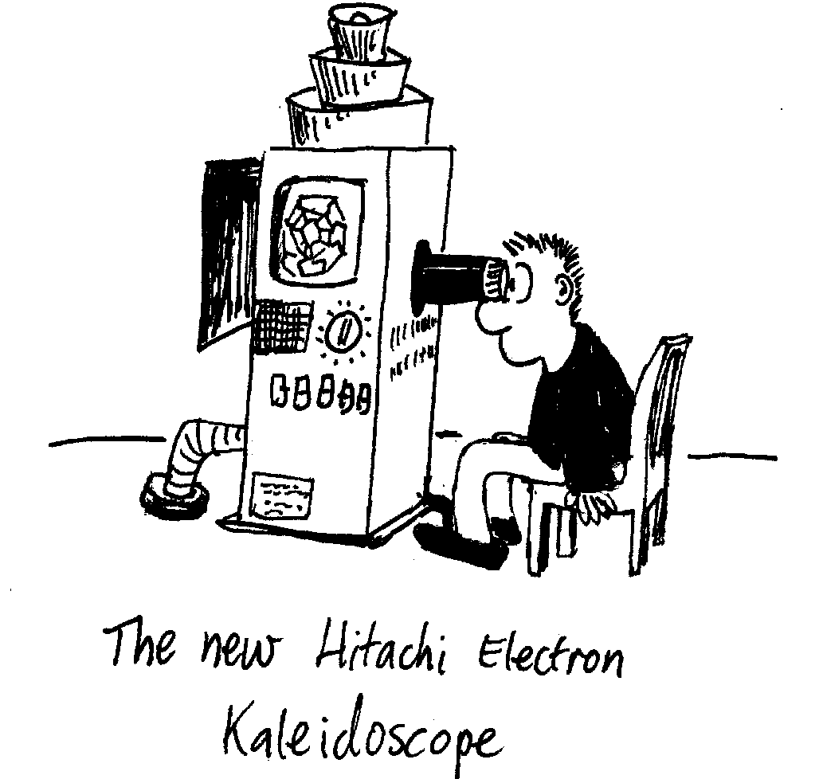
Kaleidoscope
Examine the different kaleidoscopes.
How do the images seen through them differ?

C. Quantitative Questions:

  - Some car side mirrors have a warning on them that says :”Caution: objects in mirrors may appear further away than they are”.
- Are these car mirrors concave or convex?
- Is the image from these mirrors real or virtual?
A spherical convex driving mirror in a car has a radius of curvature of 1.5 m. The driver looks in the mirror and sees the car behind. The car behind is 1.5 m high, and is 13 m away from the mirror.
- Draw a ray diagram showing the object, the mirror and the image.
- Where will the image be?
- What sort of image is this?
- How big is the image?

  - A concave shaving mirror has a focal length of 450 mm.
- How far away from your face should you hold it for the reflected image to be upright and twice the size of your actual face? Draw a ray diagram
- How far away should you hold the mirror from your face to get an image 500 mm from the mirror which is real?
- How far away should you hold the mirror from your face to get an image 500 mm from the mirror which is virtual?

Workshop Tutorials for Physics
Solutions to WR7: Mirrors

A. Qualitative Questions:

1. You want to buy a mirror but you don’t want to spend a lot of money getting a bigger mirror than you actually need.
- The angle of reflection is equal to the angle of incidence, so a ray coming from your toes to your eyes reflects off the mirror at half your height. The lower half of a full lengthy mirror only shows the floor. A mirror only needs to be half your height, so you can see all of yourself, plus a little bit to allow for your eye height being a little less than your full height.
- The mirror should be mounted so that the top is level with the top of your head.
- In your reflection left and right seem to be reversed, but not up and down. This is because of the way we define left and right as relative to ourselves, not our surroundings. For example, “towards the wall” and “away from the wall” are not reversed, just as up and down are not reversed. Up and down are defined externally, usually relative to the ground. It is important to know how your coordinate systems are defined, and whether they change as you move!

2. Dish antennas, whether for satellite TV reception, radar signals or radio-telescopes, have a particular shape.
- Dish antennas have a parabolic shape. The parabolic shape reflects all incident rays into the focal point of the dish where a receiver is mounted.
- We have assumed that the emitter is a very long way away so that all the rays are approximately parallel. This is a reasonable assumption for emitters such as satellites or radio sources many kilometers away.

B. Activity Questions:
C
f
f
C

Curved mirrors
See diagrams opposite. C is the center of curvature of the mirror, f is the focal point.
A convex mirror produces a virtual, upright, reduced image. A concave mirror will give you a real, inverted and reduced image unless the image is within the focal length. In which case the image is virtual, upright and enlarged.

Shaving Mirror
A shaving mirror gives an enlarged image. The mirror is concave. You must have your face within the focal length of the mirror, to get an upright and enlarged image. If you move far enough away from the mirror your reflection will invert and become smaller when you move outside the focal length (but this is a long way).
f
C

Right angled mirrors
You see an image of yourself as seen by others. Depth inversion occurs twice, once in each mirror, so unlike in a flat mirror, left and right are not reversed.

Kaleidoscope
The three mirror kaleidoscope makes an endlessly repeating pattern. The two mirror kaleidoscope makes a circular pattern. Kaleidoscopes with four mirrors produce a line of images.

C. Quantitative Questions:

- Some car side mirrors have a warning on them that says: “Caution: objects in mirrors may appear further away than they are”.
C
f
- Car mirrors are convex – they produce a reduced upright image. This provides an enlarged field of view.
- The image from these mirrors is virtual.
A spherical convex driving mirror in a car has a radius of curvature of 1.5 m. The driver looks in the mirror and sees the car behind. The car behind is 1.5 m high, and is 13 m away from the mirror.
- See diagram opposite.
- The mirror equation relates the image distance and the object distance to the focal length: $\frac{1}{f}=\frac{1}{s}+\frac{1}{s'}$, where s is the object distance and s’ is the image distance, f is the focal length.
The focal length is negative.
Solve for s’: $\frac{1}{s'}=\frac{1}{f}−\frac{1}{s}$ = $\frac{1}{−0\text{.}\text{75} m}−\frac{1}{\text{13} m}$ = -1.4 m⁻¹, so s’ = 1/-1.4m⁻¹ = - 0.71 m = - 71 cm.
The image appears to be 71 cm behind the mirror.
- This is a virtual image.
- To find the height of the image we use: $\frac{h_{i}}{h_{o}}=−\frac{s'}{s}$,
rearranging for h_{i} gives h_{i} = h_{o} × $−\frac{s'}{s}$= 1.5 m × $−\frac{−0\text{.}\text{71}m}{\text{13}m}$= 0.08 m = 8 cm.

- A concave shaving mirror has a focal length of 450 mm.
See diagram opposite.
The image distance is negative because the image is behind the mirror and virtual. We want a magnification of 2, so that $\frac{−s'}{s}$= 2, so s’ = -2s.
We can use the mirror formula: $\frac{1}{f}=\frac{1}{s}+\frac{1}{s'}$, and substitute for s’ to get: $\frac{1}{f}=\frac{1}{s}+\frac{1}{−2s}$
and hence s = ½ f = ½ × 450 mm = 225 mm.
f
C

Workshop Tutorials for Biological and Environmental Physics
WR8B: Lenses

A. Qualitative Questions:

- In the book Lord of the Flies by William Golding there is character called Piggy, who wears glasses. He uses them to start a fire, so that the group of boys stranded on the island can cook and stay warm. Later in the book he gets into a fight and his glasses are smashed. He then has trouble seeing because he is extremely short sighted. Comment on William Golding’s understanding of basic optics.

- The first handheld spectacles were in use at least 700 years ago. It took another hundred years for someone to invent a way of attaching them to the head, however wearing them in public was considered very bad taste until quite recently.
Three schematic eyeballs are shown below; a normal, a myopic and a hyperopic.
normal
?
?

- Which of these is myopic (short sighted)?
- Which of these is hyperopic (long sighted)?
- Sketch the myopic eyeball looking at an object. Show where the light rays converge.
- Sketch the hyperopic eyeball looking at an object. Show where the light rays converge.
- Sketch the appropriate corrective lenses (concave or convex), for these eyes, showing where the rays will converge now.

B. Activity Questions:

1. Lenses – concave and convex
Observe how the different lenses change the direction of the light rays.
Feel the different shapes and relate the shapes to the effect of the lens.
Which ones are converging? Which ones are diverging?

2. Half a lens
Hold the lens up so that an image of the light is formed on a piece of paper.
Predict what will happen if half the lens is covered with another piece of paper.
Now get someone else to cover half the lens.
What happens to the image? Was your prediction correct?
Explain your observations.
2. Lenses – finding the focal length of a convex lens
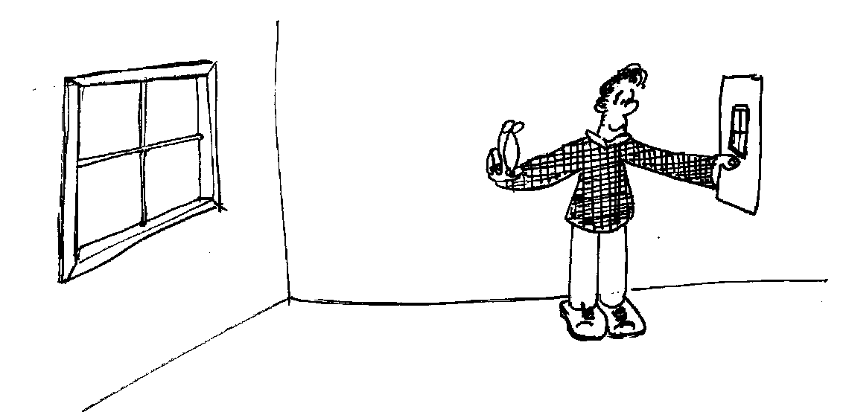
Hold the lens up to the window and hold a piece of paper behind it (on the other side of the lens from the window). Move the paper until you get a sharp image of the world outside the windows (or distant object such as a tree).
What is the focal length of the lens?

3. Real and virtual images
Examine the slide projector, and use it to produce an image.
Draw a ray diagram showing how the projector produces an image.
What sort of an image is this? How can you tell?
Now use the magnifying glass to produce an image.
Draw a ray diagram to show how this image is formed. What sort of image is this one?

C. Quantitative Question:

- You will need to estimate some sizes! Consider looking at a fly which is sitting on a wall 3 m away.
  - Draw a ray diagram showing the fly and the image of that fly formed on the back of your retina. What sort of image is it?
  - How big is the image?
  - If we approximate the optical system of the eye as a thin lens, what is the focal length of this lens?

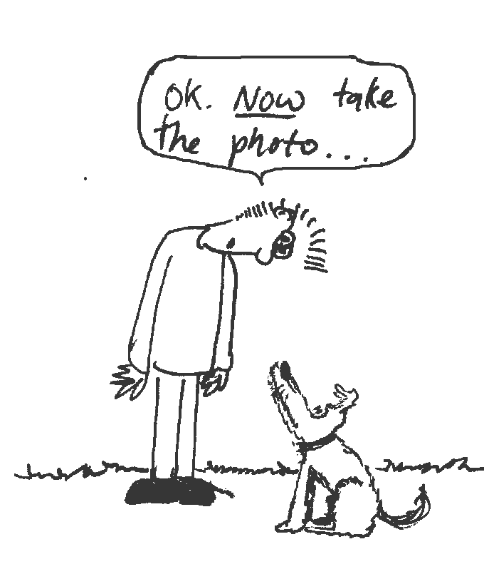
- Rebecca is trying to take a photo of Brent with their dog Barry. Usually when she takes their photo she accidentally cuts Brent’s head off. This time she is determined to get a photo showing both of them smiling at the camera. Brent is standing 3 m away, and the camera lens has a focal length of 40 mm and the film height is 24 mm.
- What is the lens to film distance of this camera?
- What is the linear magnification of the image?
- If Brent is just going to be completely in the photo, so that his feet are just seen at the bottom, and his head completely seen at the top, how tall is he?

Workshop Tutorials for Biological and Environmental Physics
Solutions to WR8B: Lenses

A. Qualitative Questions:

- In the book “Lord of the Flies” by William Golding there is a character called Piggy, who wears glasses. He uses them to start a fire, so that the group of boys stranded on the island can cook and stay warm. Later in the book he gets into a fight and his glasses are smashed. He then has trouble seeing because he is extremely short sighted. Corrective lenses for shortsightedness (myopia) are diverging or concave lenses. Diverging lenses form a virtual image behind the lens, and hence cannot be used to focus light at a point to start a fire. Piggy and friends should have starved earlier on, or Piggy must have been long sighted.
myopic
hyperopic
- Three schematic eyeballs are shown below; a normal, a myopic and a hyperopic.
See diagram opposite.
- The top eyeball is myopic (short sighted).
- The lower eyeball is hyperopic (long sighted).
- See opposite, the lens forms an image in front of the retina.
- See opposite, the lens forms the image behind the retina.
- Myopia requires a diverging (concave) lens, hyperopia requires a converging (convex) lens.
Hyperopia
Myopia

B. Activity Questions:
convex
concave

1. Lenses – concave and convex
Convex lenses are converging lenses, and concave lenses are diverging lenses. See diagram opposite.

2. Half a lens
When you cover half the lens you get a fainter image. Effectively you are cutting out half the light rays, but they still produce an entire image.
object
image
object
image
complete lens – bright image
half covered lens – faint image

3. Lenses – finding the focal length of a convex lens
Hold the lens up to the window and hold a piece of paper behind it (on the other side of the lens from the window). Move the paper until you get a sharp image of the world outside the windows (or distant object such as a tree). When you have a sharp image, you measure the distance between the lens and the image (paper). This distance is the focal length of the lens.
(Using $\frac{1}{f}=\frac{1}{o}+\frac{1}{i}$, and o = ∞ so that $\frac{1}{o}$ = 0, gives f = i )
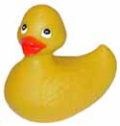

i
o
f
i
o
f

4. Real and virtual images
A slide projector produces a real, inverted and magnified image. The image must be real, because otherwise you wouldn’t be able to project it onto a screen. The image is inverted, so the slides have to be put in upside down. A projector uses a convex lens.
A magnifying glass also uses a convex lens. The image is upright, magnified and virtual. The object must be at or within the focal length of the lens.

C. Quantitative Question:

- Consider looking at a fly which is sitting on a wall 3 m away. A fly is around 3 mm long, and eyeballs are around 2cm in diameter.
i = 2 cm
o = 3 m
a. See diagram opposite. The image is real, inverted and reduced.
- The image size can be found using:
$\frac{h_{i}}{h_{o}}=\frac{i}{o}$, we know that o = 3 m, and we estimate the image distance as 2 cm (the length of the eyeball.
Assuming the fly is 3 mm long, the image height is
h_{i} = 0.003 m × (0.02 m /3 m) = 2 × 10⁻⁵ m or 20 μm. Only 20 millionths of a metre!
- If we approximate the optical system of the eye as a thin lens, the focal length can be found:
$\frac{1}{f}=\frac{1}{o}+\frac{1}{i}$ = $\frac{1}{3m}+\frac{1}{0\text{.}\text{02}m}$ = 50.3 m⁻¹, so f = 0.02 m.

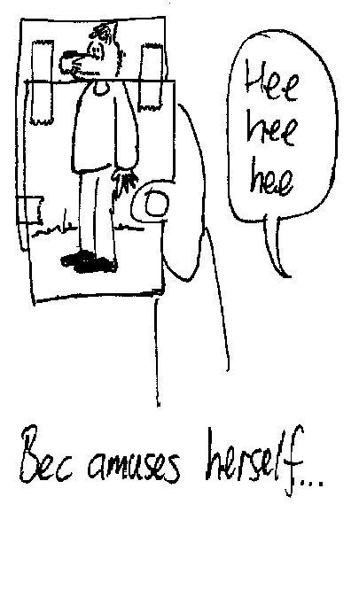
- Rebecca is trying to take a photo of Brent with their dog Barry. Usually when she takes their photo she accidentally cuts Brent’s head off. This time she is determined to get a photo showing both of them smiling at the camera. Brent is standing 3 m away, and the camera lens has a focal length of 40 mm and the film height is 24 mm.
- If $\frac{1}{f}=\frac{1}{o}+\frac{1}{i}$, $\frac{1}{0\text{.}\text{04}m}=\frac{1}{3}+\frac{1}{i}$,
so $\frac{1}{i}=\frac{1}{0\text{.}\text{04}m}−\frac{1}{3m}$ = 25 m⁻¹ and i = 0.04 m = 40 mm.
This makes sense - the image distance and focal length must be approximately the same, so that the camera can take photos of things far away.
- The linear magnification of the image is
m =$\frac{i}{o}$= $\frac{0\text{.}\text{04}m}{3m}$= 0.013.
- If Brent is only just going to be completely in the photo, so that his feet are just seen at the bottom, and his head completely seen at the top, his height is
h_{o} = h_{i} / m = 0.024 m / 0.013 = 1.84 m.
(Brent is a little over 6 foot tall.)
Workshop Tutorials for Technological and Applied Physics
WR8T: Lenses

A. Qualitative Questions:

- Is it possible to take a photo of a virtual image by placing the photographic film at the location of an image? What about for a real image? Some people claim that it is impossible to take a photo of a rainbow. Is this true?

- Rebecca has bought a new camera and is learning what all the numbers and dials on it do. Brent explains that the f - number or f - stop of the camera lens is its focal length divided by its aperture.
  - What happens inside the camera when Rebecca changes the f-stop?
  - Why would you want to change the f-stop anyway?
  - What effects would increasing the f-stop have on the photo? What else might you need to consider?

B. Activity Questions:

1. Lenses – concave and convex
Observe how the different lenses change the direction of the light rays.
Feel the different shapes and relate the shapes to the effect of the lens.
Which ones are converging? Which ones are diverging?

2. Lenses – finding the focal length of a convex lens
Hold the lens up to the window and hold a piece of paper behind it (on the other side of the lens from the window). Move the paper until you get a sharp image of the world outside the windows (or distant object such as a tree).
What is the focal length of the lens?

3. Half a lens
Hold the lens up so that an image of the light is formed on a piece of paper.
Predict what will happen if half the lens is covered with another piece of paper.
Now get someone else to cover half the lens.
What happens to the image? Was your prediction correct?
Explain your observations.

4. Real and virtual images
Examine the slide projector, and use it to produce an image.
Draw a ray diagram showing how the projector produces an image.
What sort of an image is this? How can you tell?
Now use the magnifying glass to produce an image.
Draw a ray diagram to show how this image is formed. What sort of image is this one?

C. Quantitative Question:

- Brent has bought an underwater camera to take on a diving holiday to the Great Barrier Reef. The camera has an equi-convex lens with a refractive index of 1.6 and a focal length of 25 cm.
- What is the radius of curvature of this lens?
- What is the focal length of the lens in water (n = 1.33)?
- How do you think having a clear waterproof cover over the lens affects the pictures taken? Bear in mind that when diving you wear a mask so that your eyes look through air, then glass, into the water.

- You will need to estimate some sizes! Consider looking at a fly which is sitting on a wall 3 m away.
  - Draw a ray diagram showing the fly and the image of that fly formed on the back of your retina. What sort of image is it?
  - How big is the image?
  - If we approximate the optical system of the eye as a thin lens, what is the focal length of this lens?
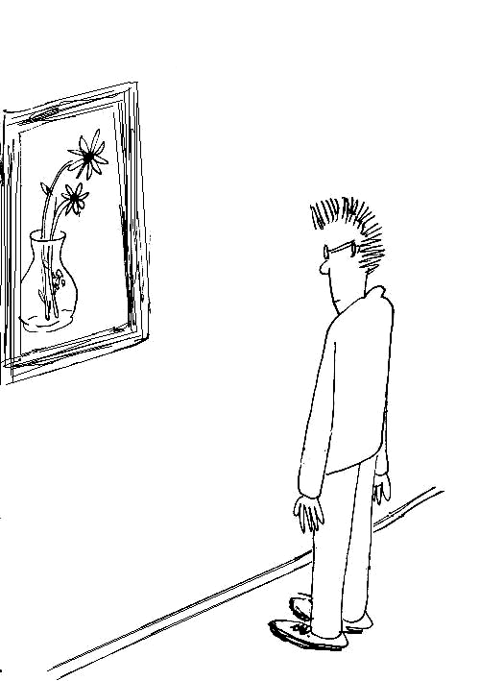

Workshop Tutorials for Technological and Applied Physics
Solutions to WR8T: Lenses

A. Qualitative Questions:

- It is not possible to take a photo of a virtual image by placing the photographic film at the location of an image because the light does not actually pass through the image, hence there would not be any light incident on the film. You could take a photo by placing the film at the position of a real image, because the light rays do pass through this point. Of course you can take a photo of a rainbow! Anything that you can see can be photographed. There are many examples of photos of rainbows.

- Rebecca has bought a new camera and is learning what all the numbers and dials on it do. Brent explains that the f - number or f - stop of the camera lens is its focal length divided by its aperture.
  - When you change the f-stop you are changing the size of the aperture. The focal length is fixed by the lens and doesn’t change.
  - A smaller aperture, or larger f-stop gives you an increased resolution, like looking through a pin hole.
  - Increasing the f-stop , by decreasing the aperture size, lets less light into the camera. This means that to get the same amount of light, or exposure, you need a longer shutter time. The longer the shutter is open, the more likely it is that someone in the photo will move, giving a blurry image. This is why films come in different speeds – a higher speed film is more sensitive and can take a photo in a shorter time, so is better for getting action shots without blurring.

B. Activity Questions:
convex
concave

1. Lenses – concave and convex
Convex lenses are converging lenses, and concave lenses are diverging lenses. See diagram opposite.
A convex lens gives a real, inverted image. A Concave lens gives a virtual upright image.

2. Lenses – finding the focal length of a convex lens
Hold the lens up to the window and hold a piece of paper behind it (on the other side of the lens from the window). Move the paper until you get a sharp image of the world outside the windows (or distant object such as a tree). When you have a sharp image, you measure the distance between the lens and the image (paper). This distance is the focal length of the lens.
(Using $\frac{1}{f}=\frac{1}{o}+\frac{1}{i}$, and o = ∞ so that $\frac{1}{o}$ = 0, gives f = i )

3. Half a lens
When you cover half the lens you get a fainter image. Effectively you are cutting out half the light rays, but they still produce an entire image.
object
image
object
image
complete lens – bright image
half covered lens – faint image

i
o
f
i
o
f

4. Real and virtual images
A slide projector produces a real, inverted and magnified image. The image must be real, because otherwise you wouldn’t be able to project it onto a screen. The image is inverted, so the slides have to be put in upside down. A projector uses a convex lens.
A magnifying glass also uses a convex lens. The image is upright, magnified and virtual. The object must be at or within the focal length of the lens.

C. Quantitative Questions:

- Brent has bought an underwater camera to take on a diving holiday to the Great Barrier Reef. The camera has an equi-convex lens with a refractive index of 1.6 and a focal length of 25 cm.
- The radius of curvature of a lens is related to the focal length by $\frac{1}{f}$= (n_{lens}-n_{air})$(\frac{1}{r_{1}}+\frac{1}{r_{2}})$, for an equiconvex lens r₁ = r₂ = r, so $\frac{1}{f}$=(n_{lens}-1)$(\frac{2}{r})$. Rearranging for r gives:
r = 2(n-1) × f = 2 (1.6 – 1) × 0.25 = 0.3 m = 30 cm.
- To find the focal length of the lens in water (n_{water} = 1.33) we use:
$\frac{1}{f}$= (n_{lens}-n_{water}) $(\frac{2}{r})$ = (1.6 – 1.33) $(\frac{2}{0\text{.}3m})$ = 1.8 m⁻¹, so f = 56 cm.
- Having a clear waterproof cover made of glass over the lens means that the lens “sees” what you see in a mask, because both you and the camera look through air, then glass, into the water. If there was no air space between the lens and the water, the focal length would be much greater, and it would take very strange blurred pictures.

- Consider looking at a fly which is sitting on a wall 3 m away. A fly is around 3 mm long, and eyeballs are around 2cm in diameter.
i = 2 cm
o = 3 m
a. See diagram opposite. The image is real, inverted and reduced.
b. The image size can be found using:
$\frac{h_{i}}{h_{o}}=\frac{i}{o}$, we know that o = 3 m, and we estimate the image distance as 2 cm (the length of the eyeball.
Assuming the fly is 3 mm long, the image height is
h_{i} = 0.003 m × (0.02 m /3 m) = 2 × 10⁻⁵ m or 20 μm. Only 20 millionths of a metre!
c. If we approximate the optical system of the eye as a thin lens, the focal length can be found:
$\frac{1}{f}=\frac{1}{o}+\frac{1}{i}$ = $\frac{1}{3m}+\frac{1}{0\text{.}\text{02}m}$ = 50.3 m⁻¹, so f = 0.02 m.

Workshop Tutorials for Physics
WR9: Optical Instruments

A. Qualitative Questions:

- Why do you think the resolving power of an instrument depends on the wavelength of radiation being used in the instrument? Would it be easier to resolve two red sources or two blue sources?

- When discussing the ability of an optical instrument to aid our ability to see we discuss the angular magnification of the instrument. Why do we talk about angular magnification rather than actual sizes of objects and images?

B. Activity Questions:

Magnifying glass
Explain how the magnifying glass works.
Draw a ray diagram showing the path of a light ray from the object to your eye.
What sort of image is produced?
What sort of lens does a magnifying glass use?

Thumb in your eye
Hold your thumb at arms length and look at it.
How can you work out the angle subtended at your eye by your thumb?
What does this tell you about the resolving power of the eye?

Microscope
Use the microscope to look at a small object.
Describe how the microscope works.
What is the difference between a simple and a compound microscope?

Telescopes
Look at the diagrams shown.
What sort of telescopes are these? Explain how they work.
Now examine the telescope on display, and use it to view a distant object out the window.
What sort of telescope is this?
objective mirror
secondary mirror
objective lens
eyepiece lens

C. Quantitative Questions:

1. A compound microscope has an objective lens of focal length 5 mm. The ocular (eyepiece) lens has a focal length of 4 cm. The lenses are separated by a distance of 24.5 cm.
- Where should an object be placed so that the final image is formed at infinity?
- What is the magnification produced by the objective lens?
- What is the magnification produced by the ocular lens?
- What is the total magnification of the microscope?

2. Brent has bought a kit to make himself a telescope so he can look at the stars and moon. Astronomical telescopes use two lenses to form an image of distant objects, such as stars.
- Explain with the aid of a diagram how Brent should arrange the two lenses to form an astronomical telescope.
- What factors determine the magnifying power of the telescope?
The moon is about 3.8 × 10⁵ km away from the earth and has a diameter of 3.16 × 10³ km.
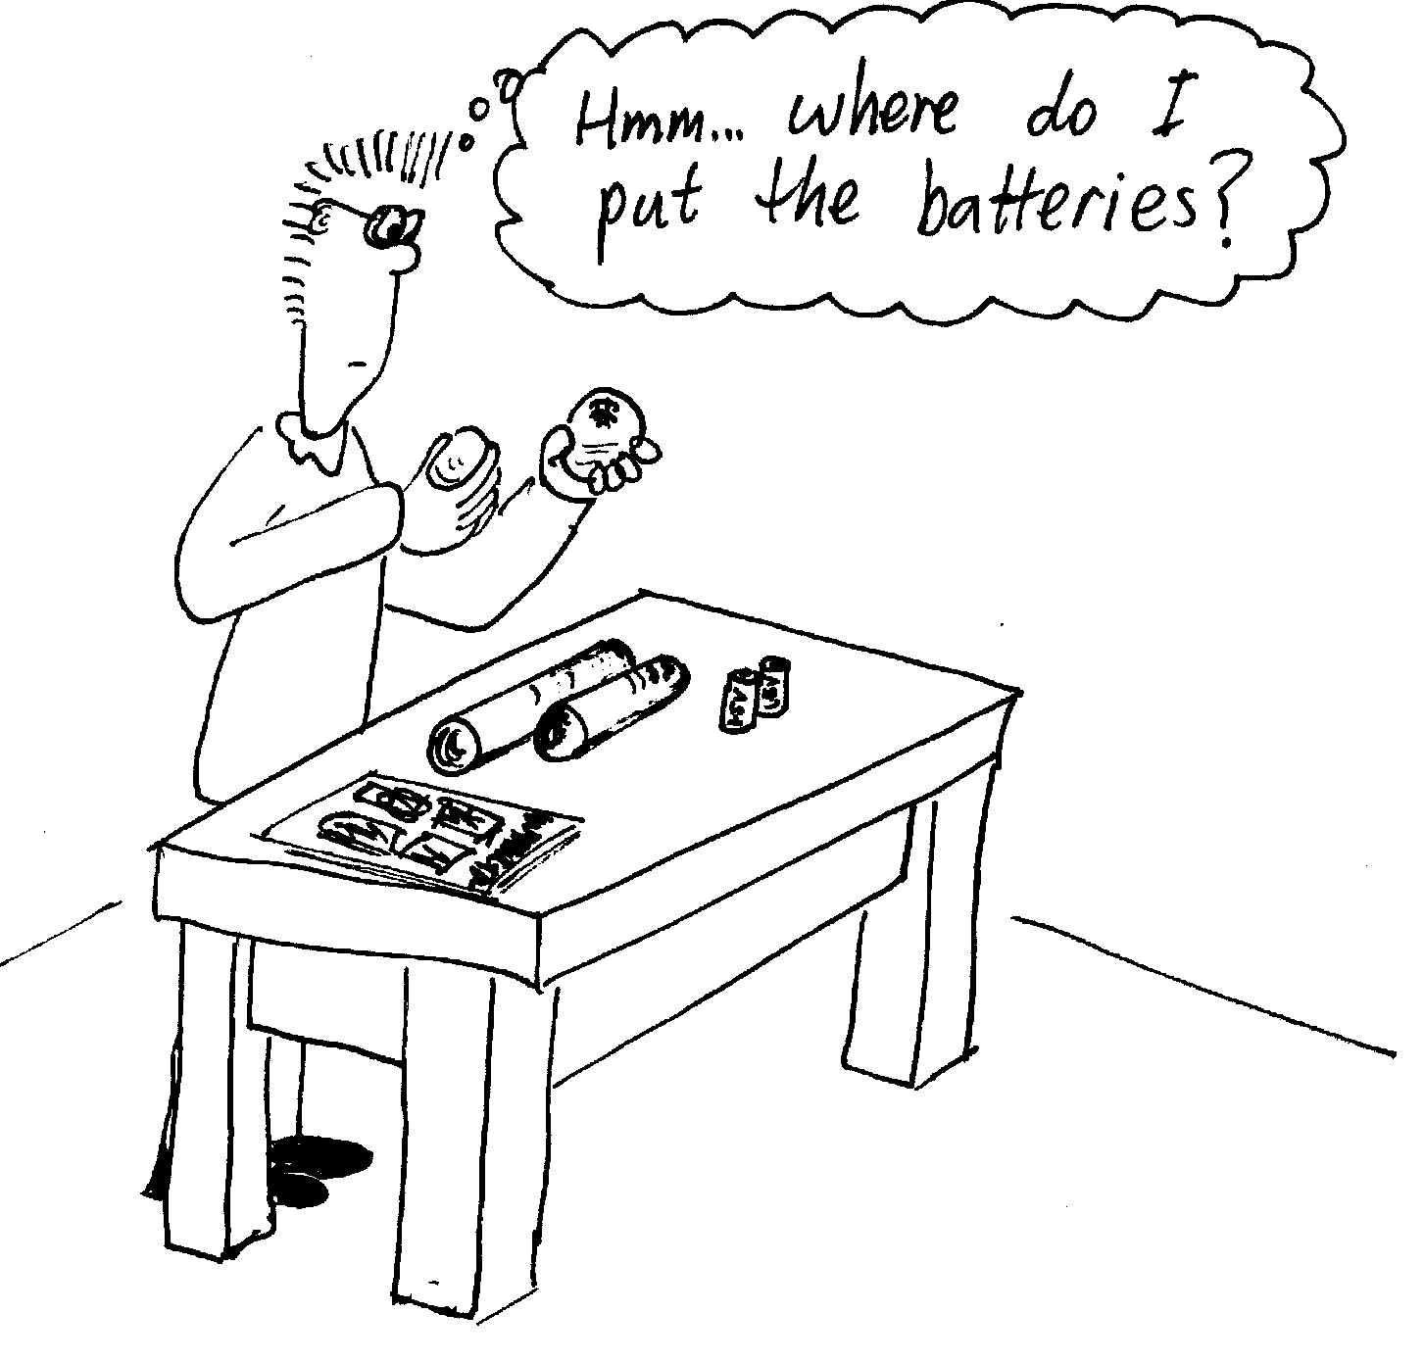
- What will be the diameter of the real image of the moon formed by an objective lens with a focal length of 16 m?

Workshop Tutorials for Physics
Solutions to WR9: Optical Instruments

A. Qualitative Questions:

- The resolving power of an instrument is governed by the Rayleigh criterion: sinθ = 1.22λ/d, where θ is the angular separation of the sources (e.g. stars viewed through a telescope) or features (fine detail viewed through a microscope) to be resolved, λ is the wavelength of the light and d is the aperture of the instrument. The Rayleigh criterion says that two features are just resolvable when the first minima of the diffraction patterns produced by the respective sources/features overlap. The larger the wavelength, the greater sinθ must be for the objects to be resolvable, and hence the longer the wavelength the lower the resolution – resolution improves with decreasing wavelength.

- When discussing the ability of an optical instrument to aid our ability to see we discuss the angular magnification of the instrument. The angular magnification is $M_{Ð}=q_{i}/q_{0}$where $q_{i}$ and $q_{o}$ are the angular sizes of the image and the object, respectively, at the standard eye near point (25cm). Dealing with angular size rather than physical object and image sizes therefore gives a definition of M that is unambiguous.

B. Activity Questions:
i
o
f

Magnifying glass
A magnifying glass uses a convex lens.
The image is upright, magnified and virtual.
The object must be at or within the focal length of the lens.

Thumb in your eye
5 cm
1 m
3º
When you hold your thumb at arms length it is approximately a metre away, and is about 5 cm tall. The angle subtended is only 3º.
The resolving power of the eye is very good, and it is easy to resolve small features on your thumb which have an angular separation much less than this.

Telescopes
A telescope is used to look at (relatively) large objects a long way away. The telescope on the left is a reflecting telescope. It uses concave mirrors to produce a real, enlarged image at the eye. Rays from a distant object come in approximately parallel and are converged by the mirrors. The telescope on the right is a refracting telescope, also called an astronomical telescope. This telescope uses a pair of convex lenses to produce a real, enlarged, upright image. The focal length of the eyepiece should be much smaller than the focal length of the objective lens.
The telescope that you used was a refracting telescope. This is the common sort of simple astronomical telescope or spotting telescope.
reflecting telescope
objective mirror
secondary mirror
refracting (astronomical) telescope
objective lens
eyepiece lens

Microscope
objective lens
eyepiece lens
A microscope is used to look at small objects close up. A simple microscope uses only one convex lens, and is really just a magnifying glass. A compound microscope which is the most commonly used type, has a pair of convex lenses, as shown. The objective lens has a small focal length compared to the eyepiece lens. The image formed by the objective is viewed by the eyepiece which acts as a magnifier.

C. Quantitative Questions:

- A compound microscope has an objective lens of focal length 5 mm. An object is placed 5.2 mm from the objective lens. The ocular (eyepiece) lens has focal length of 4 cm. The lenses are separated by a distance of 24.5 cm.
- The object should be placed at the secondary focal point (at distance –f from lens) to give an image at infinity.
- The objective magnification m_{o} = $\frac{i}{o}$ where i is the image point and o is the object point.
In this example, m_{o} = $\frac{i_{o}}{o_{o}}$= $\frac{i_{o}}{f_{o}}$. We have $\frac{1}{f_{o}}=\frac{1}{o_{o}}+\frac{1}{i_{o}}$, rearranging gives:
$\frac{1}{i_{o}}=\frac{1}{f_{o}}−\frac{1}{o_{o}}$ = $\frac{1}{i_{o}}=\frac{1}{5\text{.}0 \text{mm}}−\frac{1}{5\text{.}2 \text{mm}}$, so i = 130 mm. So now we have m_{o} = $\frac{i_{o}}{o_{o}}$= $\frac{\text{130} \text{mm}}{5\text{.}2 \text{mm}}$= 25.
- The magnification produced by the ocular or eyepiece lens is m_{e} = $\frac{i_{e}}{o_{e}}$ where i_{e} and o_{e} are the eyepiece image and object distances respectively. We have i_{e} = 245 mm – 130 mm = 115 mm. Using the lens formula again gives: $\frac{1}{f_{e}}=\frac{1}{o_{e}}+\frac{1}{i_{e}}$, rearranging gives:
$\frac{1}{i_{e}}=\frac{1}{f_{e}}−\frac{1}{o_{e}}$ = $\frac{1}{i_{e}}=\frac{1}{\text{40} \text{mm}}−\frac{1}{\text{130} \text{mm}}$, so i_{e} = - 58 mm. So now we have m_{e} = $\frac{i_{e}}{o_{e}}$= $\frac{\text{130} \text{mm}}{\text{58} \text{mm}}$= -2.2.
- The total magnification of the microscope is m_{total} = m_{o} × m_{e} = 25 × -2.2 = -56.

- Astronomical telescopes use two lenses to form an image of distant objects, such as stars.
- See diagram opposite. The lens with the longer focal length (less convex) goes on the object side.  - The magnification of a telescope is the –ve of the ratio of the focal length of the objective to the eyepiece. | f_{o}  h_{image}  r_{moon}  h_{moon}  h_{image}
- The moon is about 3.8 × 10⁵ km away from the telescope and has a diameter of 3.16 × 10³ km, and is viewed with an objective lens with focal length 16 m. Using similar triangles and looking at the diagram above, you can see that h_{moon} /r_{moon} = h_{image} /f_{o} . Rearranging for h_{image} gives:
h_{image} = (h_{moon} /r_{moon} ) × f_{o} = (3.16 × 10⁶ m / 3.8 × 10⁸ m) × 16 m = 0.13 m or 13 cm.
(Note that r_{moon} >> f_{o}, so we can use r_{moon} when really we should use r_{moon} – f_{o})

Workshop Tutorials for Physics
WR10: Physical Optics

A. Qualitative Questions:

- Consider light from a laser incident on two narrow slits. The pattern produced by the light is shown opposite.
  - If you treated light as rays moving in straight lines, what sort of pattern would you expect from the slits?
  - Explain why you need to treat light as a wave to explain the pattern that is formed.
Describe what would happen to the pattern if:
  - the distance between slits was decreased
  - the screen was moved closer to the slits
  - the width of each slit is decreased
  - one of the slits is covered.

- The diagram below shows a light source which shines on a slit. The slit is twice as long as it is wide. The angle between the center of a diffraction pattern and the first minimum is given by sinθ = λ/a where a is the width of the slit. Given this information, predict what the diffraction pattern for this source and slit will look like.
2w
w
?

B. Activity Questions:

2 source interference patterns
Place the circular wave pattern on the transparency over the pattern on the paper so that the sources are at the same point.
Now move them apart until you first get nodal lines.
How far are the sources apart now (in multiples of λ)?
Why can’t there be any nodal lines for smaller separations?

Single Slit Diffraction
Examine the diffraction pattern produced by the laser beam passing through the slit.
Why do you get maxima and minima?
What happens when you change the slit width? Explain why.

CD
Look at the light reflected from the CD.
Why do you see different colours in it?

Diffraction patterns
Shine the laser light through the fabric.
What sort of pattern do you see?
How does the pattern change when you stretch the fabric horizontally?
What about when you stretch it vertically?
Explain why this happens.

C. Quantitative Question:

- When you buy a pair of glasses you are asked whether you want all different sorts of options, like lenses that turn dark when it’s sunny, polaroid lenses and anti-scratch and antireflection coatings. Consider a lens as shown below with a coating on the glass. The peak wavelength emitted by our sun is around 500 nm, and this is the wavelength we are most sensitive to.
light,
λ = 500 nm.
glass n =1.5
coating n =1.25
air n =1.0

- If a ray of sunlight (use λ = 500 nm) is reflected from the air-coating interface, will it undergo a phase change on reflection?
- Would it undergo a phase change on reflection from the coating-glass interface?
- Given your answers to a and b, write down the condition for destructive interference of the reflected rays.
- Calculate the minimum thickness of coating required to provide anti-reflection for sunlight.

- An interference pattern is formed by shining light of wavelength λ = 550 nm through twin slits. The slits have a width of 0.03 mm and are spaced 0.15 mm apart.
  - How many complete fringes appear between the central maximum and the first minimum of the fringe envelope?
  - Sketch the pattern formed by this arrangement of slits.

Workshop Tutorials for Physics
Solutions to WR10: Physical Optics

A. Qualitative Questions:

- Consider light from a laser incident on two narrow slits.
  - If you treated light as rays moving in straight lines, you would expect to get two illuminated rectangles (essentially images of the two slits) on the screen in line with the slits – in this case the slits behave as a ‘shadow mask’ for the light.
  - You need to treat light as a wave to explain the interference pattern that is formed. A wave is a succession of crests and troughs. The alignment at a given point on the screen of crest-with-crest or crest-with-trough leads to bright (maxima in intensity) or dark (minima) ‘fringes’ respectively. This is called an interference effect and is characteristic of interacting waves.
The angular position θ of the fringes at the screen is given by $\text{sin}θ=λ/d$ for wavelength λ and distance between slits d. The actual distance between any fringe and the centre of the pattern is y_{m} = mλL/d where m is the order of the fringe (m = 0, 1, 2…) and L is the distance from the screen to the slits.
  - If the distance between slits was decreased, sinθ would be bigger, and the fringes further apart.
  - $θ=y/L$ where y is height of a fringe above the centre of screen and L is slits-screen separation. If the screen is moved closer to the slits, decreasing L, this will again lead to an increase in fringe spacing.
  - Diffraction minima occur at $a\text{sin}θ_{d}=mλ$, slit width a, integer m. For fixed d but decreased a, $q_{d}$ increases so the fringes become broader.
  - If one of the slits is covered the interference effect will disappear. However a diffraction pattern due to a single slit will be observed on the screen.

- A light source that shines on a slit. The slit is twice as long as it is wide. The angle between the center of a diffraction pattern and the first minimum is given by sinθ = λ/a where a is the width of the slit. We will see a diffraction pattern – a bright central fringe with successively fainter subsidiary maxima either side – that is exactly twice as big vertically as it is laterally.

B. Activity Questions:

2 source interference patterns
For a trough from one source to meet a crest from the other requires a path difference of ½ λ between the two waves. Hence a nodal line first appears along the axis joining the two sources when the sources are ½ λ apart. At any separation smaller that this there are no lines along which troughs and crests meet to give destructive interference.

Single Slit Diffraction
Diffraction patterns occur when light passes through a single slit. A diffraction pattern is an interference pattern due to the path difference between light arriving at a point from the left hand end of the slit and light arriving from the right hand end of the slit. A slit of width a will give a path difference of a sinθ for the two rays. The diffraction minima occur when the path difference is equal to a multiple of ½λ, i.e where a sinθ = ½ mλ, so sinθ = ½ mλ/a. The bigger the slit, the smaller the spacing between fringes.

CD
Compact discs behave like diffraction gratings. This is because the data is stored on a CD using pits, and each pit is around 500 nm wide – within the wavelength range of visible light. When light is incident on the CD it is reflected from the pits and interferes. The intensity of the resultant light depends on the path difference, which is a function of wavelength. Different wavelengths hence give constructive or destructive interference at a given point, giving a particular colour at that point.

Diffraction patterns
The network of fine threads in the fabric forms a grating. When you shine the laser light through the fabric you see a diffraction pattern.
pull
pull
pull
pull
The spacing between the maxima in the pattern (bright spots) is inversely proportional to the grid spacing; d sinθ = mλ, can be used to find the grid spacing, d, given the angular separation, θ, of the maxima.
The diagrams show the fabric to the left and the diffraction pattern to the right.
When you stretch the fabric horizontally it also squeezes in vertically, the pattern will do the reverse of this, squeezing in horizontally and stretching vertically. When you stretch it vertically it will squeeze in vertically and stretch horizontally.

C. Quantitative Question:

- Consider a lens as shown below with a coating on the glass.
- If a ray of sunlight is reflected from the air-coating interface. A phase change occurs upon reflection at an interface when the reflecting medium has higher index of refraction. Here, n_{coating} > n_{air,} so a phase change of π rad occurs.  - It would also undergo a phase change on reflection from the coating-glass interface, as n_{glass} > n_{coating}. | λ = 500 nm.  glass n =1.5  coating n =1.25  air n =1.0
- The required condition for destructive interference is 2d = (m + ½) λ/n, where d is the coating thickness and m = 0,1,2…. There is no phase change of the transmitted wave.
- The minimum thickness of coating required to provide anti-reflection for sunlight is when m = 0, so:
d = ½ (½) λ/n = ¼ × (500 × 10⁻⁹ m / 1.25) = 1.0 × 10⁻⁷ m = 10 μm.

- An interference pattern is formed by shining light of wavelength λ = 550 nm through twin slits. The slits have a width of 0.03 mm and are spaced 0.15 mm apart.
  - We know $I=I_{\text{max}}({\text{cos}}^{2}β){\left(\frac{\text{sin}α}{α}\right)}^{2}$ where $β=\frac{πd}{λ}\text{sin}θ$ and $α=\frac{πa}{λ}\text{sin}θ$.
For the interference pattern: $β=(2m+1)\frac{π}{2}$ where m = 0, 1, 2… gives zeros in intensity.
For the diffraction pattern: α = mλ gives zeroes in intensity. The first diffraction minimum is when m = 1 so sinθ = λ/a. So we can find the number of interference minima before the first diffraction minima using: $(2m+1)\frac{π}{2}=\frac{πd}{λ}\text{sin}θ=\frac{πd}{λ}\left(\frac{λ}{a}\right)$ and $2m+1=2\left(\frac{d}{a}\right)=2\left(\frac{0\text{.}\text{150}\text{mm}}{0\text{.}\text{030}\text{mm}}\right)=\text{10}$ so 2m + 1 = 10, m = 4. 5, but m must be an integer, hence m = 4.
5
4
2
0
I
I_{m}
1
2
3
4
5
3
  - The pattern formed by this arrangement of slits is shown opposite.

