**Exploding star in the constellation of the Dolphin caught blowing a bubble**

UNIVERSITY OF SYDNEY, AUSTRALIA – Astronomers at the Sydney Institute for Astronomy were part of a team to make the first images of the expanding thermonuclear fireball from a “nova” star that erupted last year in the constellation of Delphinus “The Dolphin”. The new research will be published in the journal *Nature* today. Prof. Peter Tuthill from Sydney University and co-author on the paper, says that this has got astronomers excited “Although novae often play second fiddle in the popular imagination to their more famous big cousins - the supernovae - they are a truly remarkable celestial phenomenon”.

The term *nova* – Latin for “*new”* – entered the scientific lexicon when the famous 16th century Danish astronomer Tycho Brahe first realized that on rare occasions the immutable patterns of the fixed stars could be suddenly joined by bright interlopers which took days or weeks to gradually fade from sight. Astronomers eventually traced the culprit responsible for these stellar conflagrations: an exotic, compact star called a white dwarf whose intense gravitational field is able to strip matter from a nearby larger binary-star companion.

“Like a little stellar mosquito, the white dwarf continually sucks Hydrogen from its partner, forming an ocean on its surface. After drawing about as much mass as the entire planet Saturn, the pressure reaches a critical point, then Boom! The stellar surface turns into one titanic Hydrogen bomb hurling a fireball out into space and propelling a formerly dim, obscure star system into prominence as a nova in our night skies.” explains Tuthill.

The ferocity of the expansion is breathtaking, engulfing a region the size of the Earth’s orbit within a day, and passing Jupiter’s orbit in less than two weeks. Despite the enormous size of the fireball, at the remote distance to this star of fifteen thousand light years, it took very special technology to be able to image it at all.

“We are really lucky to be collaborating with the team running the CHARA array, which sets the present state-of-the-art for making the exquisitely fine measurements needed to witness an event like this.” says Vicente Maestro, a PhD student at the University of Sydney who participated in the research. “The technical challenge posed requires magnification equivalent to watching a flower in my Spanish hometown unfold from a distance of twelve thousand kilometers away here in Sydney”.

The leader of the scientific team taking the measurements, Dr Gail Schaefer of Georgia State University, was on-hand at the Chara Array in Southern California as the data were coming in. “It was hugely exciting to see the nova grow a little bigger than before with each night’s observing. This is the first time astronomers have been able to witness an expanding fireball as if it were in the local neighborhood, rather than a tiny point of light way out in the galaxy.”

Dr Theo ten Brummelaar, Associate Director of the CHARA array, adds, “These new data allow us to study in detail exactly how the fireball evolves as the gas expands and cools. It seems like the ride is a lot more complicated and bumpy for the gas than the simple models used previously would have predicted.”

Perhaps most surprising of all, despite the fury of the detonation on the white dwarf’s surface, the star itself escapes relatively unscathed and continues to buzz around its host like a persistent mosquito accumulating more matter for a repeat performance at a future date. “That is unlikely to be in our times” suggests Hal McAlister of Georgia State University, director of the Array, “but if another nova explodes somewhere in the night sky, the CHARA array will be ready for it.”

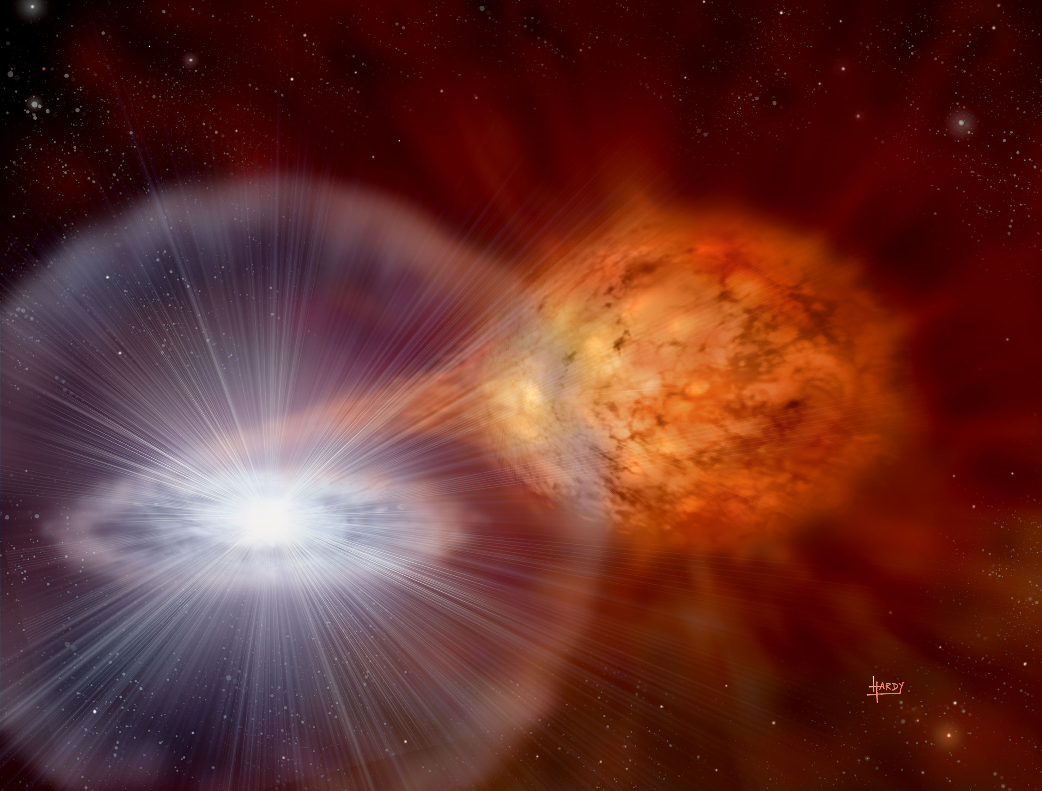

IMAGE CREDIT: © David A. Hardy / astroart.org

IMAGE CAPTION: Artist’s conception of a nova with a stream of matter being drawn from the donor star (right) by the compact white dwarf (left).



IMAGE CREDIT: Georgia State University CHARA Array

IMAGE CAPTION: The upper panels show images of Nova Del’s expanding fireball taken at two-day intervals, while the expansion as a function of time elapsed since the nova detonation is given in the lower plot.

An international team of Astronomers including the University of Sydney and led from Georgia State University contributed to this research.

**Media contact:**

Verity Leatherdale: (02) 9351 4312, 0403 067 342 or [verity.leatherdale@sydney.edu.au](mailto:verity.leatherdale@sydney.edu.au)