Astronomy Diagnostic Test (ADT) Southern Hemisphere Edition
Version 1.01

Administered in ASP1010 at Monash University, March 2002

We are conducting this survey to gain some knowledge about misconceptions commonly held among students in the Astronomy course. It is NOT for assessment purposes. The same quiz is used at the beginning and end of the course.

We ask for your ID number in order to evaluate any changes in responses to the survey questions. No information about your identity will be used by people teaching or assessing the course.

Student ID Number: ____________________

Indicate your answer for each question by ticking the box beside the appropriate answer.

You may choose only one answer for each question.

Please be sure to tick a box for each question.

1. As seen from your current location, when will an upright flagpole cast no shadow because the Sun is directly above the flagpole?
 Every day at noon.
 Only on the first day of summer.
 Only on the first day of winter.
 On both the first days of spring and autumn.
 Never from your current location.

2. When the Moon appears to completely cover the Sun (an eclipse), the Moon must be at which phase?
 Full
 At no particular phase
 First quarter
 New
 Last quarter

3. Imagine that you are building a scale model of the Earth and the Moon. You are going to use a 30 cm basketball to represent the Earth and a 7 cm tennis ball to represent the Moon. To maintain the proper distance scale, about how far from the surface of the basketball should the tennis ball be placed?
 7 cm
 15 cm
 90 cm
 9 m
 90 m

4. You have two balls of equal size and smoothness, and you can ignore air resistance. One is heavy, the other much lighter. You hold one in each hand at the same height above the ground. You release them at the same time. What will happen?
 The heavier one will hit the ground first.
 They will hit the ground at the same time.
 The lighter one will hit the ground first.

5. How does the speed of radio waves compare to the speed of visible light?
 Radio waves are much slower.
 They both travel at the same speed.
 Radio waves are much faster.

6. Astronauts inside the Space Shuttle float around as it orbits the Earth because
 they are falling in the same way as the Space Shuttle.
 there is much less gravity inside the Space Shuttle.
 they are above the Earth's atmosphere.
 there is no gravity in space.
 more than one of the above.

7. Imagine that the Earth's orbit were changed to be a perfect circle about the Sun so that the distance to the Sun never changed. How would this affect the seasons?
 We would still experience seasons, but the difference would be much MORE noticeable.
 We would still experience seasons, but the difference would be much LESS noticeable.
 We would no longer experience a difference between the seasons.
 We would continue to experience seasons in the same way we do now.

8. Where does the Sun's energy come from?
 The combining of light elements into heavier elements
 The glow from molten rocks
 The breaking apart of heavy elements into lighter ones
 Heat left over from the Big Bang

9. On about September 22, the Sun sets directly to the west as shown on the diagram below. Where would the Sun appear to set two weeks later?

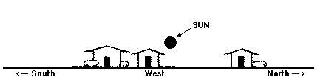
 Farther south
 In the same place
 Farther north

- If you could see stars during the day, the diagram below shows what the sky would look like at noon on a given day. The Sun is near the stars of the constellation Gemini. Near which constellation would you expect the Sun to be located at sunset?
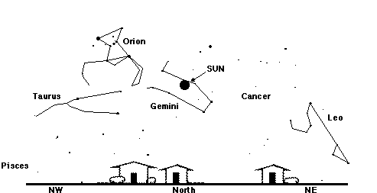
 Cancer
 Taurus
 Gemini
 Leo
 Pisces

11. Compared to the distance to the Moon, how far away is the Space Shuttle (when in space) from the Earth?
 Very close to the Earth
 About half way to the Moon
 About twice as far as the Moon
 Very close to the Moon

12. As viewed from our location, the stars of the Southern Cross can be connected with imaginary lines to form the shape of a cross. To where would you have to travel to first observe a considerable change in the shape formed by these stars?
 Across the country
 Europe
 The Moon
 Pluto
 A distant star

13. Which of the following lists is correctly arranged in order of closest-to-most-distant from the Earth?
 Moon, Sun, Pluto, stars
 Moon, Pluto, Sun, stars
 Moon, Sun, stars, Pluto
 Sun, Moon, Pluto, stars
 Stars, Moon, Sun, Pluto

14. Which of the following would make you weigh half as much as you do right now?
 Take away half of the Earth's atmosphere.
 Make the Earth spin half as fast.
 Take away half of the Earth's mass.
 Double the distance between the Sun and the Earth.
 More than one of the above

15. A person is reading a newspaper while standing 2 m away from a table that has on it an unshaded 100-watt light bulb. Imagine that the table were moved to a distance of 4 m. How many light bulbs in total would have to be placed on the table to light up the newspaper to the same amount of brightness as before?
 Three bulbs.
 One bulb.
 Two bulbs.
 Four bulbs.
 More than four bulbs

16. According to modern ideas and observations, what can be said about the location of the centre of the Universe?
 The Milky Way Galaxy is at the centre.
 An unknown, distant galaxy is at the centre.
 The Sun is at the centre.
 The Universe does not have a centre.
 The Earth is at the centre.

17. The hottest stars are what colour?
 Blue
 Red
 White
 Yellow
 Orange

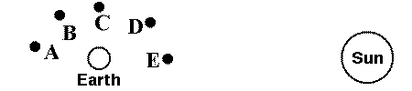
18.

The diagram above shows the Earth and Sun as well as five different possible positions for the Moon. Which position of the Moon would cause it to appear like the picture below when viewed from Earth?

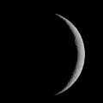
 A
 B
 C
 D
 E

- You observe a full Moon rising in the east. How will it appear in six hours?

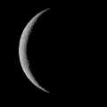
 A  B

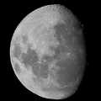
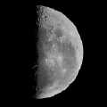
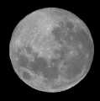
- C  D

20. With your arm held straight, your thumb is just wide enough to cover up the Sun. If you were on Saturn, which is 10 times farther from the Sun than the Earth is, what object could you use to just cover up the Sun?
 Your wrist
 A hair
 A strand of spaghetti
 Your thumb
 A pencil

21. Global warming is thought to be caused by the
 addition of carbon dioxide.
 destruction of the ozone layer.
 trapping of heat by nitrogen.

The following is background information to help analyse the quiz results

22. In general, how confident are you that your answers to this survey are correct?
 Very confident
 Confident
 Not sure
 Not very confident
 Not at all confident (just guessing)

23. What is your gender?
 Male
 Female
24. In what year are you at university?

 First year
 Second year
 Third year
 Fourth year

 Other

25. In what Faculty are you enrolled (or primarily interested if double degree)?
 Science or Engineering
 Arts
 Education
 Economics
 Other

26. Did you do Physics at the VCE level or equivalent?
 Yes
 No

27. What level of Physics have you reached at university (i.e. this year)?
 No university Physics.
 Junior (1st) year.
 Intermediate (2nd) year.
 Senior (3rd) year or higher.

28. Which best describes the level of difficulty you expect/experienced from this course?
 Extremely difficult for me
 Difficult for me
 Unsure
 Easy for me
 Very easy for me

29. What final result do you expect to earn in this course?
 High Distinction
 Distinction
 Credit
 Pass
 Fail

THANK YOU for your responses, which will feed into an Australia-wide project.

The Astronomy Diagnostic Test is Copyright © The Collaboration for Astronomy Education research (CAER)
This version by the School of Physics, University of Sydney is reproduced with permission.

Last modified on 22 August, 2001.
Question 26 reworded for Victorian context; Susan Feteris, Monash University 2002
Send comments or queries to the Astronomy Course Coordinator.
Copyright © 1998-2000, School of Physics, The University of Sydney.

