Workshop Tutorials for Introductory Physics
EI2: Electric Fields

A. Review of Basic Ideas:

Use the following words to fill in the blanks:
electric, tangent, Newton’s, tractor, force, small, accelerates, positive, force fields, gravitational, lines, arrow

Electric Fields
In science fiction movies there are often _______ _______ protecting planets and spaceships from enemy attack, or being used in “_________ beams” to abduct people. In physics, fields are used to explain action, or force, at a distance. We constantly experience a force due to Earth’s gravitational field, even when we are not in contact with the Earth. Hence we are always trapped by the Earth’s ___________ force field. This is due to the interaction of masses at a distance. Electric charges also interact at a distance, attracting or repelling each other, and they do this via an ________ field.
The way we can tell if there is an electric field somewhere is to put a very ______ test charge at rest at that position and see if it experiences a force. The electric field, E, at a point in space is defined as the electric _______, F, acting on a ________ test charge divided by the magnitude of the test charge, E = F/q₀, where q₀ is the magnitude of the charge. So if our test charge ________, it must be experiencing a force, and hence there must be a field there. If we know the mass of the particle and we can measure its acceleration then we can find the force acting on it using _______ second law (F = ma). The field is then the force per unit charge at that point.
A convenient way of representing fields is by drawing field _______. We can draw a field line by imagining a test charge at a point and drawing an ________ showing the direction of any force acting on the test charge. At any point in space the ________ to the field line tells you the direction of the force acting on a test charge at that point.

Discussion Question
Explain why field lines lead away from positive charges and towards negative charges.

B. Activity Questions:

- van de Graaff generator and wig
Place the “wig” on the generator. What do you observe?
Explain your observations. Draw field lines for the dome of the generator.
What happens when a person, insulated from the ground, touches the generator?

- Confused bubbles
Bubbles blown towards a van de Graaff generator behave in different ways.
Identify some patterns of behaviour.
Are the bubbles initially neutral?
Why would bubbles be attracted or repelled by the generator?

- Ball in a capacitor
Explain what is happening to the ping pong ball.
Why is it behaving in this manner?
How would it behave if you removed the aluminium foil?
Draw the field lines for the capacitor plates.
C. Qualitative Questions:

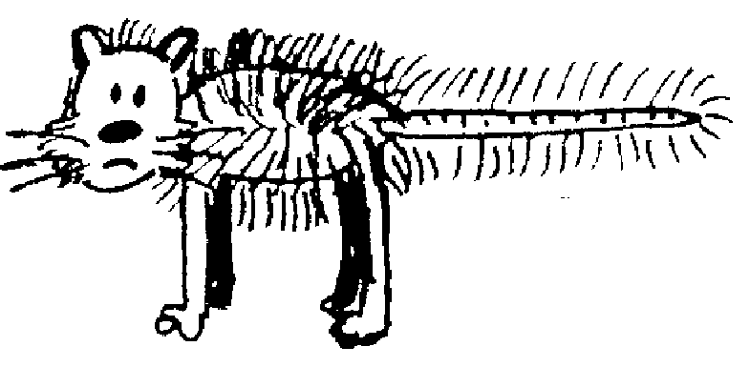
1. You charge up a cat by brushing it with a plastic comb so that the cat now has charge +q and the comb has charge –q. You charge up a test mouse to +1nC with a second comb, take that comb a long way away, then place the test mouse at different points in the room with the cat and the comb as shown below. (The room has a non-conducting floor.) Treat the cat and comb as point charges.
+q
-q
A
B
C
D
E
F

- Draw vectors showing the electric force on the test mouse at positions A, B, C, D, E and F. Draw the forces due to each charge and the net force.
- Rank the magnitudes of the electric force on the test mouse at points A, C, E and F.
- Rank the magnitudes of the electric field at points A, C E and F.
- Explain how and why your answers to part b are related to your answer for part c.
- Draw vectors showing the electric field at positions A, B, C, D, E and F. Use these vectors to help you draw field lines for the cat-comb combination.
- Are field lines “real”? Explain your answer.
V

2. Many factories use dust precipitators in their chimneys to remove airborne pollutants. The large electric field causes molecules to be ionized, and free electrons can attach to dust particles making them charged. The smoke or dust particles are attracted to the plates, and stick to them rather than being released into the atmosphere. The use of these precipitators has led to a major reduction in the levels of air pollution from factories.
In one such precipitator a pair of plates are placed in the square chimney with a large potential difference across them. A dust particle rising up the chimney has a charge of -1e.
- Draw field lines for the arrangement shown.
- Sketch the path of this particle as it ascends the chimney.
- Sketch the path of a dust particle with a charge -2e which is rising up the chimney. How will its path be different to that of the particle with charge 1e if they both have the same mass?

D. Quantitative Question:

When atoms form ionic bonds one electron is transferred from one atom to the other. This is how sodium and chlorine bind to form sodium chloride (salt). In a salt crystal the sodium is Na⁺ and the chlorine is Cl⁻, each with a charge of ±1e. They are separated in a salt crystal by 0.28 nm.
Consider only a single pair of ions, Na⁺Cl⁻, bound together.
- What is the field at a point halfway between the two ions?
- Draw a diagram showing the two ions. Draw a straight line between the two ions and extend it out to either side. Will there be any point on the line where the force on another Na⁺ ion will be zero? If so, show on your diagram approximately where this point would be.
- If you had a salt molecule with a calcium ion, Ca⁺⁺, in place of the Na⁺ would there be any point on this line where the second Na⁺ would experience no force? If so, show on your diagram approximately where this point would be.
- If there is such a point, what will the field at that point be?

