Workshop Tutorials for Introductory Physics
Solutions to EI2: Electric Fields

A. Review of Basic Ideas:

Electric Fields
In science fiction movies there are often force fields protecting planets and spaceships from enemy attack, or being used in “tractor beams” to abduct people. In physics, fields are used to explain action, or force, at a distance. We constantly experience a force due to Earth’s gravitational field, even when we are not in contact with the Earth. Hence we are always trapped by the Earth’s gravitational force field. This is due to the interaction of masses at a distance. Electric charges also interact at a distance, attracting or repelling each other, and they do this via an electric field.
The way we can tell if there is an electric field somewhere is to put a very small test charge at rest at that position and see if it experiences a force. The electric field, E, at a point in space is defined as the electric force, F, acting on a positive test charge divided by the magnitude of the test charge, E = F/q₀, where q₀ is the magnitude of the charge. So if our test charge accelerates, it must be experiencing a force, and hence there must be a field there. If we know the mass of the particle and we can measure its acceleration then we can find the force acting on it using Newton’s second law (F = ma). The field is then the force per unit charge at that point.
A convenient way of representing fields is by drawing field lines. We can draw a field line by imagining a test charge at a point and drawing an arrow showing the direction of any force acting on the test charge. At any point in space the tangent to the field line tells you the direction of the force acting on a test charge at that point.

Discussion Question
Field lines show the direction of force on a positive test charge, the definition of the electric field is the force per unit charge on a small positive test charge. The force on a positive test charge due to another positive charge is always repulsive, the force is away from the positive charge, hence field lines point away from positive charges. A positive test charge will be attracted to a negative charge, and will experience a force towards the negative charge, hence field lines lead towards negative charges.

B. Activity Questions:
off
on
field lines
- van de Graaff generator and wig
The hairs of the wig stand up because they become charged by the generator. The hair stands up because the charges exert a repulsive force on each other, the hairs try to get as far away from each other as possible and are light enough to stand up and move apart. The hairs also try to line up along the field lines, but are pulled down a bit by gravity. The finer the hair the more it will stand up. When a person touches the dome their hair will also stand up if enough charge is transferred.

- Confused bubbles
The bubbles are initially neutral. The positively charged dome of the van de Graaf generator attracts negative charges which move around to the side of the bubble facing the dome. This bubble will now be attracted to the dome. The other side of the bubble will be positively charged and if the bubble bursts, those behind it may be splashed with this excess positive charge and become positively charged and be repelled by the dome.

- Ball in a capacitor
+
-
A ping-pong ball bounces continuously in between the two charged plates of a capacitor. When it contacts with one plate it picks up sufficient charge to accelerate towards the oppositely charged plate. When the foil is removed the ball still bounces, but much more slowly because it takes a longer time to charge.
The field lines are shown opposite. The lines point from the positive plate to the negative plate, they are parallel near the middle of the plates and curve outwards near the edges of the plates
C. Qualitative Questions:
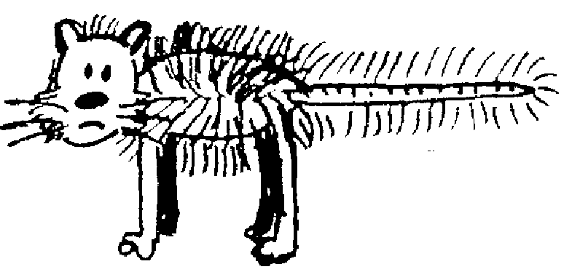
+q
-q
A
B
C
D
E
F
F_{comb}
F_{cat}
F_{net}
key:
1.

- Points C and E are both 2 grid squares away from one charge and 6.5 squares from the other, and the forces are in the same direction (towards the comb). F is two grid squares away from the comb, and 10.5 from the cat, a test charge here experiences a strong force towards the comb, but also a weak force in the opposite direction due to the cat, so the total force is weaker here than at C or E. The force at A is the weakest as it is 4 grid squares away from the cat, so it feels a relatively weak force from the cat, and is also very weakly attracted towards the comb.
Electric force at C = Electric force at E > Electric force at F > Electric force at A.
- Electric field at C = Electric field at E > Electric field at F > Electric field at A.
- The electric field at any point is defined in terms of the electrostatic force that would be exerted on a positive test charge at that point. E = F/q_{o}. The vector representing the force is a tangent to the field line.
+q
-q
A
B
C
D
E
F

- Field lines are not real, they are a convenient way of representing the field, which is a way of representing forces acting at a distance.
E
-e
-2e

2. Dust precipitators to remove airborne pollutants.
a, b. See diagram opposite. The particles follow a parabolic path, much like projectiles in a gravitational field.
c. The force on the particle with charge -2e will be greater, hence it will be more strongly attracted to the positive plate.
Note that we are ignoring other forces here such as buoyancy and drag.

D. Quantitative Question:

- The field will be equal to the field due to the Na⁺ plus that due to the Cl⁻. These will be in the same direction as the Cl⁻ will attract a positive point charge, and the Na⁺ will repel it. The total field is in the direction from the sodium ion to the chlorine ion.
^{Etotal=ENa+ECl = -}$\frac{\text{ke}}{r^{2}}$ ⁻ $\frac{−\text{ke}}{r^{2}}$^{=1.4×1011 N.C}-1
Na⁺
Cl⁻
in this region the new Na⁺ moves this way
in this region the new Na⁺ moves this way
in this region the new Na⁺ moves this way
- There is no such point in this case. If the new Na⁺ is to the left of the original Na⁺ it will move away from it. If it is anywhere to the right of the original Na⁺ it will move towards the Cl⁻.
- With a Ca⁺⁺ there will be a point to the right where the attraction of the Cl⁻ is balanced by the repulsion of the Ca⁺⁺. You can calculate where this point is by setting the force due to the Cl⁻ equal to that due to the Ca⁺⁺ and solving for r.
- If there is no force, there is no field, hence the field at this point will be zero.

