Workshop Tutorials for Introductory Physics
EI6: Electrical Safety

A. Review of Basic Ideas:

Use the following words to fill in the blanks:
disconnected, heating, contract, surges, current, static, heating, lethal, fibrillation, earthed, breathing, off, hair dryers.

Electrical Safety and First Aid
Everyone gets an occasional minor electric shock, often from ______ electricity buildup. For example you might get a little shock when you touch a car door, or a metal door handle after walking across carpet. The shock is the result of ________ passing through the body. The current has two effects, it stimulates nerves and muscles, and it causes ________ of the tissues due to dissipation of electrical energy. These effects are used by doctors to treat pain and promote healing. However both these effects, if intense enough, can be ________.
Currents of around 5 mA are generally painful, and currents larger than 10 mA can cause muscles to _________. This is very dangerous, because if you touch a live wire it may cause your hand to contract, grabbing the wire, and leaving you unable to let go. Larger currents can cause the heart muscles to desynchronize, and the heart becomes ineffective and can stop. This is called _________, and even after the current is stopped fibrillation can continue. Current can also effect the respiratory muscles, disrupting _________.
You can protect yourself from electric shock by making sure that you use appliances which are properly _________. An earth connection provides a low resistance path to the earth for any unwanted current due to surges or short circuits. This means that the current passes through the Earth connection rather than through you. Safety switches detect sudden ________ in current and cut off the electricity supply. This minimizes the time that a current can pass though a person.
A lot of electric shocks can be avoided by being careful and sensible, for example keeping appliances like _______ ________ away from sinks, and keeping trees pruned clear of power lines.
If you come across someone who has received an electric shock you need to be very careful, and not touch them or even get too close before you make sure that the current has been stopped. Always turn the power _______ if possible, and if not use a large insulator like a wooden broom handle to separate the person and the current source. Once you are sure they are ________, normal first aid procedures should be followed.

B. Activity Questions:

1. Toaster man
The ammeter (measures current) is connected at the heart position. What do you notice when you change the position of the connection from the “boot” to the “skin”?
After the power supply has been on for a while, feel the resistors. What do you notice?
First aiders always look for burns on victims of electrocution. Why?

2. Safety Switch and fuses
Examine the safety switch and fuses.
Explain how they work and the role they play in preventing power surges.

3. Earth connections
Examine the appliances.
Which ones are properly Earthed? How can you tell?

C. Qualitative Questions:
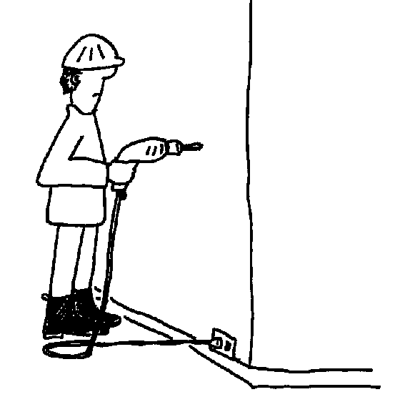

- Brian the builder is using an electric drill to put a hole in a wall so he can put a shelf up. Unfortunately Brian hasn’t checked where the power cables are inside the walls, and he’s about to drill right into one of them!
a. Draw a diagram showing the current path when Brian hits the cable if the drill is properly Earthed.
b. Draw a diagram showing the current path if the drill is not earthed.
c. What are the consequences for Brian in each case? Why is it important that appliances are correctly Earthed?

- You and your lab partner are working with electrical equipment. You see him touching two different pieces of electrical equipment at the same time.
- Why would you explain to him that this is a dangerous procedure?
Unfortunately he takes no notice of your warnings and he receives an electric shock!
- Explain what procedures you would follow to save his life, without endangering yourself.

D. Quantitative Question:

Brian the builder has drilled into a power cable in a wall, using a drill which is not Earthed. The voltage across the two live cables is 240 V, and the voltage between the drill and the Earth is also 240 V. Brian is wearing his good rubber soled boots which have a resistance of 10 MΩ, and his skin resistance is 10 kΩ. The internal body resistance is only around 100 Ω altogether.
- Draw a circuit diagram showing the resistances the current can pass through to get from the drill, through Brian, to the ground.
- Calculate the total resistance of this current path.
It takes only as little as 10 mA through the heart to cause a human heart to fibrillate and stop beating.
- What current will pass through Brian? Is he going to survive?
- What current would pass through Brian if he was working barefoot?

