Workshop Tutorials for Introductory Physics
Solutions to EI6: Electrical Safety

A. Review of Basic Ideas:

Electrical Safety and First Aid
Everyone gets an occasional minor electric shock, often from static electricity buildup. For example you might get a little shock when you touch a car door, or a metal door handle after walking across carpet. The shock is the result of current passing through the body. The current has two effects, it stimulates nerves and muscles, and it causes heating of the tissues due to dissipation of electrical energy. These effects are used by doctors to treat pain and promote healing. However both these effects, if intense enough, can be lethal.
Currents of around 5 mA are generally painful, and currents larger than 10 mA can cause muscles to contract. This is very dangerous, because if you touch a live wire it may cause your hand to contract, grabbing the wire, and leaving you unable to let go. Larger currents can cause the heart muscles to desynchronize, and the heart becomes ineffective and can stop. This is called fibrillation, and even after the current is stopped fibrillation can continue. Current can also effect the respiratory muscles, disrupting breathing.
You can protect yourself from electric shock by making sure that you use appliances which are properly Earthed. An Earth connection provides a low resistance path to the Earth for any unwanted current due to surges or short circuits. This means that the current passes through the Earth connection rather than through you. Safety switches detect sudden surges in current and cut off the electricity supply. This minimizes the time that a current can pass though a person.
A lot of electric shocks can be avoided by being careful and sensible, for example keeping appliances like hair dryers away from sinks, and keeping trees pruned clear of power lines.
If you come across someone who has received an electric shock you need to be very careful, and not touch them or even get too close before you make sure that the current has been stopped. Always turn the power off if possible, and if not use a large insulator like a wooden broom handle to separate the person and the current source. Once you are sure they are disconnected, normal first aid procedures should be followed.

B. Activity Questions:
Toaster
knife
flow of current
1. Toaster Man
For a given voltage, the greater the resistance the less current can flow, and the less likely toaster man is to be electrocuted. Electricians wear rubber soled shoes to increase the resistance between themselves and the Earth, decreasing any possible current flow through themselves. First aiders look for burns on people who have had an electric shock as the skin and internal organs act as resistors, dissipating electrical potential energy as thermal energy.

2. Safety Switch and fuses
Fuses often have a thin wire through which all the current passes. When the current flows through the wire it gets hot, due to its low but non-zero resistance. If the current gets too great the wire gets too hot and melts, opening the circuit and stopping the current from flowing. The current can get too high when there is a short circuit somewhere else in the circuit, such as a knife connecting a toaster element to Earth, so current can flow through a low resistance human rather than back through the rest of the toaster circuit.
Safety switches do the same job, but have a sensor which detects current surges and trips a switch, opening the circuit. Safety switches are very fast, and can be reset, whereas fuses have to be replaced or fitted with fresh fuse wire.
Earth
active
neutral

3. Earth connections
The appliances with a third pin in their plug are Earthed. The third wire is the Earth connection, the other two pins are the live connections – the active and the neutral. If the Earth is disconnected the appliance will usually still work, but will be unsafe to use.

C. Qualitative Questions:
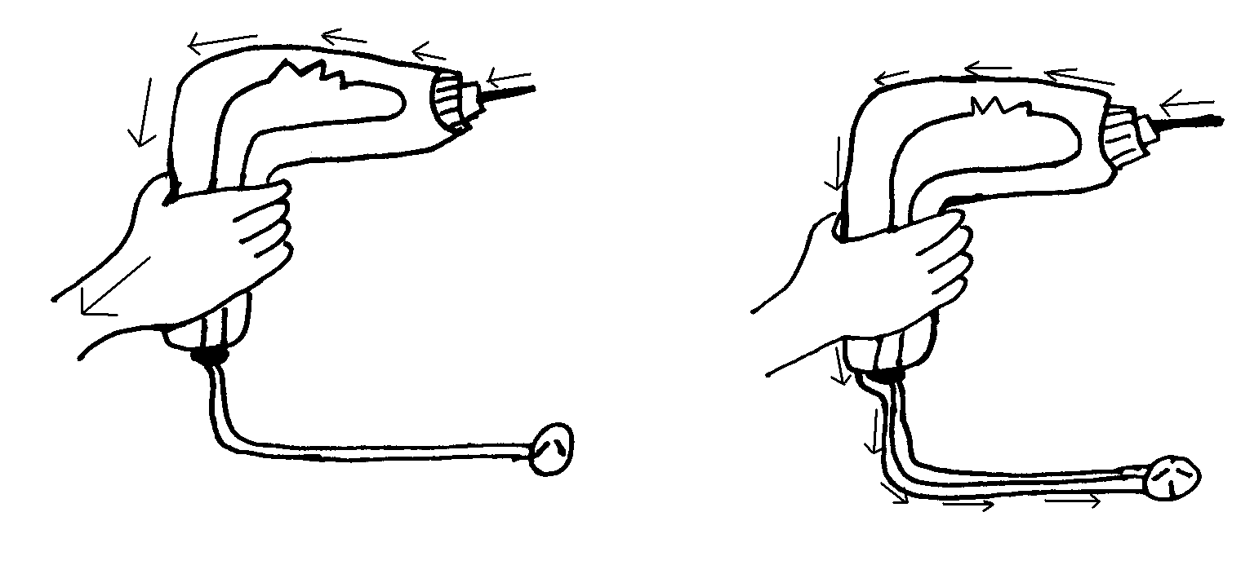
a. not Earthed.
b. Earthed.
current flow
current flow
1.

c. If the drill is Earthed only a small amount of current will flow through Brian, especially if he is wearing rubber soled boots. The Earth connection provides a path of very low resistance for the current. If the drill is not Earthed the path of least resistance from the power cable through the drill and to Earth is via Brian. Brian will probably be burnt, receive a shock, and may even be electrocuted. | 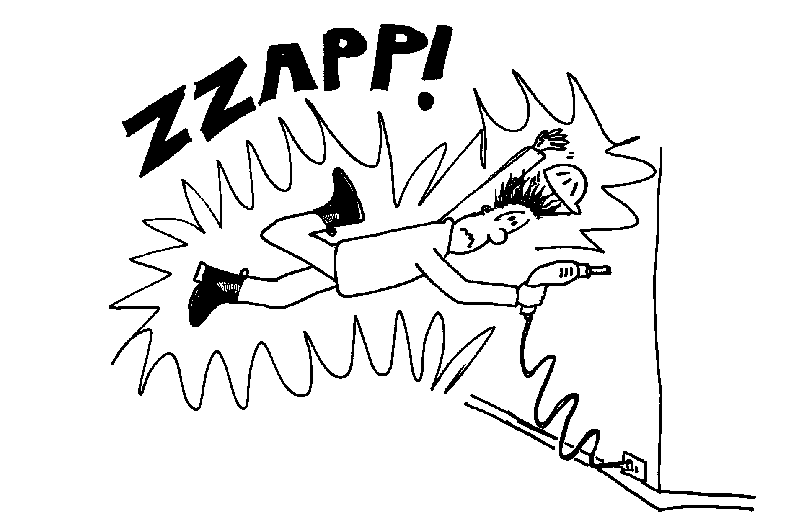

2. Your lab partner is touching two pieces of equipment at once.
- If the two pieces of equipment are at different potentials, then there is a potential difference or voltage between them. If he touches both at once he will provide a conducting path between them, and a current may flow through his body. This would be very dangerous if the current were large. Even if the equipment is properly Earthed, the potential difference may be greater between the two pieces of equipment than between either piece and the ground, and a current may flow from one to the other, or to the ground, via your lab partner.
- If your lab partner is electrocuted, DO NOT touch him! Make sure that the power is turned off or he is disconnected before you go near him. If necessary you should use something non-conductive, like a wooden broom handle, to disconnect him. Then you would follow usual first aid procedure, check for consciousness, etc, and resuscitate if not breathing. Resistors dissipate energy as heat, the greater the resistance, the hotter it will get. Skin has a high resistance, and victims of electrocution usually have burns where the current entered and exited the body. If he is conscious you should check for burns at the entry and exit points of the current, and finally you would tell him that you told him so, and explain to him the benefits of listening to your lab partner.

D. Quantitative Question:

Brian the builder has drilled into a power cable in a wall, using a drill which is not Earthed.
R_{skin}
R_{skin}
R_{skin}
R_{skin}
R_{boot}
R_{boot}
R_{skin} ~ 10 kΩ
R_{internal} ~ 100 Ω
R_{boot} ~ 10 MΩ
240 V
R_{internal}
- See opposite.
- R_{total} = R_{skin}.+ R_{internal} + R_{skin} + R_{boot}
= 10 × 10³ Ω + 100 Ω + 10 × 10³ Ω + 10 × 10⁶ Ω
~ 10 × 10⁶ Ω
- Using Ohm’s law,
i = V/R = 240V / 10 × 10⁶ Ω = 2.4 × 10⁻⁵ A
- If Brian was working barefoot his total resistance would be
R_{total} = R_{skin}.+ R_{internal} + R_{skin}
= 10 × 10³ Ω + 100 Ω + 10 × 10³ Ω = 20 × 10³ Ω
so the current would be
i = V/R = 240V / (20 × 10³ Ω) = 1.2 × 10⁻² A = 12 mA.
There is a chance that Brian’s heart would stop.

