Workshop Tutorials for Physics
ER1: Charge and Coulomb’s Law

A. Qualitative Questions:

- Which of the following effects are fundamentally electrical in nature? Briefly discuss the origin of each effect.
  - tension in a spring,
  - “crackles” when you take clothes off,
  - “crackles” from walking on dry leaves,
  - the spiral structure of galaxies,
  - nerve conduction,
  - nuclear fission,
  - the auroras,
  - pressure in a gas.

- In a simple (but not very accurate) model of the helium atom, two electrons (each of charge = -e) orbit a nucleus consisting of two protons (charge = +2e) and two neutrons (charge = 0). Is the magnitude of the force exerted on the nucleus by one of the electrons less than the force exerted on the electron by the nucleus? Explain your answer.

B. Activity Questions:

- Tape Charge
Stick two strips of tape on the desk, then peel them off.
Hang them close to each other and see what happens. Explain your observations.

- Electroscope and electrophorus
Charge up the plate using the electrophorus, by first rubbing the lower plate with the rubber glove, then placing the metal plate on the lower plate. Before the upper plate is removed, touch the top of the metal plate with your finger.
Explain how the metal plate becomes charged.
One can separate the electroscope leaves by both touching and not touching the electroscope with the metal plate.
Explain how.

- Charged rods
Charge up the rods using different materials. How do the items get charged?
Balance a charged rod on a watch glass. How can you accelerate it without touching or blowing on it?

C. Quantitative Questions:

- Newton’s law of gravitation says that the magnitude of the force between any two objects with mass is proportional to the masses of the objects and decreases with the square of the distance between them:
F_{G} = $\frac{{\text{Gm}}_{1}m_{2}}{r^{2}}$.
  - How is Newton’s law of gravitation similar to Coulombs law? How is it different?
In a simple (but not very accurate) model of the hydrogen atom, an electron orbits the nucleus at a mean distance of 5.29 × 10⁻¹¹ m. The nucleus (a proton) has a mass of 1.67 × 10⁻²⁷ kg and the electron has a mass of 9.11 × 10⁻³¹ kg.
  - What is the ratio of the gravitational force to the electrostatic force acting on the electron due to the nucleus?

Data:
G = 6.67 × 10⁻¹¹ N.m².kg⁻²
ε₀ = 8.85 × 10⁻¹² N.m².C⁻²
e = 1.6 × 10⁻¹⁹ C

2. Rebecca and Brent are putting up their Christmas decorations ready for Christmas Eve. Brent hangs a pair of glass-ball Christmas tree decorations from a single 40 cm long thread looped over a pin as shown. Rebecca wants the balls to hang 20 cm apart (centre to centre), and she suggests to Brent that he put in another pin so the balls hang apart.
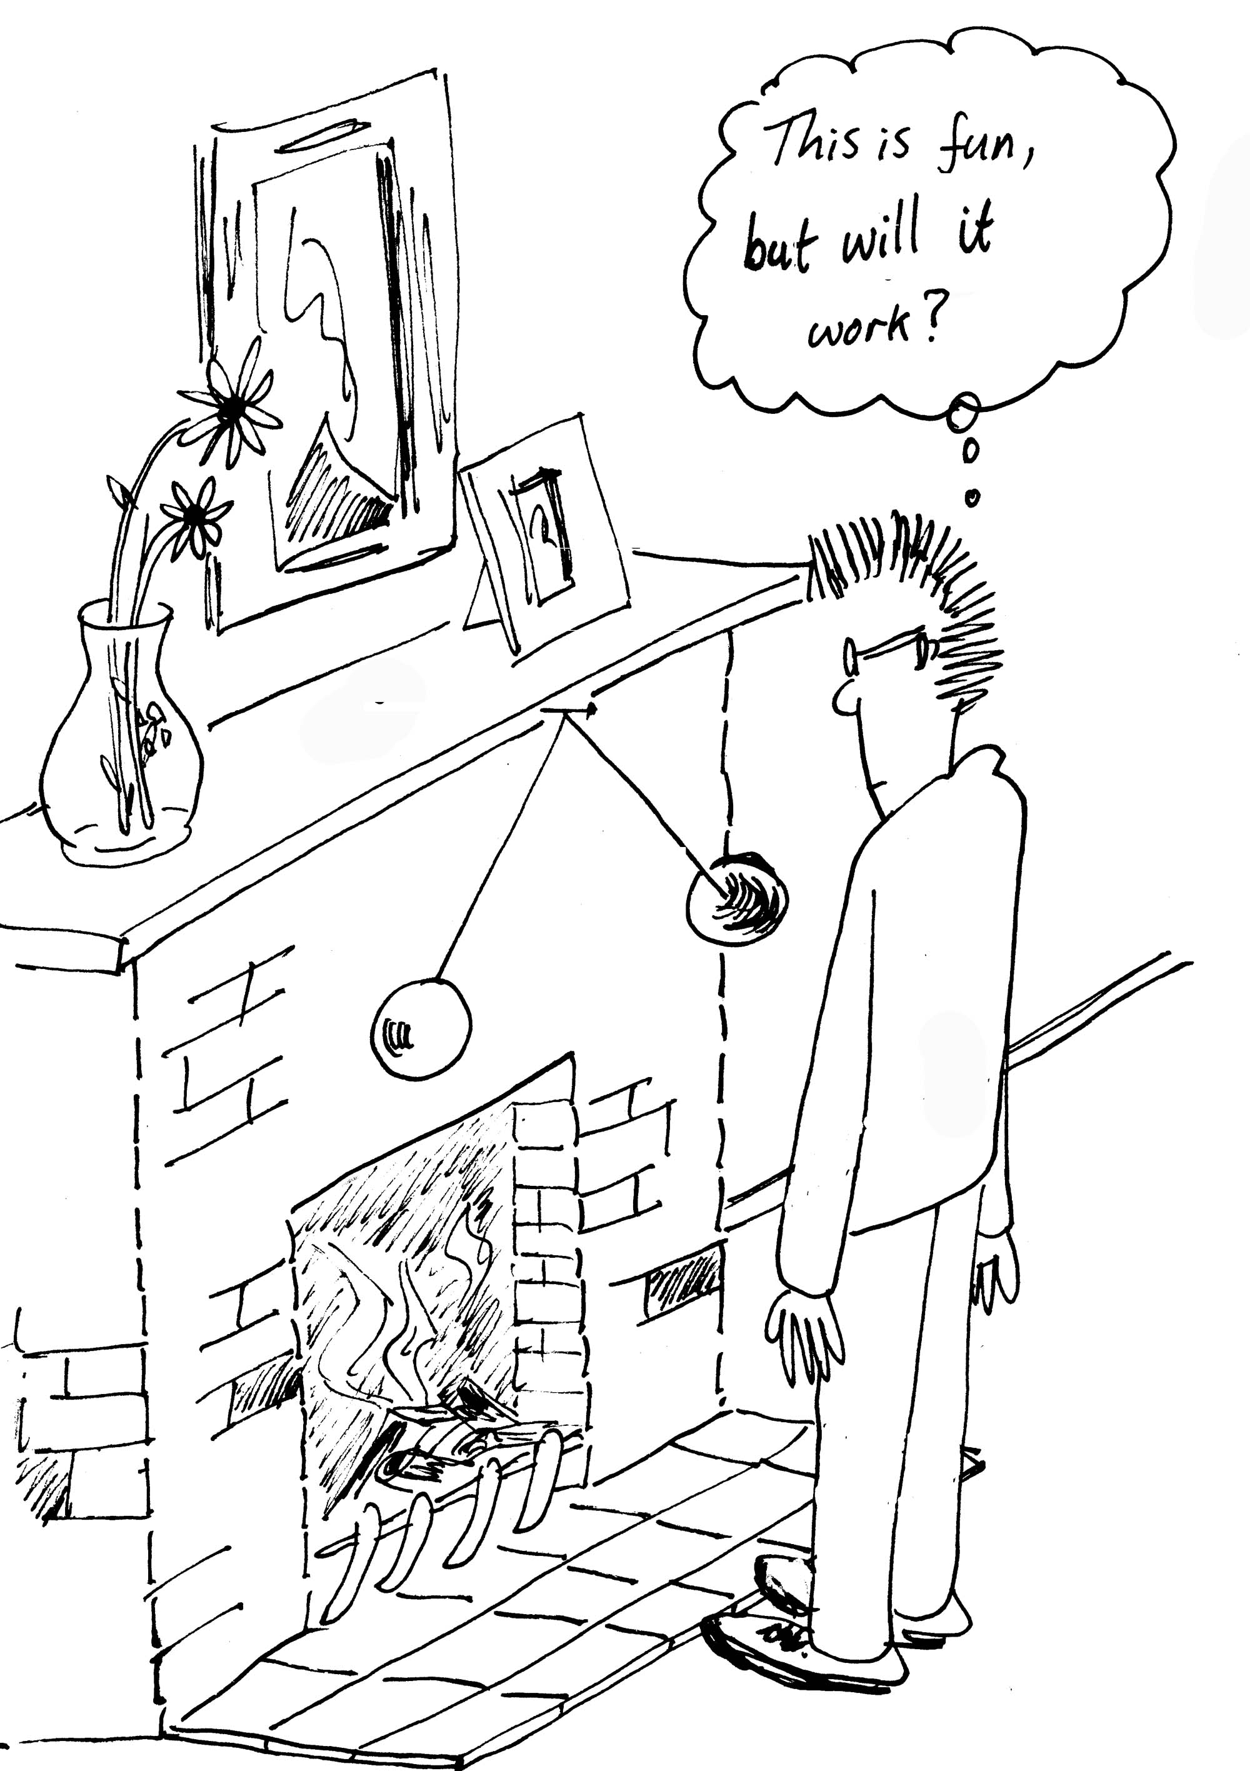
Not wanting to make lots of pin holes in the wall, Brent suggests that they charge the balls up instead so that they repel each other, thus removing the need for another pin, and simultaneously creating an interesting talking point. The thread is non-conducting, and the balls are coated in a shiny and conductive metal paint. The balls each have a mass of 10 g and a radius of 5 cm. The thread is very fine so its mass can be ignored. Brent uses Barbara the cat to charge up a Perspex rod, by rubbing it on her fur until it starts crackling and she runs away. He then uses the rod to charge the balls while holding them in contact by the threads
- Draw a diagram showing all the forces acting on the balls.
- How much charge must be placed on each ball so that they hang 20 cm apart (centre to centre) as Rebecca wants them to?
- This may be fun, but will it work?

