Workshop Tutorials for Biological and Environmental Physics
ER2B: Electric Fields

A. Qualitative Questions:

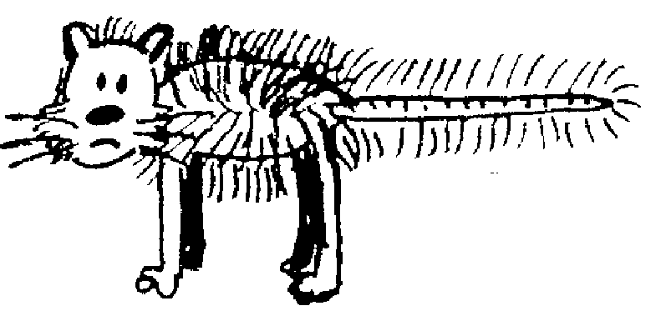
1. You charge up a cat by brushing it with a plastic comb so that the cat now has charge +q and the comb has charge –q. You charge up a test mouse to +1nC with a second comb, take that comb a long way away, then place the test mouse at different points in the room with the cat and the comb as shown below. (The room has a non-conducting floor.) Treat the cat and comb as point charges.
+q
-q
A
B
C
D
E
F

- Draw vectors showing the electric force on the test mouse at positions A, B, C, D, E and F. Draw the forces due to each charge and the net force.
- Rank the magnitudes of the electric force on the test mouse at points A, C, E and F.
- Rank the magnitudes of the electric field at points A, C E and F.
- Explain how and why your answers to part b are related to your answer for part c.
- Draw vectors showing the electric field at positions A, B, C, D, E and F. Use these vectors to help you draw field lines for the cat-comb combination.
- Are field lines “real”? Explain your answer.

- In the figure below the + signs represent a very wide and very long sheet of charge.
C D

A
B

- Draw vectors to show the direction of the electric field at the points A, B, C and D.
Two students are trying to decide where the field is strongest. Brent says that because C and D are further from the charges, the field must be weaker at these points than at A and B. Rebecca says that the field will be the same at C and D as it is at A and B because of the way the field lines are drawn.
- Draw the field lines and decide who you agree with. Explain why the other student is wrong.

B. Activity Questions:

- van de Graaff generator and wig
Place the “wig” on the generator. What do you observe?
Explain your observations. Draw field lines for the dome of the generator.
What happens when a person, insulated from the ground, touches the generator?

- Ball in a capacitor
Explain what is happening to the ping pong ball.
Why is it behaving in this manner?
How would it behave of you removed the aluminium foil?
Draw the field lines for the capacitor plates.

- Confused bubbles
Bubbles blown towards a van de Graaff generator behave in different ways.
Identify some patterns of behaviour.
Are the bubbles initially neutral?
Why would bubbles be attracted or repelled by the generator?

C. Quantitative Questions:

1. When atoms bind ionically at least one electron is transferred from one atom to the other. This is how sodium and chlorine bind to form sodium chloride (salt). In a salt crystal the sodium is Na⁺ and the chlorine is Cl⁻, each with a charge of ±1e. They are separated in a salt crystal by 0.28 nm.
- Considering only a single pair of ions, Na⁺Cl⁻, what will the force between the two ions be?
- What is the field at point halfway between the two ions?
- Draw a diagram showing the two ions. Draw a straight line between the two atoms and extend it out to either side. Will there be any point on the line where the force on another Na⁺ ion will be zero? If so, show on your diagram approximately where this point would be.
- If you had a salt molecule with a calcium ion, Ca⁺⁺, in place of the Na⁺ would there be any point on this line where the second Na⁺ would experience no force? If so, show on your diagram approximately where this point would be.
- If there is such a point, what will the field at that point be?
- What is the ratio of the force on the Cl⁻ to that on the Ca⁺⁺ ?

2. Cell membranes are made up of a double layer of fats, about 8.0 nm thick, as shown below.
Inside the cell there is an excess of negative ions, mostly Cl⁻, and outside there is an excess of positive ions, mostly Na⁺. The cell maintains an electric field across the membrane of 10⁷ N.C⁻¹.
8.0 nm
out

in

- Draw field lines for the section of membrane shown.
- What must be the charge per unit area on either side of the membrane?

