Workshop Tutorials for Biological and Environmental Physics
Solutions to ER2B: Electric Fields

A. Qualitative Questions:
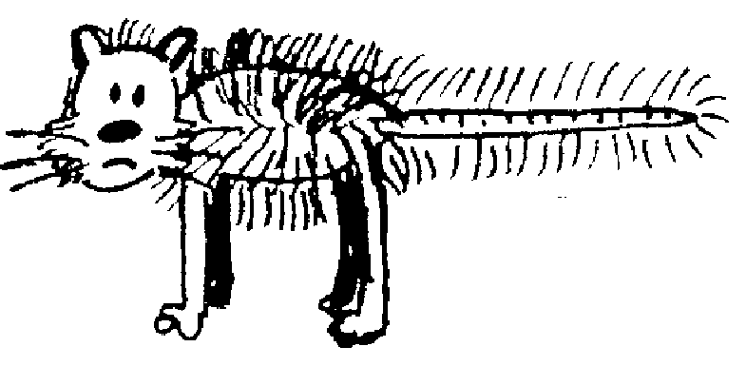
+q
-q
A
B
C
D
E
F
F_{comb}
F_{cat}
F_{net}
key:
1.

- Points C and E are both 2 grid squares away from one charge and 6.5 squares from the other, and the forces are in the same direction (towards the comb). F is two grid squares away from the comb, and 10.5 from the cat, a test charge here experiences a strong force towards the comb, but also a weak force in the opposite direction due to the cat, so the total force is weaker here than at C or E. The force at A is the weakest as it is 4 grid squares away from the cat, so it feels a relatively weak force from the cat, and is also very weakly attracted towards the comb.
Electric force at C = Electric force at E > Electric force at F > Electric force at A.
- Electric field at C = Electric field at E > Electric field at F > Electric field at A.
- The electric field at any point is defined in terms of the electrostatic force that would be exerted on a positive test charge at that point. E = F/q_{o}. The vector representing the force is a tangent to the field line.
+q
-q
A
B
C
D
E
F

- Field lines are not real, they are a convenient way of representing the field, which is a way of representing forces acting at a distance.
A B
C D
2. Electric field due to a sheet of charge.
- The field lines all point away from the sheet of positive charge. See opposite.
- Brent is wrong. The net force is perpendicular and away from the sheet. Components of the forces acting in any other direction cancel each other out. As long as the sheet is infinite, there is always a pair of charges at the same distance away in either direction from the points shown. All the field vectors have the same magnitude, and are parallel. Hence the density of field lines is not changing as we move away from the sheet, so the magnitude of the field is constant.

B. Activity Questions:
off
on
field lines
- van de Graaff generator and wig
The hairs of the wig stand up because they are charged by the generator. Usually the dome becomes positive, so negative charges move from the wig to the dome, leaving it positively charged. The hair stands up because the charges exert a repulsive force on each other, the hairs try to get as far away from each other as possible and are light enough to stand up and move apart.
The hairs also line up along the field lines. When a person touches the dome their hair will also stand up if enough charge is transferred.

- Ball in a capacitor
+
-
A ping-pong ball bounces continuously in between the two charged plates of a capacitor. When it touches one plate it picks up charge and accelerates towards the oppositely charged plate. If the foil is removed the ball still bounces, but much more slowly because it takes longer to charge. The field lines are shown opposite. The lines point from the positive plate to the negative plate, they are parallel near the middle of the plates and curve outwards near the edges of the plates

- Confused bubbles
The bubbles are initially neutral. The positively charged dome of the van de Graaff generator attracts negative charges which move around to the side of the bubble facing the dome. This bubble will now be attracted to the dome. The other side of the bubble will be positively charged and if the bubble bursts, those behind it may be splashed with this excess positive charge and become positively charged and be repelled by the dome.

C. Quantitative Questions:

1. Electrostatic forces and fields between ions in a salt crystal.
- F = $\frac{{\text{kq}}_{1}q_{2}}{r^{2}}$ = 8.9×10⁹ Nm²C⁻² ×(1.6 × 10⁻¹⁹C)²/ (0.28×10⁻⁹m)² = 2.9×10⁻⁹ N.
- The field will be equal to the sum of the field due to the Na⁺ and that due to the Cl⁻. These will be in the same direction as the Cl⁻ will attract a positive point charge, and an Na⁺ will repel it.
E_{total}=E_{Na}+E_{Cl}=$\frac{\text{ke}}{r^{2}}$+$\frac{\text{ke}}{r^{2}}$ = 2×8.9×10⁹ Nm²C⁻²×1.6×10⁻¹⁹C/(0.14×10⁻⁹m)²=1.4×10¹¹ N.C⁻¹
- There is no such point for this case, another Na⁺ will move away from the existing Na⁺ and towards the Cl⁻ if it is to the right of the Na⁺, and away further to the left if it is to the left of the Na⁺. See diagram below.
Ca⁺⁺ or Na⁺
Cl⁻
0.28 nm
0.68nm
F =E = 0 with Ca⁺⁺

- With a Ca⁺⁺ there will be a point to the right where the attraction of the Cl⁻ is balanced by the repulsion of the Ca⁺⁺. We require that F_{Cl} = F_{Ca}.
F_{Cl} = $\frac{{\text{kq}}_{1}q_{2}}{R^{2}}$= $\frac{−2\text{ke}\text{.}e}{(R+0\text{.}\text{28} \text{nm})^{2}}$ = F_{Na}. Now we can solve for R.
Cancel the k’s and e’s : 1/ R² = 2 / (R+0.28 nm)² or R² = (R + 0.28 × 10⁻⁹ m )²/2
take the square root of both sides: R = (R +0.28 nm)/√2.
- R(√2-1) = 0.28 × 10⁻⁹ m so R = 0.28 × 10⁻⁹ m/(√2-1) = 0.68 nm. If there is no force, the field is zero.
- The force will be the same on both ions, according to Newton’s 3rd law.

2. a. The field, if uniform, is E = V/d = 90 × 10⁻³V/ 8.0×10⁻⁹ m = 1.125×10⁷V.m⁻¹ ~ 1.1×10⁷V.m⁻¹.
b. The energy required to move 3 Na⁺ ions across this voltage gradient is
W = qΔV = 3×1.6×10⁻¹⁹C × 90 × 10⁻³V = 4.3×10⁻²⁰ J.
But 2 K⁺ ions move into the cell, doing work, W = qΔV = 2×1.6×10⁻¹⁹C × 90 × 10⁻³V = 2.9×10⁻²⁰ J.
The pump must supply the difference of 1.4×10⁻²⁰J.

