Workshop Tutorials for Biological and Environmental Physics
ER5B: Capacitance

A. Qualitative Questions:
d
A
- A capacitor consists of two parallel plates with area A which are separated by a distance d.
What will be the effect on the capacitance of :
- Pushing the plates toward each other so d is halved?
- Doubling the area, A, of both plates?
- Doubling the area of one plate only?
- Sliding one of the plates relative to the other so the overlap is halved?
- Doubling the potential difference between the plates?

- The cell membranes of axons and dendrites can be modelled as a circuit of resistors and capacitors, as shown below. R_{m} is the resistance of the membrane, R_{i} is the internal resistance of the cell and C_{m} is the capacitance of the membrane. When an impulse is received at a synapse there is a sharp “pulse” at that point, either a positive change in the membrane potential (an excitatory post synaptic potential) or a negative change (an inhibitory post synaptic potential). This pulse is transmitted along the dendrite to the cell body. Note that this is a passive process, the impulse is not reinforced as it travels, unlike the transmission of action potentials in the axon. Explain what effect the combination of resistance and capacitance has on the pulse as it moves along the dendrite.

R_{i}
R_{i}
R_{i}
R_{i}
R_{i}
R_{m}
R_{m}
R_{m}
R_{m}
C_{m}
C_{m}
C_{m}
C_{m}

B. Activity Questions:

- Variable capacitor I – giant capacitor
Examine the variable capacitor.
How can the capacitance be varied?
What happens to the paper strips when the capacitor is turned on? Why?
Sketch the electric field between the plates.

- Variable capacitor II – tuning capacitor
Examine the variable capacitor.
How can the capacitance be varied?
Can you think of where these devices might be used?

- Energy stored by a capacitor
Examine the circuit set up to show how energy (½ CV²) is stored by a capacitor.
Does changing the voltage supplied increase the capacity of the capacitor?
Does changing the supply voltage change the amount of energy that can be stored?
This is similar to the circuit found in the electronic flash in a camera.

C. Quantitative Questions:

- Nerve cells, such as that shown in the diagram below, transmit electrical signals between sensory receptors and the brain, and then to the muscles. A nerve cell has a cell body with dendrites where the signals come in, and a long axon at the other end where signals are sent out.
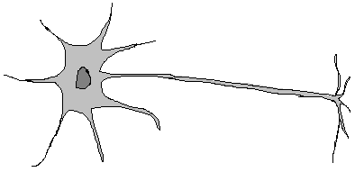
Cell body
dendrite
axon

A particular nerve cell connects a pressure sensitive cell in your big toe to another nerve in your spinal cord. The axon has a membrane with a 90mV potential difference across an 8.0 nm thick membrane . The axon is like a long tube, with a radius of 5μm and a length of 1m. The dielectric constant of the membrane is 7.
- Given the radius of the axon and the thickness of the membrane, what sort of capacitor can you treat the axon membrane as being equivalent to?
- What is the capacitance per unit area of the axon?
- What is the capacitance of the axon?
- What is the magnitude of charge separated by the axon membrane?
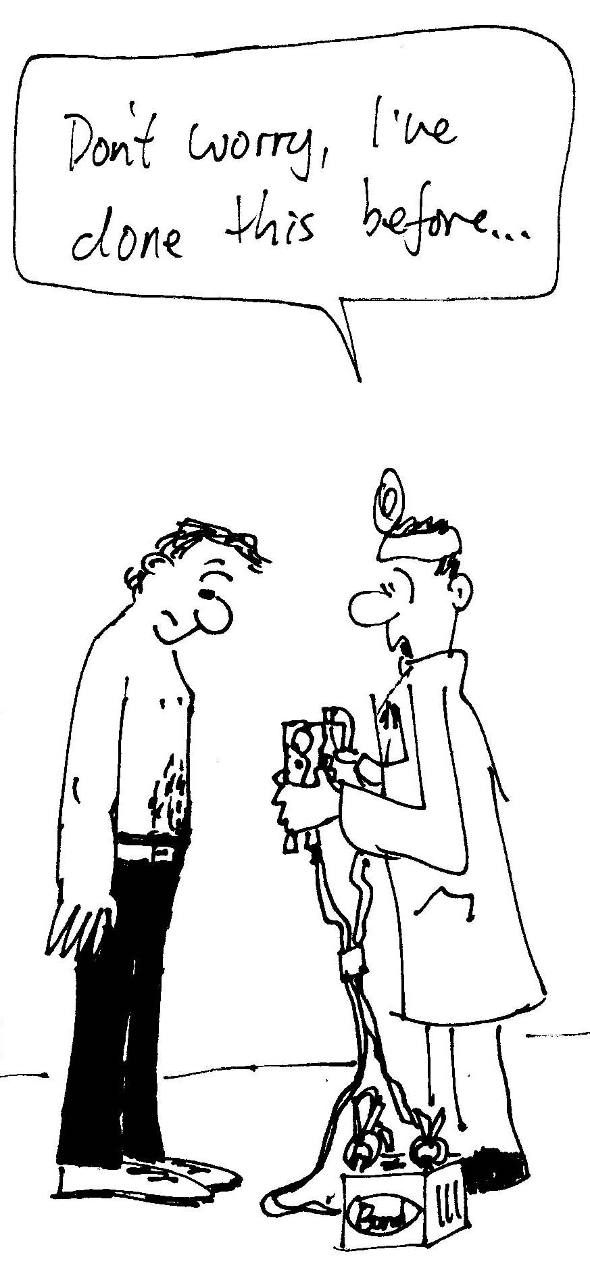
2. Electric shock can injure and harm. But it can also be used (by experts, and judiciously!) to revive people using a cardiac defibrillator which sends an electrical impulse to the heart to re-start it, for example after a heart attack. You see these being used all the time on television shows like ER, General Hospital, All Saints etc. when people are rushed into the emergency room after suffering a heart attack or bad electric shock.
A certain cardiac defibrillator consists of a capacitor charged up to 1.0 × 10⁴ V (10,000 volts) with a total stored energy of 450 J.
- Calculate the charge on the capacitor in this defibrillator.
- If the internal resistance of the defibrillator is small, and the resistance across the skin of the patients chest is 1.0 kΩ, how long will it take the defibrillator to discharge 90% of its stored charged into the patients chest?

