Workshop Tutorials for Physics
ER6: Circuits

A. Qualitative Questions:

- Consider the circuit containing 5 identical globes shown below. (Treat the globes as if they obey Ohm’s law, even though real light globes are not Ohmic.)
V
A

B
C
D E

Rank the globes, A to E, in order of increasing brightness. (Note that some may have equal brightness.)
You may want to redraw the circuit.

2. A capacitor in an RC circuit has a charge qo when the switch is open. The capacitor will discharge when the switch is closed.
- Does the time taken for the charge to fall to qo/2 depend on qo?
- Does the time required for the voltage to drop by a certain amount (say 1 volt) depend on the initial voltage?
- Does it depend on C or R?

B. Activity Questions:

- Torch – a simple circuit
Dismantle the torch and examine its components.
Draw a circuit diagram for the torch, labelling each component and showing its function.

- Resistivity and resistance
Measure the resistance of the objects displayed.
How does the length of the object affect its resistance?
Does the shape or size of its cross section have an affect?

- Current - Voltage characteristics
Sketch a graph of I vs V for a resistor and a globe.
Now do some measurements with a resistor and globe.
Do they agree with your predictions?

- Toaster man – resistors in series
The ammeter (measures current) is connected in the heart position.
What do you notice when you change the position of the connection from the “boot” to the “skin”?

- Simple membrane model – resistors in parallel
Cell membranes have channels across them which can open and close allowing current (ions) to flow in or out of the cell. This can be modeled as switches and resistors in parallel.
Close one of the switches, leaving the rest open. Measure the resistance of the membrane.
Close each of the switches, and measure the resistance each time you add another resistor in parallel.
What is happening to the total resistance? Why?
What effect does this have on current flow across the membrane?

C. Quantitative Questions:

- Any power supply, such as a mobile phone charger or a solar cell, can be treated as a source of emf, ε, (a battery) in series with a resistor, r, which is the internal resistance of the power supply.
R
power supply
r
ε

A solar cell generates a potential difference of 0.10 V across a 500 Ω resistor. The same solar panel generates a potential difference of 0.15 V across a 1000 Ω resistor.
- Write an equation relating the voltage drops around the circuit.
- What is the emf, ε, of the solar cell?
- What is the internal resistance of the solar cell?
The area of the cell is 5 cm². The rate per unit area at which it receives light energy is 2.0 mW cm⁻².
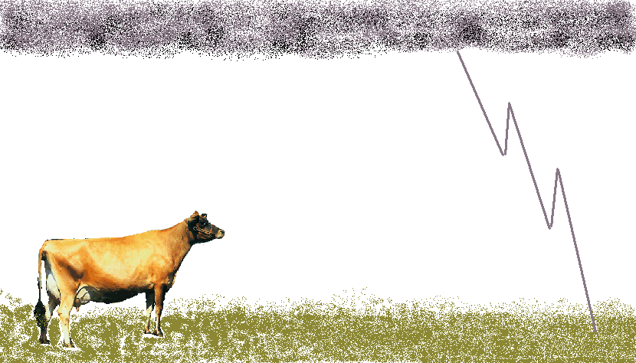
- What is the efficiency of the cell for converting light energy to thermal energy in the 1000 Ω external resistor?

2.
When lightning hits the ground it usually spreads out radially as it penetrates the ground.
Cows are often injured or killed by lightning. Consider a cow which is standing in a field when lightning strikes near by. The cow is facing towards the strike which is 10 m away.

- Draw a circuit diagram showing the cow as a path of resistors between the ground at the front end of the cow near the strike and the ground at the far end of the cow. Consider the front feet to be connected to a single source of emf. Include the resistances across the feet, legs and body.
- If the resistance to enter each hoof is approximately 600 Ω, that through each leg is 500 Ω and the body resistance is around 1000 Ω, what is the total resistance of the cow?
- It takes around 100 mA or more across the body to stop a human heart, and a similar amount to stop a cows heart. If the potential difference between the front legs and the back legs is 150V, is the cow going to be killed?
- Even if the cow isn’t killed, what injuries due to the current might it suffer and why?

