Workshop Tutorials for Physics
ER8: Electromagnetic Induction

A. Qualitative Questions:

- Two circular loops lie adjacent to each other. One is connected to a source that supplies a current; the other is a simple closed ring. The current in the first loop is clockwise. The loops can be arranged so that they stand parallel to each other (arrangement I) or next to each other (arrangement II).
arrangement I arrangement II

- Would you expect a difference in the induced current when the power supply is turned on in the two arrangements? Explain why or why not.
- In which directions will the induced currents be in these two arrangements when the power supplies are turned on?
- Sketch a graph of the current as a function of time when the power supply is turned on and then off again for the first arrangement of coils.

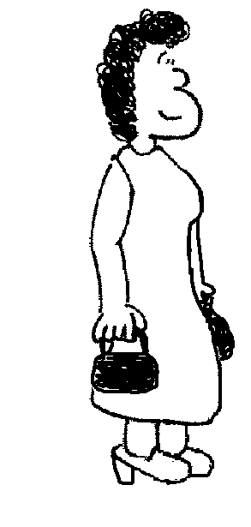
- A metal detector at an airport security checkpoint contains two coils, one in either side. One coil acts as a transmitter and the other as a receiver. The transmitting coil is connected to a power supply which provides an alternating current. The receiving coil is connected to a sensor which detects changes in current and an alarm.
i
transmitting coil
receiving coil
  - How can a coil act as a transmitter? What is actually transmitted?
  - How does the second coil act as a receiver?
When a person walks between the two coils carrying something made of metal an alarm is sounded.
  - Why do metal objects set off the alarm? Explain what is happening here.

B. Activity Questions:

- Electromagnetic Induction – two coils of wire and a magnet
If a magnet is moved into and out of a closed loop of wire, a current is induced in the loop of wire.
Does the direction of the current depend on the motion of the magnet relative to the loop? What happens if the magnet is reversed?
Does the magnitude of the current depend on the speed of the motion, the number of turns of wire, angle between the loop and the magnet? What happens if the loop is moved and the magnet is stationary?
Will a similar phenomenon be observed if a current carrying coil of wire moves relative to a loop of wire?

2. Torque on a current carrying coil in a magnetic field
N
S
N
S

Draw the magnetic force at the points marked by dots on the diagrams opposite.
In which of the above cases is the loop more likely to start turning on its own if held stationary prior to release?

3. Magnetic braking and damping – magnets in pipes
Why do magnets take longer falling down a copper pipe than a plastic pipe?
What happens when the pipe has a slit in it? Why?

- Jumping Rings.
What makes the ring jump?
Try to make the different sorts of rings jump.
What sort of ring won’t jump? Why?
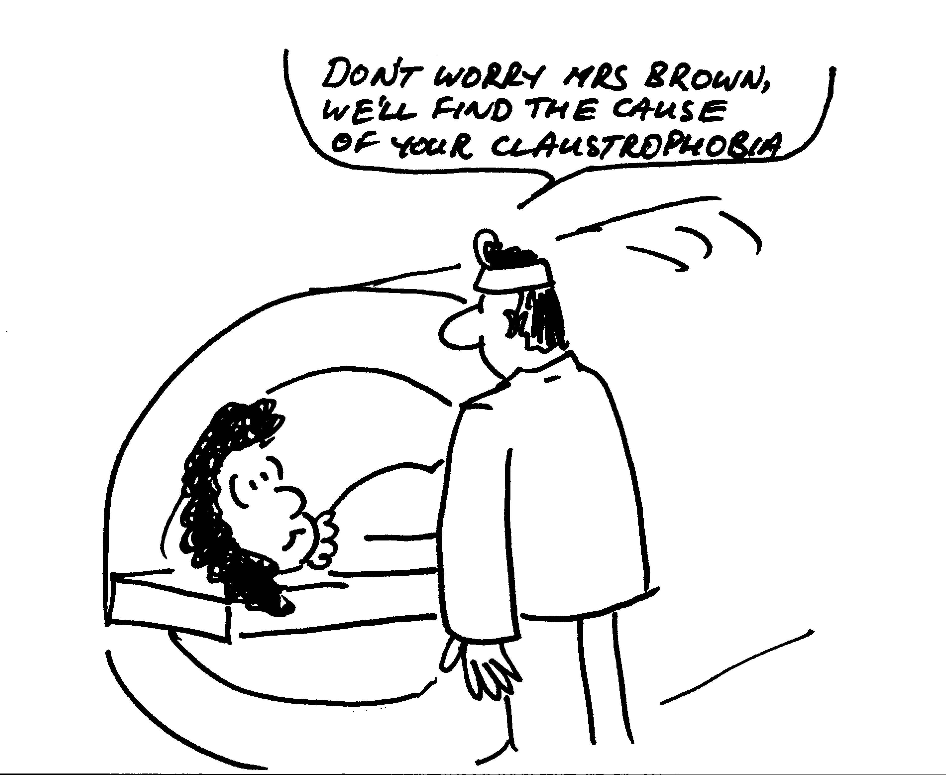

C. Quantitative Questions:

1. Magnetic resonance imaging (MRI) is used to produce images of the interior of the body, especially the brain. The patient is strapped down tightly to a flat stretcher which is then slid into the MRI scanner. The scanner produces a strong magnetic field which is varied in time.
a. Why are patients asked to remove all jewelry and any clothing with zips or metal buttons or clips?
The human body has been described as a bag of salt water, because it contains a great deal of fluid with dissolved ions. A woman is in an MRI scanner which can produce a field of 1.5 T. The largest surface area through which magnetic flux passes is 0.04 m² and has a normal which is parallel to the direction of the field.
b. If the maximum average induced emf is to be kept less than 0.01 V, how long must it take for the machine to be powered down from maximum field to zero?

- A helicopter is hovering with its 5.0 m long blades rotating at 200 rpm. The local magnetic field is directed upwards at approximately 60º to the horizontal and has a magnitude of 50 mT. What is the induced emf between the hub (where the blades join to the helicopter) and the tips of the blades?
(Hint – the emf induced across a short length, Δl, of conductor is the rate at which it cuts through magnetic flux.)

