Workshop Tutorials for Physics
Solutions to QR2: Wave Functions I - Particles as Waves

A. Qualitative Questions:
θ
d
dsinθ
- Electron diffraction.
- The electrons are behaving as waves. When they are reflected from different planes of atoms in the crystal there is a path difference between the waves from the different planes. When the path difference, Δl, is equal to an integer number of wavelengths there will be constructive interference, when Δl = nλ and n = 0, 1, 2…. This corresponds to the condition nλ=2d sinθ, and is known as Bragg’s law. When the path difference is equal to n+ ½λ there will be complete destructive interference.
The wave function tells us about the probability of the particle being at a particular position, so where there is constructive interference there is a high probability of finding particles, and where there is destructive interference there will be no particles.
- If the accelerating voltage used to accelerate the electrons was increased then the electrons would have more kinetic energy and hence a greater velocity and greater momentum. The de Broglie wavelength of the particles, λ = h/p, would be smaller. Using Bragg’s law, the angular separation, θ, is proportional to the wavelength, so the diffraction maxima (and minima) will be closer together.
- Neutrons of kinetic energy, K, will have a de Broglie wavelength of λ = h/p = h/√(2m.K), which will be much smaller than the de Broglie wavelength for electrons with energy K, because neutrons have a much greater mass, m. As above, a smaller wavelength gives more closely spaced maxima and minima.  - If the electrons used for both cases have the same wavelength, the crystal with a lattice spacing of d will give greater separation of diffraction maxima than one with a spacing of 1.5d because the angular separation is inversely proportional to d, i.e. θ ∝ 1/d. | Decrease λ by increasing m or K,  or increase d.

- Mass, momentum and waves.
a. No, Brent should not agree that X-rays have mass. They certainly do not have a rest mass, which is not a problem since photons are never found at rest. Rebecca's argument ignores relativistic considerations. At relativistic speeds the momentum not only depends on the rest mass but on the total energy of the particle. In a nutshell, momentum not only depends on mass, but total energy. As the photons have energy they have momentum, even though they do not have mass. The Compton effect provides experimental evidence of photon momentum, as the target electron gains momentum, which must come from the photon.
b. It is generally true that light is quantised and only a whole photon can be absorbed, not part of a photon. Compton scattering is better modeled as an absorption and re-emission process, than simply a scattering process. The photon is absorbed, and then a second photon is emitted from the electron giving a net change in energy and momentum of the electron.
e⁻
e⁻
e⁻
excited electron
photon with
wavelength λ
electron with momentum p+Δp
electron with momentum p
photon with
momentum p-Δp
and wavelength λ+ΔL

In Compton scattering we treat the process as single scattering event, while in the photoelectric effect no photon is emitted after absorption.
B. Activity Questions:

- Electron interference
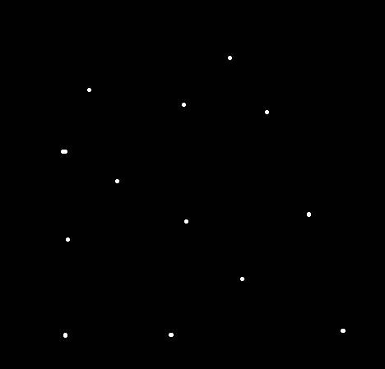
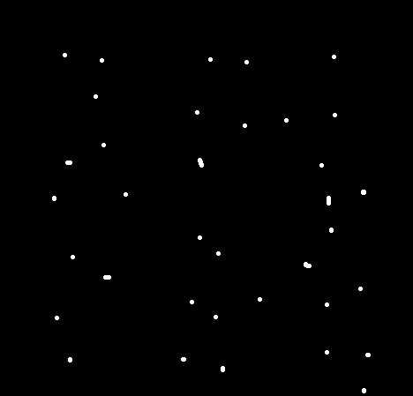
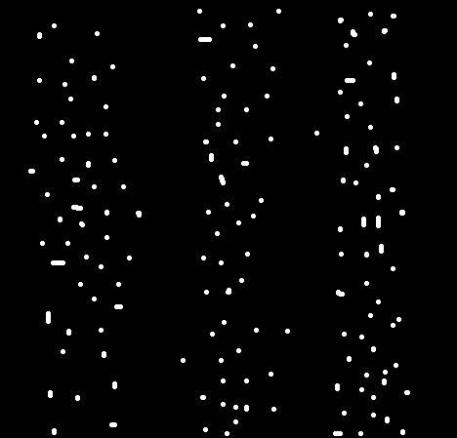
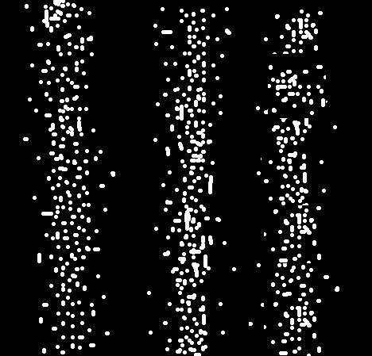
A beam of photons is directed through two narrowly spaced horizontal slits. The emerging beam falls on a sheet of film. Four exposures of the film are shown, exposure time increasing to the right.

- The pictures are made up of discrete points of light, the electrons are small localised object which are interacting with only a single grain of the film.
- The later pictures show distinct stripes. Waves passing through twin slits will produce an interference pattern, as is observed here. Hence the electrons are behaving as waves.
- Quantum mechanics views electrons as both waves and particles. They exhibit particle properties when they interact with matter, and wave properties as they propagate through space, leading to effects such as interference.

- Wave and particle nature of light 1- interference pattern
This demonstrates the wave nature of light. A particle could only pass through one slit or the other. However, a wave can pass through both slits simultaneously and interfere with itself.

- Wave and particle nature of light 2- emission spectra
If you accept that the spectral lines result from transitions of electrons from one energy level to another, then the excess energy of an electron when it jumps down from one energy level to another is released as a photon. These lines have discrete colours (frequencies) and correspond to photons of different energies.

C. Quantitative Questions:

- de Broglie wavelengths.
- λ = h/p = h/mv = h / √(2m.K) If the all the particles all have the same energy, then λ will depend inversely on the square root of the mass. The electron will have the smallest mass and hence the greatest wavelength, the α particle will have the shortest wavelength and the neutron and proton will be in between.
- The electron, which we assume to have very little kinetic energy initially, is accelerated through 25 kV, hence it will gain 25 keV, or 25 × 10³ eV × 1.6 × 10⁻¹⁹ J.eV⁻¹ = 4 × 10⁻¹⁵ J.
- The de Broglie wavelength of such electrons will be
λ = h / √(2m.K)
= 6.63 × 10⁻³⁴ J.s / √(2 × 9.1 × 10⁻³¹ kg × 25 × 10³ eV × 1.60 × 10⁻¹⁹ J.eV⁻¹)
= 7.8 × 10⁻¹² m = 7.8 pm.
(Note that a 25 keV electron is slightly relativistic and we should really use relativistic mechanics to obtain an accurate answer.)

- Compton scattering.
- Δλ = λ₂ − λ₁ = h(1 − cosθ)/m_{e}c = 2.43 pm (1− cos 180º ) = 2.43 pm (1−(−1)) = 4.86pm.
- Energy of photon =hc/λ. Difference in energy E₁ − E₂ = hc/λ₁− hc/λ₂ .
λ₂ = λ₁ + Δλ = (6.0 + 4.86) pm = 10.86 pm.
So E₁ − E₂ = 6.63 × 10⁻³⁴ J.s × 3 × 10⁸ ms⁻¹(1/6.0pm – 1/10.86 pm) = 14.8 × 10¹⁵ J.
- Since energy is conserved in the collision the kinetic energy of the scattered electron will equal the energy difference above i.e. 14.8 × 10⁻¹⁵J or 93keV.

