Ball in a Capacitor

Apparatus
huge parallel plate capacitor (two large metal plates mounted parallel to each other so that they can slide closer or further apart), van de Graaff generator or some other means of charging the capacitor, table tennis ball coated in conductive paint or wrapped in aluminium foil and suspended on a thread from a retort stand

Action
The students hang the ball between the capacitor plates and observe the balls behaviour when the capacitor is charged. They can experiment with hanging the ball at different heights and moving the plates to different separations. If the ball is covered in foil they can remove the foil and see what effect this has.

The Physics
Charge separation occurs on the surface of the coating on the ball, positive charges are attracted towards the negative plate and negative charges are attracted towards the positive plate. The ball with not be perfectly spherical, nor is it likely to be precisely halfway between the plates, hence the attraction towards one plate will be slightly greater than the attraction towards the other. The ball will accelerate and swing to touch one plate. When it touches the plate, charge transfer occurs and the ball becomes charged the same way as the plate. It is then repelled by this plate and attracted by the other plate. It swings across to the other plate, where it becomes oppositely charged. It then bounces back and forth between the plates. Removing the foil prevents or greatly slows the transfer of charge, so the ball will still be attracted to one plate, but will then only bounce extremely slowly or stick to the one plate.
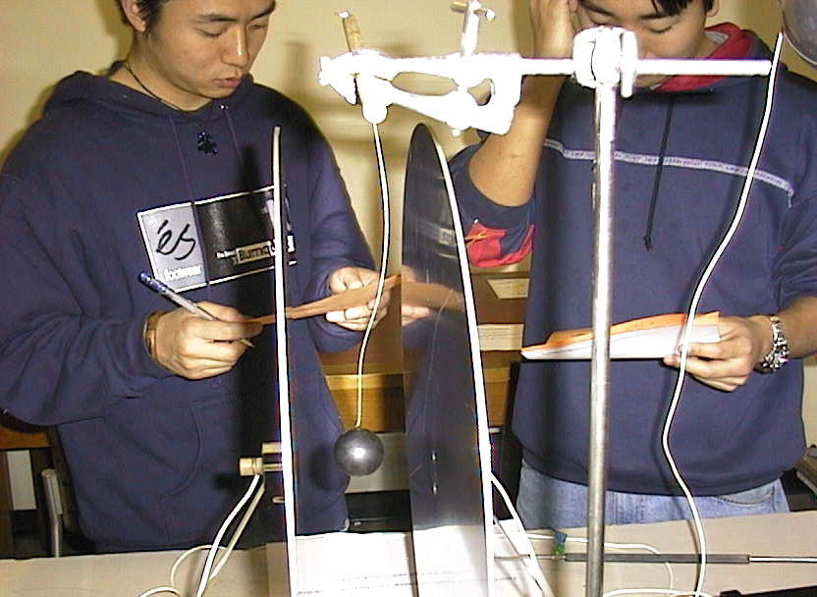

Students at the University of New South Wales puzzling over the ball in the capacitor.

Accompanying sheet

Ball in a Capacitor

Hang the ball between the capacitor plates.

Charge up the capacitor.
What do you observe?
Why is this happening?
Sketch the field lines for the capacitor.

