Batteries II

Apparatus
selection of different batteries, voltmeter, wires and resistors

Action
The students examine the circuit and determine which way the current is flowing. They can then measure the changes in potential across different components.

The Physics
The electrons move in the opposite direction to conventional current (flow of positive charges). The electrons gain potential energy as they move through the potential difference supplied by the battery, and lose potential energy as they pass through the resistors. The role of the battery is to supply energy to the electrons, it is a source of emf.
The person responsible for naming positive and negative charge was Benjamin Franklin who did not know that the charge carriers in a metal are really negatively charged electrons. So we are stuck with the notion of conventional current which we imagine to be a flow of positive charge, out of a battery’s positive terminal, through a conducting path, and into its negative terminal. Some people like to be more realistic and imagine the actual flow of electrons in the opposite direction. Provided either convention is kept constant in calculating variables in a circuit, you will obtain the correct answer.
The battery provides an electrical potential difference which causes a current to flow.

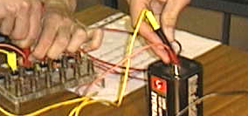

A battery being connected to different globes and resistors.

Accompanying sheet

Batteries II

Examine the circuits containing the batteries.
In which direction is the current flowing in each circuit?
In which direction are the electrons moving?

Describe the changes in potential energy of the electrons
as they move around the circuit.
What is the role of the battery?

