Charged Rods

Apparatus
perspex, glass and metal rods, silk and fur for rubbing, petrie dish and watch glass, small lumps of blu-tack.

Action
The students charge a rod by rubbing it and balance it on the watch glass. They then charge a second rod, and by bringing the end of it near the first rod they can accelerate the rod balanced on the glass, causing it to spin. They should also try to charge the metal rod.

The Physics
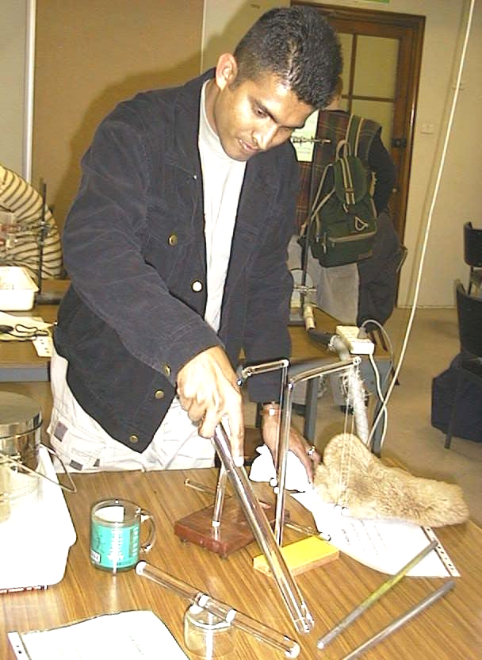
The rods are charged by electrons moving to or from them from the fur or silk. The glass and Perspex rods will become charged, and can be used to show electrostatic force at a distance (an electric field). The metal rod is a conductor, and excess charge on the metal will flow to the person charging the rod and to earth so it will not become charged.
A student at the University of Sydney experimenting with charging glass and Perspex rods.

silk handkerchief

rabbit fur

perspex rod
rod balanced on watch glass

metal rods

Accompanying sheet

Charged Rods

Charge up the rods using different materials.
How do the items get charged?

Balance a charged rod on a watch glass.
How can you accelerate it without touching or blowing on it?

Could you charge a metal rod in the same way?
How would the charge distribution differ?

