Charging Capacitors

Apparatus
range of large capacitors and resistors connected in series to a low voltage power supply, oscilloscope to view charging/discharging curves
Note – depending on the students experience in connecting circuits, the circuits can be set up in advance or left for the students to connect.

Action
The students connect up the circuit to the oscilloscope and the power supply. They should observe the charging curve for the RC circuit. They then connect a different resistor and observe the effect on the charging time. If multiple capacitors (or a variable capacitor) are available they can also experiment with varying the capacitance.

The Physics
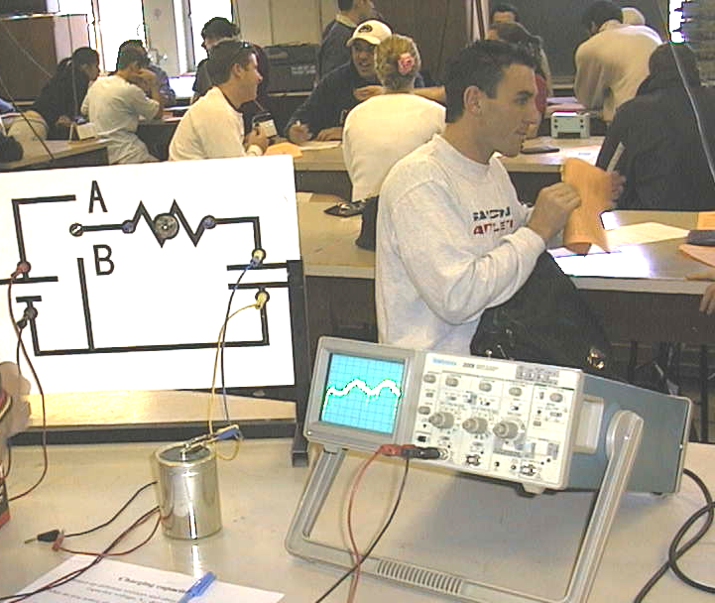
The voltage across the capacitor increases during the charging phase such that $V(t)=V_{0}({\text{1-e}}^{\frac{−t}{\text{RC}}})$. The larger the capacitance or the resistance, the greater the time constant, RC, and the longer it takes for the capacitor to charge. Many students find a fluid analogy helpful – the bigger the bucket or the narrower the hose to fill it, the longer it takes to fill.

An RC circuit hooked up to an oscilloscope at the University of New South Wales for an Industrial Design workshop.

Accompanying sheet

Charging Capacitors

Connect up different resistors
and observe the effect on the capacitor voltage, V_{c}, during charging.

What do you notice about the rate of charging with different resistors in the circuit?

Suppose instead that we kept the resistor fixed and changed the capacitor
would this produce a similar result?

