Earth Connections

Apparatus
selection of appliances with and without earth connections, and a dismantled appliance showing where the earth lead connects; for example hair dryers, toasters, power drills

Action
The students examine the appliances and identify the earth connection. They should discuss the importance of correctly earthing appliances.

The Physics
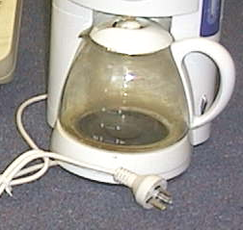
The appliances with a third pin in their plug are earthed. The third wire is the earth connection, the other two pins are the live connections – the active and the neutral. If the earth is disconnected the appliance will usually still work, but will be unsafe to use. The earth connection usually provides a low resistance path from the casing of an appliance to the ground. If there is a short circuit and there is current flow to the case, the current will flow through the earth connection rather than through anyone touching the appliance.
Earth
active
neutral

Accompanying sheet

Earth Connections

Examine the appliances.
Which ones are properly Earthed? How can you tell?

What is the role of the Earth connection?
Why is it important that appliances be properly Earthed?

