Electromagnetic Induction – 2 Coils of Wire and a Magnet

Apparatus
Power supply, current carrying coil, second coil connected to ammeter, bar magnet
If a centre-zero ammeter is not available it is worthwhile using the zero-adjust to move the needle’s zero position well onto the scale.

Action
The students experiment with moving the coils relative to each other, and observing the induced current. They also experiment with moving the magnet in and out of the coil in different directions. They should investigate the effects of speed and direction of movement on the induced current.

The Physics
The direction of the current depends on the motion of the magnet relative to the loop and changes when the magnet is reversed. The magnitude of the current depends on the speed of the motion, number of turns of wire and the 'angle' between the loop and the magnet. It doesn’t matter whether the coil or the magnet is moved, only the relative motion of the two is important (it was this observation that led Einstein to his theory of relativity).
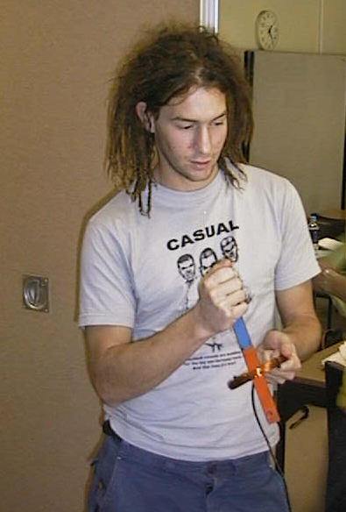
A current carrying coil of wire has a magnetic field so there will be an induced current in a closed loop of wire which is moving relative to a current carrying coil. Moving the coil should produce exactly the same effect as moving the magnet.

A student at the University of Sydney experimenting with a magnet and a coil.

Accompanying sheet

Electromagnetic Induction – 2 Coils of Wire and a Magnet

Move the magnet in and out of the loop of wire with the ammeter.
Does the direction of the current depend on the motion of the magnet relative to the loop?
What happens if the magnet is reversed?
What happens if the loop is moved and the magnet is stationary?

Now repeat these observations using the current carrying coil instead of the magnet.

