Electroscope and Electrophorus

Apparatus
Perspex plate, rubber gloves, metal plate with insulating handle, electroscope

Action
The students rub or slap the perspex plate with the rubber gloves which moves charge (by friction) onto the perspex plate. They then place the metal plate over the perspex plate which induces charge separation on the metal plate. The students then touch the upper surface of the metal plate with a finger, allowing the excess charge from the top surface to flow to Earth while leaving the excess charge on the bottom surface. This leaves the metal plate with a net charge. When they hold the metal plate with the insulating handle and bring it close to the electroscope the leaves will separate. They should note that they don’t need to touch the electroscope for the leaves to separate.

The Physics
The charging is achieved by friction, with organic molecules being broken on the gloves and Perspex. The metal is a conductor so charges will easily separate and the excess charges flow through the persons finger (also a conductor) to Earth. When the charged metal plate is held near the electroscope it attracts opposite charges from the leaves towards the top cap, leaving the leaves charged. The leaves will have like charge and hence will repel each other and separate. The leaves will have the same sign charge as the plate. If the plate is touched to the electroscope some excess charge will move from the plate to the electroscope, and the leaves will again have like charge, and the same sign charge as the plate.
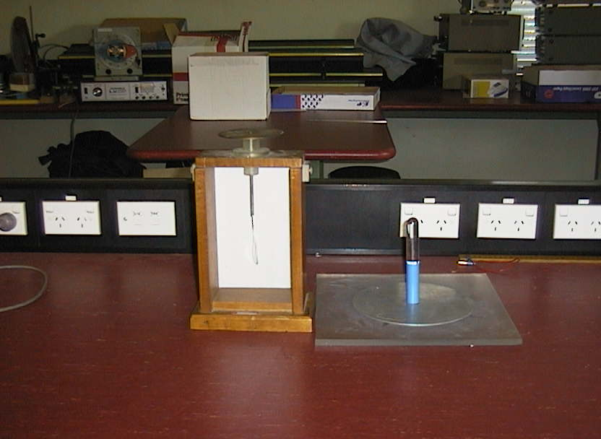
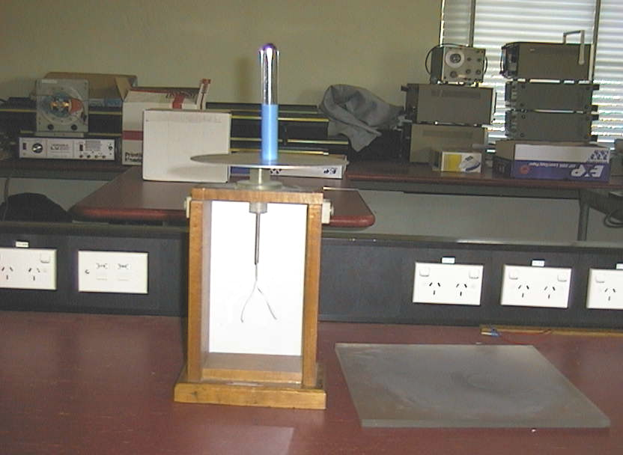

Accompanying sheet

Electroscope and Electrophorus

Slap the bottom plate with the rubber gloves.
Now put the upper (metal) plate on top of the lower plate.
Touch your finger to the upper surface of the metal plate.

Using the handle, hold the plate above the electroscope.
What is happening here? How does the plate become charged?

