Energy Stored by a Capacitor

Apparatus
very large capacitor, battery, low voltage motor with fan or other attachment
Note – disposable cameras use capacitors to provide a quick burst of energy for the flash, these make an excellent example of the use of capacitors and a cheap additional display.

Action
The students connect the battery to the capacitor and allow it to charge. They then disconnect the battery and attach the capacitor to the motor. They should discuss how energy is stored in a capacitor, and how this can be used.

The Physics
The capacitor stores electrical potential energy U= ½ CV², in the form of stored charge and an electric field. Capacitors can make useful short term back up power supplies, and are used when a brief but rapid supply of energy is needed, for example in camera flashes.

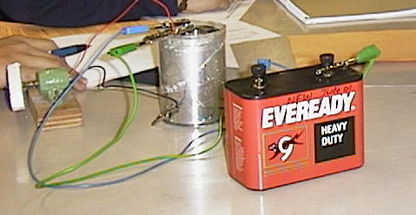

Large capacitor with battery and motor.

Accompanying sheet

Energy Stored by a Capacitor

Connect the battery to the capacitor and allow it to charge up.
Now disconnect the battery and connect the motor to the capacitor.

How is energy stored in the capacitor?
Give an example of when this energy storage would be useful?

