Faraday’s Icepail

Apparatus
electroscope, large metal can, perspex or glass rod, fur to charge the rod, metal ball on an insulating stick to charge the can
Note: any means of charging the ball on the stick can be used.

Action
The students charge up a rod and use it to charge up the metal ball on the stick. They then lower the ball into the can, which sits on top of the electroscope. They should observe the leaves of the electroscope separating. They then touch the ball to the bottom of the inside of the can. The can should now be charged, and the leaves stay separated when the ball is removed. The students should remove the can from the electroscope, discharge it (for example by Earthing via a finger) and check whether the ball retains any excess charge.

The Physics
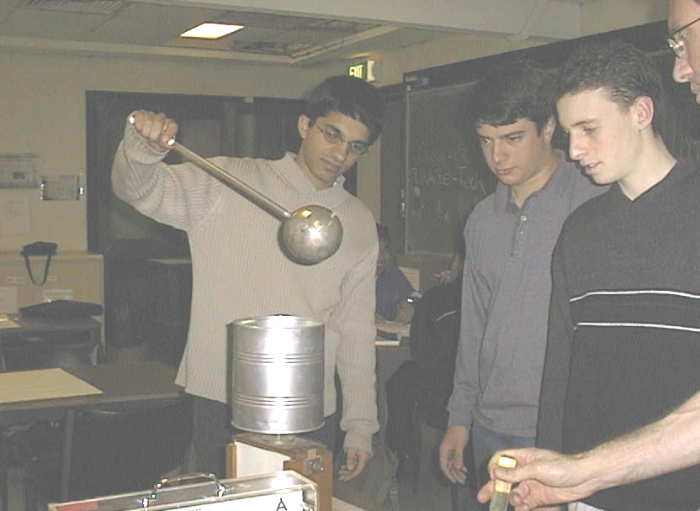
When the ball is touched to the inner surface all its excess charge is transferred to the container and appears on the outer wall of the container. All the charge is transferred because when the ball is in contact with the container they act as a single conductor. The electric field within a conductor is zero, and if you draw a Gaussian surface inside the conductor it will contain zero charge because E = 0 everywhere on the surface. Hence the ball can contain no charge. When the ball is removed, they should see that it has no charge, thus confirming Gauss’s law.

Students at the University of Sydney experimenting with Faraday’s Icepail

Accompanying sheet

Faraday’s Icepail

Charge the metallic ball.
Lower the ball into the pail without touching the walls.
What do you observe?

Touch the inner surface of the pail with the ball.
Now what do you observe?

Take the ball out of the pail.
How did the initially neutral pail become charged?

