Flux

Apparatus
solar cell, desk lamp, ammeter

Action
The students hold the solar cell under the lamp and observe how the voltage varies as the angle and position of the solar cell is changed. They should relate the current to the flux of photons incident on the solar cell. (Note- students should be cautioned not to put the solar cell too close to the light as it may melt.)

The Physics
The current is directly proportional to the flux of photons incident on the solar panel. This will be a maximum when the surface of the panel is perpendicular to the direction of the flow of photons, and a minimum when it is parallel. The flux can also be increased by moving the solar cell closer to the light.
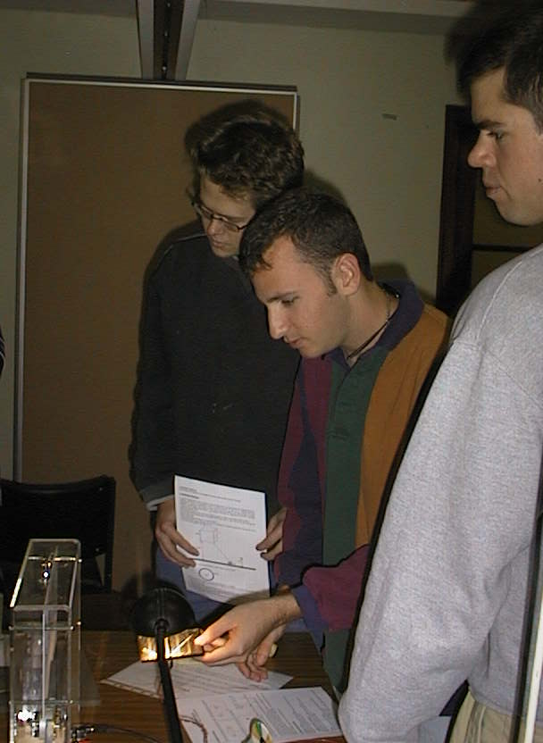

Students at the University of Sydney measuring the current output of a solar cell for different orientations of the cell relative to the light source.

Accompanying sheet

Flux

Hold the solar panel in front of the light.

How can you orient the panel to maximise the flux?

How can you orient the panel to minimise the flux?

If the orientation were kept constant,
how would the flux change if you doubled the area of the panel?

