Jumping Rings

Apparatus
AC power supply, coil wrapped around a large ferrite core, solid and split metal rings
Note – it helps to have a momentary switch connecting the power supply to the core so it is not left turned on.

Action
The students place a ring over the core and switch on the power supply. They should observe that a solid ring will jump but a split ring or non-conducting ring will not. If the power supply is a large one, they can also hold the ring in place and feel it heating up.

The Physics
An AC coil with a long iron core produces an alternating magnetic flux, mostly in the region in and near the core. An emf is induced in a small conducting ring when it is slipped over the core and the power is turned on to the coil. If the ring is complete, a current is induced and the resulting magnetic force is sufficient to launch the ring several feet into the air. A split ring or a non-conductive ring will not jump because no current is induced.
Note – some safety warnings may be needed, such as do not stand over the apparatus. It is also best to have some clear space around the apparatus.
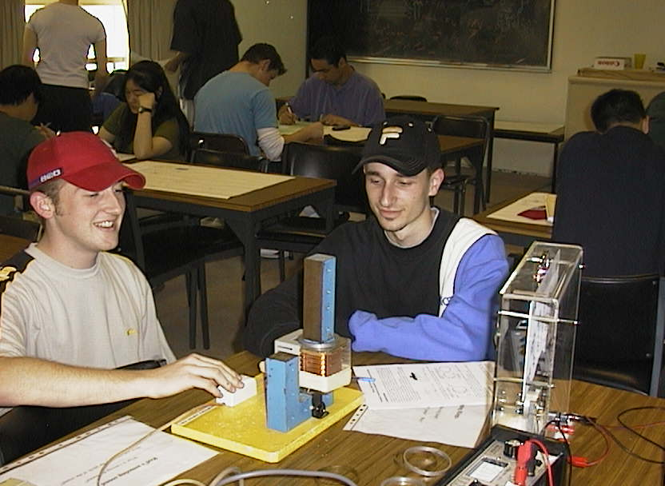

Students with the jumping rings at the University of Sydney.

Accompanying sheet

Jumping Rings.

Place a ring over the ferrite core.
Depress the switch to run a current through the coil.

What makes the ring jump?

What sort of ring won’t jump? Why?

