Magnetic Braking I – Damped Pendulums

Apparatus
large horseshoe magnet or pair of magnets, pendulums made from complete and incomplete metal loops, pendulums made from complete sheets of aluminium or copper, and from sheets with slits

Action
The students allow the different pendulums to swing between the magnetic poles and observe which ones are braked and which ones are not. They should try to predict in advance how the pendulums will behave and then compare their observations to their predictions.

The Physics
In all cases extensive swirls of currents, eddy currents, are induced in sheets and loops without slits and not in sheets or loops with slits. The induced currents experience a force due to the magnetic field from the magnets, which produces a force on the pendulum opposing the motion that causes them, braking the pendulums without slits.
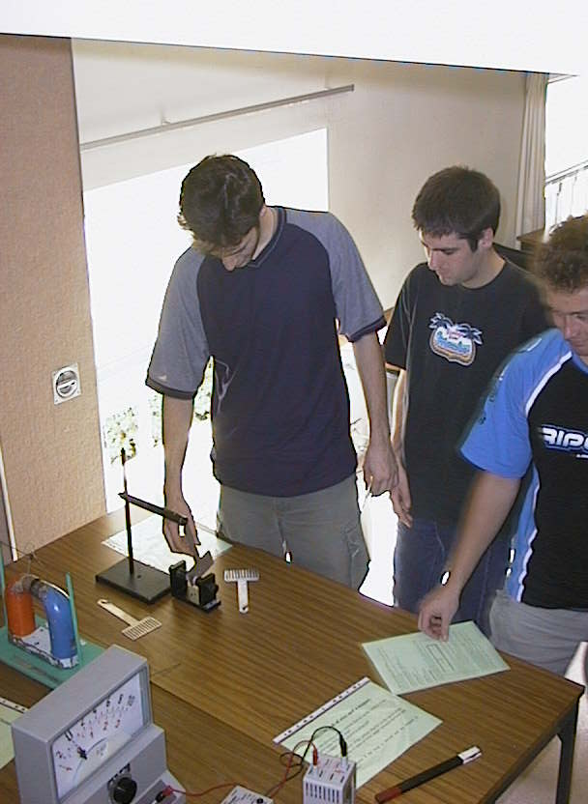

Students at the University of Sydney experimenting with a simple loop style pendulum in a magnetic field.

Some simple pendulum designs

Accompanying sheet

Magnetic Braking I – Damped Pendulums

Which pendulums will swing freely and which will be damped by the magnetic field?

Try the different pendulums and see what happens.

Explain your observations.
Were your predications correct?

