Magnetic Field around a Current Carrying Wire

Apparatus
One current carrying wire, power supply, several compasses or large compass needles
This can also be done using iron filings and a high current.

Action
The students place the compasses or compass needles at various positions around the wire. They then turn the power supply on so that current runs through the wire. They should observe the deflection of the needles due to the current.

The Physics
A current produces a magnetic field. The magnetic field is perpendicular to the direction of the current and decreases linearly with distance from the current. The direction can be found pointing the right thumb in the direction of the current. The direction the fingers curl gives the direction of the field.

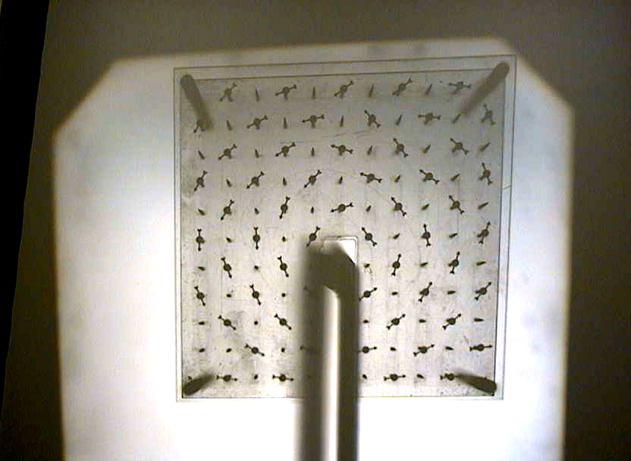

Accompanying sheet

Magnetic Field around a Current Carrying Wire

Turn on the power supply and observe what happens to the compass needles.

What happens when you change the direction of the current?

Draw a diagram showing the current and the field it produces.

