Magnetic Force- the Pinch Effect

Apparatus
two long current carrying wires or strips of foil, mounted vertically and parallel to each other, power supply and connections

Action
The students turn the power supply on so that current runs through both wires in the same direction. They should observe the wires pinching in towards each other. If they change the connections so that the currents are anti-parallel they will see the wires move apart.

The Physics
Both currents produce a magnetic field. A current carrying wire in a magnetic field experiences a force proportional to the cross product of the current in the wire and the external field, F ∝ i×B. The force is perpendicular to both the field and the current, and the direction can be found using the right hand rule for cross products: curl your fingers from i towards B and your thumb points in the direction of F. The force will be towards the other wire when the currents are parallel, and away from it when the currents are anti-parallel.
i_{a}
B due to i_{b}
F_{ba} = force on i_{b} due to B field from i_{a}
F_{ab} = force on i_{a} due to B field from i_{b}
i_{b}
B due to i_{a}
F_{ba}
F_{ba}
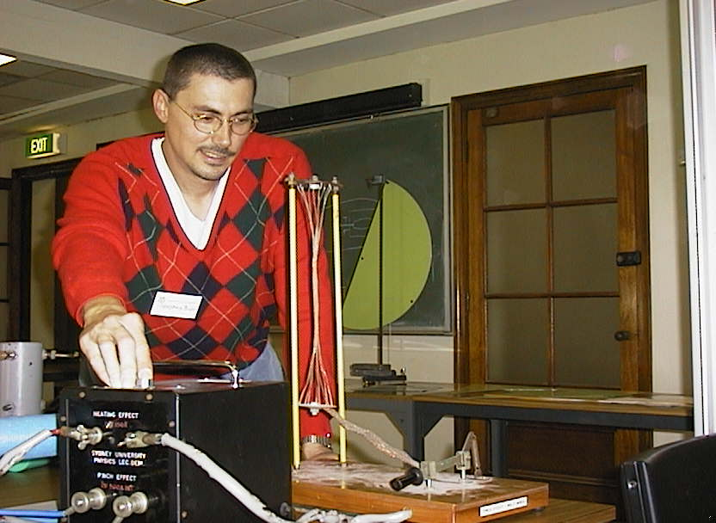

A tutor at the University of Sydney demonstrating the pinch effect.

Accompanying sheet

magnetic force - the Pinch Effect

Turn on the power supply and observe what happens to the wires.

How can you make them repel instead of attracting?

Draw a diagram showing the field, current and forces on the wires.

