Magnets and Magnetic Fields

Apparatus
selection of magnets, iron filings, perspex sheet

Action
The students place the sheet over the top of the magnets. They then sprinkle the iron filings on the perspex sheet. They should then sketch field lines for the magnets, and notice which field is similar to the Earth’s magnetic field.

Note: the Perspex sheet is important because it keeps the filings from coming into direct contact with the magnets and sticking to them. When done the students can lift the sheet and pout the filings back into a container to be reused, this is much less messy than trying to remove them from a magnet.

The Physics
The iron filings are attracted to the poles of the magnet and tend to line up along field lines.
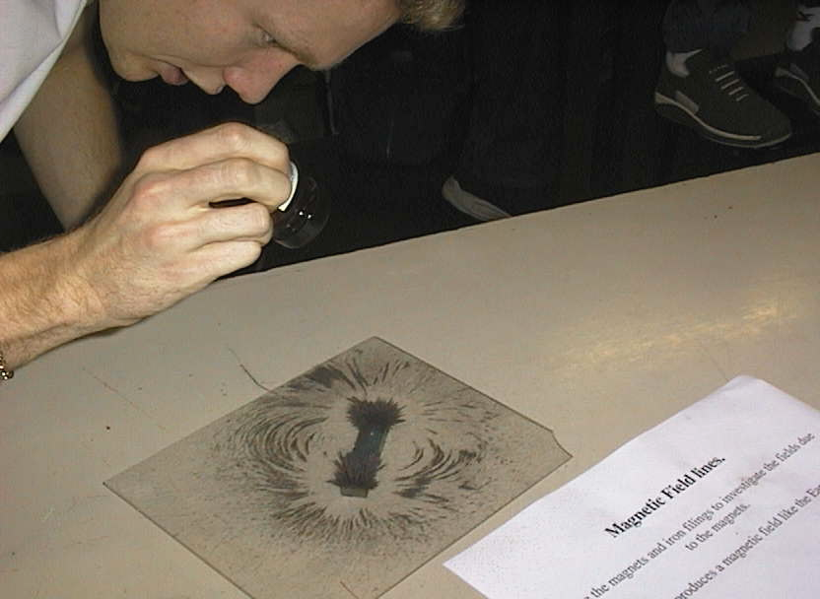
The Earth has a magnetic field like a bar magnet’s, however what we call the north pole of the Earth is actually at the south magnetic pole.

A student at the University of New South Wales using iron filings to see the magnetic field around a bar magnet.

Accompanying sheet

Magnets and Magnetic Fields

Use the iron filings to investigate the field lines of the magnets.

How do these compare the field lines of the Earth?
Many animals such as pigeons and some fish have a magnetic sense
which allows them to use the Earth’s magnetic field to navigate.

Please keep the filings on the sheet, and the magnet underneath!

