Ohm’s Law

Apparatus
ammeter, variable voltage power supply, resistors, resistor colour code chart

Action
The students attach a resistor to the power supply and measure the current through the resistor for different voltages. They should calculate the resistance of the resistor, and then check their answer using the resistor colour code chart.

The Physics
The resistors obey Ohm’s law, so the current through the resistor is I=V/R where V is the voltage across the resistor and R is the resistance. The resistance, R, will be a constant for a resistor for large ranges of V. Note that this is not the case for many components, such as globes. The students may find small discrepancies in their calculated value for R and that read from the chart, this is a good opportunity for some comments on uncertainty, and it is worthwhile pointing out the “tolerance” of the resistors. There may also be a small difference due to resistance in the wires, inaccuracy and internal resistance of the power supply.
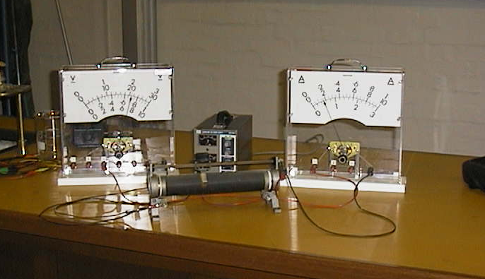

Accompanying sheet

Ohm’s Law

Use the variable voltage supply and the current meter
to find the resistance of the mystery resistor.

Check your result with the resistor colour code provided.
Do they match?

Why might there be some difference?

