Safety Switch and Fuses

Apparatus
a safety switch, selection of fuses including a few burnt out ones

Action
The students examine the switch and fuses and discuss the role and importance of these devices.

The Physics
Safety switches open, stopping current flow, when a sensor detects a surge in current. A surge in current usually indicates a short circuit, when the current increases due to a large drop in resistance. This may be due to the current passing through a low resistance human to flow to Earth rather than through relatively higher resistance circuitry. A fuse is made of a material, often a thin metal wire or strip, which heats ups and melts when a large enough current passes through it. This protects machinery and people from power surges, but cannot be reset the way a switch can be, the wire or entire fuse must be replaced.
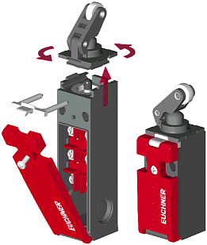
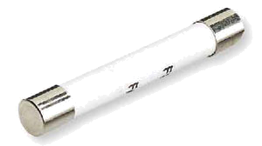
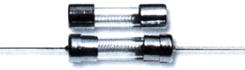
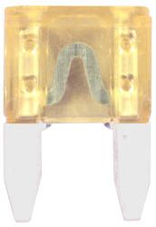

Accompanying sheet

Safety Switch and Fuses

Examine the safety switch and fuses.

Explain how they work and the role they play in preventing power surges.

How can safety switches protect you from short circuits?

