Toaster Man – Resistors in Series

Apparatus
ammeter, low voltage power supply, “toaster man” circuit, leads with alligator clips

Action
The students measure the current through toaster man’s heart for different positions of the power supply leads.

The Physics
The resistance of the current path is changed by connecting the power supply to different points. When the resistance is lower the current is higher and vice versa. This demonstrates the importance of insulation, for example wearing rubber soled shoes when working with high voltages. Small currents of only 10 mA can disrupt the heart beat and lead to fibrillation. This demonstration started as a demonstration on why poking knives into toasters is a bad idea, hence the name toaster man.
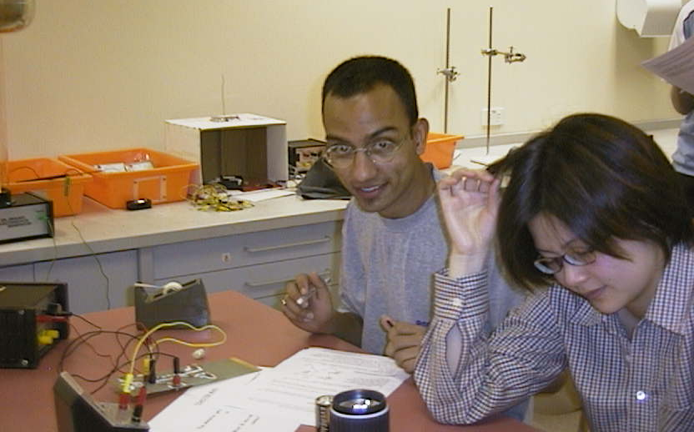
R_{skin} ~ 100 kΩ
R_{internal} ~ 100 Ω
R_{boot} ~ 10 MΩ
V
A
R_{skin}
R_{skin}
R_{skin}
R_{skin}
R_{boot}
R_{boot}
R_{internal}
ammeter
power supply

Students at the Australian Catholic University experimenting with “toaster man”.

Accompanying sheet

Toaster Man

Connect the ammeter across toaster man’s heart.

Attach one lead from the power supply to toaster man’s hand.

What current flows when the other lead is connected to his boot?
What about when it is connected straight to his foot?

