Torch – a Simple Circuit

Apparatus
a few cheap torches that can be taken apart

Action
The students take the torches apart, identify the components and draw a circuit diagram for the torch. They should try to identify the current path.

The Physics
The torch is a very simple circuit, containing only three components; a switch, a globe and a battery. The components are connected in series. The battery stores energy as electric potential energy, which is converted to light and heat by the globe, when the switch is closed to connect the circuit.  For a current to flow and the torch to work there needs to be a complete circuit. In a metal cased torch the case itself often forms part of the circuit. | B  G  S

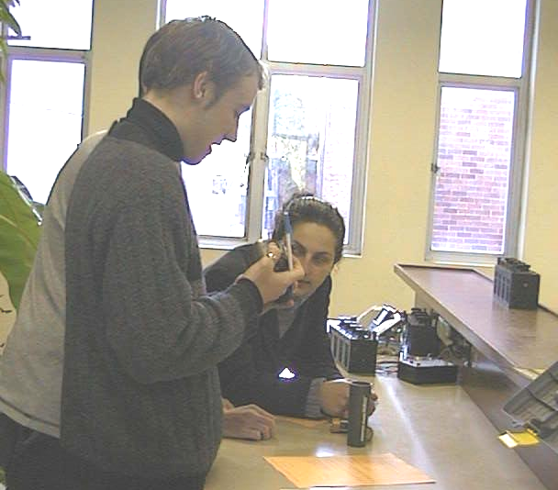

Optometry students at the University of New South Wales dismantling a torch.

Accompanying sheet

Torch – a Simple Circuit

Dismantle the torch and examine its components.

Draw a circuit diagram for the torch.
Is it a complete circuit?
Trace the flow of current in the torch.
Label each component and show its function.

When you have finished, please put the torch back together again.

