Tuning Circuit

Apparatus
tuning circuit from a dismantled radio, with components visible

Action
The students examine the circuit and identify the main components. They should draw a diagram showing how the tuning circuit works.

The Physics
A tuning circuit consists of an inductor and a capacitor, usually in parallel.
Either the inductance of the inductor or the capacitance of the capacitor must be able to be varied. By varying either the capacitance or inductance the resonant frequency of the circuit is varied. When the resonant frequency matches an incoming signal, for example the carrier wave of your favourite radio station, then the circuit is tuned to that frequency and the radio program can be heard.

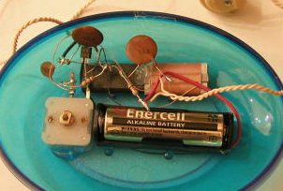

variable capacitor
inductor

Accompanying sheet

Tuning Circuit

Examine the circuit and identify the main components.
How is this circuit tuned?

Draw a circuit diagram showing how it works.

