Variable Capacitor II – Tuning Capacitor

Apparatus
variable capacitor

Action.
The students examine the capacitor and explain how the capacitance is varied. They should describe and give examples of how such capacitors are used.

The Physics
The capacitor is a series of leaves. Rotating the “stem” rotates one set of leaves so that the area of overlap changes. This changes the value of the capacitor.
Variable capacitors can be used in tuning devices such as radios where dialing up the radio station is just twisting the “stem”. The variable capacitor is part of the resonant circuit where maximum response to the transmitted signal depends on matching the resonant frequency of the circuit with the frequency of the signals carrier waves.

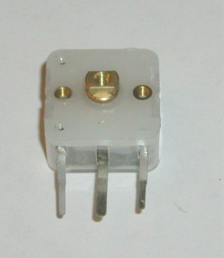

Accompanying sheet

Variable Capacitor II – Tuning Capacitor

Examine the variable capacitor.
How can the capacitance be varied?

Can you think of where these devices might be used?

