van de Graaff Generator

Apparatus
van de Graaff generator, insulating block (e.g. polystyrene)

Action
The students take turns standing on a thick piece of polystyrene with a hand on the generator. If you have small numbers it’s handy to bring a camera for this one, it makes good photos for open day, and if you have a digital camera you can email students photos of themselves later on.

The Physics
The generator charges you up to a very high voltage, which means a lot of extra charges. People’s hair tends to stand up because the charges exert a repulsive force on each other, the hairs try to get as far away from each other as possible. The hairs also try to line up along field lines.

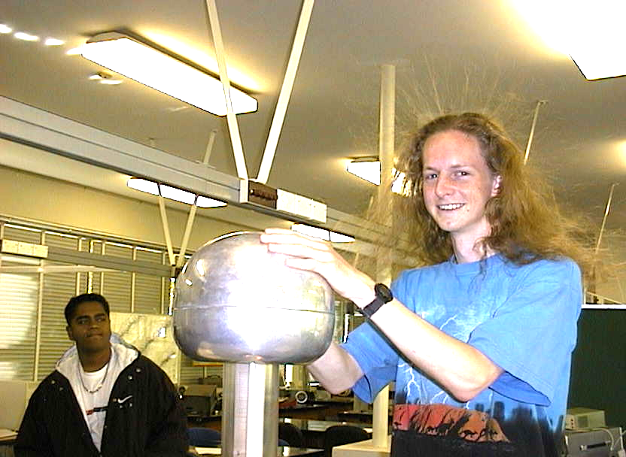
Note: make sure other students stay clear, and the student in contact with the generator doesn’t take their hand off and on.

Student at University of Sydney attached to a van de Graaff generator.

Accompanying sheet

van de Graaff Generator

While the generator is turned off:
Stand on the block and place your hand on the generator.

Now get someone to turn it on.

What do you feel?
What can you see when someone is touching it?
Explain your observations.

