van de Graaff Generator and Wig

Apparatus
van de Graaff generator , paper, string or hair “wig”, sticky tape
A paper wig can be quickly made by cutting several pieces of scrap paper into strips, leaving a few inches uncut at the bottom so they can be stuck to the van de Graaff generator.

Action
The students attach the wig to the generator and turn it on. They may also want to experiment with holding strips of tape near the generator.

The Physics
The generator charges the wig to a very high voltage, which means a lot of extra charges. The hair stands up because the charges exert a repulsive force on each other and the hairs try to get as far away from each other as possible. The hairs also try to line up along field lines.

Note: this demonstration replaces the van de Graaff generator demonstration on the previous page if you do not wish students to touch the generator or if the students are uncomfortable with touching it.
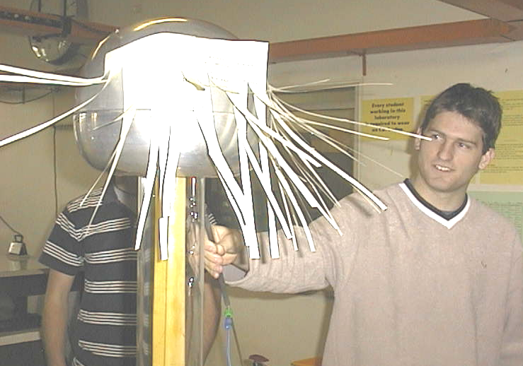

Students at the University of New South Wales experimenting with a van de Graaff generator

Accompanying sheet

van de Graaff Generator and Wig

Put the wig on the generator.

Now turn it on.

Explain what happens to the wig.
What does this tell you about the field around the generator?

