A Loaded Race

Apparatus
ramp, several balls of different sizes and masses, several cylinders (for example large and small cans of different masses)

Action
The students try to predict which can or ball will win a given race. They then allow the objects to roll down the ramp and check their predictions.
Note that a full “chunky soup” can is interesting because it can not be considered a solid mass, the contents move about changing the behaviour of the can.

The Physics
Neglecting air resistance, all the solid spheres will hit the bottom at the same time. From energy conservation equations we have mgh = ½ mv² + ½ Iω² rearranging for v gives v = $\sqrt{\text{10}7}$gh ~ 1.19 gh for solid spheres. Thus the velocity at the bottom of the ramp is independent of M and R so all the balls should reach the bottom at the same time.
For a solid cylinder v = $\sqrt{43}$gh ~ 1.15 gh, so generally spheres have a higher speed than a cylinder and will win the race.
A soup can with contents that slosh about will also take longer than one with more solid contents.
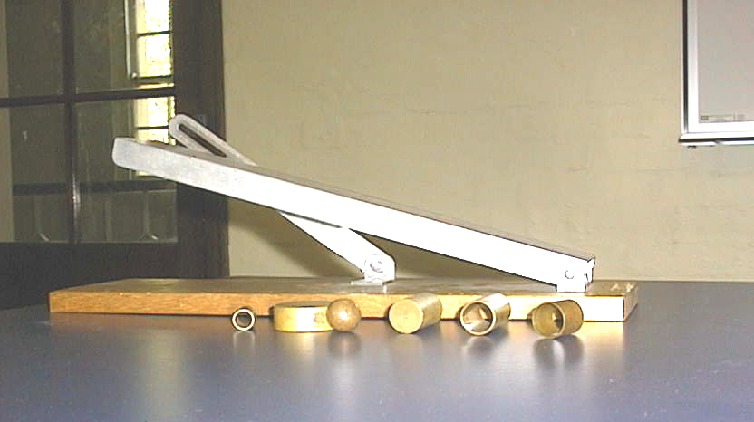

Accompanying sheet

A Loaded Race

What determines how fast a sphere or cylinder rolls down a hill?

Examine the various objects.
Which will roll fastest?

Experiment with rolling them down the hill.
Why do some roll faster than others?

