Air Track

Apparatus
air track, several gliders (with springs, e.g metal loops, at the ends) of the same size plus a few of different sizes

Action
The students experiment with colliding moving and stationery objects of the same size, and of different size. The students should consider what happens when a moving object collides with a stationary one, what effect the relative masses have, and what role friction plays. They should consider the difference between elastic and inelastic collisions.

The Physics
The air track provides an almost frictionless surface, so any external horizontal forces acting on the gliders are very small. This means that the gliders can be considered as an isolated system. If the air track is turned off this is no longer the case. The springs on the gliders, e.g. metal loops, help to ensure the collisions are elastic and the gliders do not stick together. In elastic collisions kinetic energy is conserved, and in all collisions momentum is conserved.
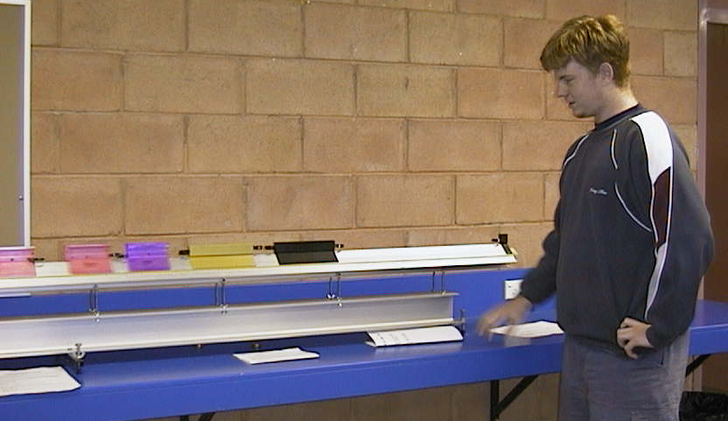

A student at the University of Western Sydney experimenting with collisions on an air track.

Accompanying sheet

Air Track

What happens when a moving object collides with an identical stationary one?
What if they have different masses?

Send two identical objects, spaced a few centimetres apart,
with the same velocity towards a third.
What happens when they collide?
This is like a row of moving traffic hitting a stationary vehicle.

Put three identical objects in a row with equal spacing.
What happens when you collide a fourth object with them?

