Balloons

Apparatus
packet of balloons, long ones work particularly well

Action
The students blow up a balloon and then let it go. They should watch the balloon and note the direction it moves in, and the position of the hole as it flies.

The Physics
When the balloon is released the air inside it rushes out because it is under pressure. The air comes out the neck of the balloon. For momentum to be conserved the balloon (and remaining air) must move in the opposite direction. This is what happens, and the balloon whizzes around the room, moving in the opposite direction to the airflow.

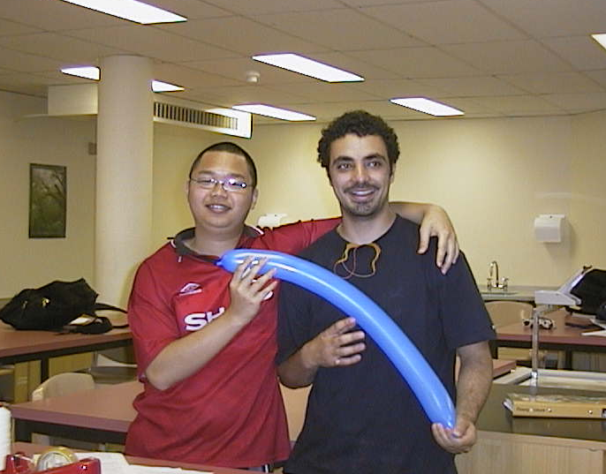

Students at the Australian Catholic University ready to launch a balloon.

Accompanying sheet

Balloons

Blow up a balloon, and do not tie off the neck.

Now let it go. What does the balloon do?

Explain what happens in terms of conservation of momentum.

