Bicycle Wheel

Apparatus
smoothly rotating stool, bicycle wheel with handle through centre about which the wheel can spin (i.e. the handle should not spin with the wheel)
Note: a foot pedal operated motor with a belt attached to a pulley is useful to spin the wheel to large angular velocities, however this is not necessary. A good velocity can be obtained by hand, and this is safer with large classes.

Action
The students spin up the wheel and attempt to tilt it. The wheel should be carefully passed to a student sitting at rest on the rotating stool. This student slowly tilts the wheel to different angles. They can control the direction and speed at which the stool rotates by changing the angle of the spinning wheel.

The Physics
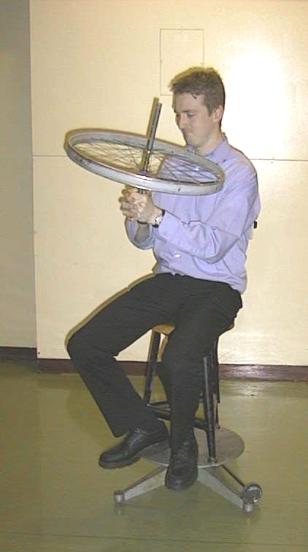
A large torque is needed to tilt the spinning wheel. Angular momentum must be conserved, and a rapidly spinning bicycle wheel has a large angular momentum. The wheel exerts a large reaction force upon the person attempting to change its angular momentum. When the person is on the rotating stool there is no strong frictional force holding the person still, and so they begin to rotate due to the large reaction force, and the total angular momentum is constant.

Note: the bicycle wheel should not be spun too fast as it can be dangerous if dropped or held too close to the body. The student on the stool should be cautioned to tilt the wheel very slowly. This activity needs close supervision.

Tilting the bicycle wheel causes the person to rotate on the stool.

Accompanying sheet

Bicycle Wheel

Spin up the bicycle wheel.
What do you feel when you try to tilt the wheel?

Carefully hand the wheel to someone sitting on the rotating stool.
What happens when they tilt the wheel? Why?

Caution: hold the spinning wheel carefully away from yourself.

