Centre of Mass and Stability

Apparatus
a selection of items such as blocks stacked as a staircase, simple wooden wine bottle holder with (empty) bottle, baseball bat with stand which balances bat at centre of mass

Action
The students examine the items and determine when an object will be stable, and when not. An interesting extension is for them to stand with their backs against a wall and attempt to touch their toes.

The Physics
As long as the center of mass is over the base, an object will be stable. When you try to touch your toes you lean back and put your bottom out, so that your centre of mass stays over your feet. The wall behind you prevents this so you cannot touch your toes and maintain your balance.
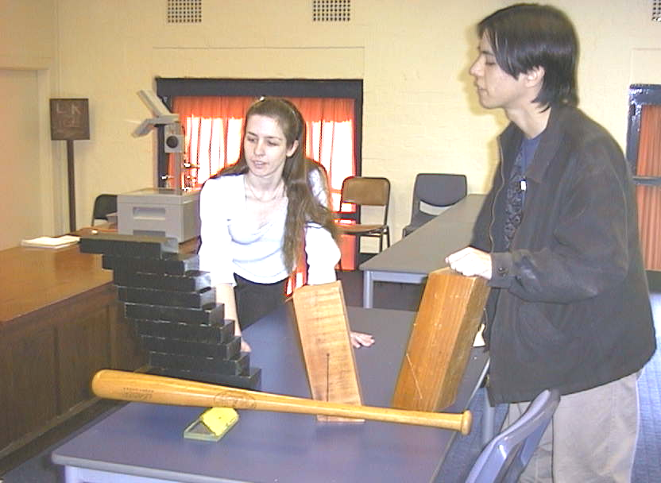
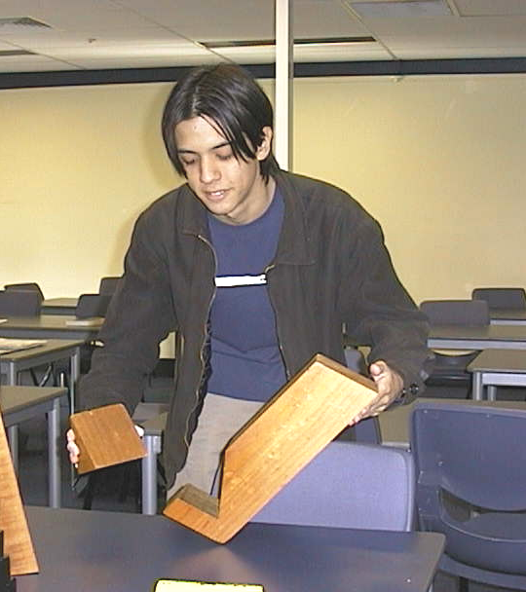

Students at the University of Sydney experimenting with the stability of different objects

Accompanying sheet

Centre of Mass and Stability

Examine the objects on display.
Where is the centre of mass in each object? How can you tell?

Stand with your back against the wall and try to touch your toes.
What happens? Why?

