Clocks

Apparatus
a clock with a “seconds” hand

Action
The students observe the clock and calculate the angular velocity of the three hands. They may also calculate the linear velocity of the hands if the radius is measurable (if the clock is not mounted high up on a wall).

The Physics
The angular velocity is independent of the clock size, however for larger clocks the linear velocity of the pointers at the end of the hands will be greater.
The second hand goes through 2π radians in 1 min, or 2π radian/60 seconds,
so ω = π/30 rad.s⁻¹ = 0.03 rad.s⁻¹.
The minute takes one hour = 60 s/min × 60 min = 3600 s to go around,
so ω = 2π / 3600 rad.s⁻¹ = 1.7 × 10⁻³ rad.s⁻¹.
The hour hand takes 12 hours = 12 hours × 60 min/hour × 60 s/min = 43200 s to do 2π radians,
so ω = 2π rad/43200 s = 1.5 × 10⁻⁴ rad.s⁻¹.

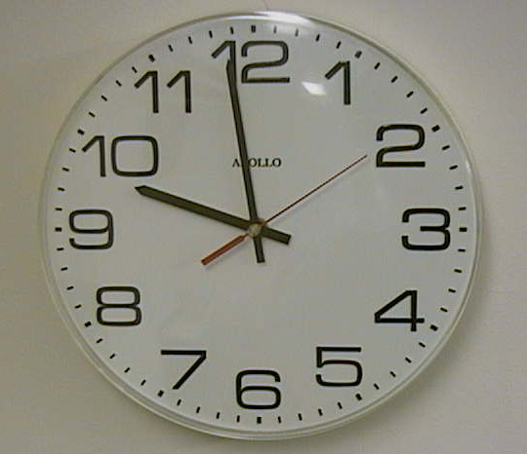

Accompanying sheet

Clocks

What is the angular velocity of the second hand?

What are the angular velocities of the minute and hour hands?
Does it matter how big the clock is?

Does the length of the hands make a difference to their linear velocity?

