Drop and Horizontal Throw

Apparatus
drop and throw apparatus (see below), two marbles or ping-pong balls

Action
The students observe what happens when the two marbles are released, and try to see which, if either, hits the ground first. They should try to predict what will happen before using the apparatus.

The Physics
The two marbles start with zero velocity in the vertical direction, and on release only one has a horizontal component to its velocity. The horizontal and vertical components of the velocity and displacement of the marbles are independent. In the vertical direction they both start with v = 0, and accelerate due to gravity, hence they both fall at the same rate and hit the ground together, although one will still have a horizontal velocity equal to its initial horizontal velocity.
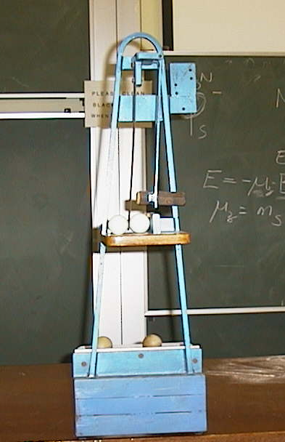
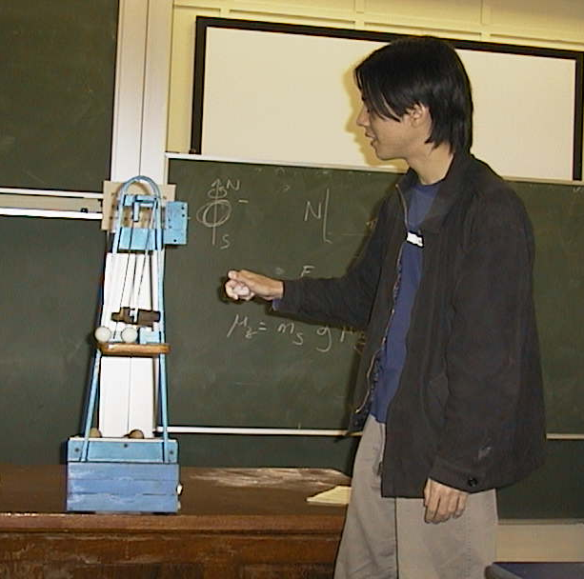

rod

hammer

hole

When the student releases the hammer it will swing back, striking the rod which holds the first ball in place over the hole, and knocking it into the second ball. The first ball drops directly down, the second follows a parabola.

Accompanying sheet

Drop and Horizontal Throw

Set up the marbles ready to be released.

What will happen when they are released?
What are the initial velocities of the two marbles on release?

Which, if either, will hit the ground first? Why?

Release the marbles and check your predictions.

