Falling Cats

Apparatus
a stool which rotates smoothly,
enough floor space for other students to stand well back.

Action
The students look at the diagram showing how a cat falls, and attempt to rotate themselves 180º on the stool, without assistance and without touching anything else. Note that this is quite difficult and may take some practice.

The Physics
Angular momentum is conserved throughout the maneouvre, see diagrams below. This demonstration is adapted from Dr Karl Kruszelnicki’s book “Fidgeting Fat, Exploding Meat and Gobbling Whirly Birds and Other Delicious Science Moments”

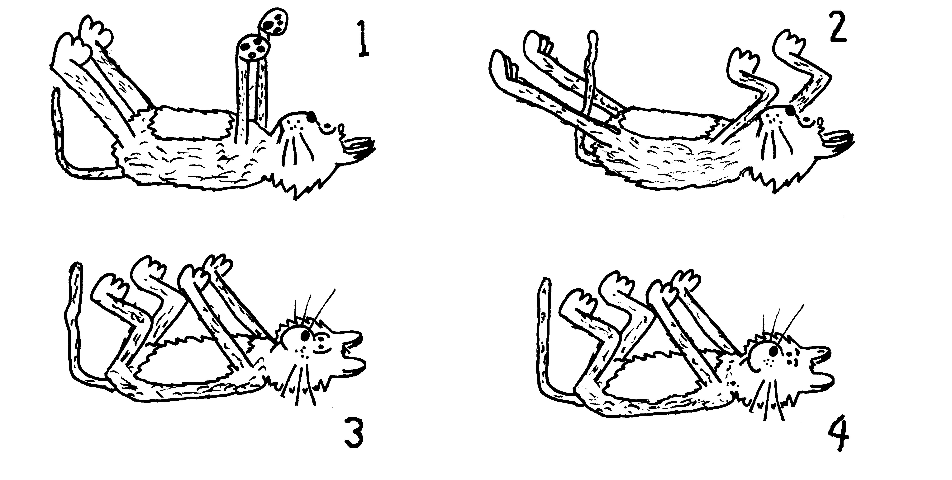
Pull in front legs (arms) and rotate them 60º clockwise. Outstretched rear legs have to rotate 30⁰ anti-clockwise.
Falling with all four limbs sticking straight out.
Extend front legs (arms) and rotate them 30ºanti-clockwise, and pull in back legs which have to rotate 60º clockwise.
You should now be rotated 30º clockwise. Repeat this 5 times and you’ll be facing the right way and ready to land!

Accompanying sheet

Falling Cats

Sit on the stool.

Look at the diagram showing how a cat turns itself around in mid air.
Can you turn yourself through 180º in the same way?

Is conservation of angular momentum being violated here?

