Finding Your Own Centre of Mass

Apparatus
two bathroom scales, long plank (approx 1.8 m – 2 m long) with line halfway along plank.

Action
The plank is laid with a scale beneath each end such that the readings are still visible. Before starting the students should check that the reading is the same on each scale, or the scales can be adjusted to ensure this is the case. A student lies on the plank while two others observe the readings on the scales. They direct the student to edge towards or away from them until the readings on the two scales are identical. When this is done the student notes where the mid line of the plank crosses their body.

The Physics
When the readings are identical the force on each scale is the same. This means that the centre of mass of the person is midway between the scales, i.e. where the mid line of the plank is. This is usually around hip height for females and a little higher than this for males.
It is also interesting to experiment with curving the body such that the centre of mass is over the plank, but not within the body. They will need to lie on their sides to do this. This is what high jumpers do to send their centre of mass below the bar while the body goes above it.

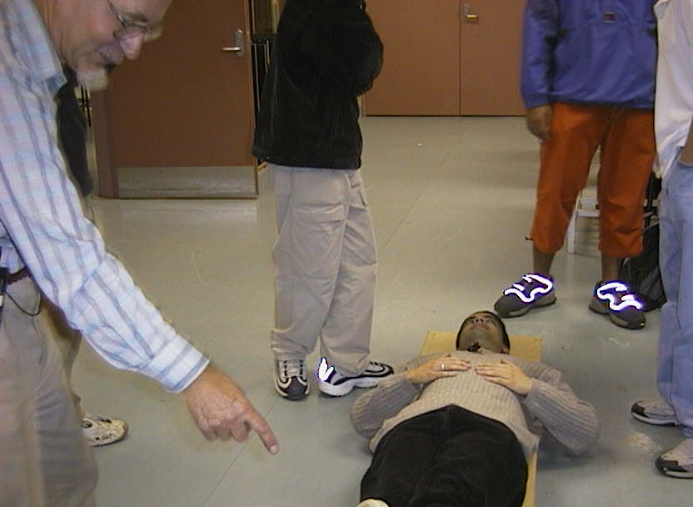

A University of Western Sydney student finding his centre of mass.

Accompanying sheet

Finding Your Own Centre of Mass

Use the bathroom scales and the plank to find
your own centre of mass.

When your center of mass is halfway between the scales,
they will have the same reading. Why is this?

Is it where you expect it to be?
Is it different for other people in your group?

